

CONSULTANCY SERVICES TO VERIFY AND RECORD ASSETS UNDER THE UGIFT PROGRAMME

REF: MOFPED/UGIFT/CONS/25/26/00015

ASSET VERIFICATION REPORT

SUBMITTED BY:

Plot 31, Bukoto Street
P.O Box 7657, Kampala, Uganda
+256 (0) 39 2000216/0772525235
email: cpa@cpa.ug

www.cpa.com

September 2026

Contents
Executive summary
1 Introduction and background
1.1 Introduction
1.2 Background to the verification
1.3 Justification
1.4 Objectives of the assignment
1.5 Scope of work
2 Approach and methodology
2.1 Preparation
2.2 What teams checked
2.3 Fieldwork and itinerary
2.4 Facilities and institutions expected
2.5 Quality assurance
2.6 Bringing the findings together
2.7 Asset categories, condition, use and identification
2.8 Valuation basis
3 Findings
3.1 Availability, condition, identification and value
3.2 Ministries, departments and agencies
3.2.5 Ministry of Finance, Planning and Economic Development
3.2.6 Ministry of Works and Transport
3.2.7 Ministry of Education and Sports
3.2.8 Ministry of Agriculture, Animal Industry and Fisheries
3.2.9 Ministry of Health
3.2.10 Office of the Prime Minister
3.2.11 Ministry of Water and Environment
3.2.12 Ministry of Gender, Labour and Social Development
3.2.13 National Environment Management Authority
3.2.14 Public Procurement and Disposal of Public Assets Authority
3.2.15 Office of the Auditor General
3.2.16 Ministry of Local Government
3.2.17 Ministry of Lands, Housing and Urban Development
3.3 Health centres
3.4 Seed secondary schools
3.5 Blood banks
3.6 Facilities verified, completion and inconsistencies
3.7 UgIFT support to service delivery
3.8 Summary of findings
4 Recommendations
4.1 Maintenance and repairs
4.2 Restore safe operation
4.3 Complete works and bring stored assets into use
4.4 Equip staff to operate and maintain assets
4.5 Strengthen identification and custody
4.6 Resolve programme-list inconsistencies
4.7 Plan for continued service delivery
4.8 Priorities for follow-up
4.9 Facility findings and recommended actions
5 Conclusion
Appendices
Appendix A Summary count schedule
Appendix B Asset totals by category and register class
Appendix C Condition and use schedules
Appendix D Recorded value and net book value schedules
Appendix E Utilisation and identification schedules
Appendix F Programme-list reconciliation
Appendix G Asset information for institutional handover
Appendix H Evidence supporting the findings
Appendix I Photographic record of verified assets
List of tables
Table 1: Key statistics of the UgIFT asset verification
Table 2: Local government field itinerary
Table 3: Facilities on the programme list
Table 4: Programme outputs at closure
Table 5: Availability of verified assets by institution group
Table 6: Condition of verified assets by institution
Table 7: Identification of verified assets by institution group
Table 8: Recorded value and net book value by institution group
Table 9: Availability of assets: Ministries, departments and agencies
Table 10: Condition of assets: Ministries, departments and agencies
Table 11: Identification of assets: Ministries, departments and agencies
Table 12: Recorded value and net book value: Ministries, departments and agencies

Table 12a: Recorded cost by asset category: MoWT

Table 12b: Condition and use of assets: MoES

Table 12c: Engraving status of assets: MoES

Table 12d: Condition and use of assets: MAAIF

Table 12e: Engraving status of verified assets: MAAIF
Table 13: Availability of assets: Health centres
Table 14: Condition of assets: Health centres
Table 15: Health centre buildings: residential and non-residential
Table 16: Identification of assets: Health centres
Table 17: Recorded value and net book value: Health centres
Table 18: Availability of assets: Seed secondary schools
Table 19: Condition of assets: Seed secondary schools
Table 20: Identification of assets: Seed secondary schools
Table 21: Recorded value and net book value: Seed secondary schools
Table 22: School buildings and furniture: composition
Table 23: Availability of assets: Blood banks
Table 24: Condition of assets: Blood banks
Table 25: Identification of assets: Blood banks
Table 26: Recorded value and net book value: Blood banks
Table 27: Programme-list facilities verified, completed and providing services
Table 28: Facilities requiring completion or preparation for use
Table 29: Inconsistencies between the programme list and the facilities found
Table 30: Expected facilities and the outcomes established during verification
Table 31: Confirmed additional beneficiaries outside the programme list
Table 32: User gaps and challenges raised by facilities that described service delivery
Table 33: Priority actions to protect assets and restore service
Table 34: Facility findings and recommended actions
Table 35: Summary count schedule by institution group
Table 36: Assets by report category and institution group
Table 37: Assets by register class and institution group
Table 38: Condition of assets by report category
Table 39: Stated reasons for assets not in use by institution group
Table 40: Recorded value and net book value by institution group
Table 41: Recorded value and net book value by ministry and blood bank
Table 42: Recorded value and net book value by report category
Table 43: Engraving of verified assets by institution group
Table 44: Engraving of verified assets by report category
Table 45: Facilities with assets not in use, in storage or broken down by institution group
Table 46: Programme-list entries with an inconsistency
Table 47: Ground-return identities outside the programme list
Table 48: Verified facilities with works outstanding or not yet providing services
Table 49: Asset information prepared for handover
List of figures
Figure 1: Seed schools and health centres hold most verified assets
Figure 2: Most verified assets were in use
Figure 3: Share of assets in good condition by institution
Figure 4: Most assets were in use; broken assets were the smaller share
Figure 5: Delivery bed with a torn mattress cover at a health centre, Busia District (Bukedi)
Figure 6: Damaged drip stand at a health centre, Moroto District (Karamoja)
Figure 7: Broken desk frame at a seed secondary school, Namisindwa District (Bugisu)
Figure 8: Stacked desks, chairs and stools, some recorded as broken and none engraved, at Napak Seed Secondary School, Napak District (Karamoja)
Figure 9: Cracked health centre block above collapsed ground, Bulambuli District (Bugisu)
Figure 10: Water tank on a cracked base at a seed secondary school, Kibuku District (Bukedi)
Figure 11: Stained and peeling ceiling at a health centre, Sironko District (Bugisu)
Figure 12: Flood-affected older health facility at Butiaba, Buliisa District (Bunyoro)
Figure 13: Desktop computers, a printer and UPS units still boxed in the store at Lungulu Seed Secondary School, Nwoya District (Acholi), awaiting a power connection for installation
Figure 14: Largely empty ICT and library block with a few chairs and items kept in one corner at Iriiri Seed Secondary School, Napak District (Karamoja), not yet in use while the school remained with the contractor
Figure 15: HP computer sets stacked in store with cables still bundled and not installed at Bumufuni Seed Secondary School, Bulambuli District (Bugisu)
Figure 16: Laboratory stools and desks stored and not yet in use at Butungama Seed Secondary School, Ntoroko District (Tooro), where the school buildings were still under construction
Figure 17: Boxed projector, air conditioner and other equipment in store at King Solomon Seed Secondary School, Kagadi District (Bunyoro), kept boxed because the school was still under construction
Figure 18: Chairs, desks and laboratory stools stacked in a hall at King Solomon Seed Secondary School, Kagadi District (Bunyoro), where most assets remained in storage because the school was still under construction
Figure 19: Clinical equipment kept in store among cartons and not in use at Kihuukya Health Centre III, Hoima City (Bunyoro)
Figure 20: Boxed handheld pulse oximeters at Kibiri Health Centre III, Makindye-Ssabagabo Municipal Council (Buganda), where equipment was still being arranged after the facility opened on 31 August 2026
Figure 21: Hospital beds and screens stacked in storage at a health centre, Kagadi District (Bunyoro)
Figure 22: Pedal suction unit marked MAJANJI H/C III still in its packing, recorded as not in use for lack of technical knowledge, Majanji Health Centre III, Busia District (Bukedi)
Figure 23: Breakdowns and storage were the main reasons assets were not in use
Figure 24: Power and user skills were the main reasons equipment stood idle
Figure 25: Most verified movable assets were not engraved
Figure 26: Engraving reading GOU/MOH-UGIFT PROJECT FY/2023/2024 on a desk at Namwaya Health Centre III, Tororo District (Bukedi)
Figure 27: Engraving reading APESSS MOES/UGIFT/KABE/SPLRS/2023-24/001 on a desk at Aperikira Seed Secondary School, Kaberamaido District (Teso)
Figure 28: Chair engraved UgIFT/ BUDDE SEED S.S M-PHALL CHAIR with a serial number at Budde Seed Secondary School, Butambala District (Buganda)
Figure 29: Chairs engraved BSS UGIFT with serial numbers at Budde Seed Secondary School, Butambala District (Buganda)
Figure 30: Engraving reading GOU/MOH-UGIFT PROJECT F/Y 2023/2024 on a bench at Bududa Health Centre III, Bududa District (Bugisu)
Figure 31: Wheelchair backrest marked GOU/MOH UGIFT-PROJECT. FY2023/2024 at Kalemungole Health Centre III, Moroto District (Karamoja)
Figure 32: Refrigerator marked GOU/MOH-UGIFT PROJECT FY2024-2025/01 at Kalemungole Health Centre III, Moroto District (Karamoja)
Figure 33: Engraving reading GOU/MOH-UGIFT PROJECT FY2023-2024/01 on a weighing scale at Kalemungole Health Centre III, Moroto District (Karamoja)
Figure 34: Engraving reading GOU/MOH-UGIFT PROJECT FY2023-2024/01 on a delivery bed at Kalemungole Health Centre III, Moroto District (Karamoja)
Figure 35: Engraving reading GOU/MOH-UGIFT PROJECT FY/2023/2024 on a table at Kamoru Health Centre III, Kotido District (Karamoja)
Figure 36: Engraving reading KDLG-UGFIT/HLTH/MAT/ODT/003 on a table at Kyabasara Health Centre III, Kagadi District (Bunyoro)
Figure 37: Classroom desks marked RUPA SEED with serial numbers, without a UgIFT marking, at Rupa Seed School, Moroto District (Karamoja)
Figure 38: Engraving reading KWN/MED-EQ/MOYOK HCIII on a steel cupboard at Moyok Health Centre III, Kween District (Sebei)
Figure 39: Engraving reading KING SOLOMON SEED SECONDARY SCHOOL, without a UgIFT marking, on furniture at King Solomon Seed Secondary School, Kagadi District (Bunyoro)
Figure 40: Microscope marked KAMORU HC III by hand at Kamoru Health Centre III, Kotido District (Karamoja)
Figure 41: Hand-scratched marking beginning Bumu/2020- on a wheelchair armrest at Bumugibole Health Centre III, Bulambuli District (Bugisu)
Figure 42: Seed schools and health centres hold most of the recorded value
Figure 43: Assets verified: Ministries, departments and agencies
Figure 44: Condition of assets: Ministries, departments and agencies
Figure 45: Engraving status of eligible assets: Ministries, departments and agencies
Figure 46: Recorded value and net book value: Ministries, departments and agencies
Figure 46a: Assets verified: MoFPED
Figure 46b: Assets verified: MoWT
Figure 46c: Assets verified: MoES
Figure 46d: Assets verified: MAAIF
Figure 46e: Assets verified: MoH
Figure 46f: Assets verified: OPM
Figure 46g: Assets verified: MoWE
Figure 46h: Assets verified: MoGLSD
Figure 46i: Assets verified: NEMA
Figure 46j: Assets verified: PPDA
Figure 46k: Assets verified: OAG
Figure 46l: Assets verified: MoLG
Figure 46m: Assets verified: MoLHUD
Figure 47: Assets verified: Health centres
Figure 48: Condition of assets: Health centres
Figure 49: Engraving of movable assets: Health centres
Figure 50: Recorded value and net book value: Health centres
Figure 51: Most health centre buildings are non-residential
Figure 52: Assets verified: Seed secondary schools
Figure 53: Condition shares: Seed secondary schools
Figure 54: Share of movable assets engraved: Seed secondary schools
Figure 55: Recorded value and net book value: Seed secondary schools
Figure 56: Chairs, stools and desks dominate school furniture
Figure 57: Assets verified: Blood banks
Figure 58: Condition of assets: Blood banks
Figure 59: Engraving of movable assets: Blood banks
Figure 60: Recorded value and net book value: Blood banks
Figure 61: Completed blood bank building at Arua Regional Blood Bank, Arua City (West Nile)
Figure 62: Donor couches in the donor room at Arua Regional Blood Bank, Arua City (West Nile)
Figure 63: Markings PEP II/UBTS/COMP/11/016 and UBTS/UGIFT/ARBB/UPS/001 on uninterruptible power supplies at Arua Regional Blood Bank, Arua City (West Nile)
Figure 64: Blood bank refrigerator at Arua Regional Blood Bank, Arua City (West Nile)
Figure 65: Platelet agitator at Arua Regional Blood Bank, Arua City (West Nile)
Figure 66: Chest freezer at Arua Regional Blood Bank, Arua City (West Nile)
Figure 67: Donor couches in the donor room at Hoima Regional Blood Bank, Hoima City (Bunyoro)
Figure 68: Engraving reading UBTS/UGIFT/VCH/001 on equipment at Hoima Regional Blood Bank, Hoima City (Bunyoro)
Figure 69: Blood collection balance at Hoima Regional Blood Bank, Hoima City (Bunyoro)
Figure 70: Benchtop centrifuge at Hoima Regional Blood Bank, Hoima City (Bunyoro)
Figure 71: Water fire extinguisher at Hoima Regional Blood Bank, Hoima City (Bunyoro)
Figure 72: Generator in an outdoor enclosure at Hoima Regional Blood Bank, Hoima City (Bunyoro)
Figure 73: A third of verified seed schools had works outstanding
Figure 74: Unfinished school block at Got Apwoyo Seed Secondary School, Nwoya District (Acholi)
Figure 75: Unfinished classroom block at Sidok Seed Secondary School, Kaabong District (Karamoja)
Figure 76: Latrine block under construction at Sidok Seed Secondary School, Kaabong District (Karamoja)
Figure 77: Building works and construction materials at Ndhew Seed Secondary School, Nebbi District (West Nile)
Figure 78: School block awaiting completion at Butungama Seed Secondary School, Ntoroko District (Tooro)
Figure 79: Building works at a seed secondary school, Kiboga District (Buganda)
Figure 80: Classroom block with earthworks in the foreground at Kihungya Seed Secondary School, Buliisa District (Bunyoro)
Figure 81: Unfinished laboratory building at a health centre, Sironko District (Bugisu)
Figure 82: Biology laboratory under construction at a seed secondary school, Buliisa District (Bunyoro)
Figure 83: Unfinished laboratory interior at Kihungya Seed Secondary School, Buliisa District (Bunyoro)
Figure 84: Library interior under construction at Kihungya Seed Secondary School, Buliisa District (Bunyoro)
Figure 85: ICT laboratory interior under construction at Kitawoi Seed Secondary School, Kween District (Sebei)
Figure 86: Laboratory benches with cupboard doors not yet fitted, in a science laboratory block recorded as under construction, at King Solomon Seed Secondary School, Kagadi District (Bunyoro)
Figure 87: Empty computer laboratory at Kaptum Seed Secondary School, Kween District (Sebei), where the buildings had not been handed over and no ICT equipment had been received
Figure 88: Maternity care and access to education were the most reported benefits
Figure 89: Health centre building at Kibiri HC III, Makindye-Ssabagabo Municipal Council (Buganda)
Figure 90: Health centre buildings and covered walkway at Kihuukya HC III, Hoima City (Bunyoro)
Figure 91: Binocular microscope at Kihuukya HC III, Hoima City (Bunyoro)
Figure 92: Adult weighing scale with a height meter and waiting benches at Iruhura HC III, Kabarole District (Tooro)
Figure 93: Maternity block entrance and access ramp at Kamuli HC III, Tororo District (Bukedi)
Figure 94: Classroom furnished with desks and a whiteboard at Gyagenda Memorial Seed Secondary School, Kalangala District (Buganda)
Figure 95: Books displayed on library shelves at Sibanga Seed School, Manafwa District (Bugisu)
Figure 96: ICT laboratory block and entrance ramp at Sisiyi Seed Secondary School, Bulambuli District (Bugisu)
Figure 97: Power, staffing and space were the gaps most often raised
Figure 98: Most facilities met repairs from their own funds or staff
Figure 99: Annual, monthly and quarterly checks were the most common stated intervals
Figure 100: Infant radiant warmer at a health centre, Makindye-Ssabagabo Municipal Council (Buganda)
Figure 101: Oxygen cylinders marked KIBIRI HCIII at Kibiri HC III, Makindye-Ssabagabo Municipal Council (Buganda)
Figure 102: Wooden waiting bench at Kibiri HC III, Makindye-Ssabagabo Municipal Council (Buganda)
Figure 103: Delivery bed and clinical furniture at a health centre, Kabarole District (Tooro)
Figure 104: Oxygen concentrator at Kalemungole HC III, Moroto District (Karamoja)
Figure 105: Suction apparatus at Kalemungole HC III, Moroto District (Karamoja)
Figure 106: Oxygen concentrator at Kamoru HC III, Kotido District (Karamoja)
Figure 107: Instrument trolley with delivery instruments at Kamoru HC III, Kotido District (Karamoja)
Figure 108: Medical-waste bins and ward beds at Butiaba HC III, Buliisa District (Bunyoro)
Figure 109: Laboratory centrifuge at Butiaba HC III, Buliisa District (Bunyoro)
Figure 110: Blood pressure apparatus on a mobile stand at Butiaba HC III, Buliisa District (Bunyoro)
Figure 111: Office chairs at Butiaba HC III, Buliisa District (Bunyoro)
Figure 112: Kangaroo care chair at Kyabasara HC III, Kagadi District (Bunyoro)
Figure 113: Infant weighing scale at Buwembe HC III, Busia District (Bukedi)
Figure 114: Autoclave above a gas cylinder at Buwembe HC III, Busia District (Bukedi)
Figure 115: Autoclave at Atar HC III, Kween District (Sebei)
Figure 116: Kangaroo care chair at Atar HC III, Kween District (Sebei)
Figure 117: Binocular microscope on a trolley at Namusita HC III, Budaka District (Bukedi)
Figure 118: Infant weighing scales at Namusita HC III, Budaka District (Bukedi)
Figure 119: Delivery bed with side rails at Kabweri HC III, Kibuku District (Bukedi)
Figure 120: Health centre building, Nwoya District (Acholi)
Figure 121: Solar panels at Kalemungole HC III, Moroto District (Karamoja)
Figure 122: Patient toilet block at Kalemungole HC III, Moroto District (Karamoja)
Figure 123: Power house at Kyabasara HC III, Kagadi District (Bunyoro)
Figure 124: Latrine block and paved access at Kyabasara HC III, Kagadi District (Bunyoro)
Figure 125: Solar batteries at Bunangaka HC III, Bulambuli District (Bugisu)
Figure 126: Solar batteries and control equipment at Atar HC III, Kween District (Sebei)
Figure 127: Sanitation block with external handwashing basins at Kibiri HC III, Makindye-Ssabagabo Municipal Council (Buganda)
Figure 128: Waste disposal structure at Kibiri HC III, Makindye-Ssabagabo Municipal Council (Buganda)
Figure 129: Water tanks on a steel tower at Kabweri HC III, Kibuku District (Bukedi)
Figure 130: Science laboratory tables and stools at a seed secondary school, Kalangala District (Buganda)
Figure 131: Library shelves and reading tables at Gyagenda Memorial Seed Secondary School, Kalangala District (Buganda)
Figure 132: Anatomical teaching model at Gyagenda Memorial Seed Secondary School, Kalangala District (Buganda)
Figure 133: Laboratory glassware and equipment at Gyagenda Memorial Seed Secondary School, Kalangala District (Buganda)
Figure 134: Desktop computers and classroom furniture at a seed secondary school, Busia District (Bukedi)
Figure 135: Classroom desks at a seed secondary school, Ntoroko District (Tooro)
Figure 136: Classroom desks at King Solomon Seed Secondary School, Kagadi District (Bunyoro)
Figure 137: Laboratory benches and sinks at Bweema Seed Secondary School, Buvuma District (Buganda)
Figure 138: Classroom desks at Bweema Seed Secondary School, Buvuma District (Buganda)
Figure 139: Laboratory supplies and an anatomical teaching model at Rupa Seed School, Moroto District (Karamoja)
Figure 140: Computer equipment in the school ICT room at Kabeywa Seed Secondary School, Kapchorwa District (Sebei)
Figure 141: Library shelving and tables at Kabeywa Seed Secondary School, Kapchorwa District (Sebei)
Figure 142: Office desk and other furniture at Lwamata Town Council Seed Secondary School, Kiboga District (Buganda)
Figure 143: Laboratory tables at Lwamata Town Council Seed Secondary School, Kiboga District (Buganda)
Figure 144: Library shelving at Lwamata Town Council Seed Secondary School, Kiboga District (Buganda)
Figure 145: Anatomical skeleton teaching model at Kamonkoli Seed Secondary School, Budaka District (Bukedi)
Figure 146: Laboratory benches, stools and sinks at Nansanga Seed Secondary School, Budaka District (Bukedi)
Figure 147: Library shelving with books at Nansanga Seed Secondary School, Budaka District (Bukedi)
Figure 148: Buildings at a seed secondary school, Nwoya District (Acholi)
Figure 149: School blocks at Gyagenda Memorial Seed Secondary School, Kalangala District (Buganda)
Figure 150: School buildings and courtyard at a seed secondary school, Buvuma District (Buganda)
Figure 151: Raised water storage tank at a seed secondary school, Buvuma District (Buganda)
Figure 152: Sanitation block at Bweema Seed Secondary School, Buvuma District (Buganda)
Figure 153: Water tank and enclosed service structures at Bweema Seed Secondary School, Buvuma District (Buganda)
Figure 154: Borehole apron and pipework at Katikekire Seed School, Moroto District (Karamoja)
Figure 155: Section of the science laboratory exterior at Iriiri Seed Secondary School, Napak District (Karamoja)
Figure 156: Water storage tanks at Lopei Seed Secondary School, Napak District (Karamoja)
Figure 157: Computer and library block at Lopei Seed Secondary School, Napak District (Karamoja)
Figure 158: Water tanks on a rendered plinth and steel tower at Alerek Seed Secondary School, Abim District (Karamoja)
Figure 159: Water storage tanks at Rengen Seed School, Kotido District (Karamoja)
Figure 160: Gas cylinders and pipework at King Solomon Seed Secondary School, Kagadi District (Bunyoro)
Figure 161: Water tank on a masonry support at King Solomon Seed Secondary School, Kagadi District (Bunyoro)
Figure 162: Elevated water tank on a steel tower at King Solomon Seed Secondary School, Kagadi District (Bunyoro)
Figure 163: Rainwater tank beside a staff house at Rupa Seed School, Moroto District (Karamoja)
List of acronyms
GOU Government of Uganda
GPS Global positioning system
HC Health centre
ICT Information and communications technology
IFMIS Integrated Financial Management Information System
LGFC Local Government Finance Commission
MAAIF Ministry of Agriculture, Animal Industry and Fisheries
MDA Ministry, department or agency
MoES Ministry of Education and Sports
MOES Ministry of Education and Sports (as engraved)
MoFPED Ministry of Finance, Planning and Economic Development
MoGLSD Ministry of Gender, Labour and Social Development
MoH Ministry of Health
MOH Ministry of Health (as engraved)
MoLG Ministry of Local Government
MoLHUD Ministry of Lands, Housing and Urban Development
MoPS Ministry of Public Service
MoWE Ministry of Water and Environment
MoWT Ministry of Works and Transport
NEMA National Environment Management Authority
OAG Office of the Auditor General
OPM Office of the Prime Minister
PforR Program-for-Results
PPDA Public Procurement and Disposal of Public Assets Authority
RCU Reform Coordination Unit
TELA Teacher Effectiveness and Learner Assessment
UBTS Uganda Blood Transfusion Services
UgIFT Uganda Intergovernmental Fiscal Transfer
UGX Uganda shillings
UPS Uninterruptible power supply

Executive summary

1 Introduction and background

1.1 Introduction
This report presents the findings of the UgIFT asset verification undertaken by the Ministry of Finance, Planning and Economic Development as part of programme closure activities. It sets out the status of the assets provided by the programme to the targeted national institutions responsible for supporting the implementation of the programme, Blood Banks and local governments specifically targeting seed secondary schools and health facilities upgraded from Health Centre II to Health Centre III.

1.2 Background to the verification
The Uganda Intergovernmental Fiscal Transfers (UgIFT) Programme is a government programme implemented through a Programme-for-Results (PforR) launched and aligned with the broader IGFT Reform Programme (2015). UgIFT 1.0 began with US$200 million in FY2017/18, supporting Education and Health. This was later expanded through additional financing of US$300 million, including US$240 million in credit and US$60 million in grants, with US$50 million from the IDA Refugee Support Window, expanding beyond Education and Health to water and Environment and Agriculture (micro-scale irrigation) making the overall funding total of US$500 million.

The Intergovernmental Fiscal Transfer Reform Programme (IGFT RP) was revised in 2020 to align with the Third National Development Plan (NDP III 2020/21 - 2024/25), and to directly contribute to Four (04) Programmes i.e. Human Capital Development; Public Sector Transformation; Natural Resources, Environment, Climate change, Land and Water Management; and Development Plan Implementation.

Overall, the development objective of the UgIFT Programme was to: “Improve the adequacy, equity, and effectiveness of financing and the oversight, management, and delivery of Local Government services in Education, Health, Water and Environment, and Agriculture (micro-scale irrigation), including refugees and their host communities”.
Specifically, the Programme sought to:
- Increase the adequacy and predictability of fiscal transfers to Local Governments for service delivery;
- Improve the equity and transparency of allocation mechanisms through the introduction of formula-based transfers;
- Strengthen performance incentives and accountability systems for Local Governments; and
- Expand access to quality education and health infrastructure, particularly in under-served areas.

The UgIFT Programme had four components aimed at strengthening the intergovernmental fiscal transfer system while supporting investments in service delivery infrastructure. These included;

Component 1: Reform of the Intergovernmental Fiscal Transfer System
This supported the design and implementation of a reformed fiscal transfer framework based on objective and transparent allocation criteria. This resulted into introduction of formula-based grants - Revised allocation formulas reflecting population, infrastructure gaps, and service delivery needs.

Component 2: Education Infrastructure Development
This component financed the construction and upgrading of education facilities, particularly government secondary schools in under-served sub-counties. This involved construction and equipping of new secondary schools - classrooms, laboratories, administration blocks, sanitation facilities, teachers’ houses, furniture and ICT equipment in the different local governments.
Component 3: Health Infrastructure Development
This supported investments in health facilities to improve access to primary health care services at the local level. The major outputs under the component were construction and upgrading of health centers - Staff accommodation, sanitation facilities and provision of medical equipment.

Component 4: Local Government Performance and Institutional Strengthening
This aimed at Strengthening local government capacity in planning, budgeting, procurement, and infrastructure management. Under this component, Annual local government performance assessments have been undertaken across the 176 Local governments, capacity building and technical support strengthened monitoring and reporting systems across the Local governments.

The Programme was implemented through a clearly defined results framework that connected actions and incentives across three levels of government to strengthen service delivery outcomes. The programme came to an end in December 2025 and had accomplished the following outputs under the different components;

- Budget Support
- Education: 196 of 259 Seed Schools are complete of which 189 are operational.
- Health: 354 of 373 health facility upgrades/new constructions (HC II to HC III) are complete.
- Water and Environment: 758 - piped water systems, 5,398- point water sources, 7,082 water supply systems rehabilitated, 325 designs completed, and 256 sanitation facilities in the targeted service units.
- Agriculture (Micro-scale Irrigation): Over 6,235 irrigation systems were installed (4,843 hectares under irrigation), 632 irrigation demonstration sites in 135 LGs set up.
- Refugee intervention: 51 primary schools and 35 health facilities in refugee hosting districts (RHD) were transitioned and integrated into the LG service.
- Blood Banks: Regional Blood Banks in Arua and Hoima were completed and commissioned while Soroti Regional Blood Bank was rehabilitated.

- Grant management
Assets for institutional strengthening and retooling including ICT equipment and vehicles were provided. The Ministry of Finance, Planning and Economic Development (MoFPED) through PFM Coordination Unit (RCU) manages the Government of Uganda counterpart funding of the programme to support the grant management component of the UgIFT programme. The grant management supports in financing of Central Government actions intended to achieve programme objectives and Disbursement Linked Indicators (DLIs). To this end, MoFPED through RCU supported MDAs to acquire different assets meant to support programme implementation.

1.3 Justification
The UgIFT programme came to an end on 31st December 2025. As part of the programme’s closure activities, MoFPED, through RCU, commissioned an end-of-programme asset verification exercise to take stock of the assets procured under the programme and to establish where those assets were, how they were being used as part of the processes to hand them over to government for sustainability purposes.

1.4 Objectives of the assignment
The objective of the assignment was to undertake verification and recording of all assets acquired under the UgIFT Programme. Specifically, the assignment intended to;
- Identify and verify the existence of the assets
- Verify the assets condition and status: specifically, the condition on functionality, usage/performance and location, among others
- Assess financial management aspects: residual value of the investments/hardware/tools for purposes of financial reporting for project closure
- List the assets that are obsolete, unserviceable and require disposal
- Develop a computerized database of the investment/hardware/tools to facilitate recording of new deployed assets/investments
- Undertake PFM Assessment on Asset Management practices (including sustainability, Operations and Maintenance) of the UgIFT implementing LGs

1.5. Scope of Work
The assignment covered all targeted institutions at National and Local Government that directly implemented the UgIFT programme from coordination, support and implementation across the country. At the Local Government level, the verification focused on upgraded improved health facilities and seed secondary schools. Specifically, the assignment involved the following tasks;
- Verification of the Asset’s Records of targeted MDAs and LGs
- Physical and Functional Verification of assets
- Data Consolidation for generation of a single data base of assets provided by the programme
- Generation of an IFMIS ready Asset Register for Integration, and Migration into IFMIS
- Review of the UgIFT Asset Management Practices

1.6 Expected deliverables
- Report with the list and current status of assets acquired under the programmes;
- An automated up-to-date assets data base of UgIFT Investments across MDALGs;
- Report on the estimated value of assets under the programme as well as operations and maintenance arrangements;
(iv) IFMS-Ready Asset Register and Data Migration Report;
(v) Report on functionality of assets relating to systems investments;
(vi) Report on Assessment of Asset Management Practices, Risks and recommendations.

2 Approach and methodology

The verification exercise was conducted using a participatory and consultative process and implemented in three interlinked phases: Preparatory and inception phase, Data collection phase and Report writing phase.

2.1 Preparation
The Inception phase was completed and the inception report submitted on 18th June 2026 which provided an agreed scope, approach and work plan for the exercise. The team also undertook a pilot test in Wakiso District Local Government, with verification carried out at Buloba Health Centre III and Sumbwe Seed Secondary School, which helped in design of data collection tool and the deployment plans.

2.2. Data collection
This exercise was undertaken in two phases first at National level and later at the Local government level.
National level: Physical visits to verify assets provided by the programme at the national-level was completed on the 19th of August 2026. This covered 15 MDAs including; Ministry of Works and Transport (MoWT); Ministry of Education and Sports (MoES); Ministry of Agriculture, Animal Industries and Fisheries (MAAIF); Ministry of Health (MoH); Office of the Prime Minister (OPM); Ministry of Water and Environment (MoWE); Ministry of Gender, Labour and Social Development (MoGLSD); Local Government Finance Commission; National Environment Management Authority (NEMA); Public Procurement and Disposal of Assets Authority (PPDA); Office of the Auditor General (OAG); Ministry of Public Service (MoPs); Ministry of Lands, Housing and Urban Development (MoLHUD); Ministry of Local Government (MoLG) and Ministry of Finance, Planning and Economic Development (MoFPED). Additionally, three Blood Banks of Hoima, Arua and Soroti were covered.

Local government level: The local government verification covered all UgIFT upgraded/ constructed Health Centres and Seed Secondary Schools in all the 176 LGs. The process began with a training of field teams prior to the actual field verification.

Training of field teams: A total of 85 Research Assistants (RAs) and 7 Regional Supervisors were trained. The training took place from 21st to 23rd August 2026 and physical verification started on the 24th of August 2026 across all the 176 Local governments. During the Asset verification, the RAs visited Seed Secondary Schools, Health Centres and Blood Banks.

Physical verification: This exercise commenced on the 24th of August 2026 and was completed on 17th September 2026. The local government physical verification involved entry meetings with the LG leadership at the LG headquarters for authorization and review of reports relating to UgiFT assets, key informant interviews with the technical teams especially the Chief Administrative Officers, Finance Officers, District Health Officers and District Education Officers. Thereafter, the RAs proceeded to the facilities for physical verification of the assets.

At local government level, the programme list had 629 facilities: 371 health centres and 258 seed secondary schools. The list recorded 547 facilities (87.0%) as complete and 82 (13.0%) as ongoing. The ongoing works were more common among seed secondary schools (63, or 24.4%) than among health centres (19, or 5.1%).

2.3. Quality assurance
Regional supervisors checked daily field activity and reviewed the completed tools. The central technical team carried out spot checks and helped resolve operational questions. Teams compared institutional asset information with the items and explanations provided during visits, while supervisors referred matters requiring clarification to the team leader and the field coordinator.

2.4 Asset categories, condition, use and identification
Asset categories. Each asset was counted once and assigned to one report category. Health centre assets were grouped as clinical equipment, clinical furniture, maternity ward equipment and health centre ICT equipment. On the other hand, seed secondary school assets were grouped as school furniture, school computers and related equipment and school support equipment. Another category included other ICT equipment, other furniture, vehicles, motorcycles and buildings, which apply to MDAs, Blood Banks and LGs alike.

Condition and use. Condition and use were reported as recorded for each asset during the verification. A working asset is one recorded as functional and in use. An asset recorded as faulty was reported as not working and not in use. This included assets that were broken down or damaged. An asset that was new and in store was recorded as functional but not in use. Additionally, an asset that was held elsewhere, not yet delivered or awaiting power installation, completion of buildings or trained users, was also recorded as functional but not in use.

Identification. An asset is properly identified when carried a UgIFT programme marking. However, there were other assets that had no UgIFT marking but the officers on ground identified them as UgIFT assets.

2.5 Valuation
The Government of Uganda Asset Accounting Policies and Guidelines 2023 was used to determine the recorded values, depreciation and net book values.

2.6 Analysis and reporting
Analysis and reporting was done through triangulation of the literature from different policy, Planning and Financial documents including: the Government of Uganda Asset Accounting Policies and Guidelines 2023; asset registers; asset records at national and local government levels; physical inspections; discussions with facility managers; photographs and asset counts for each institution.

2.7. Challenges and Limitations to the assignment

Difficult terrain and poor physical accessibility of facilities: Physical accessibility presented a significant operational challenge especially for facilities located in areas characterised by difficult terrain and limited transport accessibility such as Bwesumbu HC III, Bwesumbu Seed School, Buhuhira and Kabingo in Kasese District. In addition, accessing facilities within the Island was difficult, time consuming and expensive. This led the teams to overshoot the anticipated time for data collection.

High transportation cost: Given the national wide coverage, the rising fuel prices led to high field costs. The field teams spent more money than was anticipated. The costs were extra ordinarily higher for island facilities like Kalangala, Buvuma, Mayuge among others. For instance, Kalangala had 3 facilities with long distance on water that required hiring a private boat since it was not a common route to the transporters and outside the ferry schedules. A similar situation was encountered in Buvuma and Namayingo districts.

Poor record keeping: In many LGs and facilities, there were no clear records about the assets delivered under UgIFT. The LGs and the facilities had incomplete or missing UgIFT asset registers which delayed data collection. Subsequently, the teams took longer in such facilities identifying the assets as most of these were not engraved with the UgIFT identifiers while others were not engraved at all. In addition, the field teams encountered situations where some Assets could not be physically accessed especially for schools since it was holiday time.

3 Findings
This section presents the verification findings at national and local government levels.
The findings follow one sequence for the programme as a whole and again for each institution group: availability of the assets, condition of the assets, identification including engraving, and financial aspects. Ministries and agencies come first, then health centres, seed secondary schools and the regional blood banks. Health centres and seed schools are reported at facility-type level, by asset category, rather than facility by facility. Later sections return to the programme list, service delivery and the priorities for follow-up.

3.1 Availability, condition, identification and value

3.1.1 Availability of the assets
The verification records in this report hold 226,273 assets. Seed secondary schools hold 145,376 (64.2%) and health centres 63,599 (28.1%). Ministries and agencies hold 16,668 and the blood banks 626. Figure 1 shows the shares, and Table 5 lists them.
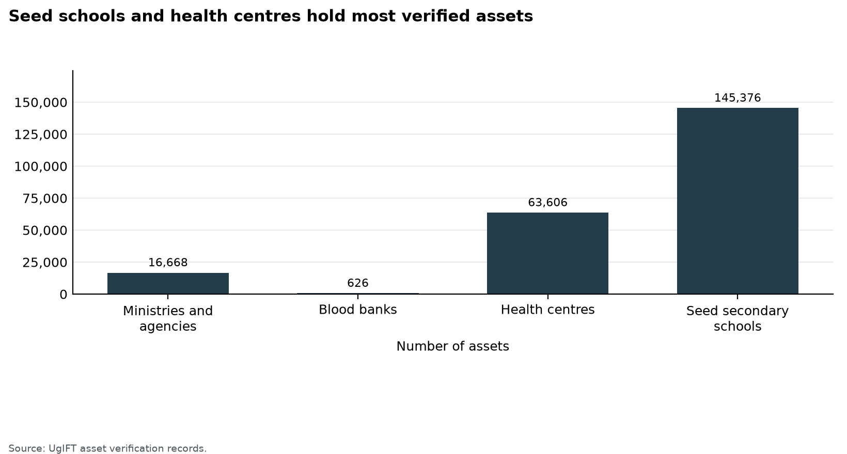
Figure 1: Seed schools and health centres hold most verified assets
Table 5: Availability of verified assets by institution group
Institution | Assets verified | Share
Ministries and agencies | 16,668 | 7.4%
Blood banks | 626 | 0.3%
Health centres | 63,599 | 28.1%
Seed secondary schools | 145,376 | 64.2%
District offices | 4 | 0.0%
Total | 226,273 | 100.0%

3.1.2 Condition of assets
Good condition means an asset is in use or in store. On that definition, 215,892 assets (95.4%) were in good condition: 212,773 in use and 3,119 in store. 3,392 assets (1.5%) were broken, and 6,989 (3.1%) were not in use for another reason. Figure 2 shows how the stock divides. Figure 3 compares the share in good condition, and Figure 4 shows the count behind it. Table 6 places every ministry beside the health centres, seed schools and blood banks.
Most of the stock was already in service. The assets that were not in use tell a shorter story. Some were in store and still in good condition, so they can be issued once power, a room or handover is in place. Others were broken and need repair before they can support a service. The rest were not in use because delivery, installation or the facility itself was not yet ready. At the ministries, 20 assets were not in use. Sixteen of them were at the Ministry of Works and Transport, whose location was still being traced, and three were damaged laptops at the Office of the Prime Minister. Health centres had the larger share of assets in store. Seed schools had the larger share of broken furniture.
The field visits show how those numbers sit in a facility. At Lungulu Seed Secondary School in Nwoya District, desktop computers, a printer and UPS units were still boxed because the school was waiting for a power connection. At Nansanga Seed Secondary School in Budaka, 27 of 28 desktop computers remained packed for lack of reliable power. Broken desks and stools were in classrooms and stores at seed schools in Namisindwa and Napak. A delivery bed at a health centre in Busia District had a torn mattress cover. At Arua Regional Blood Bank, six blood pressure machines were damaged or not functional. The same pattern runs through the categories in the sections that follow: most assets work and are in use, a smaller group is in store and still sound, and a smaller group again is broken.
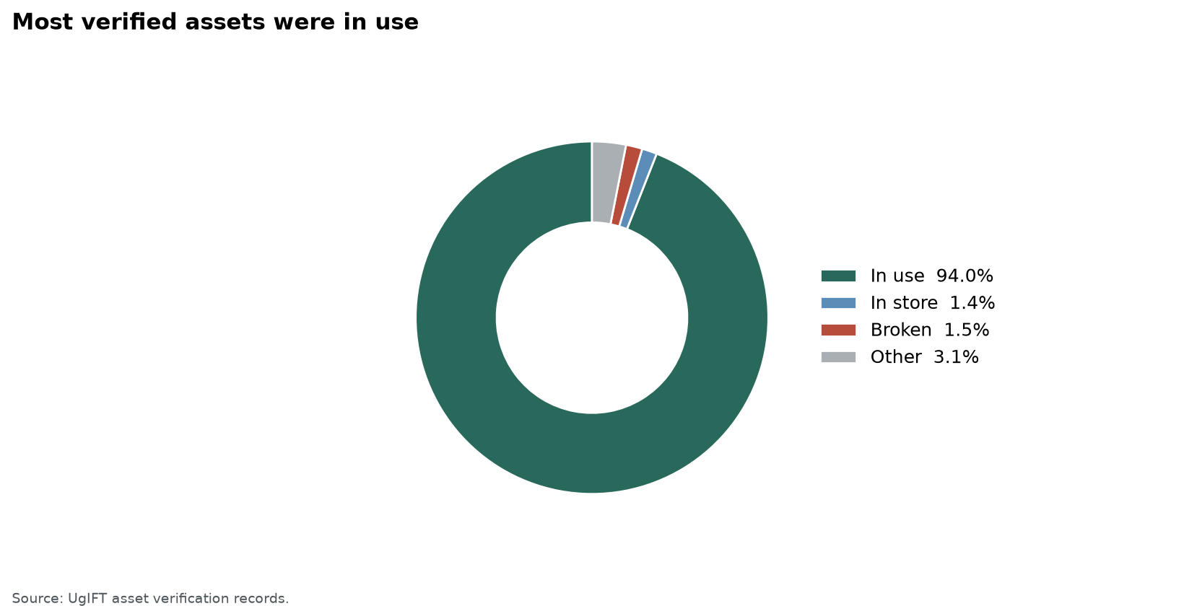
Figure 2: Most verified assets were in use
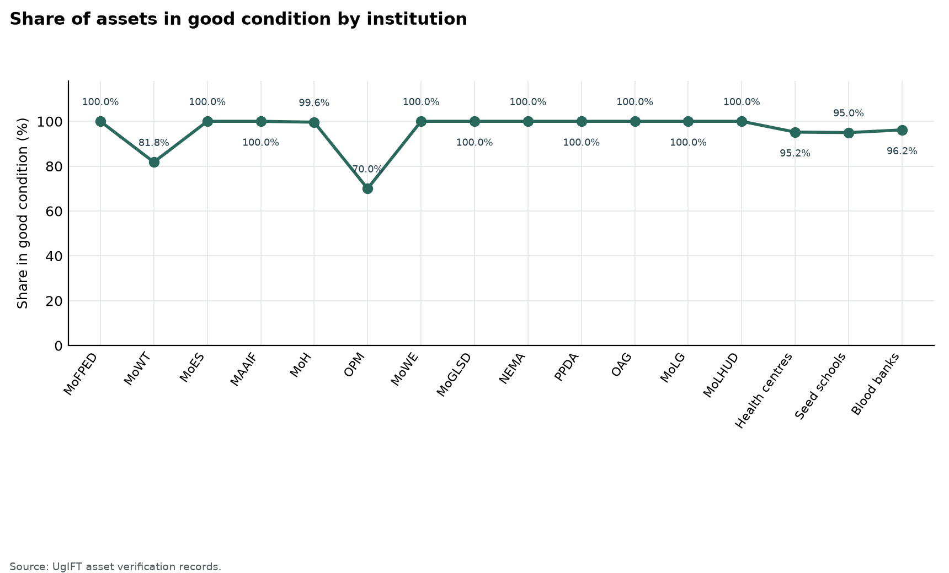
Figure 3: Share of assets in good condition by institution
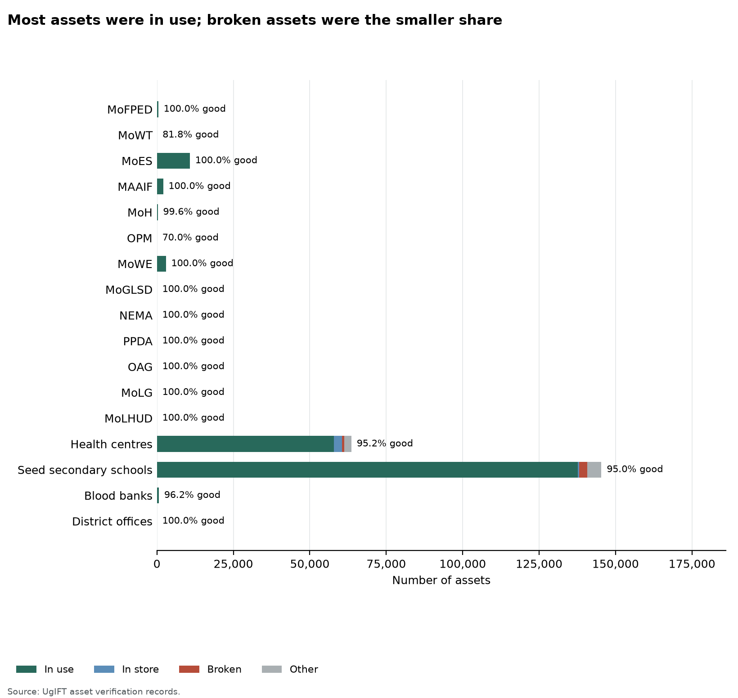
Figure 4: Most assets were in use; broken assets were the smaller share
Table 6: Condition of verified assets by institution
Institution | Assets verified | Good condition |  | Broken | Other
Institution | Assets verified | In use | In store | Broken | Other
MoFPED | 458 | 458 | 0 | 0 | 0
MoWT | 88 | 88 | 0 | 0 | 0
MoES | 10,783 | 10,783 | 0 | 0 | 0
MAAIF | 2,045 | 2,045 | 0 | 0 | 0
MoH | 264 | 263 | 0 | 1 | 0
OPM | 10 | 7 | 0 | 3 | 0
MoWE | 2,939 | 2,939 | 0 | 0 | 0
MoGLSD | 10 | 10 | 0 | 0 | 0
NEMA | 6 | 6 | 0 | 0 | 0
PPDA | 5 | 5 | 0 | 0 | 0
OAG | 20 | 20 | 0 | 0 | 0
MoLG | 13 | 13 | 0 | 0 | 0
MoLHUD | 27 | 27 | 0 | 0 | 0
Health centres | 63,599 | 57,918 | 2,629 | 660 | 2,392
Seed secondary schools | 145,376 | 137,585 | 490 | 2,722 | 4,579
Blood banks | 626 | 602 | 0 | 6 | 18
District offices | 4 | 4 | 0 | 0 | 0
Total | 226,273 | 212,773 | 3,119 | 3,392 | 6,989
Good condition is assets in use plus assets in store. Broken assets are counted on their own, including broken assets found in store. Other assets are not in use for another reason. The four condition columns sum to assets verified.
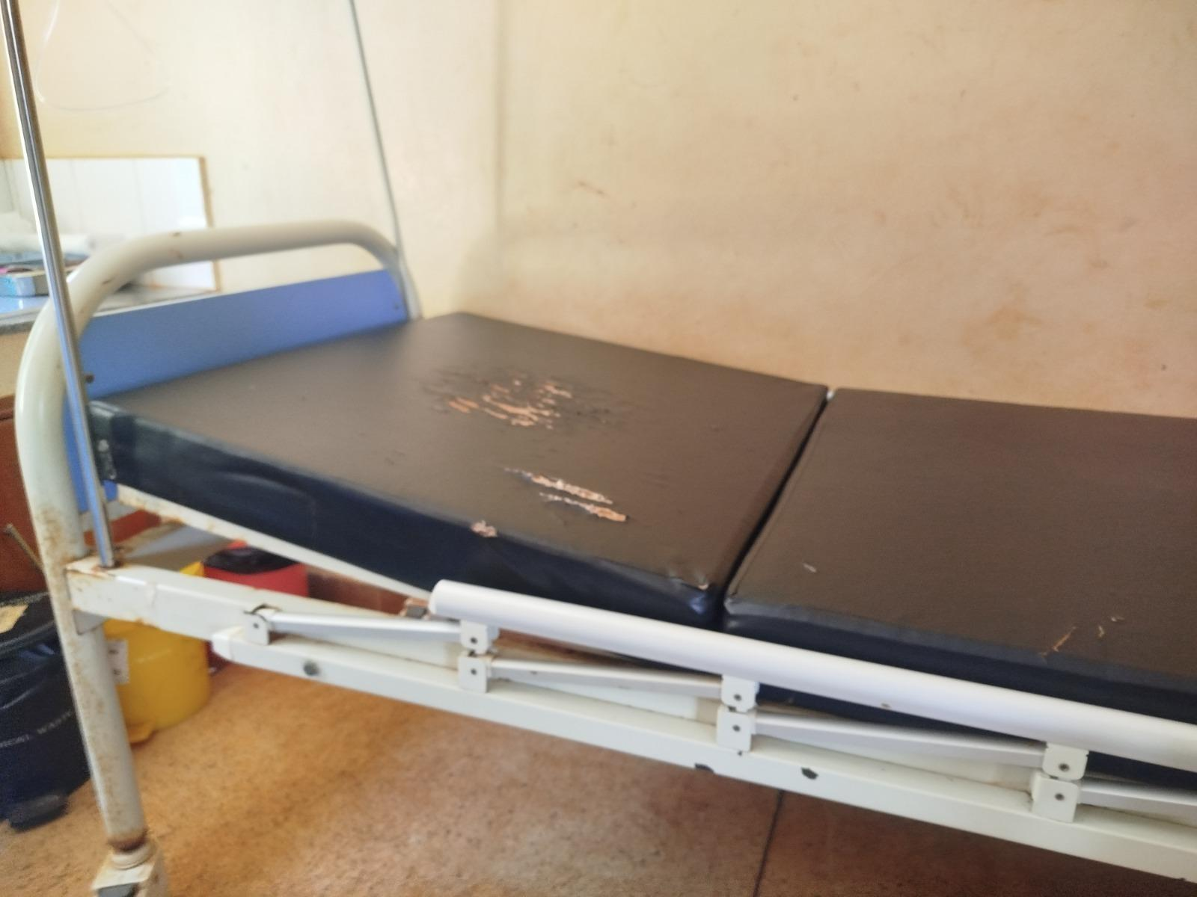  Figure 5: Delivery bed with a torn mattress cover at a health centre, Busia District (Bukedi) | 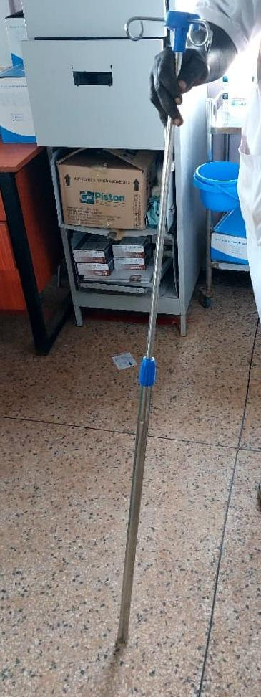  Figure 6: Damaged drip stand at a health centre, Moroto District (Karamoja) | 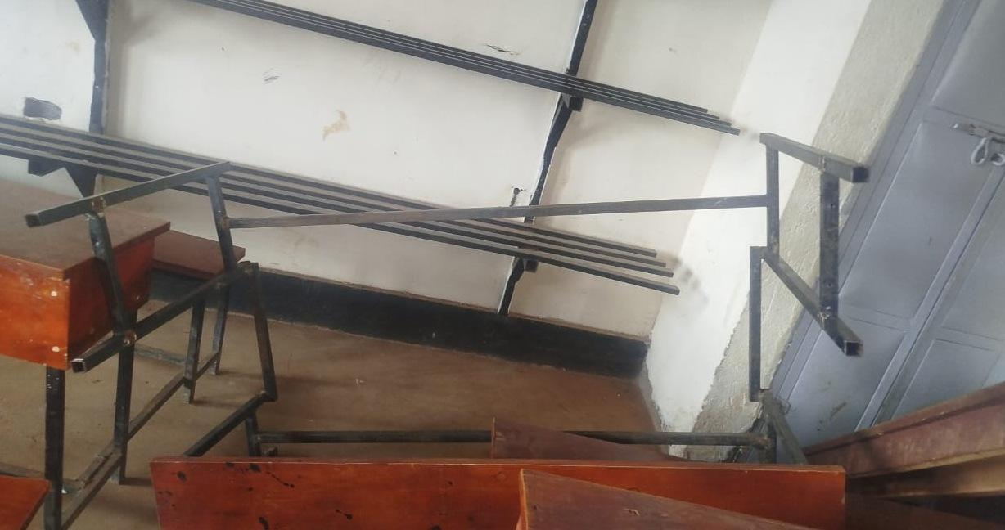  Figure 7: Broken desk frame at a seed secondary school, Namisindwa District (Bugisu)

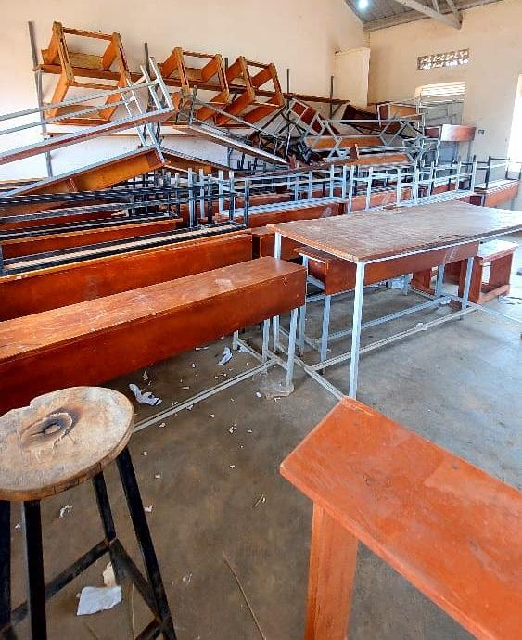  Figure 8: Stacked desks, chairs and stools, some recorded as broken and none engraved, at Napak Seed Secondary School, Napak District (Karamoja) | 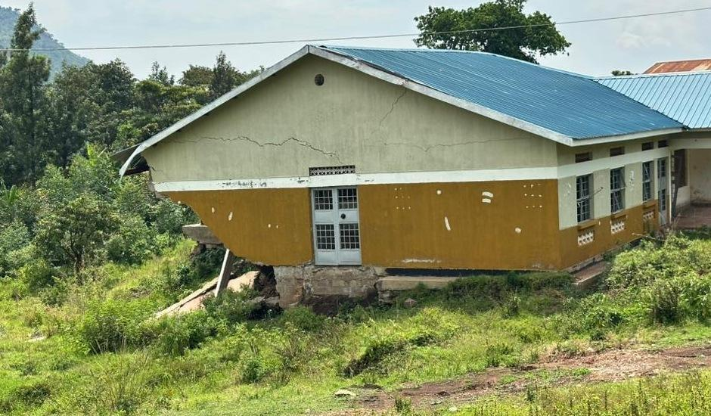  Figure 9: Cracked health centre block above collapsed ground, Bulambuli District (Bugisu) | 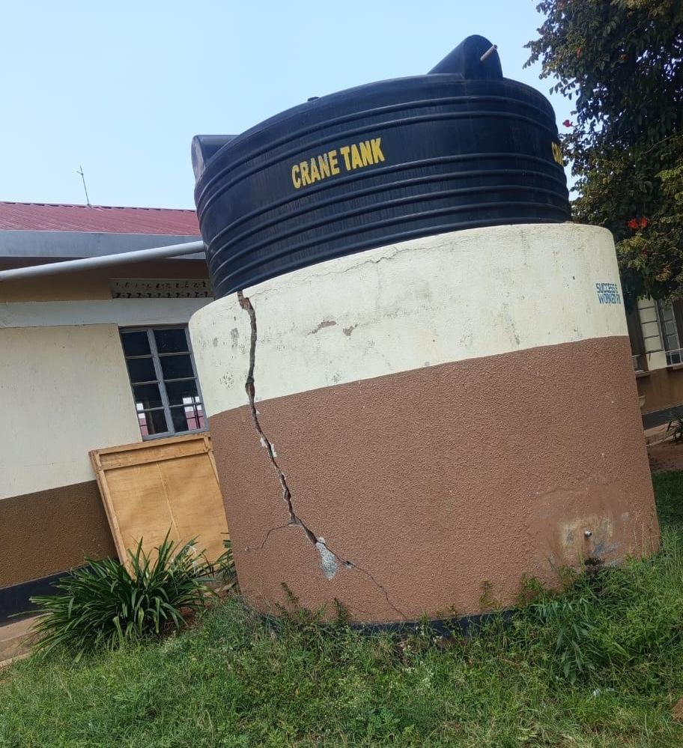  Figure 10: Water tank on a cracked base at a seed secondary school, Kibuku District (Bukedi)

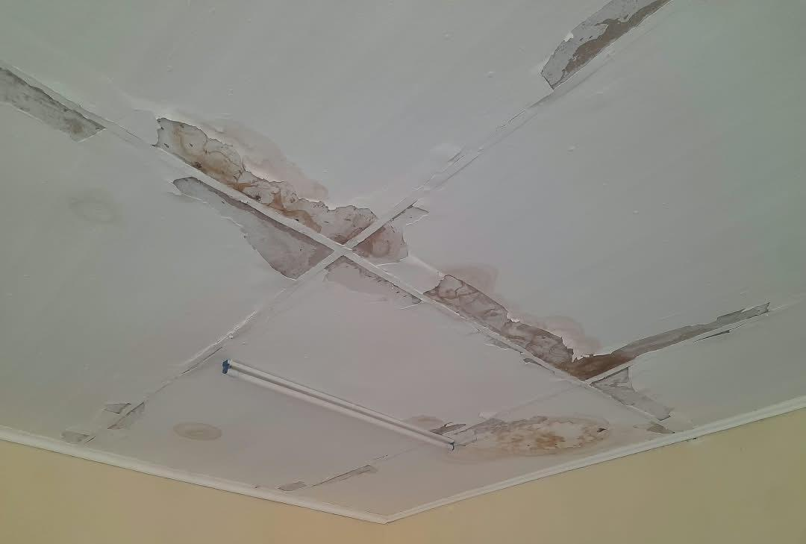  Figure 11: Stained and peeling ceiling at a health centre, Sironko District (Bugisu) | 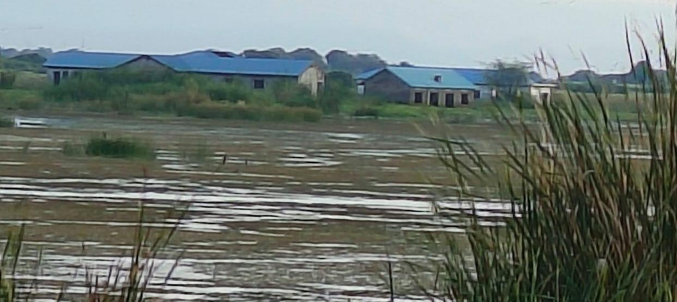  Figure 12: Flood-affected older health facility at Butiaba, Buliisa District (Bunyoro)

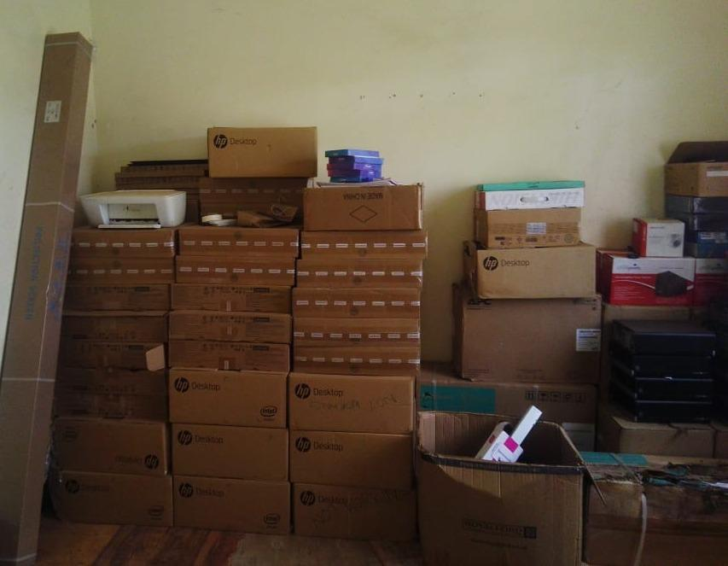  Figure 13: Desktop computers, a printer and UPS units still boxed in the store at Lungulu Seed Secondary School, Nwoya District (Acholi), awaiting a power connection for installation | 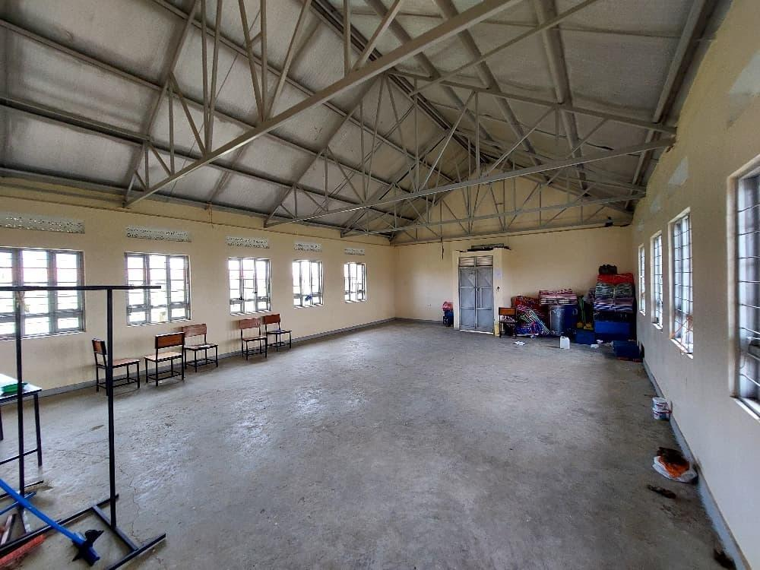  Figure 14: Largely empty ICT and library block with a few chairs and items kept in one corner at Iriiri Seed Secondary School, Napak District (Karamoja), not yet in use while the school remained with the contractor

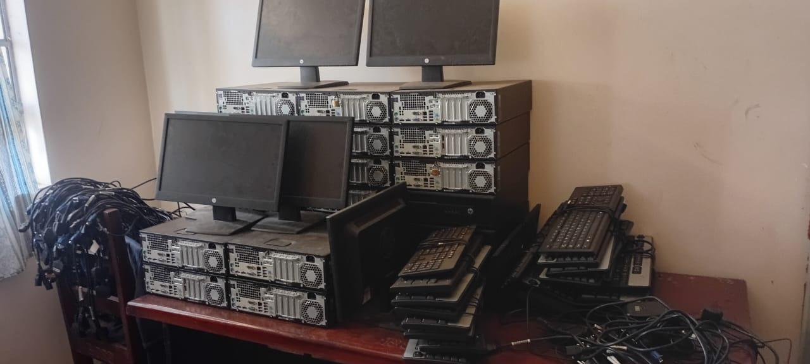  Figure 15: HP computer sets stacked in store with cables still bundled and not installed at Bumufuni Seed Secondary School, Bulambuli District (Bugisu) | 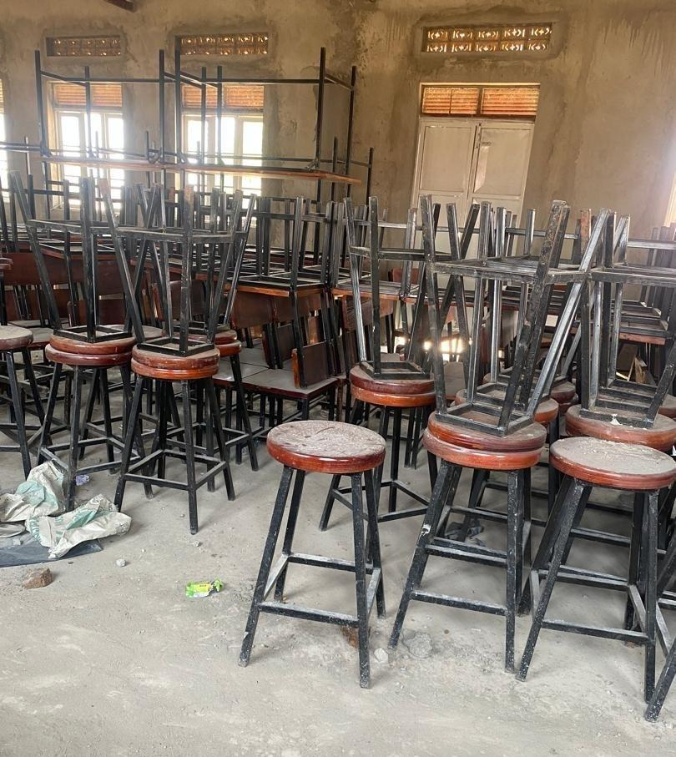  Figure 16: Laboratory stools and desks stored and not yet in use at Butungama Seed Secondary School, Ntoroko District (Tooro), where the school buildings were still under construction

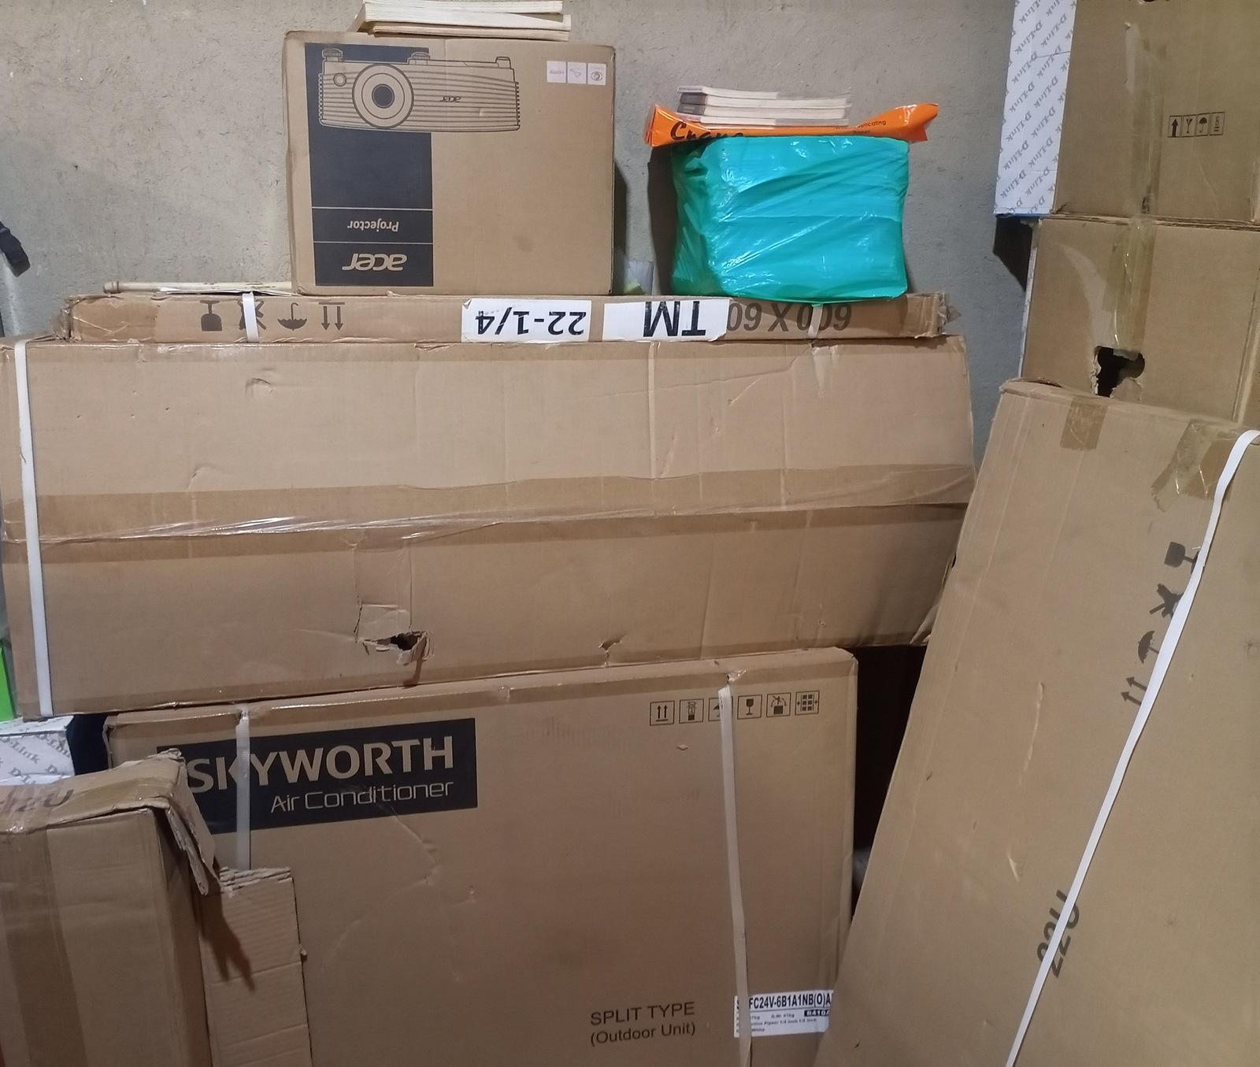  Figure 17: Boxed projector, air conditioner and other equipment in store at King Solomon Seed Secondary School, Kagadi District (Bunyoro), kept boxed because the school was still under construction | 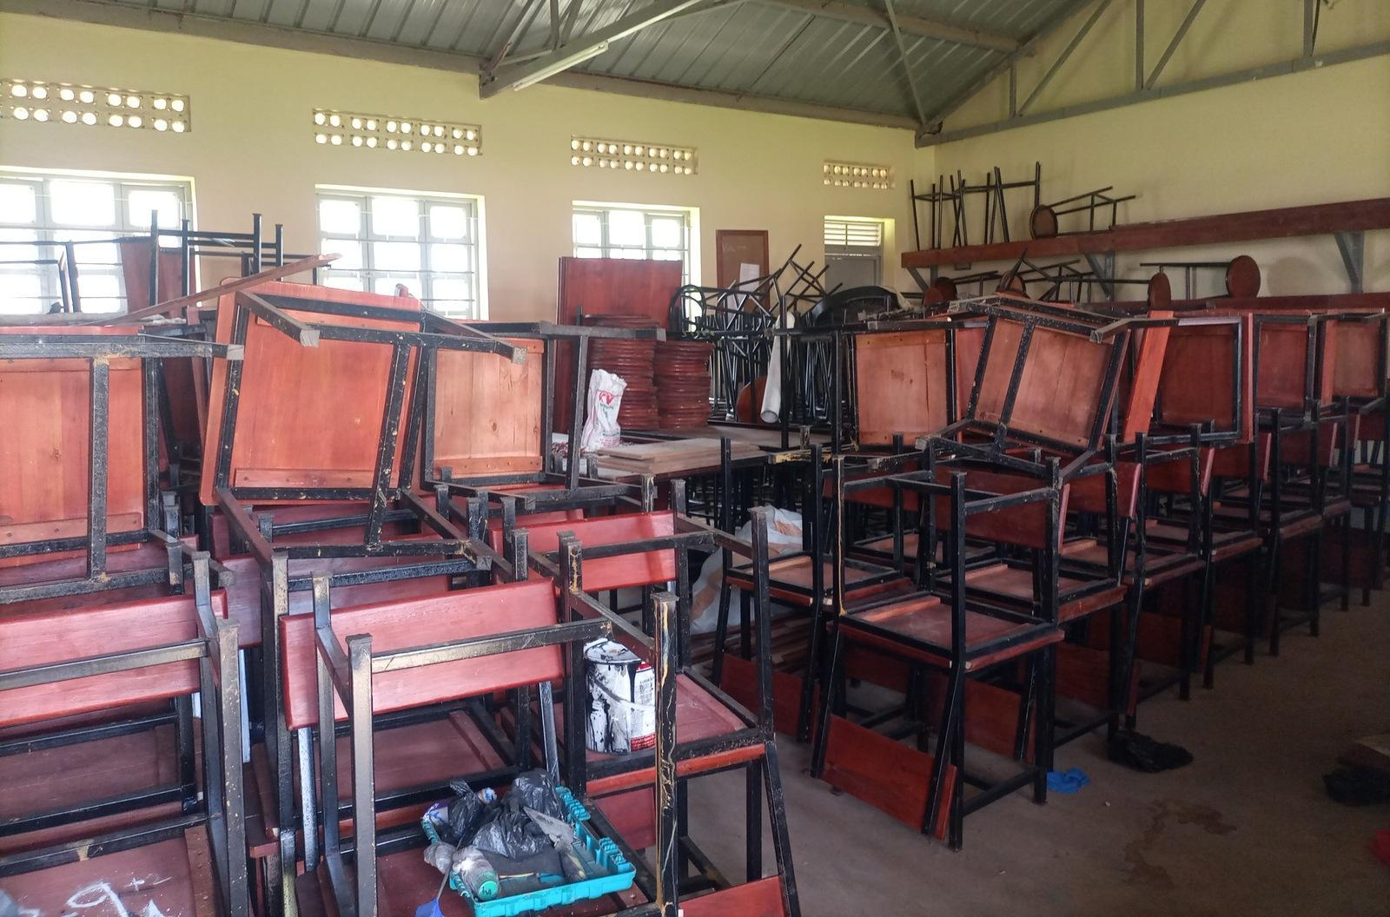  Figure 18: Chairs, desks and laboratory stools stacked in a hall at King Solomon Seed Secondary School, Kagadi District (Bunyoro), where most assets remained in storage because the school was still under construction

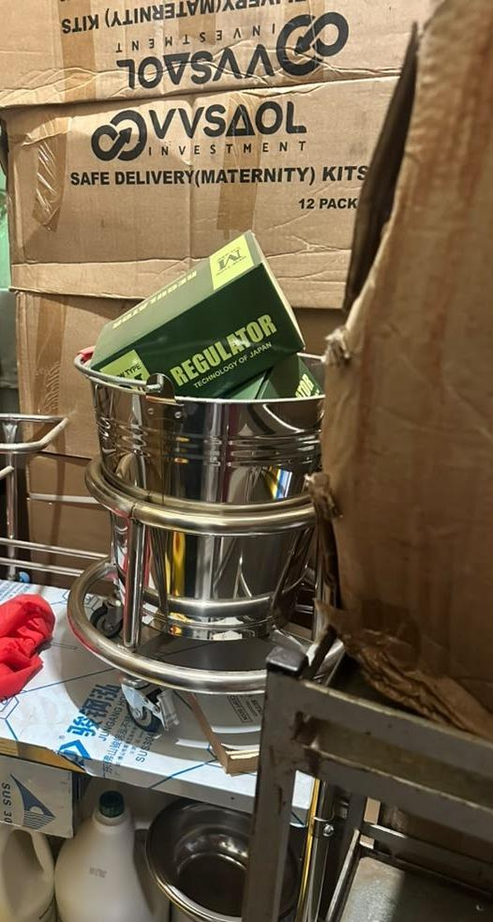  Figure 19: Clinical equipment kept in store among cartons and not in use at Kihuukya Health Centre III, Hoima City (Bunyoro) | 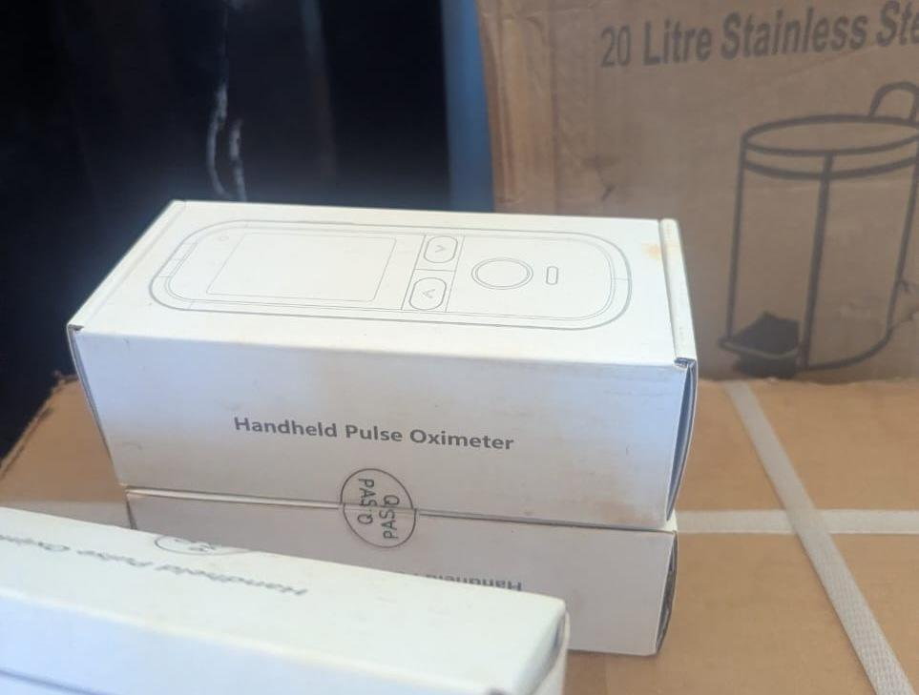  Figure 20: Boxed handheld pulse oximeters at Kibiri Health Centre III, Makindye-Ssabagabo Municipal Council (Buganda), where equipment was still being arranged after the facility opened on 31 August 2026 | 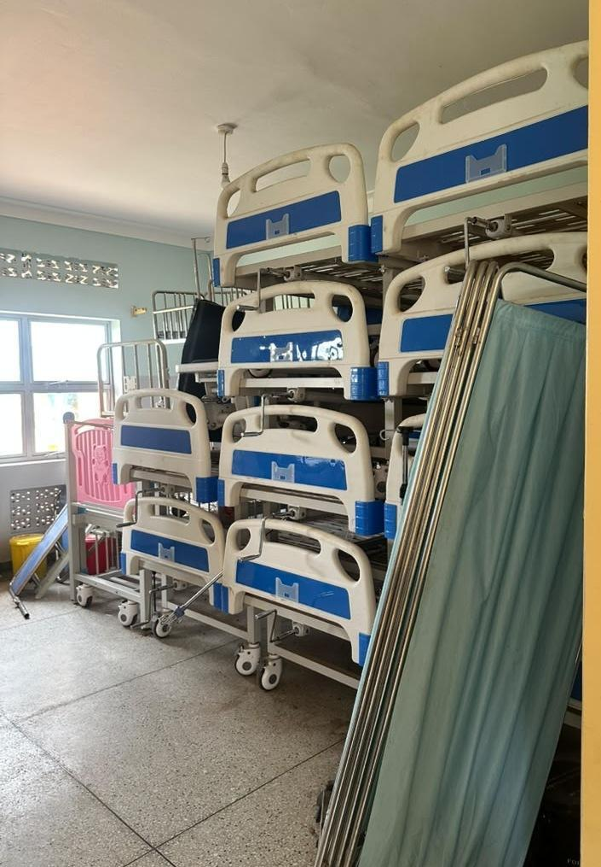  Figure 21: Hospital beds and screens stacked in storage at a health centre, Kagadi District (Bunyoro) | 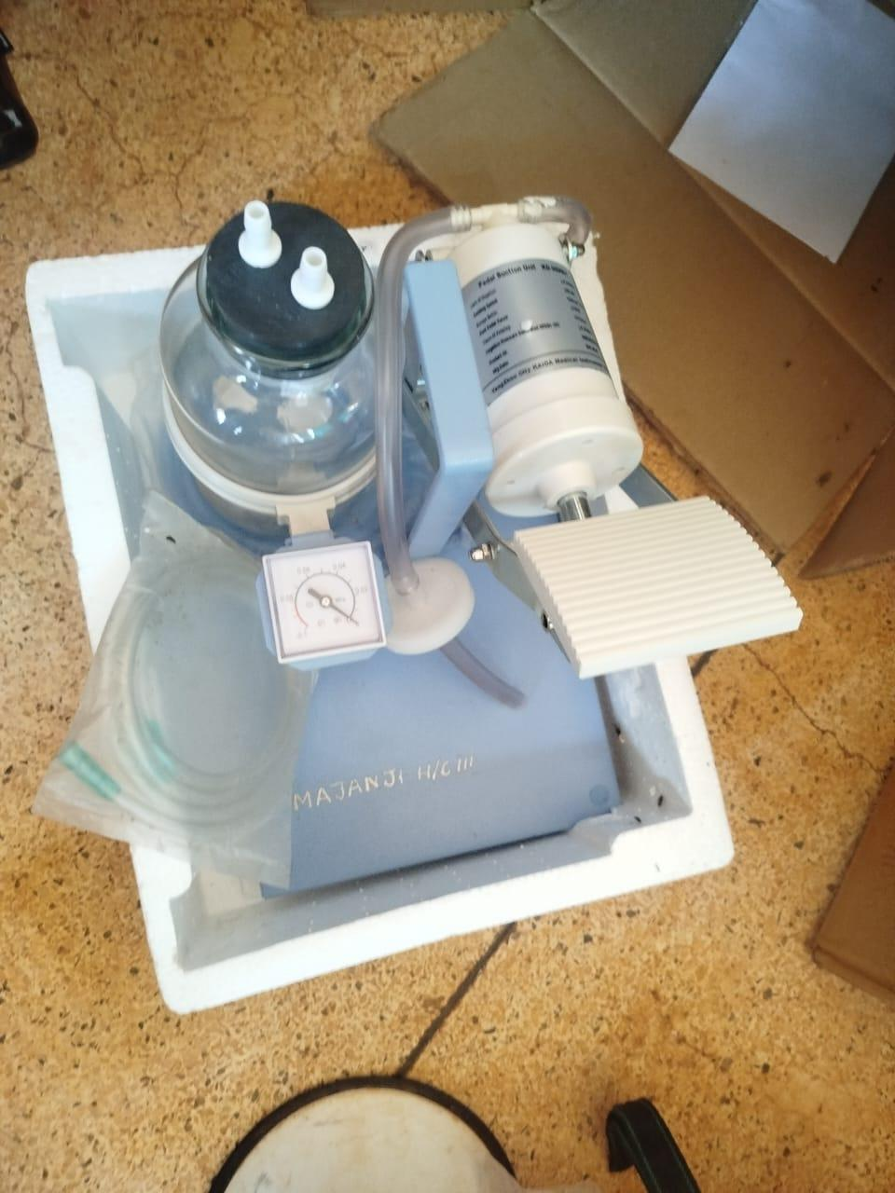  Figure 22: Pedal suction unit marked MAJANJI H/C III still in its packing, recorded as not in use for lack of technical knowledge, Majanji Health Centre III, Busia District (Bukedi)

Figure 23 groups the stated reasons for assets that were not in use. Figure 24 shows the operating constraints facilities named when equipment stood idle.
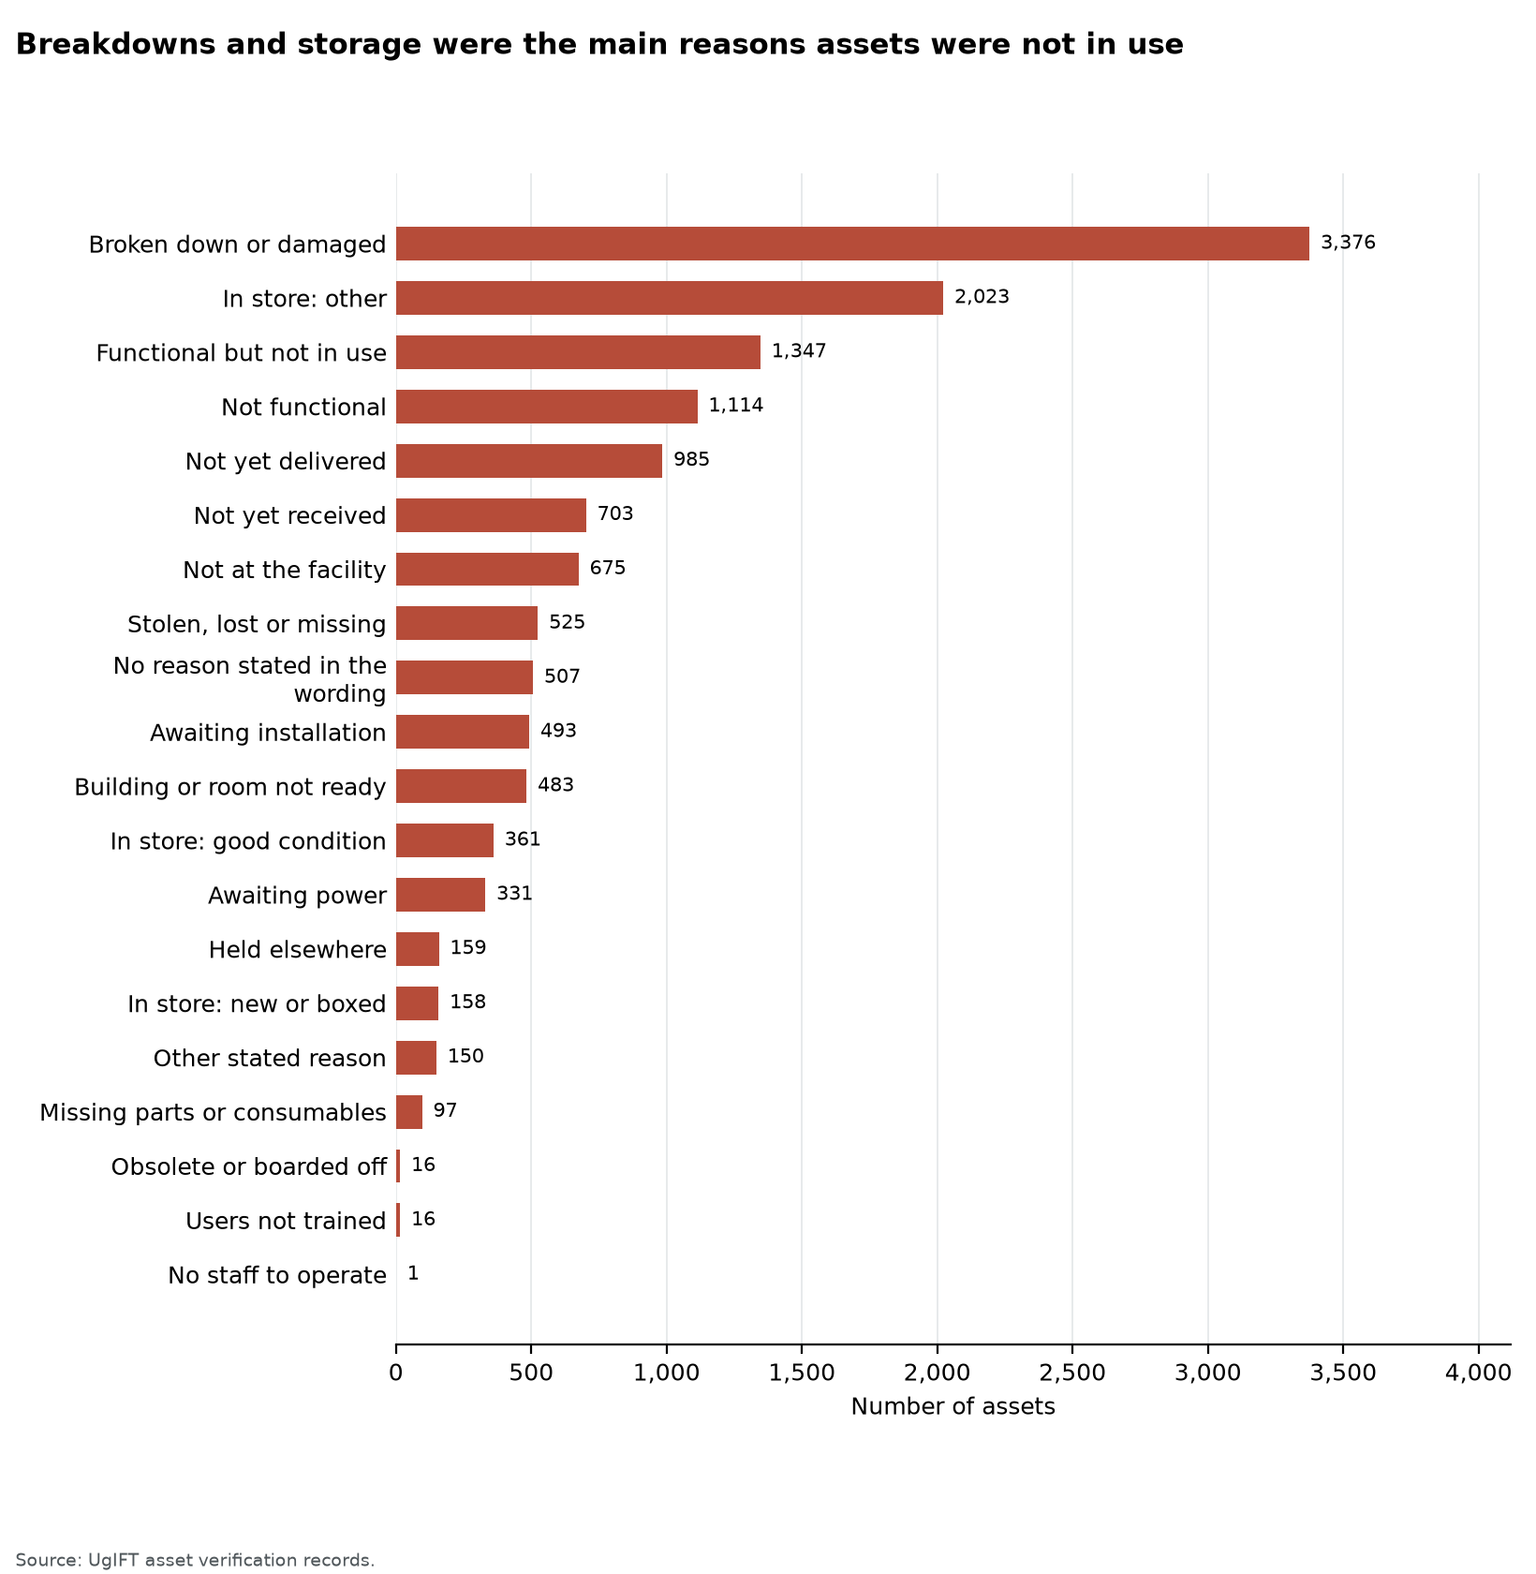
Figure 23: Breakdowns and storage were the main reasons assets were not in use
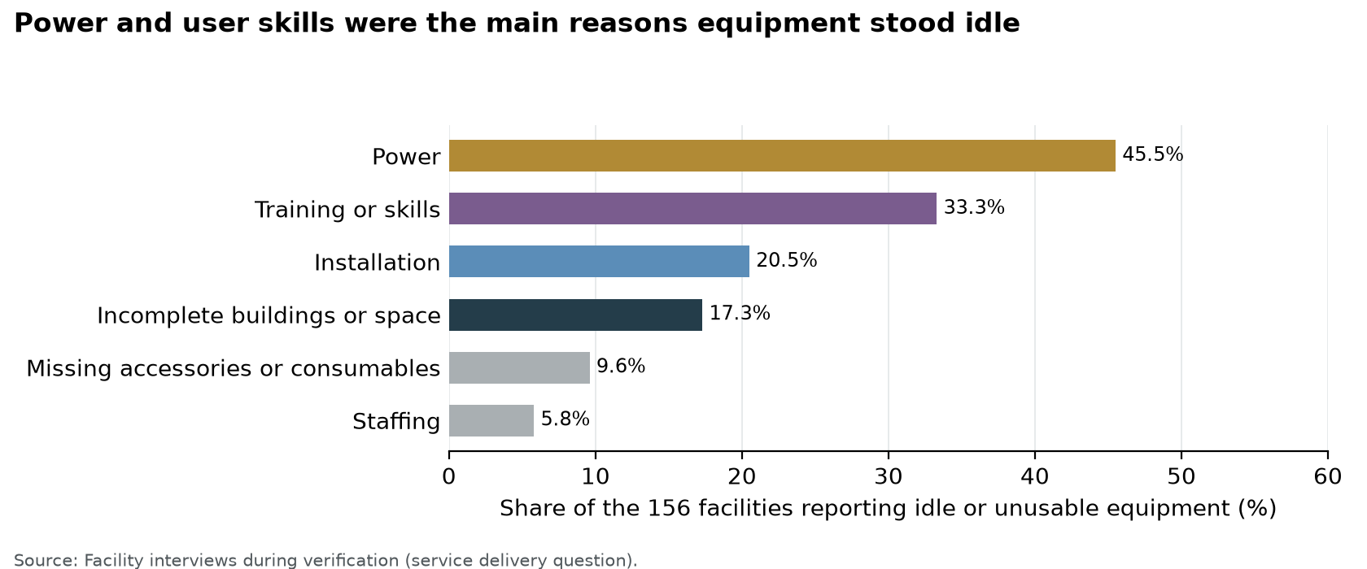
Figure 24: Power and user skills were the main reasons equipment stood idle

3.1.3 Identification, including engraving
Of 216,736 movable assets, 49,457 (22.8%) were engraved and 167,279 (77.2%) were not engraved. 23,434 (10.8%) carried the UgIFT marking. Ministries and agencies had engraved 31.5% of their movable assets, seed schools 25.3% and health centres 15.2%. The Ministry of Education and Sports accounts for most of the ministry assets that were not engraved: the TELA handsets and tablets carry no engraving. Figure 25 gives the comparison, and Table 7 lists the counts.
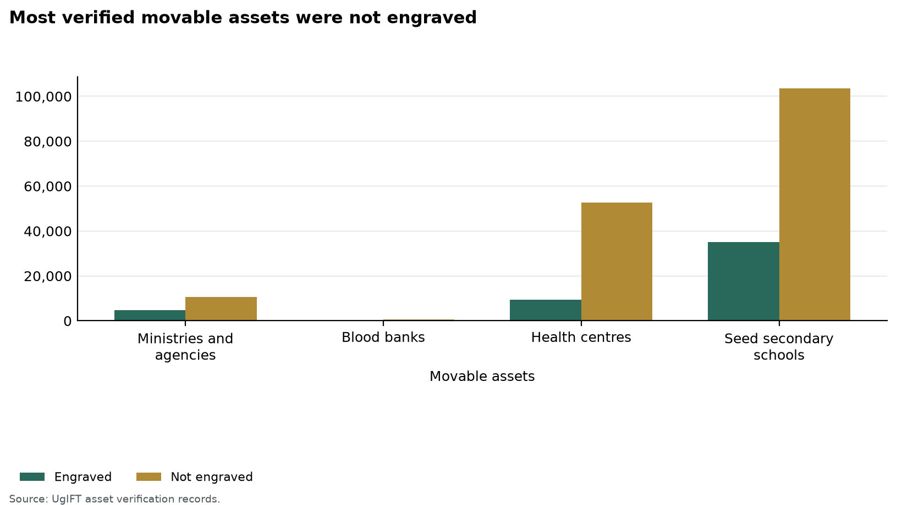
Figure 25: Most verified movable assets were not engraved
Table 7: Identification of verified assets by institution group
Institution | Assets verified | Movable assets | Engraved | Properly engraved | Not engraved
Ministries and agencies | 16,668 | 15,385 | 4,843 (31.5%) | 4,730 (30.7%) | 10,542 (68.5%)
Blood banks | 626 | 605 | 43 (7.1%) | 26 (4.3%) | 562 (92.9%)
Health centres | 63,599 | 62,071 | 9,446 (15.2%) | 3,817 (6.1%) | 52,625 (84.8%)
Seed secondary schools | 145,376 | 138,671 | 35,121 (25.3%) | 14,861 (10.7%) | 103,550 (74.7%)
Total | 226,276 | 216,732 | 49,453 (22.8%) | 23,434 (10.8%) | 167,279 (77.2%)
Movable assets exclude buildings, structures and land. Properly engraved means the UgIFT marking. A dash means the assets are identified through property and site records rather than engraving.
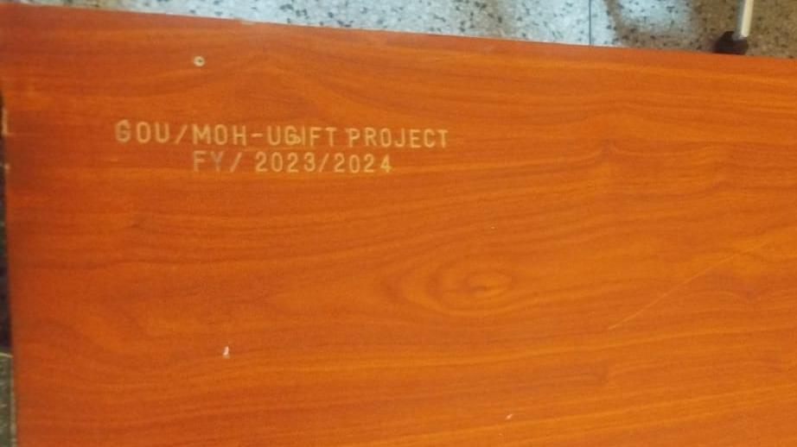  Figure 26: Engraving reading GOU/MOH-UGIFT PROJECT FY/2023/2024 on a desk at Namwaya Health Centre III, Tororo District (Bukedi) | 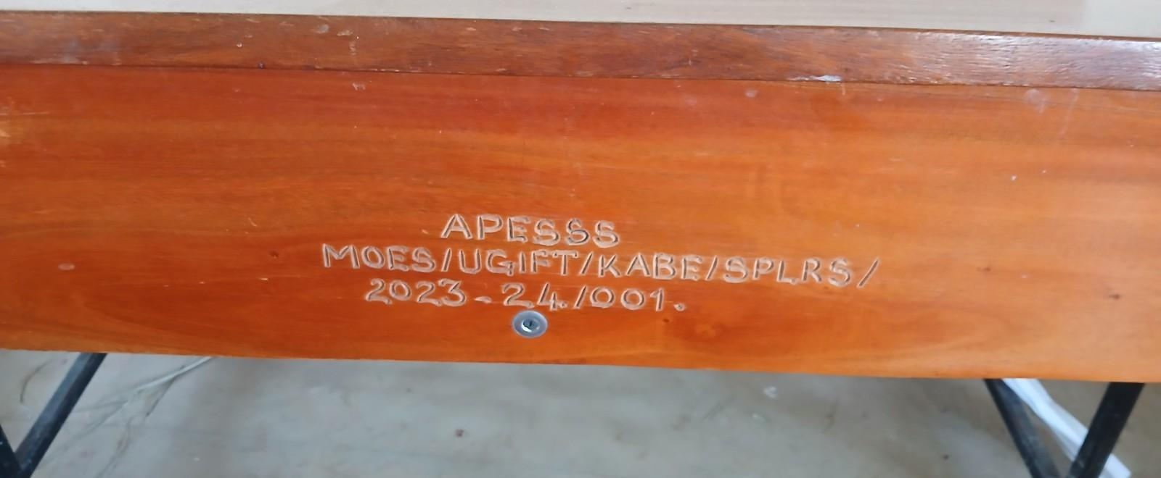  Figure 27: Engraving reading APESSS MOES/UGIFT/KABE/SPLRS/2023-24/001 on a desk at Aperikira Seed Secondary School, Kaberamaido District (Teso)

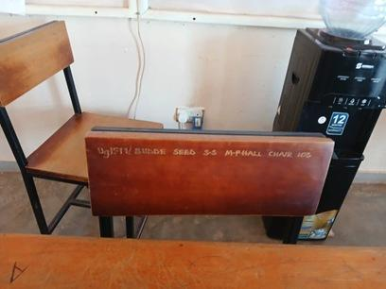  Figure 28: Chair engraved UgIFT/ BUDDE SEED S.S M-PHALL CHAIR with a serial number at Budde Seed Secondary School, Butambala District (Buganda) | 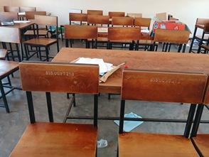  Figure 29: Chairs engraved BSS UGIFT with serial numbers at Budde Seed Secondary School, Butambala District (Buganda)

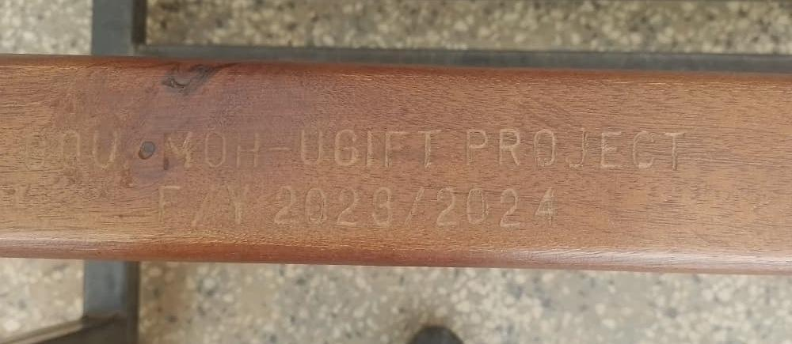  Figure 30: Engraving reading GOU/MOH-UGIFT PROJECT F/Y 2023/2024 on a bench at Bududa Health Centre III, Bududa District (Bugisu) | 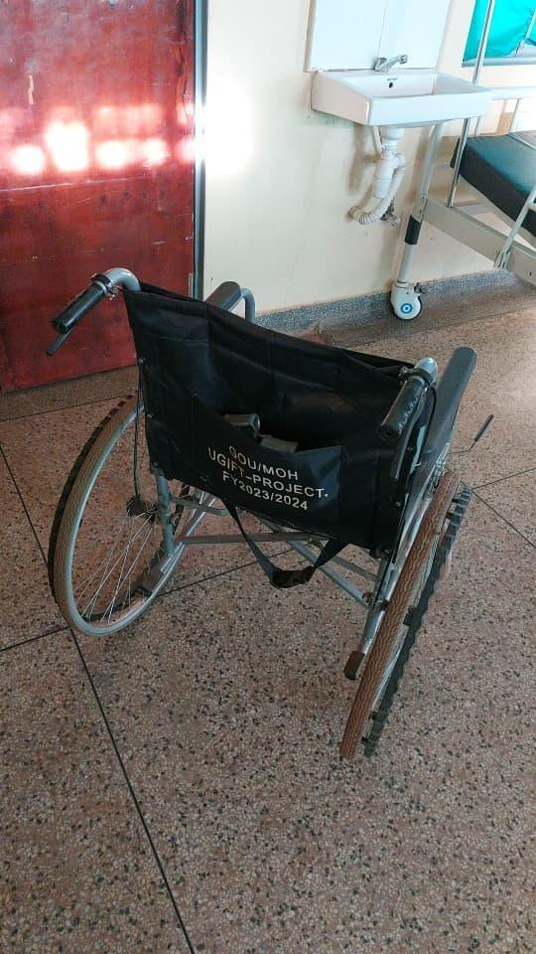  Figure 31: Wheelchair backrest marked GOU/MOH UGIFT-PROJECT. FY2023/2024 at Kalemungole Health Centre III, Moroto District (Karamoja) | 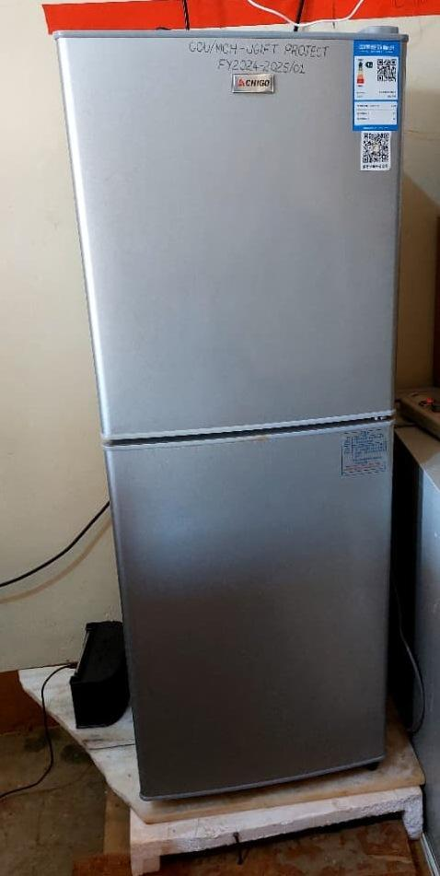  Figure 32: Refrigerator marked GOU/MOH-UGIFT PROJECT FY2024-2025/01 at Kalemungole Health Centre III, Moroto District (Karamoja)

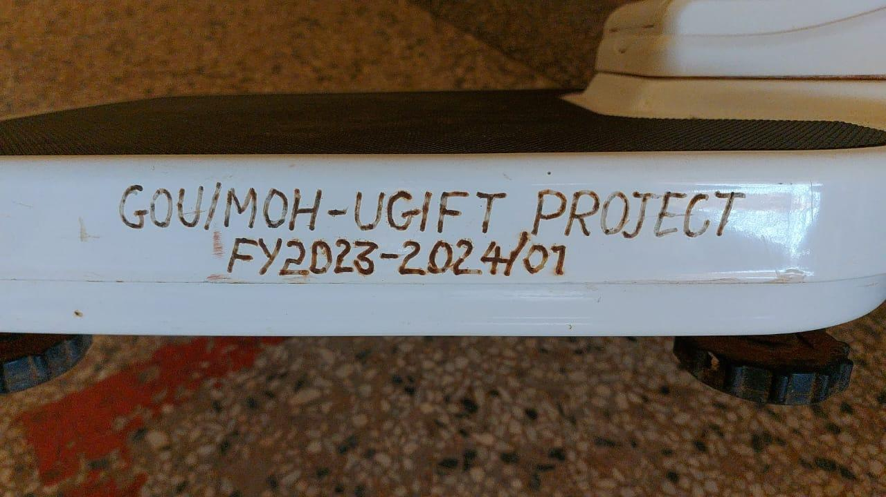  Figure 33: Engraving reading GOU/MOH-UGIFT PROJECT FY2023-2024/01 on a weighing scale at Kalemungole Health Centre III, Moroto District (Karamoja) | 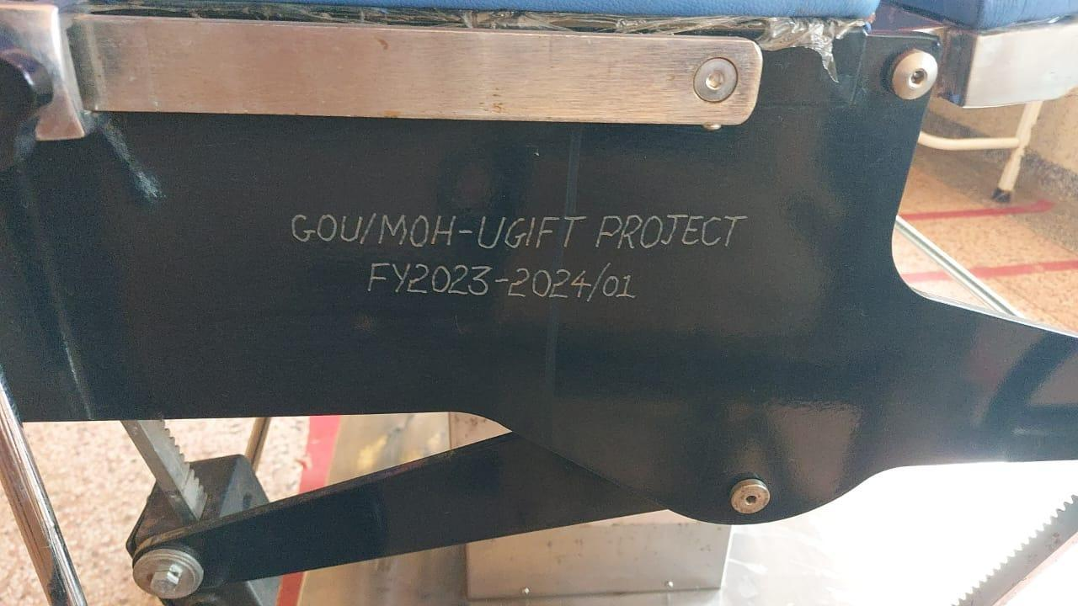  Figure 34: Engraving reading GOU/MOH-UGIFT PROJECT FY2023-2024/01 on a delivery bed at Kalemungole Health Centre III, Moroto District (Karamoja)

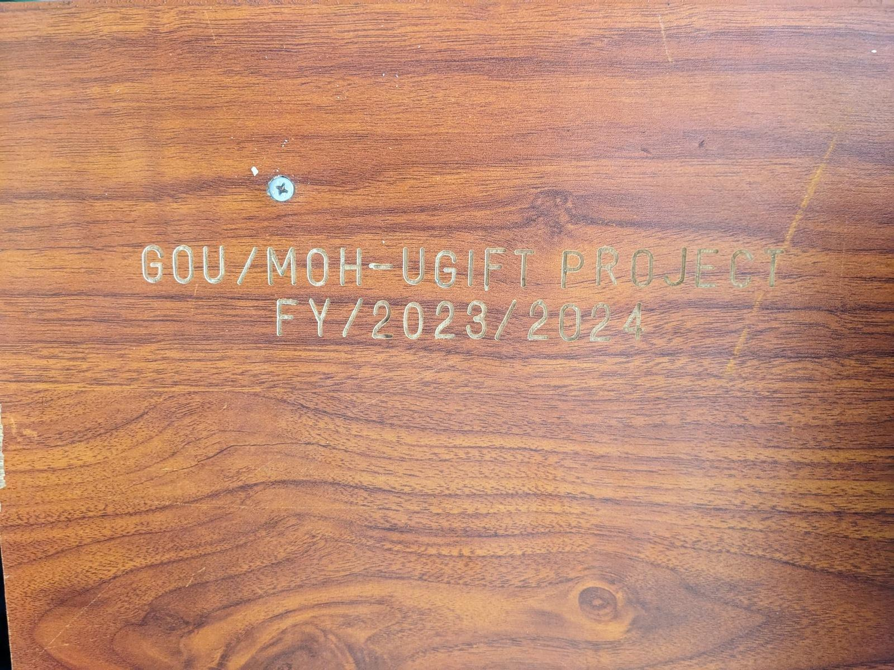  Figure 35: Engraving reading GOU/MOH-UGIFT PROJECT FY/2023/2024 on a table at Kamoru Health Centre III, Kotido District (Karamoja) | 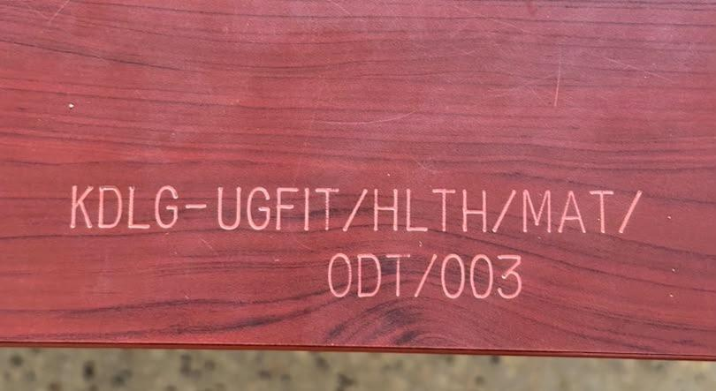  Figure 36: Engraving reading KDLG-UGFIT/HLTH/MAT/ODT/003 on a table at Kyabasara Health Centre III, Kagadi District (Bunyoro)

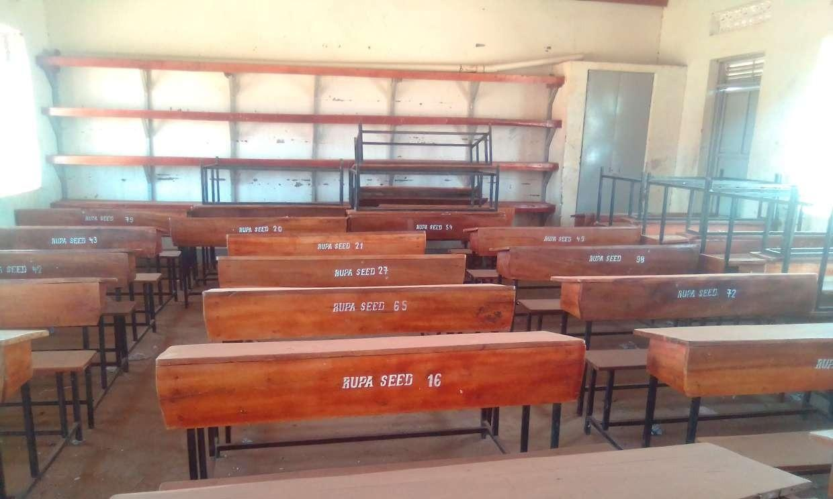  Figure 37: Classroom desks marked RUPA SEED with serial numbers, without a UgIFT marking, at Rupa Seed School, Moroto District (Karamoja) | 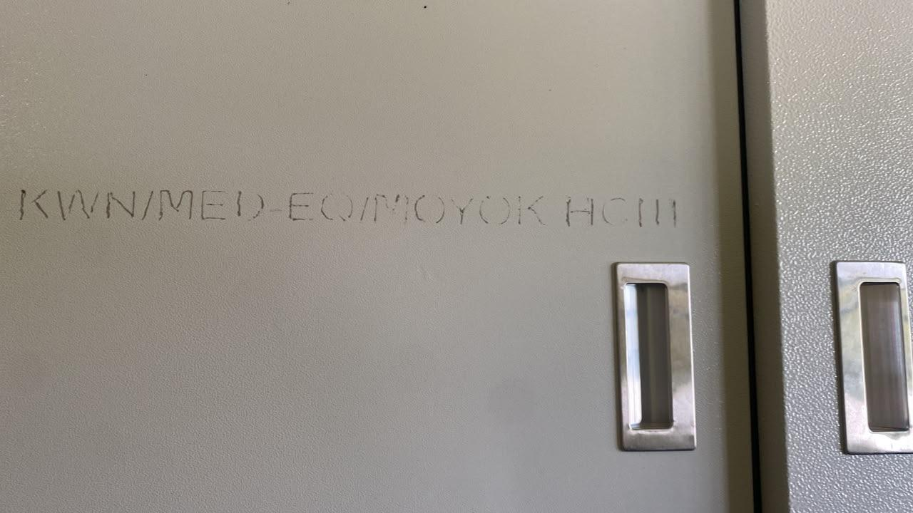  Figure 38: Engraving reading KWN/MED-EQ/MOYOK HCIII on a steel cupboard at Moyok Health Centre III, Kween District (Sebei)

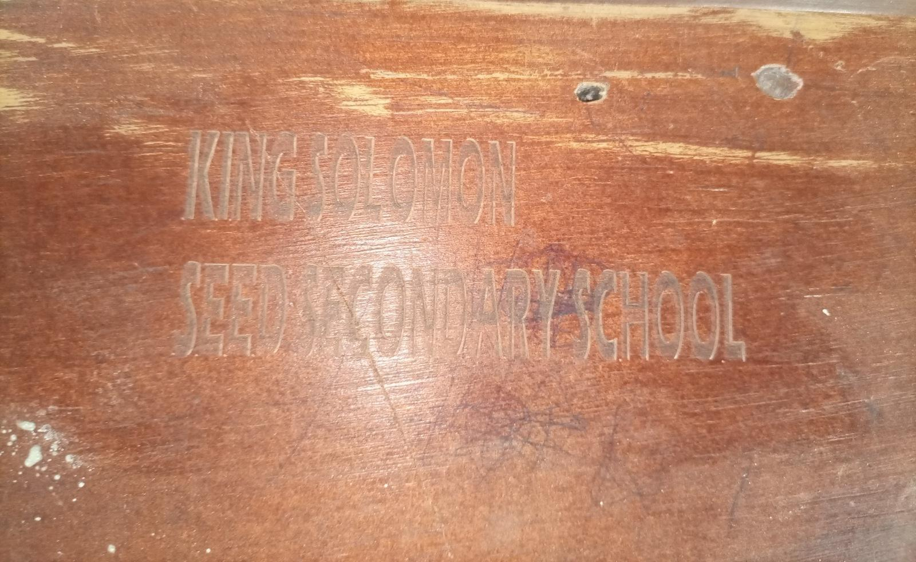  Figure 39: Engraving reading KING SOLOMON SEED SECONDARY SCHOOL, without a UgIFT marking, on furniture at King Solomon Seed Secondary School, Kagadi District (Bunyoro) | 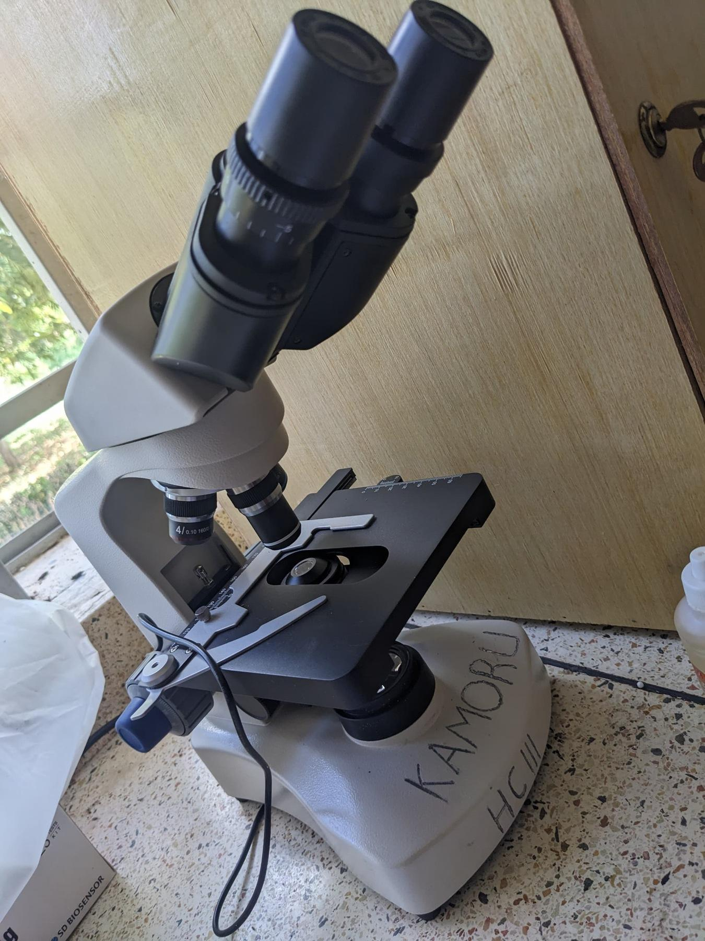  Figure 40: Microscope marked KAMORU HC III by hand at Kamoru Health Centre III, Kotido District (Karamoja) | 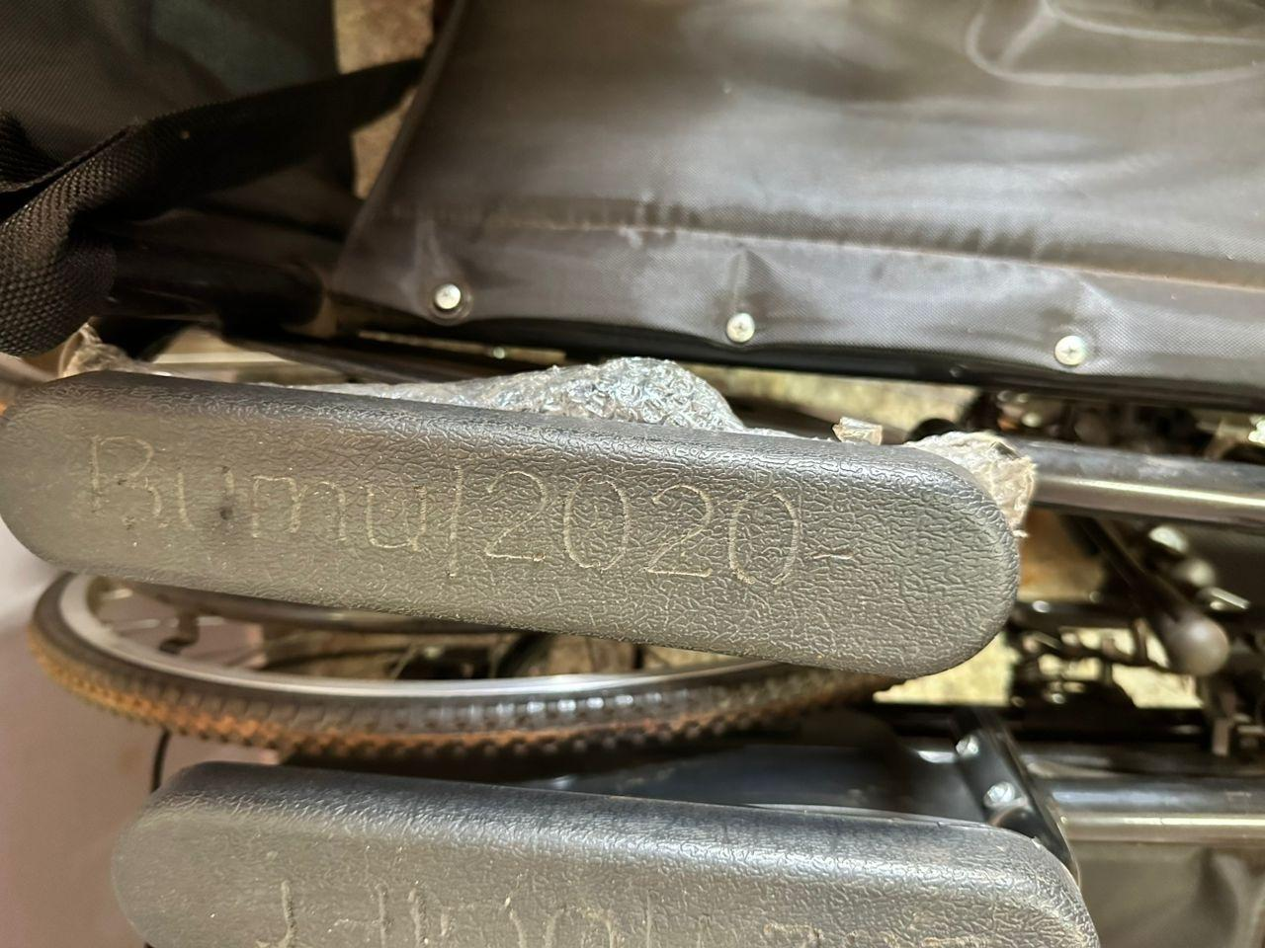  Figure 41: Hand-scratched marking beginning Bumu/2020- on a wheelchair armrest at Bumugibole Health Centre III, Bulambuli District (Bugisu)

3.1.4 Financial aspects
The 226,273 assets carry a recorded value of UGX 969,828,849,306 and a net book value of UGX 826,487,592,908 at 30 September 2026. Seed schools hold 69.9% of the recorded value and health centres 26.8%, mainly in buildings. Ministries and agencies hold UGX 30,466,956,001 (3.1%) and the blood banks UGX 1,451,584,715. Net book value is 85.0% of recorded value at seed schools and 84.1% at health centres, against 100.0% at the ministries and agencies. Figure 42 shows the comparison, and Table 8 lists the amounts.
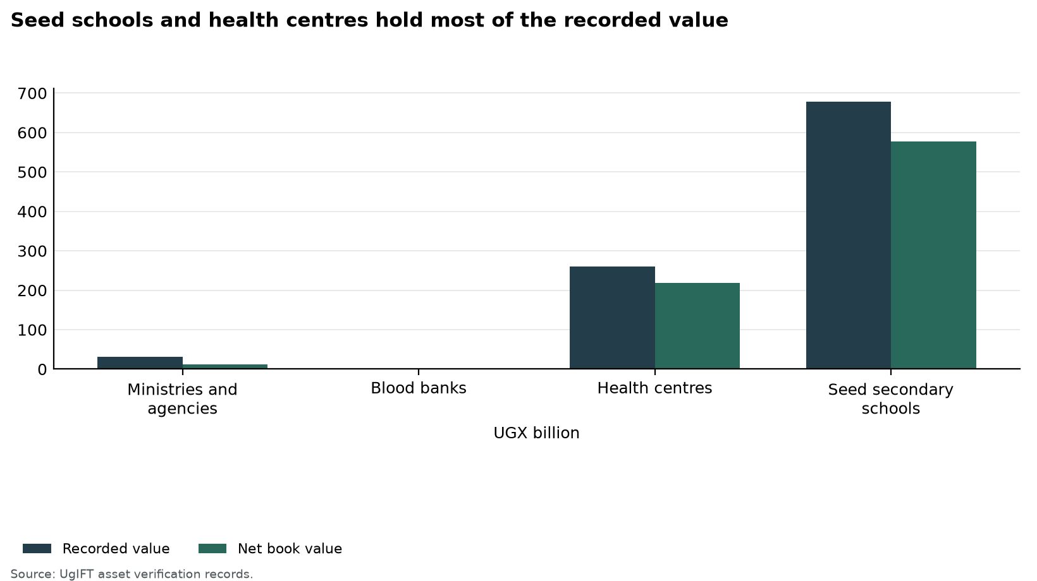
Figure 42: Seed schools and health centres hold most of the recorded value
Table 8: Recorded value and net book value by institution group
Institution | Assets | Recorded value UGX | Depreciation UGX | Net book value UGX
Ministries and agencies | 16,668 | 30,466,956,001 | 0 | 30,466,956,001
Blood banks | 626 | 1,451,584,715 | 514,105,544 | 937,479,171
Health centres | 63,599 | 259,662,759,164 | 41,291,769,808 | 218,378,252,366
Seed secondary schools | 145,376 | 678,247,549,426 | 101,549,907,057 | 576,704,905,370
Total | 226,269 | 969,828,849,306 | 143,355,782,409 | 826,487,592,908
Recorded value is the cost in the verification records. Net book value is that cost less accumulated depreciation to 30 September 2026, and is not taken below zero.

3.2 Ministries, departments and agencies

3.2.1 Availability of the assets
This part counts the assets verified. MoFPED held 458 assets (2.7%). Figure 43 shows the count, and Table 9 lists it.
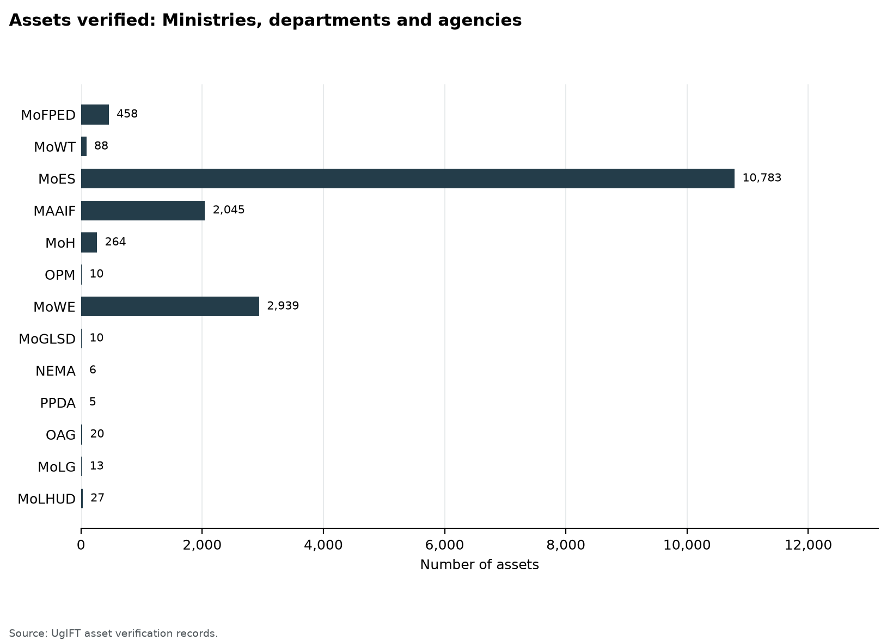
Figure 43: Assets verified: Ministries, departments and agencies
Table 9: Availability of assets: Ministries, departments and agencies
Institution | Assets verified | Share
MoFPED | 458 | 2.7%
MoWT | 88 | 0.5%
MoES | 10,783 | 64.7%
MAAIF | 2,045 | 12.3%
MoH | 264 | 1.6%
OPM | 10 | 0.1%
MoWE | 2,939 | 17.6%
MoGLSD | 10 | 0.1%
NEMA | 6 | 0.0%
PPDA | 5 | 0.0%
OAG | 20 | 0.1%
MoLG | 13 | 0.1%
MoLHUD | 27 | 0.2%
Total | 16,668 | 100.0%

3.2.2 Condition of assets
16,664 assets (99.9%) were in good condition, of which 16,664 were in use and 0 were in store. 4 (0.0%) were broken and 16 (0.1%) were not in use for another reason. The lowest share in good condition was OPM at 70.0%. Figure 44 shows the split. Table 10 states the counts.
The Ministry of Education and Sports holds 10,783 of these assets, mainly TELA handsets and tablets, all recorded in use. The Ministry of Works and Transport completed its tracing exercise and confirmed that all 88 assets were available and in use. Three laptops at the Office of the Prime Minister were damaged. LGFC and MoPS received no UgIFT assets.
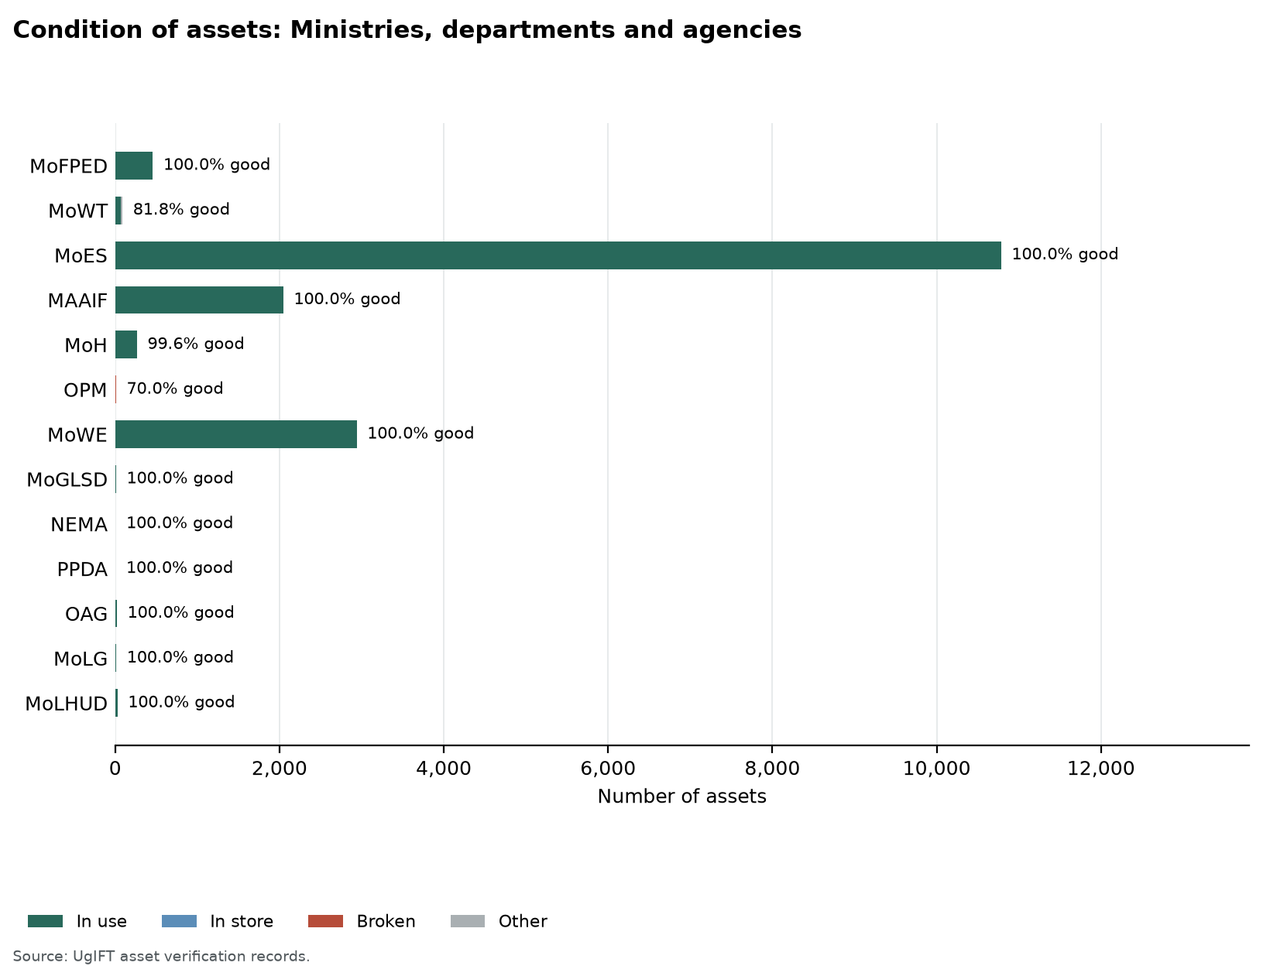
Figure 44: Condition of assets: Ministries, departments and agencies
Table 10: Condition of assets: Ministries, departments and agencies
Institution | Assets verified | Good condition |  | Broken | Other
Institution | Assets verified | In use | In store | Broken | Other
MoFPED | 458 | 458 | 0 | 0 | 0
MoWT | 88 | 88 | 0 | 0 | 0
MoES | 10,783 | 10,783 | 0 | 0 | 0
MAAIF | 2,045 | 2,045 | 0 | 0 | 0
MoH | 264 | 263 | 0 | 1 | 0
OPM | 10 | 7 | 0 | 3 | 0
MoWE | 2,939 | 2,939 | 0 | 0 | 0
MoGLSD | 10 | 10 | 0 | 0 | 0
NEMA | 6 | 6 | 0 | 0 | 0
PPDA | 5 | 5 | 0 | 0 | 0
OAG | 20 | 20 | 0 | 0 | 0
MoLG | 13 | 13 | 0 | 0 | 0
MoLHUD | 27 | 27 | 0 | 0 | 0
Total | 16,668 | 16,664 | 0 | 4 | 0
Good condition is assets in use plus assets in store. Broken assets are counted on their own, including broken assets found in store. Other assets are not in use for another reason. The four condition columns sum to assets verified.

3.2.3 Identification, including engraving
Of the 15,385 assets eligible for engraving, 4,843 (31.5%) were engraved and 10,542 (68.5%) were not engraved. 4,730 (30.7%) carried the UgIFT marking and 113 (0.7%) carried another marking only. Figure 45 shows the position. Table 11 sets out the counts.
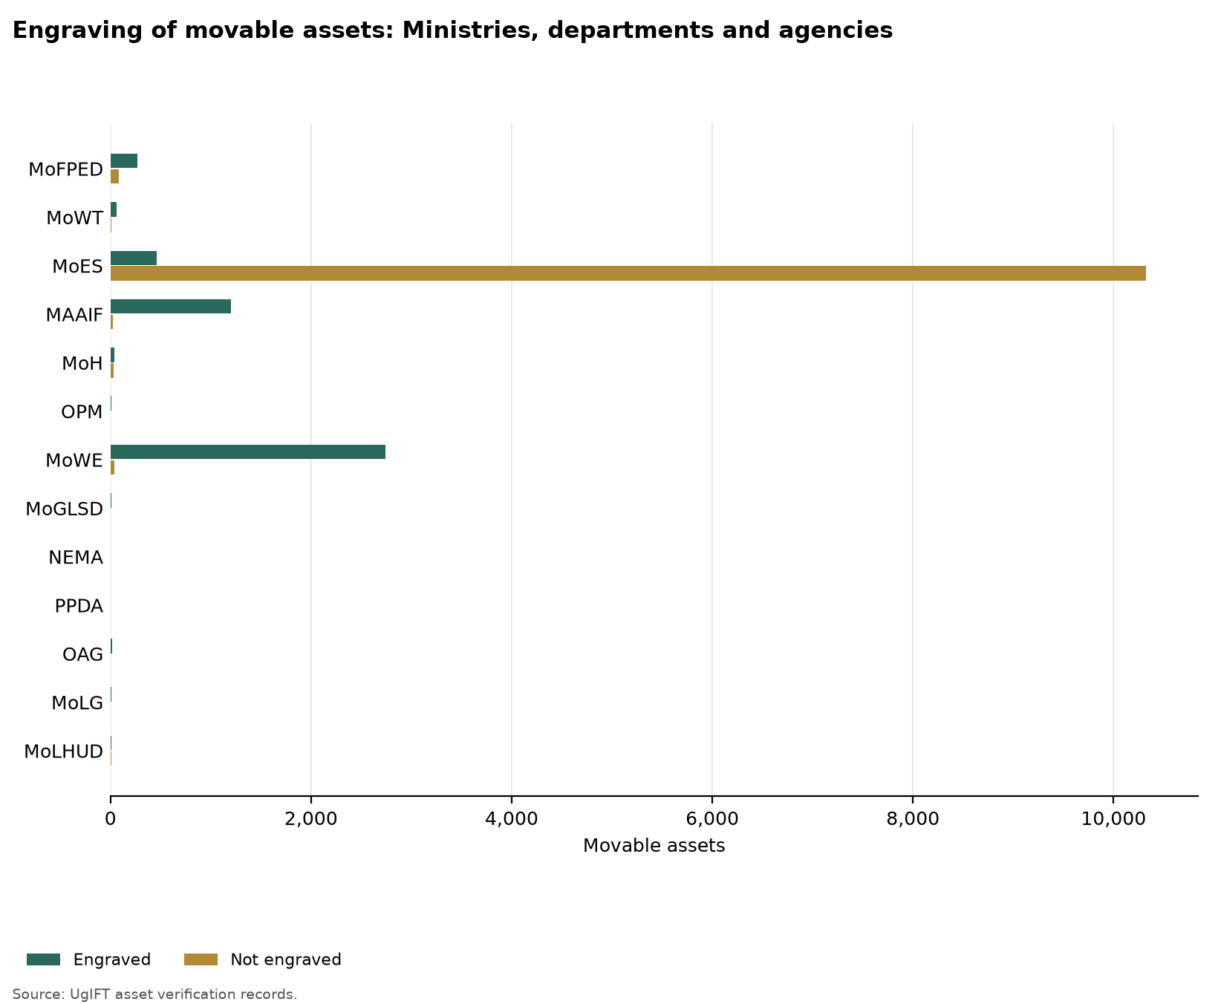
Figure 45: Engraving status of eligible assets: Ministries, departments and agencies
Table 11: Identification of assets: Ministries, departments and agencies
Institution | Assets verified | Assets eligible for engraving | Engraved | Properly engraved | Not engraved
MoFPED | 458 | 358 | 272 (76.0%) | 252 (70.4%) | 86 (24.0%)
MoWT | 88 | 72 | 63 (87.5%) | 62 (86.1%) | 9 (12.5%)
MoES | 10,783 | 10,783 | 458 (4.2%) | 458 (4.2%) | 10,325 (95.8%)
MAAIF | 2,045 | 1,227 | 1,204 (98.1%) | 1,200 (97.8%) | 23 (1.9%)
MoH | 264 | 73 | 41 (56.2%) | 14 (19.2%) | 32 (43.8%)
OPM | 10 | 10 | 10 (100.0%) | 10 (100.0%) | 0 (0.0%)
MoWE | 2,939 | 2,782 | 2,740 (98.5%) | 2,707 (97.3%) | 42 (1.5%)
MoGLSD | 10 | 10 | 8 (80.0%) | 8 (80.0%) | 2 (20.0%)
NEMA | 6 | 6 | 1 (16.7%) | 1 (16.7%) | 5 (83.3%)
PPDA | 5 | 5 | 5 (100.0%) | 5 (100.0%) | 0 (0.0%)
OAG | 20 | 20 | 20 (100.0%) | 6 (30.0%) | 0 (0.0%)
MoLG | 13 | 13 | 8 (61.5%) | 7 (53.8%) | 5 (38.5%)
MoLHUD | 27 | 26 | 13 (50.0%) | 0 (0.0%) | 13 (50.0%)
Total | 16,668 | 15,385 | 4,843 (31.5%) | 4,730 (30.7%) | 10,542 (68.5%)
Assets eligible for engraving exclude buildings, structures, land and accessories for which engraving is not applicable. Properly engraved means the UgIFT marking. A dash means the assets are identified through property and site records rather than engraving.

3.2.4 Financial aspects
Recorded value was UGX 30,466,956,001 and net book value at 30 September 2026 was UGX 30,466,956,001. Accumulated depreciation was UGX 0. Figure 46 compares recorded value and net book value. Table 12 gives the figures.
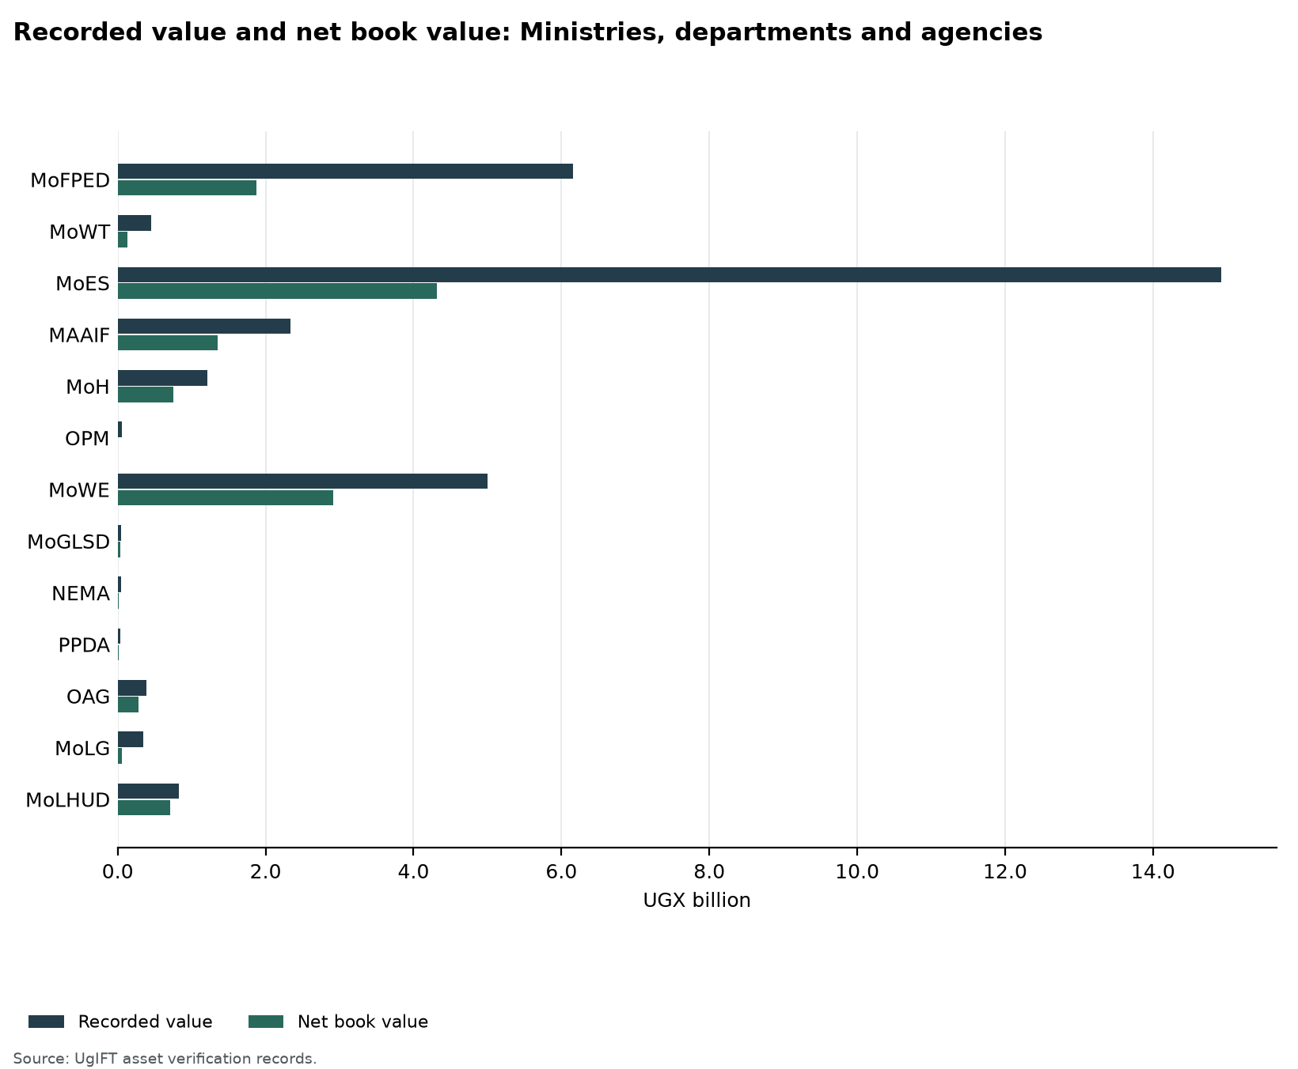
Figure 46: Recorded value and net book value: Ministries, departments and agencies
Table 12: Recorded value and net book value: Ministries, departments and agencies
Institution | Assets | Recorded value UGX | Depreciation UGX | Net book value UGX
MoFPED | 458 | 5,615,661,760 | 0 | 5,615,661,760
MoWT | 88 | 340,968,220 | 0 | 340,968,220
MoES | 10,783 | 14,760,581,751 | 0 | 14,760,581,751
MAAIF | 2,045 | 1,844,366,458 | 0 | 1,844,366,458
MoH | 264 | 953,859,009 | 0 | 953,859,009
OPM | 10 | 53,535,300 | 0 | 53,535,300
MoWE | 2,939 | 5,993,100,537 | 0 | 5,993,100,537
MoGLSD | 10 | 20,120,000 | 0 | 20,120,000
NEMA | 6 | 27,324,409 | 0 | 27,324,409
PPDA | 5 | 0 | 0 | 0
OAG | 20 | 228,773,680 | 0 | 228,773,680
MoLG | 13 | 31,114,879 | 0 | 31,114,879
MoLHUD | 27 | 597,549,997 | 0 | 597,549,997
Total | 16,668 | 30,466,956,001 | 0 | 30,466,956,001
Recorded value is the cost in the verification records. Net book value is that cost less accumulated depreciation to 30 September 2026, and is not taken below zero.

3.2.5 Ministry of Finance, Planning and Economic Development
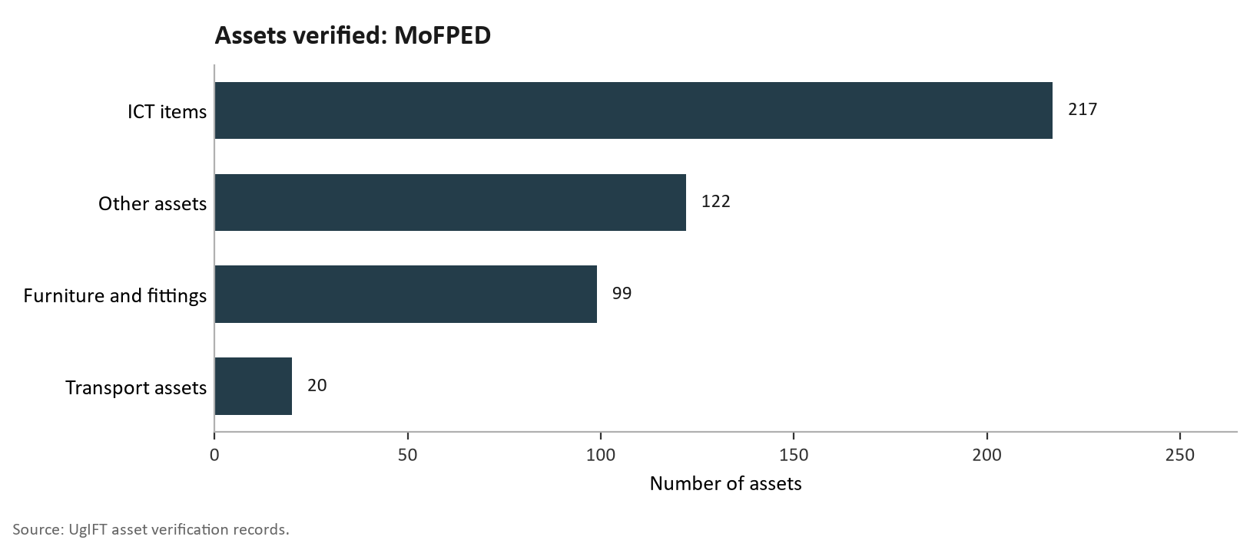
Figure 46a: Assets verified: MoFPED
MoFPED held 458 assets: 217 ICT items, 122 other assets, 99 furniture and fittings and 20 transport assets. The main items were office chairs and desks, desktop computers, tablets and 20 Toyota Hilux double cabin pickups. All 458 assets (100.0%) were working and in use, and none was broken down. Of the 358 verified assets, 272 (76.0%) were engraved and 86 (24.0%) were not engraved; 252 (70.4%) were properly engraved with the UgIFT marking, and 20 (5.6%), the pickups, were not properly engraved, carrying their registration numbers only. The recorded value of the ministry's UgIFT assets is UGX 5,615,661,760.
The ministry held 113 computers (73 desktops and 40 laptops), all working and in use; 103 (91.2%) were engraved and 10 (8.8%) were not engraved. Its 17 tablets and 14 office desk phones were all working and engraved. The ministry keeps a UgIFT asset register and the consolidated register for all MDAs that received UgIFT assets.
Expected: Staff computers should support their workload, and portable equipment should remain identifiable and accountable. Found: The computers were working, but users reported that some keyboards and power backup units had failed and that some older computers were freezing. Laptop losses were supported by police letters. The team also reported difficulty obtaining some laptops for engraving.
Gap: Equipment reliability, follow-up of lost assets and completion of identification each required a specific management response. Recommended action: The ministry should assess the failed accessories and freezing computers, follow up the reported laptop losses, and arrange a supervised exercise to engrave all remaining portable equipment.
Expected: Furniture should remain assigned to a location and custodian when offices move. Found: When programme staff moved to premises already furnished, their earlier furniture was left in the old building. Some remained in store, while staff said other items had gone to different offices.
Gap: The move had split the furniture between storage and other offices, requiring confirmation of its present custody and use. Recommended action: The ministry should inspect the old store and recipient offices, confirm the condition and custodian of each item, and approve reuse or other appropriate treatment of furniture no longer required.

3.2.6 Ministry of Works and Transport
The Ministry did not provide a UgIFT Asset Register. Physical verification at MoWT identified 88 assets: 63 ICT items, mainly Lenovo desktop computers, monitors, uninterruptible power supply (UPS) units, video-conferencing equipment and HP Color LaserJet printers; one Toyota Hilux pickup; and 24 other assets. The 24 records grouped under other assets comprised 16 keyboards, four Dell OptiPlex 7090 desktop system units, two Lenovo ThinkBook notebooks, and two records without usable asset descriptions (entered as 'Ministry of Local Government' and 'PPDA'), as presented in Figure 46b.
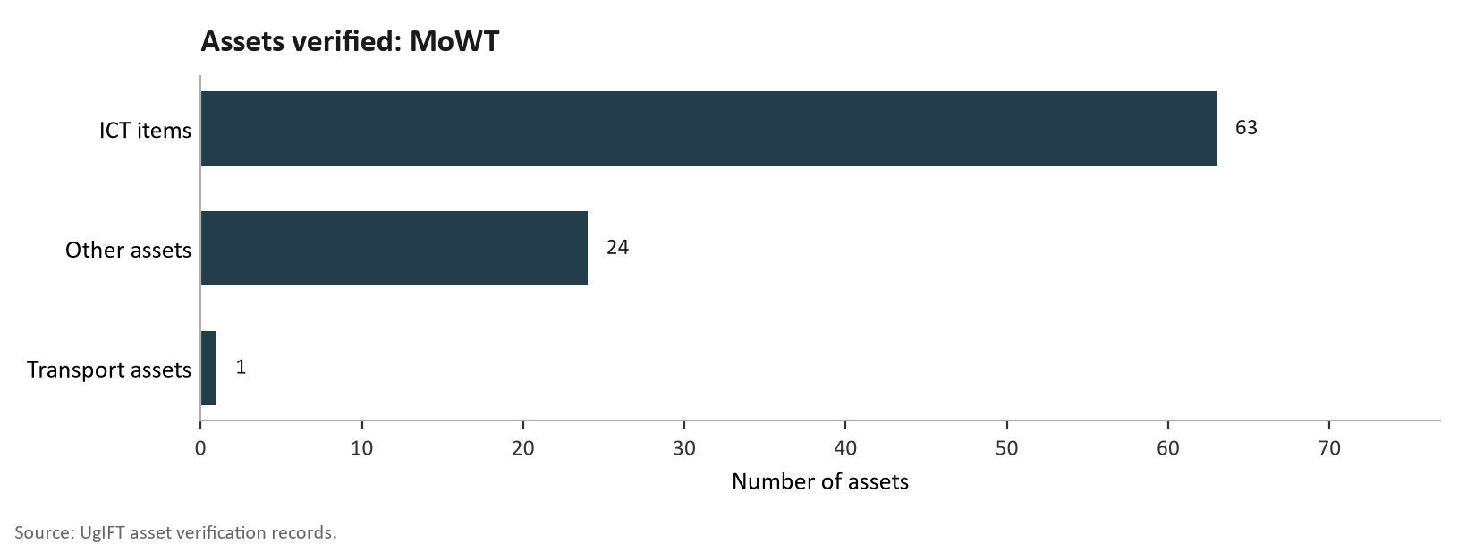
Figure 46b: Assets verified: MoWT

All 88 assets were verified, working and in use; none was broken down. Of these, 72 (81.8%) were eligible for engraving and 16 keyboards (18.2%) were exempt. Among the 72 eligible assets, 63 (87.5%) were engraved: 62 (86.1%) with the UgIFT marking and 1 (1.4%) with another marking; 9 (12.5%) were not engraved. Recorded value: UGX 340,968,220.

Table 12a: Recorded cost by asset category: MoWT
Asset category | Assets | Recorded cost UGX
ICT equipment | 63 | 126,534,110
Vehicle | 1 | 196,018,110
Other assets | 24 | 18,416,000
Total | 88 | 340,968,220

3.2.7 Ministry of Education and Sports
The verification at the Ministry of Education and Sports (MoES) established that the ministry had 10,783 assets. All the assets are ICT equipment and these include 9,324 TELA handsets, 1,001 tablets (976 of them inspection tablets), 456 laptops, a photocopier and a printer. The breakdown of these assets is shown below in figure 46c. Teacher, Effectiveness and Learner Achievement (TELA) is the system, financed by UgIFT, that the ministry uses to monitor attendance and performance in schools; the handsets and inspection tablets are deployed in local governments and remain MoES assets.
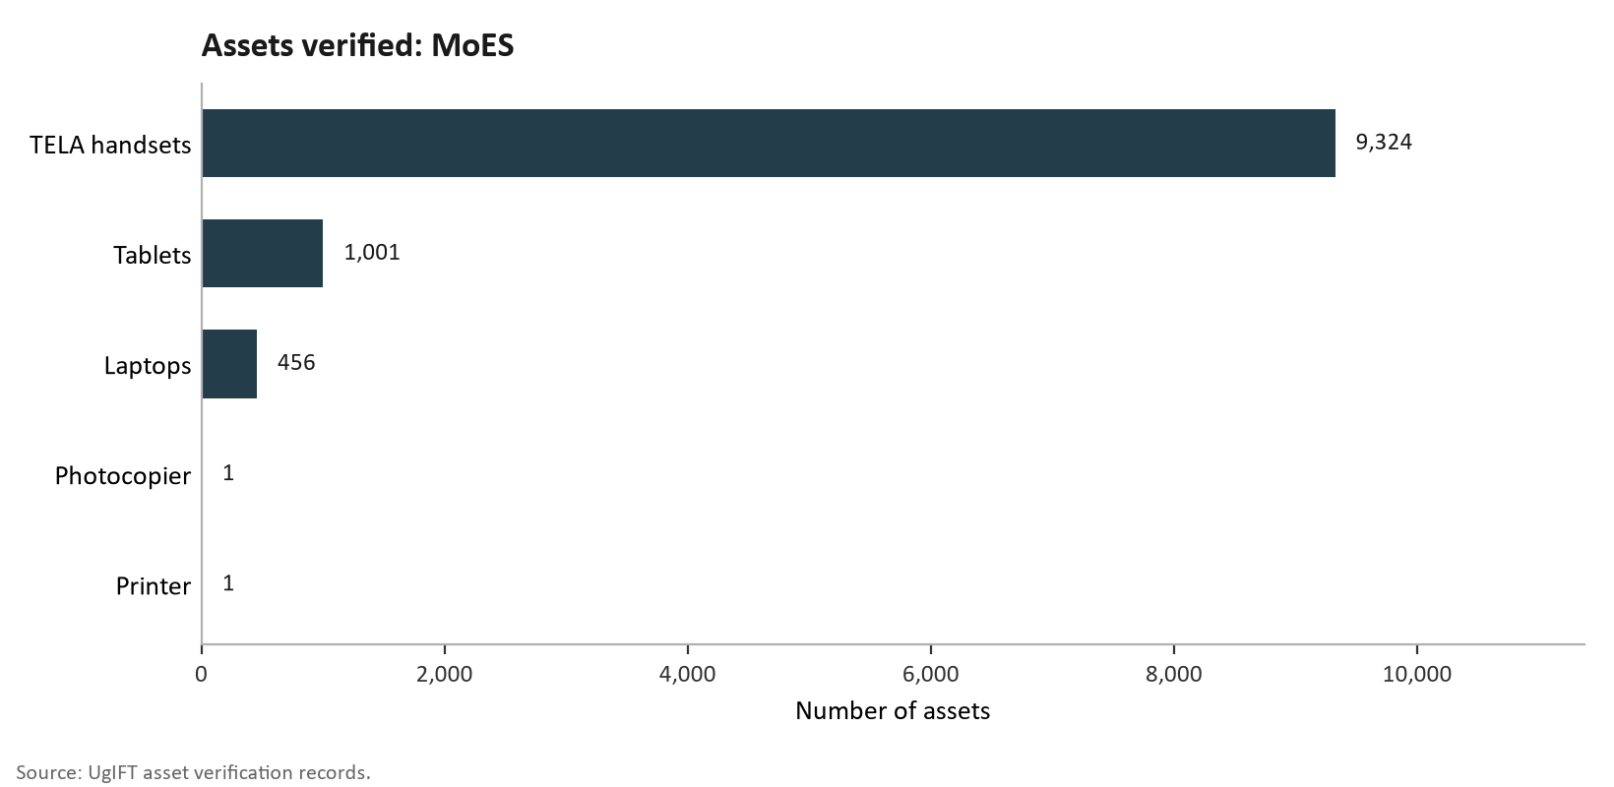
Figure 46c: Assets verified: MoES
All the 10,783 assets (100.0%) are in good working condition and in use. Of the verified assets, 458 (4.2%) were engraved, all with the UgIFT marking, while 10,325 (95.8%) were not engraved. None of the handsets or tablets carries an engravement mark. All the 456 laptops are in good condition, properly engraved and in use. The recorded value is UGX 14,760,581,751, the highest among the MDAs.

Table 12b: Condition and use of assets: MoES
Status | Assets | Share
Good working condition and in use | 10,783 | 100.0%
Not working or not in use | 0 | 0.0%
Total | 10,783 | 100.0%
Table 12c: Engraving status of assets: MoES
Engraving status | Assets | Share
Engraved with the UgIFT marking | 458 | 4.2%
Not engraved | 10,325 | 95.8%
Total | 10,783 | 100.0%

3.2.8 Ministry of Agriculture, Animal Industry and Fisheries
The verification team verified UgIFT assets at the Ministry of Agriculture, Animal Industry and Fisheries (MAAIF) and established that it held 2,045 assets. These included 1,206 ICT equipment, 2 vehicles and 837 others. The ICT items were mainly 819 tablets, 211 computers (162 desktops and 49 laptops), 149 monitors and 15 printers. The breakdown of the assets mentioned above is shown in figure 46d.
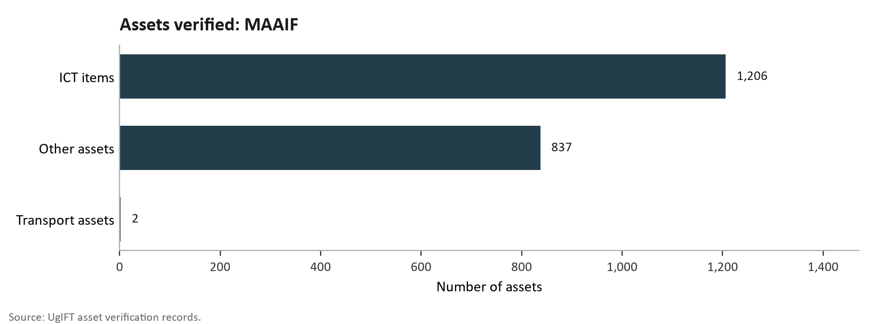
Figure 46d: Assets verified: MAAIF

All 2,045 assets (100.0%) are in good condition and in use. Of the 1,227 verified assets, 1,204 (98.1%) are engraved, 1,200 (97.8%) with the UgIFT marking, and 23 (1.9%) were not engraved, among them two drones, a handheld global positioning system (GPS) unit and a projector.

Table 12d: Condition and use of assets: MAAIF
Status | Assets | Share
Good working condition and in use | 2,045 | 100.0%
Not working or not in use | 0 | 0.0%
Total | 2,045 | 100.0%
Table 12e: Engraving status of verified assets: MAAIF
Engraving status | Assets | Share of verified assets
Engraved with the UgIFT marking | 1,200 | 97.8%
Other engraving | 4 | 0.3%
Not engraved | 23 | 1.9%
Total verified assets | 1,227 | 100.0%
All 211 computers and 819 tablets are in good condition, properly engraved and in use. The ministry had working laptops and printers carrying the UgIFT engraving. The recorded value is UGX 1,844,366,458.

3.2.9 Ministry of Health
It was not possible to obtain an Assets Register from the Ministry of Health or a listing of assets that were obtained by the MOH. The verification relied on the listing provided by the Ministry of Finance, Planning and Economic Development. A total of 264 assets were verified in the MoH. Of the 264 assets, 39 were ICT equipment (such as laptops and photocopiers), 25 assets were transport assets (such as motor vehicles and motor cycles) and 200 assets were a broad category of other assets (Figure 46e).
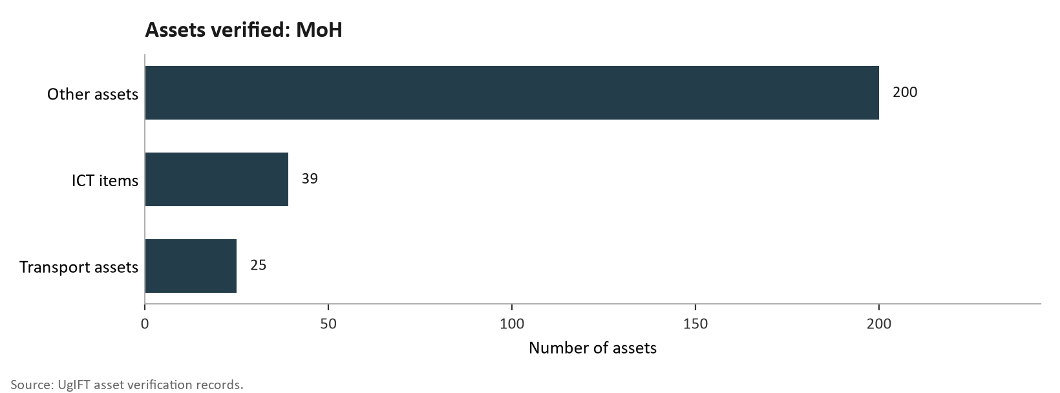
Figure 46e: Assets verified: MoH
The assets in good working condition were 263 which is 99.6%, among those in good condition and in use were 26 computers (2 desktops and 24 laptops). Only one assets, a pick-up double cabin was not in good working condition and had been boarded off. Out of the 73 movable assets, 41 assets (56%) were engraved while 32 assets were not engraved. There were 14 assets (19%) that were properly engraved with the engrave mark indicating the ministry of Health, the UgIFT mark and the serial number. The MoH assets were valued at UGX 953,859,009 and a net book value of UGX 953,859,009.
Expected: Office equipment in use should be identifiable by a durable engraving. Found: Two heavy duty printers, one at the Industrial Area engineering office and one at headquarters, were in use and in good condition but not engraved. Nine laptops were also not engraved.
Gap: Working equipment at separate offices still lacked the engraving needed for straightforward physical identification. Recommended action: The ministry should engrave these items, link the engravings to their serial numbers and office locations, and obtain custody confirmation from the receiving units.

3.2.10 Office of the Prime Minister
The Assets Register for the Office of the Prime Minister was not obtained and no list of assets was provided. The verification relied on the listing obtained from the Ministry of Finance, Planning and Economic Development. Office of the Prime Minister received 10 assets which were all HP laptop computers (Figure 46).
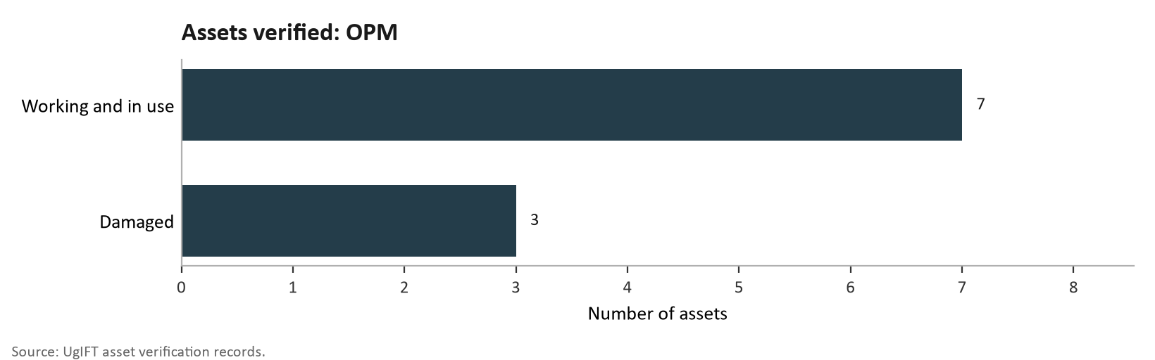
Figure 46f: Assets verified: OPM
Seven (70.0%) were in good working condition and were in use. Three (30.0%) were damaged, and out of use. All the 10 laptops were properly engraved with the UgIFT marking. The recorded value these computers is UGX 53,535,300.
The office should assess repair needs for the three damaged laptops and return serviceable equipment to use.
Expected: Computers should have enough capacity for the work assigned to their users. Found: Users reported that the capacity of the HP Envy i3 laptops was below the volume of work handled, such as the performance assessment of local governments, although the machines were described as being in fair condition.
Gap: A usable laptop could still be poorly matched to the workload of its user. Recommended action: The office should assess the requirements of the affected users and decide whether upgrading, reallocating or replacing the laptops would provide suitable capacity.

3.2.11 Ministry of Water and Environment
The Asset Verification at the Ministry of Water and Environment found out that the ministry keeps a Log book with UgIFT assets but does not conform to UgIFT Standards.
The logbook recorded 2,939 assets, all classified as ICT equipment.
The verified assets received by the Ministry were Two Thousand Three Hundred and Sixty-Seven (2,368) tablets, Two Thousand Three Hundred and Forty-Four (2,344) were Euron tablets, One Hundred and Eighty-Eight (188) Computers that included, thirty-one (31) laptops) with their keyboards and UPS units, the Ministry also received Sixteen (16) real time kinematic GPS machines.
The 172 items previously shown as other assets are ICT-related items and are included in the ICT equipment total. They comprise 157 keyboards recorded with Dell OptiPlex computers, 7 airborne ground-penetrating radar units, 3 Samsung Galaxy Tab S9 tablets, 2 Lenovo ThinkBook notebooks, 1 Kyocera heavy-duty copier, 1 Huawei 65-inch infrared screen and 1 UPS unit.
Figure 46g. presents the UgIFT assets verified for MoWE.
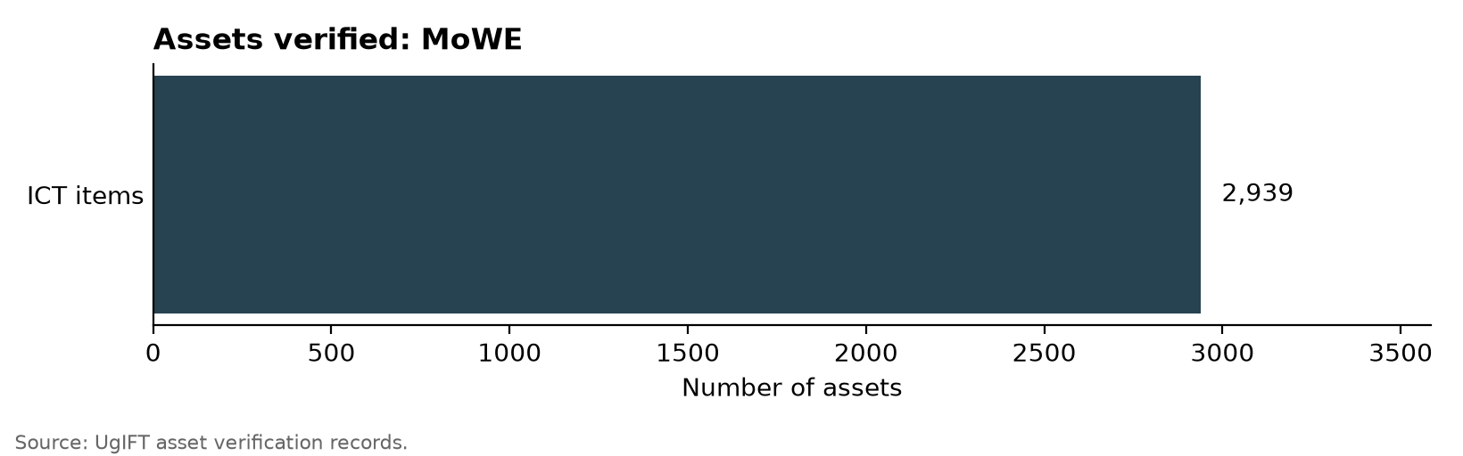
Figure 46g: Assets verified: MoWE

The findings further indicated that all 2,939 assets (100.0%) were in good working condition and in use. Of the 2,782 verified assets, 2,740 (98.5%) were engraved, 2,707 (97.3%) with the UgIFT marking, and 42 (1.5%) were not engraved. The recorded value was UGX 5,993,100,537.

3.2.12 Ministry of Gender, Labour and Social Development
The Asset Verification at the Ministry of Gender, Labour and Social Development found out that the ministry keeps a well organized UgIFT asset register and had Ten (10) UgIFT assets received.
The ICT assets comprised Eight (8) Lenovo ThinkPad Laptops, and Two (2) Samsung Tablets.
Figure 46h. presents the UgIFT assets verified for MoGLSD.
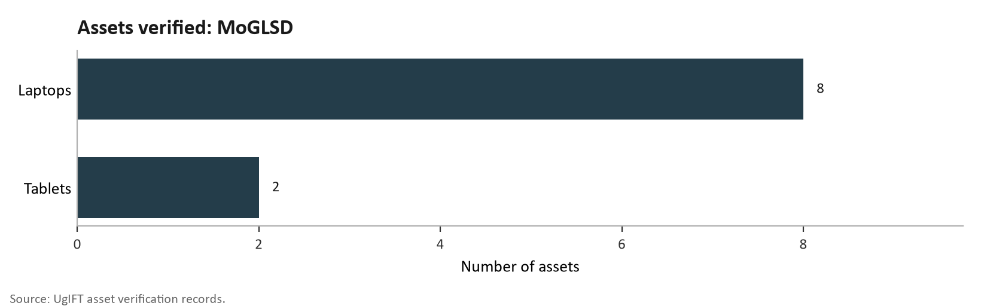
Figure 46h: Assets verified: MoGLSD

The findings further indicate that all the Ten (100%) verified UgIFT assets were in good working condition and in use.
The asset verification at the MoGLSD found out that Eight Lenovo ThinkPad Laptops (80.0%) were properly engraved with the UgIFT marking and the Two Samsung Tablets (20.0%) were not engraved. The findings pointed out the recorded value to be UGX 20,120,000.

3.2.13 National Environment Management Authority
The verification done at the National Environment Management Authority (NEMA) found that it held 6 ICT items: 4 laptops, a printer and a heavy-duty photocopier. All 6 (100.0%) were working and in use. One (16.7%) was engraved while 5 (83.3%) were not engraved, including all 4 laptops. The recorded value is UGX 27,324,409.
The Lenovo laptops serving the executive office and environmental audit, together with a heavy-duty printer, were working but not engraved. The authority was awaiting a MoFPED team to engrave them.
Expected: Computers and shared office equipment should remain identifiable wherever they are used. Found: Four Lenovo laptops serving the executive office and environmental audit, together with a heavy duty printer, were working but not engraved. The authority was awaiting a MoFPED team to engrave them.
Gap: The equipment could support work, but lacked a durable identifying mark. Recommended action: The authority should engrave the five items, record their serial numbers and custodians, and include them in regular physical checks.
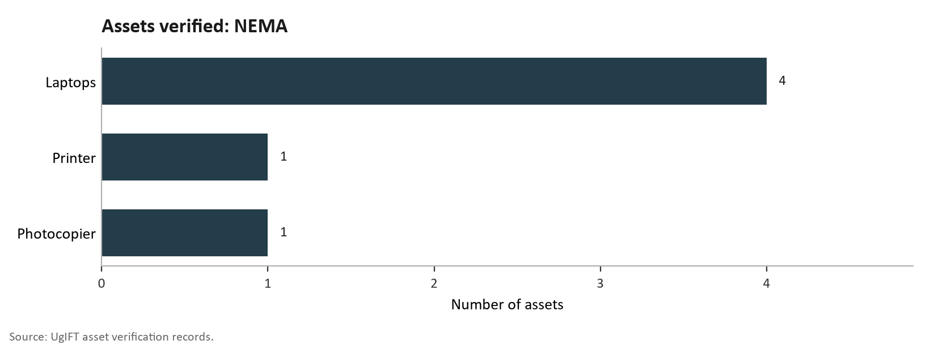
Figure 46i: Assets verified: NEMA

3.2.14 Public Procurement and Disposal of Public Assets Authority
It was not possible to obtain an Assets Register from the Public Procurement Disposal Agency or a listing of assets that were obtained by the PPDA. The verification relied on the listing obtained from the Ministry of Finance, Planning and Economic Development. A total of 5 assets were verified in PPDA, these were 3 Lenovo ThinkPad laptops, a Samsung Galaxy tablet and an HP printer (Figure 46).
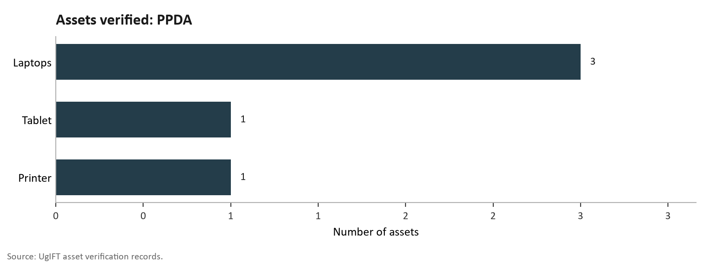
Figure 46j: Assets verified: PPDA
All 5 assets were in good working condition, in use and properly engraved with the UgIFT marking. The MF register does not state a recorded cost or net book value for these assets.

3.2.15 Office of the Auditor General
Evidence gathered during the verification confirmed that OAG had no Ugift asset register rather a list which indicated 20 assets; 18 of which were ICT items (16 laptops and 2 printers) and 2 pickup vehicles. All 20 (100.0%) were working, in use and engraved: 6 (30.0%) were properly engraved with the UgIFT marking and 14 (70.0%) were not properly engraved, carrying only the office's own asset code (12) or a vehicle registration number (2) but the two pickups had their registration numbers changed. Of the 16 laptops, 6 (37.5%) carried the UgIFT marking and 10 (62.5%) the office's asset code. The assets were worthy UGX 228,773,680.

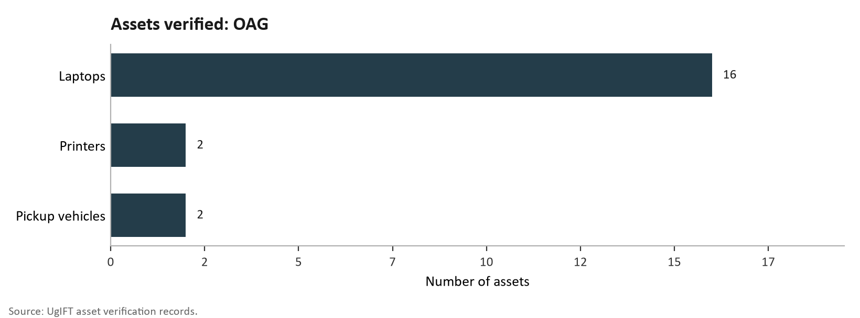
Figure 46k: Assets verified: OAG

3.2.16 Ministry of Local Government
The asset verification at the Ministry of Local Government (MoLG) found that the ministry kept a well-organised UgIFT asset register and had 13 UgIFT assets: one double-cabin pickup and 12 ICT items. The ICT assets comprised 6 computers, 4 computer peripherals and 2 copiers. Figure 46l presents the UgIFT assets verified for MoLG.
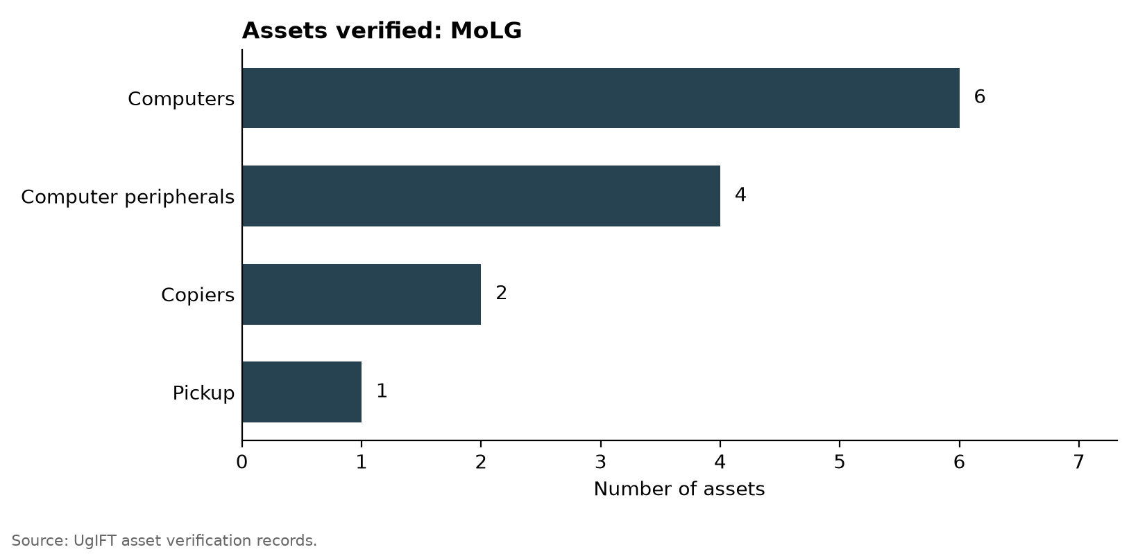
Figure 46l: Assets verified: MoLG
The findings further indicate that all 13 (100.0%) verified UgIFT assets were in good condition and working (in use). Out of the 13 assets, eight (61.5%) were engraved while five (38.5%) were not engraved. Of the eight assets that were engraved, 7 (53.8%) were engraved with a UgIFT marking while one was not. In terms of ICT Equipment which formed the bulk of assets, 3 (50.0%) were engraved and 3 (50.0%) were not. The findings pointed out the recorded value to be UGX 31,114,879.

3.2.17 Ministry of Lands, Housing and Urban Development
The findings from the verification exercise indicate that MoLH &UD had 27 UgIFT assets. These include 25 Honda motorcycles and 2 other assets (Helmets). All 27 (100.0%) were in good condition and were working (in use). Of the 26 verified assets, 13 (50.0%) were not properly engraved, carrying only their registration numbers, and 13 (50.0%) were not engraved at all. Figure 46m shows the UgIFT assets verified from the MoLH &UD.
Additionally, the ministry received survey equipment and other motorcycles that it gave out to local governments. The findings further indicate the recorded value to be UGX 597,549,997.

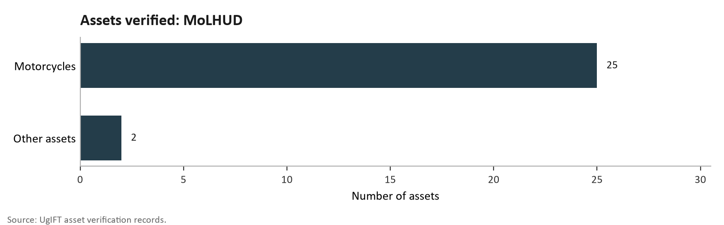
Figure 46m: Assets verified: MoLHUD

The ministry should keep the beneficiary list current and apply the UgIFT engraving so that each motorcycle can be traced to the receiving local government.

LOCAL GOVERNMENTS
The asset verification exercise at the LG level covered all the 176 LGs across the country with 629 UgIFT facilities that received support from UgIFT programme of which 371 are Health Centres and 258 are Seed Secondary Schools. A total of 208,975 assets were verified of which 63,599 were for Health Centres and 145,376 were for Seed Secondary Schools across all LGs. Of the 208,975 assets, 195,503 (93.6%) were in good condition and in use,3119 (1.5%) were not in use. 3382 were broken assets. The details are presented in sections 3.3 (Health Centres) and 3.4 (Seed secondary schools).

3.3 Health Centres

3.3.1 Availability of the assets
The verification findings indicate that health facilities received 63,599 assets across clinical equipment, clinical furniture, maternity ward equipment, ICT equipment, buildings, other movable assets and land. Consumables are excluded. Table 13 and Figure 47 present the assets by category.
Table 13: Availability of assets in Health Centres
Asset category | Assets verified | Share
Clinical equipment | 25,960 | 40.8%
Clinical furniture | 20,139 | 31.7%
Maternity ward equipment | 7,438 | 11.7%
ICT equipment | 410 | 0.6%
Health centre buildings | 1,525 | 2.4%
Other health centre assets | 8,124 | 12.8%
Land | 3 | 0.0%
Total | 63,599 | 100.0%

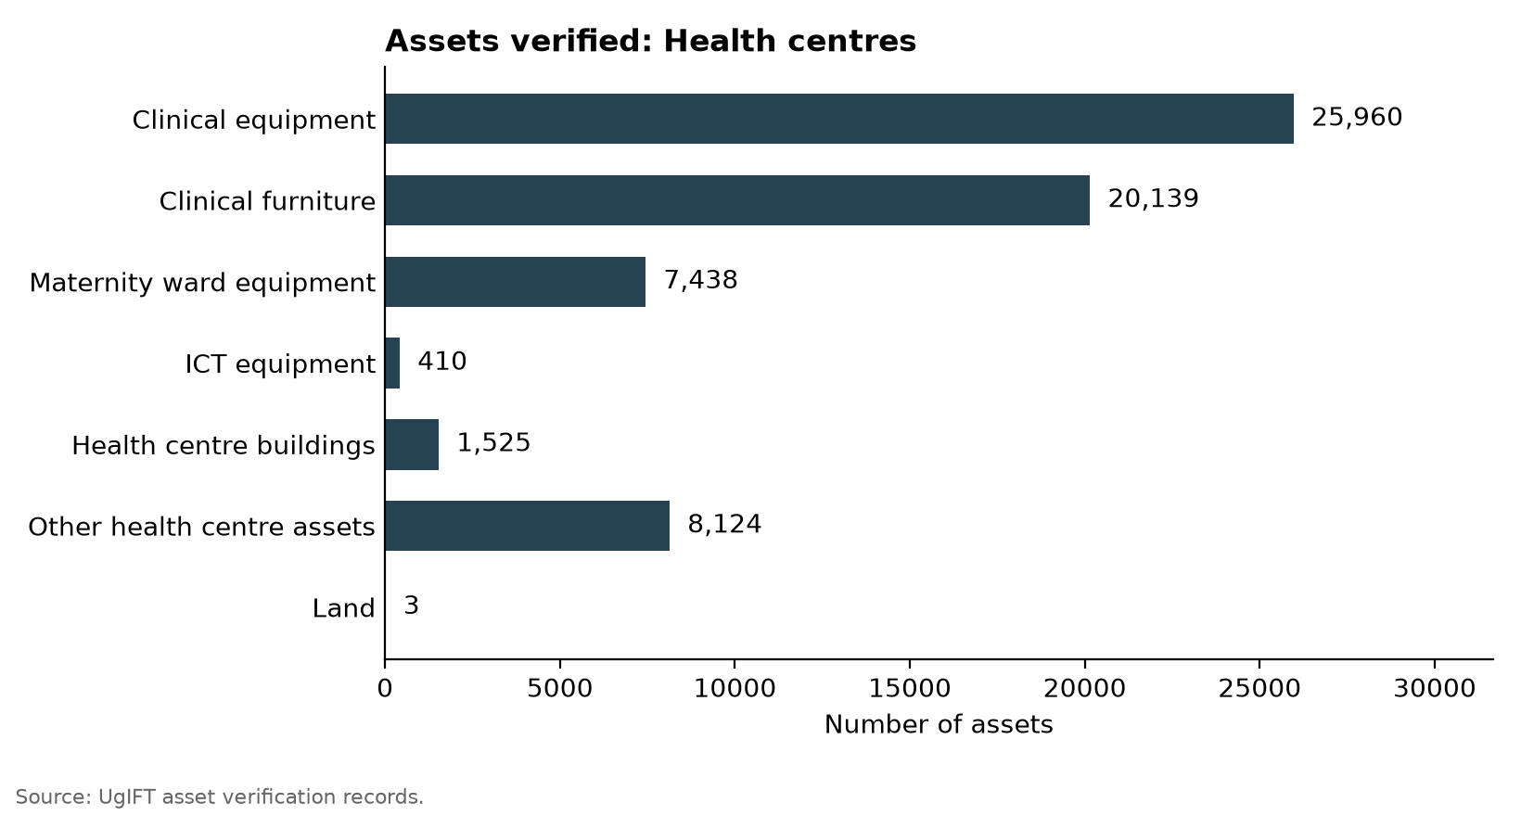
Figure 47: Assets verified: Health centres

3.3.2 Condition of assets
The findings indicate that of 63,599 health-centre assets, 60,547 (95.2%) were in good condition: 57,918 (91.1%) were in use and 2,629 (4.1%) were in store. A further 660 (1.0%) were broken and 2,392 (3.8%) were not in use for another reason. ICT equipment had the lowest share in good condition at 89.3%. Figure 48 and Table 14 present the condition of the assets.

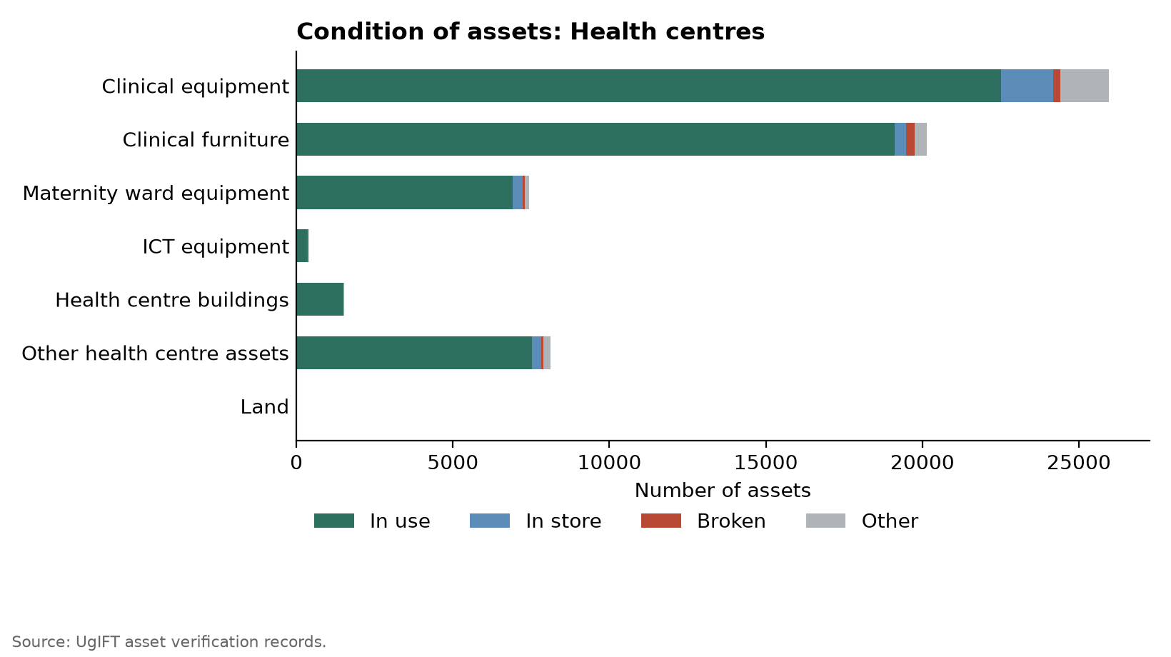
Figure 48: Condition of assets: Health centres
Table 14: Condition of assets: Health centres
Asset category | Assets verified | Good condition |  | Broken | Other
Asset category | Assets verified | In use | In store | Broken | Other
Clinical equipment | 25,960 | 22,507 | 1,677 | 220 | 1,556
Clinical furniture | 20,139 | 19,110 | 360 | 277 | 392
Maternity ward equipment | 7,438 | 6,918 | 303 | 69 | 148
ICT equipment | 410 | 361 | 5 | 5 | 39
Health centre buildings | 1,525 | 1,495 | 0 | 6 | 24
Other health centre assets | 8,124 | 7,527 | 284 | 83 | 230
Land | 3 | 3 | 0 | 0 | 0
Total | 63,599 | 57,918 | 2,629 | 660 | 2,392
Good condition is assets in use plus assets in store. Broken assets are counted on their own, including broken assets found in store. Other assets are not in use for another reason. The four condition columns sum to assets verified.
Of the 2,392 (3.8%) health-centre assets not in use for another reason included those that were not delivered, idle, had missing parts, lacked power, not needed at the facility, rooms/ wards for installation of the equipment, held at another facility, awaiting installation, lost/missing and unused because staff were not trained and no specialist was available to operate the equipment. Examples include a wall-mounted blood pressure machine at Butawata Health Centre III recorded as not functional, a wheelchair at Aarapoo Health Centre III that had not been delivered, a patient screen at Ayer Health Centre III that was on the delivery note but not seen, a paediatric bed at Okwerodot Health Centre III supplied without a mattress, and an autoclave at Anamwany Health Centre III left unused for lack of electricity.
In terms of buildings, they are categorised into two i.e. 482 residential and 1,043 non-residential buildings. Residential buildings are staff houses and other buildings described as residential. Table 15 and Figure 49 depicts buildings.
Table 15: Health Centre buildings: residential and non-residential
Building type | Assets verified | Share
Residential buildings | 482 | 31.6%
Non-residential buildings | 1,043 | 68.4%
Total | 1,525 | 100.0%

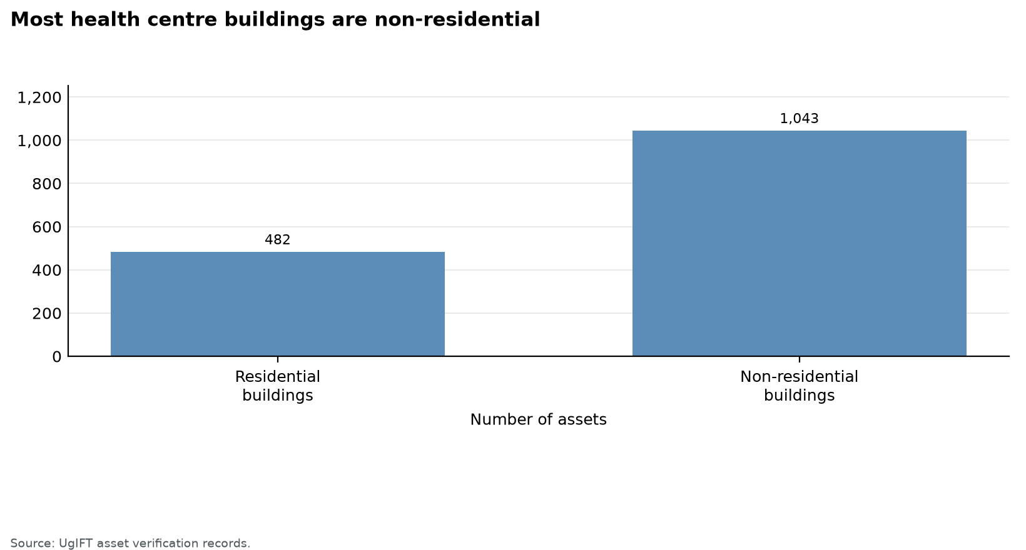

3.3.3 Identification
Of 63,599 assets in Health Centres, 62,071 are movable assets of which 9,446 (15.2%) were engraved and 52,625 (84.8%) were not engraved. It was noted that 3,817 (6.1%) carried the UgIFT identifier and 5,629 (9.1%) carried other modes of marking with no UgIFT identifier as depicted in Figure 49 and Table 16.
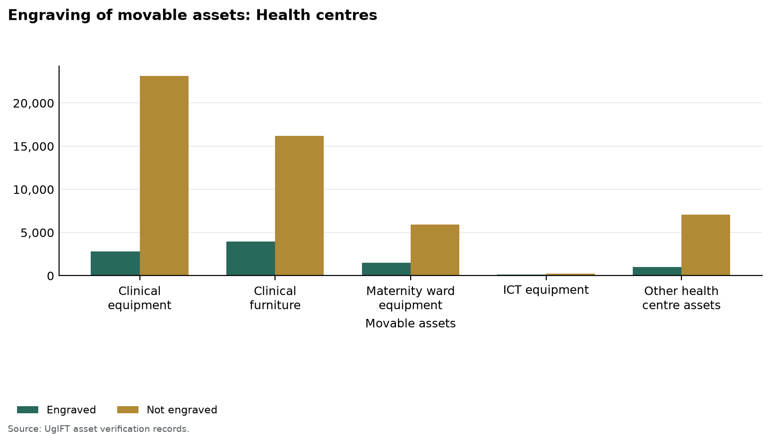
Figure 49: Engraving of movable assets: Health centres
Table 16: Identification of assets: Health centres
Asset category | Assets verified | Movable assets | Engraved | Properly engraved with UgIFT | Not engraved
Clinical equipment | 25,960 | 25,960 | 2,815 (10.8%) | 1,043 (4.0%) | 23,145 (89.2%)
Clinical furniture | 20,139 | 20,139 | 3,934 (19.5%) | 1,576 (7.8%) | 16,205 (80.5%)
Maternity ward equipment | 7,438 | 7,438 | 1,510 (20.3%) | 815 (11.0%) | 5,928 (79.7%)
ICT equipment | 410 | 410 | 155 (37.8%) | 133 (32.4%) | 255 (62.2%)
Health centre buildings | 1,525 | - | - | - | -
Other health centre assets | 8,124 | 8,124 | 1,032 (12.7%) | 250 (3.1%) | 7,092 (87.3%)
Land | 3 | - | - | - | -
Total | 63,599 | 62,071 | 9,446 (15.2%) | 3,817 (6.1%) | 52,625 (84.8%)
Movable assets exclude buildings, structures and land. Properly engraved means the UgIFT marking. A dash means the assets are identified through property and site records rather than engraving.
The seven consumable records were removed from the asset analysis. The remaining 8,124 other health-centre assets are movable. Three pieces of land are reported separately: the plot at Kyamwinula Health Centre III in Tororo Municipal Council and the two plots recorded as hospital land at Nalubembe Health Centre III and Kabweri Health Centre III in Kibuku District.

3.3.4 Financial aspects
The findings indicate that the recorded value of assets was UGX 259,662,759,164 and net book value as at 30 September 2026 was UGX 218,378,252,366, while accumulated depreciation was UGX 41,291,769,808. Figure 50 and Table 17 give the recorded value and net book value.

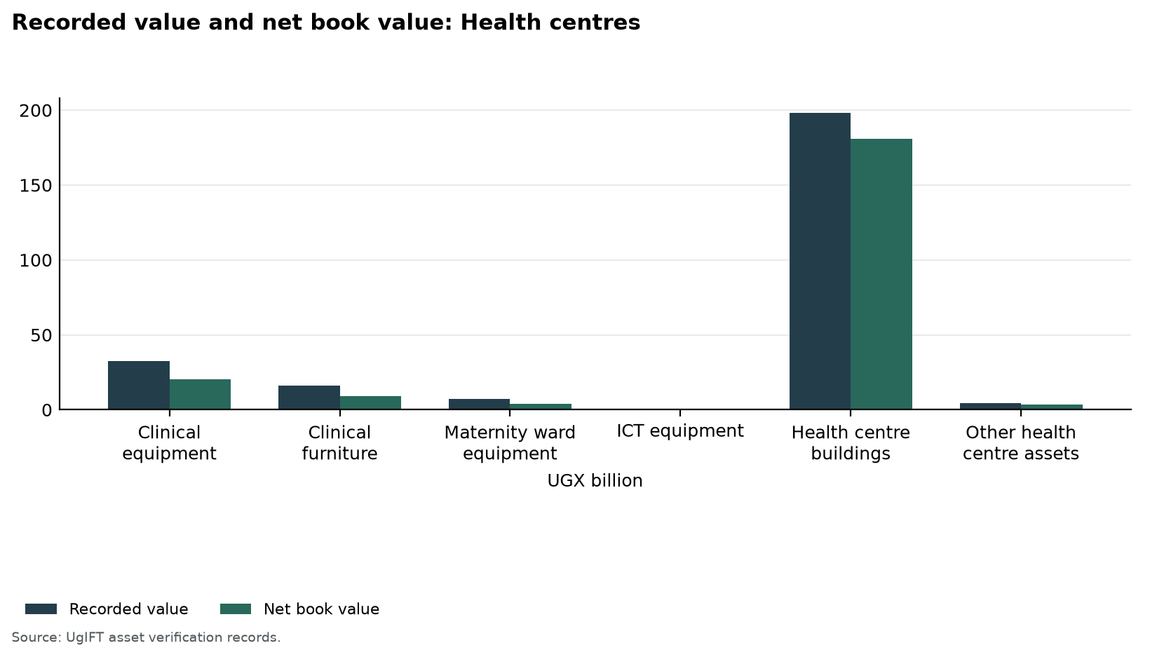
Figure 50: Recorded value and net book value: Health centres
Table 17: Recorded value and net book value: Health centres
Asset category | Assets | Recorded value UGX | Depreciation UGX | Net book value UGX
Clinical equipment | 25,960 | 32,419,253,988 | 12,264,441,553 | 20,154,812,435
Clinical furniture | 20,139 | 16,115,597,625 | 6,920,036,277 | 9,202,824,358
Maternity ward equipment | 7,438 | 7,419,395,159 | 3,270,066,317 | 4,149,328,842
ICT equipment | 410 | 876,467,375 | 646,446,250 | 230,021,125
Health centre buildings | 1,525 | 198,198,049,954 | 17,166,034,514 | 181,032,015,440
Other health centre assets | 8,124 | 4,583,995,063 | 1,024,744,897 | 3,559,250,166
Land | 3 | 50,000,000 | 0 | 50,000,000
Total | 63,599 | 259,662,759,164 | 41,291,769,808 | 218,378,252,366
Recorded value is the cost in the verification records. Net book value is that cost less accumulated depreciation to 30 September 2026, and is not taken below zero.

3.4 Seed secondary schools

3.4.1 Availability of the assets
This part counts the assets verified. School buildings held 4,341 assets (3.0%). Figure 52 shows the count, and Table 18 lists it.
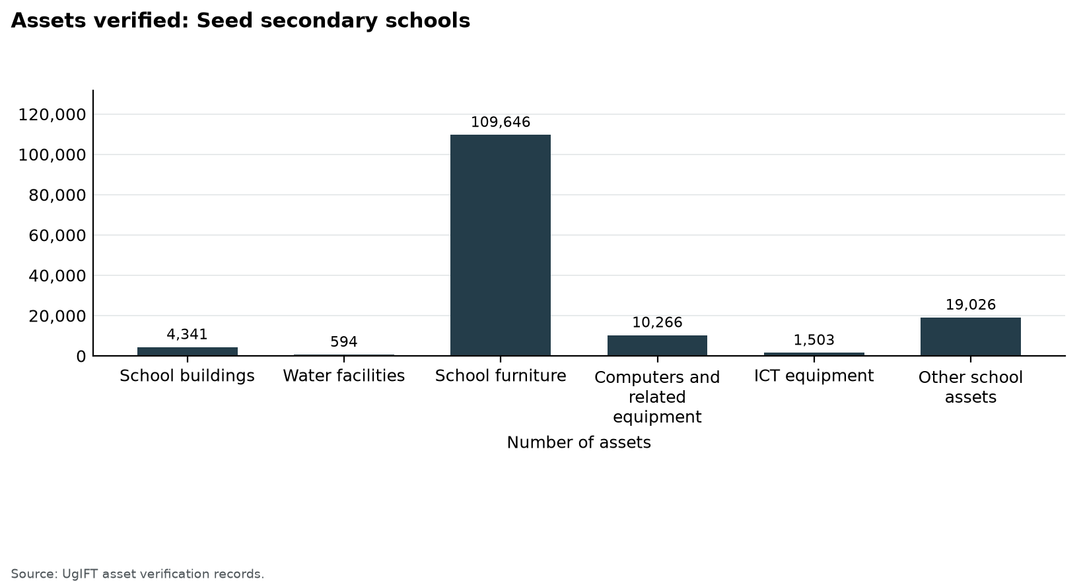
Figure 52: Assets verified: Seed secondary schools
Table 18: Availability of assets: Seed secondary schools
Asset category | Assets verified | Share
School buildings | 4,341 | 3.0%
Water facilities | 594 | 0.4%
School furniture | 109,646 | 75.4%
Computers and related equipment | 10,266 | 7.1%
ICT equipment | 1,503 | 1.0%
Other school assets | 19,026 | 13.1%
Total | 145,376 | 100.0%

3.4.2 Condition of assets
138,075 assets (95.0%) were in good condition, of which 137,585 were in use and 490 were in store. 2,722 (1.9%) were broken and 4,579 (3.1%) were not in use for another reason. The lowest share in good condition was Computers and related equipment at 88.4%. Figure 53 shows the split. Table 19 states the counts.
School furniture is the largest category, at 109,646 assets. Of the furniture, desks, tables, chairs and stools account for 101,453, and 2,455 furniture assets were broken. Computers and related equipment had 85.5% in use. School buildings split into 577 residential and 3,764 non-residential, and water facilities are reported separately (Table 22 and Figure 56).
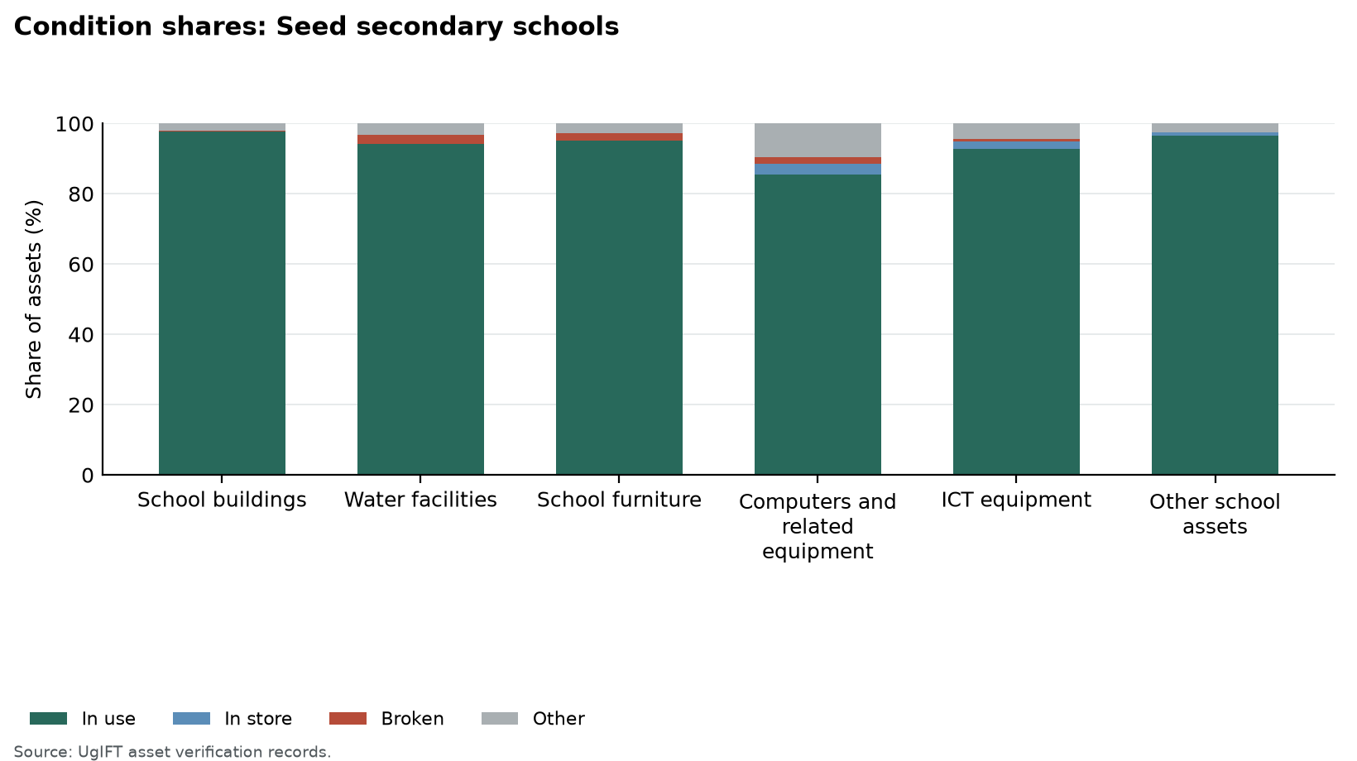
Figure 53: Condition shares: Seed secondary schools
Table 19: Condition of assets: Seed secondary schools
Asset category | Assets verified | Good condition |  | Broken | Other
Asset category | Assets verified | In use | In store | Broken | Other
School buildings | 4,341 | 4,238 | 3 | 14 | 86
Water facilities | 594 | 560 | 0 | 15 | 19
School furniture | 109,646 | 104,233 | 0 | 2,455 | 2,958
Computers and related equipment | 10,266 | 8,777 | 301 | 208 | 980
ICT equipment | 1,503 | 1,395 | 30 | 11 | 67
Other school assets | 19,026 | 18,382 | 156 | 19 | 469
Total | 145,376 | 137,585 | 490 | 2,722 | 4,579
Good condition is assets in use plus assets in store. Broken assets are counted on their own, including broken assets found in store. Other assets are not in use for another reason. The four condition columns sum to assets verified.

3.4.3 Identification, including engraving
Of 138,671 movable assets, 35,121 (25.3%) were engraved and 103,550 (74.7%) were not engraved. 14,861 (10.7%) carried the UgIFT marking and 20,260 (14.6%) carried another marking only. Figure 54 shows the position. Table 20 sets out the counts.
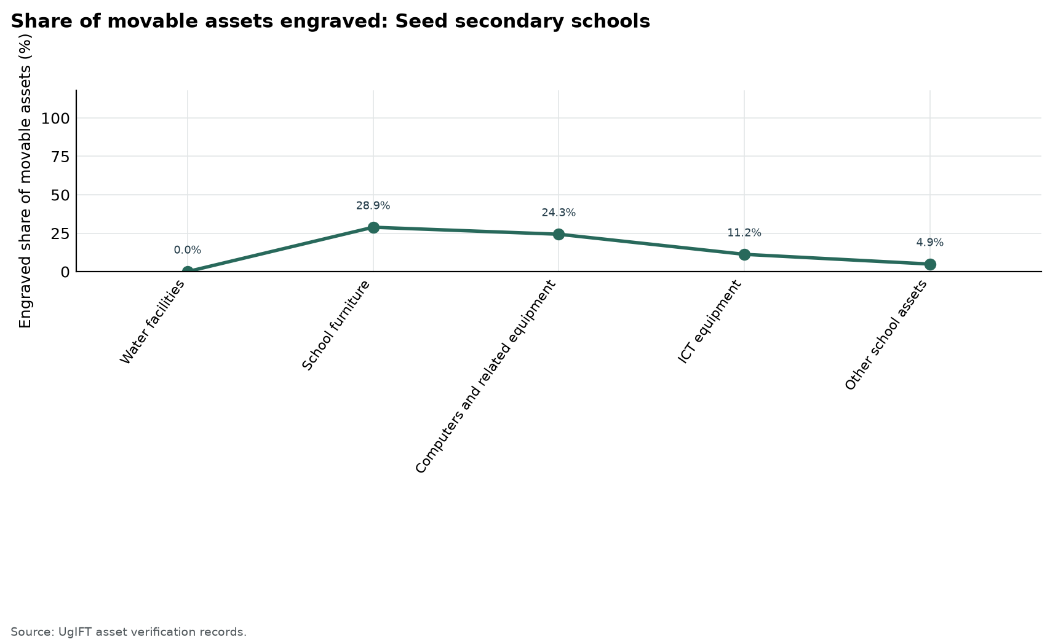
Figure 54: Share of movable assets engraved: Seed secondary schools
Table 20: Identification of assets: Seed secondary schools
Asset category | Assets verified | Movable assets | Engraved | Properly engraved | Not engraved
School buildings | 4,341 | - | - | - | -
Water facilities | 594 | 96 | 0 (0.0%) | 0 (0.0%) | 96 (100.0%)
School furniture | 109,646 | 109,646 | 31,656 (28.9%) | 14,405 (13.1%) | 77,990 (71.1%)
Computers and related equipment | 10,266 | 10,059 | 2,445 (24.3%) | 310 (3.1%) | 7,614 (75.7%)
ICT equipment | 1,503 | 1,503 | 169 (11.2%) | 5 (0.3%) | 1,334 (88.8%)
Other school assets | 19,026 | 17,367 | 851 (4.9%) | 141 (0.8%) | 16,516 (95.1%)
Total | 145,376 | 138,671 | 35,121 (25.3%) | 14,861 (10.7%) | 103,550 (74.7%)
Movable assets exclude buildings, structures and land. Properly engraved means the UgIFT marking. A dash means the assets are identified through property and site records rather than engraving.

3.4.4 Financial aspects
Recorded value was UGX 678,247,549,426 and net book value at 30 September 2026 was UGX 576,704,905,370. Accumulated depreciation was UGX 101,549,907,057. Figure 55 compares recorded value and net book value. Table 21 gives the figures.
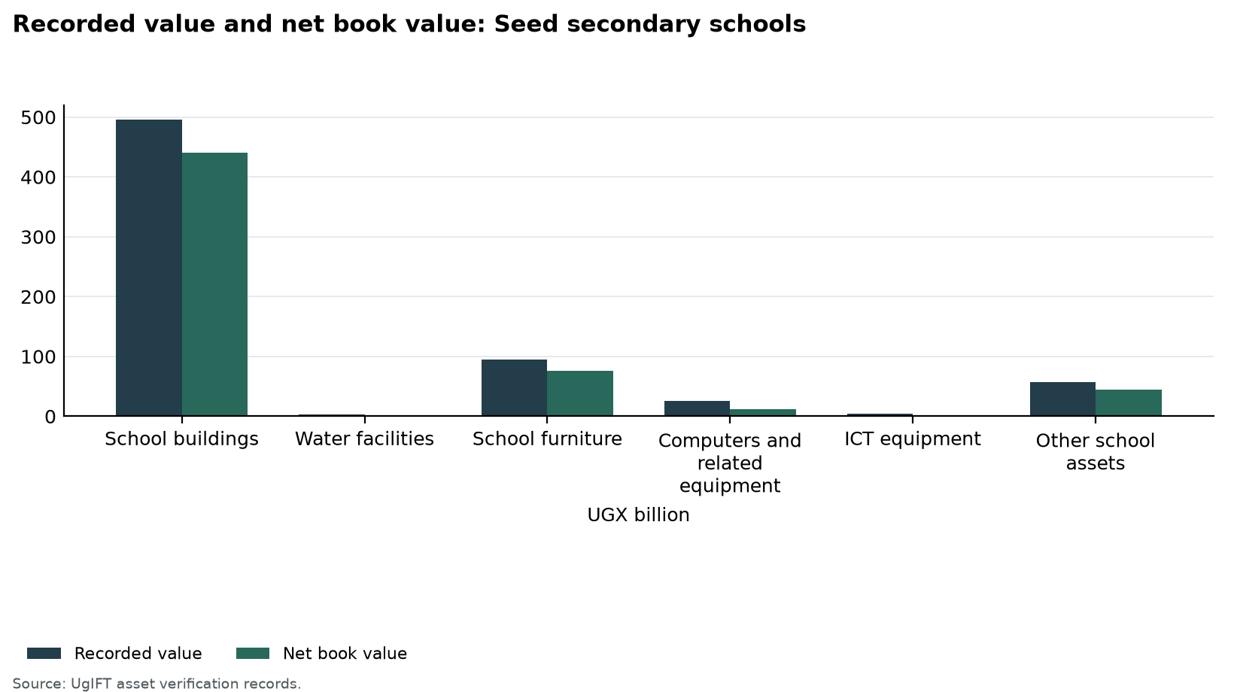
Figure 55: Recorded value and net book value: Seed secondary schools
Table 21: Recorded value and net book value: Seed secondary schools
Asset category | Assets | Recorded value UGX | Depreciation UGX | Net book value UGX
School buildings | 4,341 | 495,160,116,359 | 54,728,357,865 | 440,431,758,495
Water facilities | 594 | 3,076,630,427 | 817,399,552 | 2,259,230,875
School furniture | 109,646 | 94,322,583,307 | 18,004,437,908 | 76,325,408,399
Computers and related equipment | 10,266 | 25,434,940,136 | 13,385,662,572 | 12,049,277,564
ICT equipment | 1,503 | 3,790,186,812 | 2,174,847,712 | 1,615,339,100
Other school assets | 19,026 | 56,463,092,385 | 12,439,201,448 | 44,023,890,937
Total | 145,376 | 678,247,549,426 | 101,549,907,057 | 576,704,905,370
Recorded value is the cost in the verification records. Net book value is that cost less accumulated depreciation to 30 September 2026, and is not taken below zero.
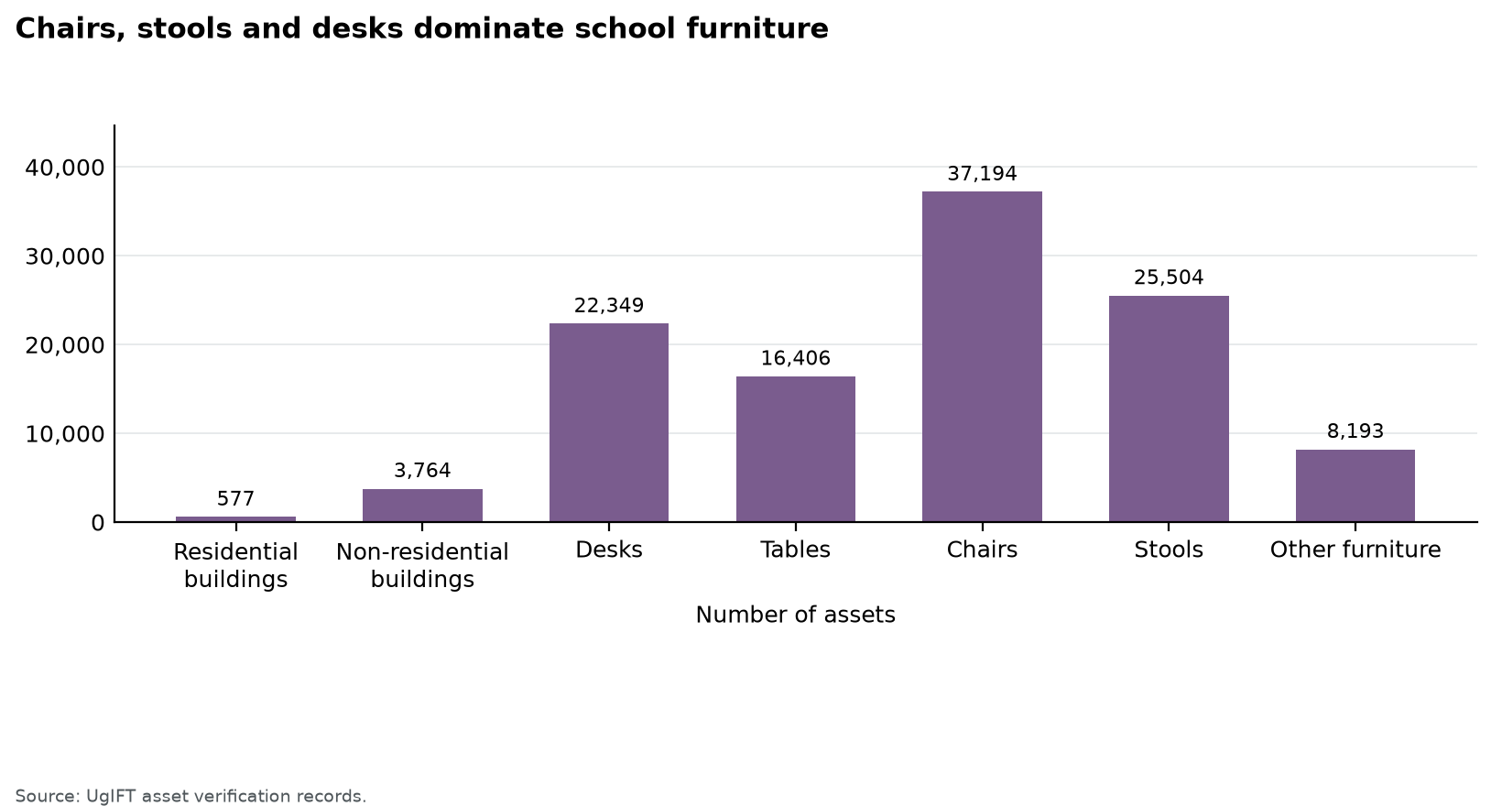
Figure 56: Chairs, stools and desks dominate school furniture
Table 22: School buildings and furniture: composition
Item | Assets verified | Share of buildings and furniture
Residential buildings | 577 | 0.5%
Non-residential buildings | 3,764 | 3.3%
Desks | 22,349 | 19.6%
Tables | 16,406 | 14.4%
Chairs | 37,194 | 32.6%
Stools | 25,504 | 22.4%
Other furniture | 8,193 | 7.2%
Residential buildings are staff houses, staff quarters and dormitories. Water tanks and similar installations are in water facilities, not in buildings. Desks, tables, chairs, stools and other furniture add up to school furniture.

3.5 Blood banks

3.5.1 Availability of the assets
This part counts the assets verified. Arua Regional Blood Bank held 277 assets (44.2%). Figure 57 shows the count, and Table 23 lists it.
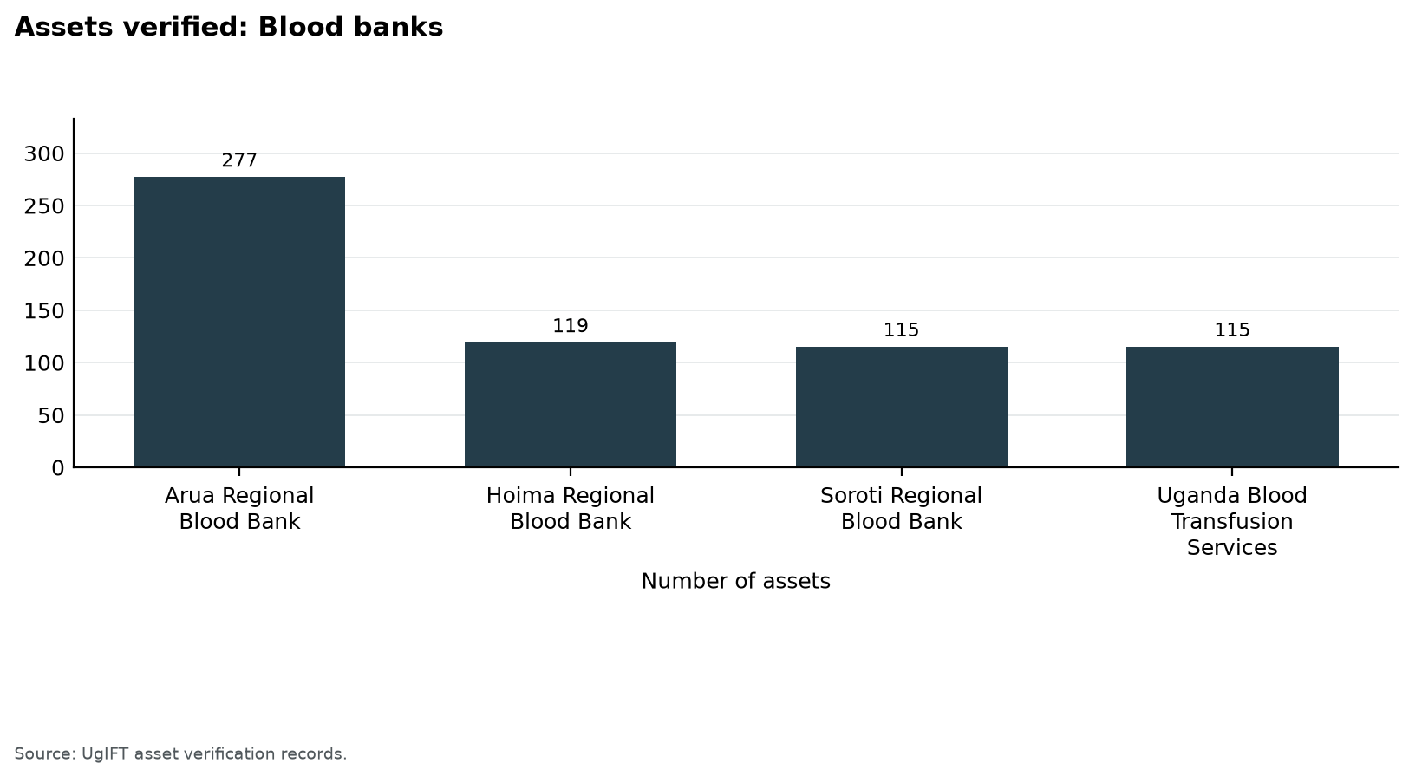
Figure 57: Assets verified: Blood banks
Table 23: Availability of assets: Blood banks
Institution | Assets verified | Share
Arua Regional Blood Bank | 277 | 44.2%
Hoima Regional Blood Bank | 119 | 19.0%
Soroti Regional Blood Bank | 115 | 18.4%
Uganda Blood Transfusion Services | 115 | 18.4%
Total | 626 | 100.0%

3.5.2 Condition of assets
602 assets (96.2%) were in good condition, of which 602 were in use and 0 were in store. 6 (1.0%) were broken and 18 (2.9%) were not in use for another reason. The lowest share in good condition was Arua Regional Blood Bank at 91.3%. Figure 58 shows the split. Table 24 states the counts.
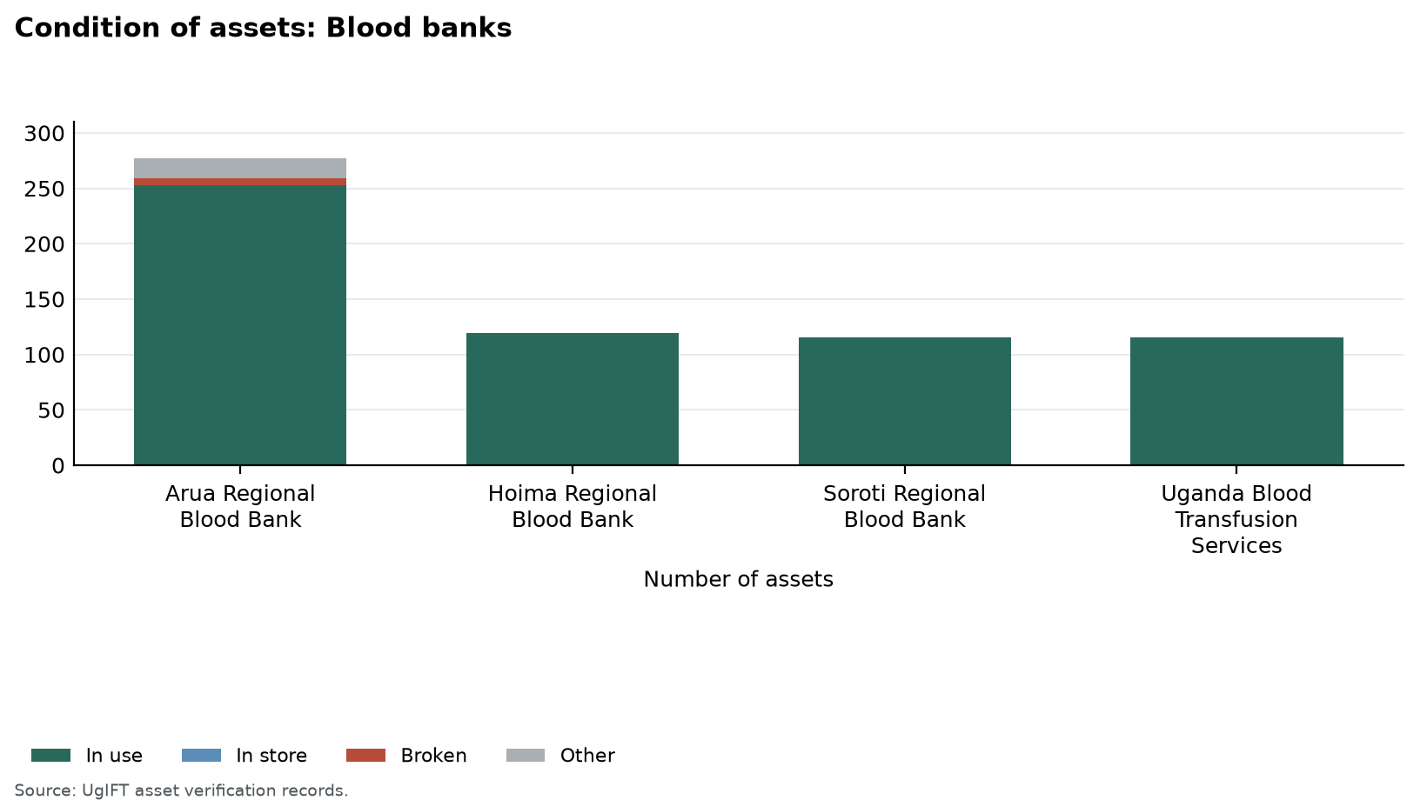
Figure 58: Condition of assets: Blood banks
Table 24: Condition of assets: Blood banks
Institution | Assets verified | Good condition |  | Broken | Other
Institution | Assets verified | In use | In store | Broken | Other
Arua Regional Blood Bank | 277 | 253 | 0 | 6 | 18
Hoima Regional Blood Bank | 119 | 119 | 0 | 0 | 0
Soroti Regional Blood Bank | 115 | 115 | 0 | 0 | 0
Uganda Blood Transfusion Services | 115 | 115 | 0 | 0 | 0
Total | 626 | 602 | 0 | 6 | 18
Good condition is assets in use plus assets in store. Broken assets are counted on their own, including broken assets found in store. Other assets are not in use for another reason. The four condition columns sum to assets verified.

3.5.3 Identification, including engraving
Of 605 movable assets, 43 (7.1%) were engraved and 562 (92.9%) were not engraved. 26 (4.3%) carried the UgIFT marking and 17 (2.8%) carried another marking only. Figure 59 shows the position. Table 25 sets out the counts.
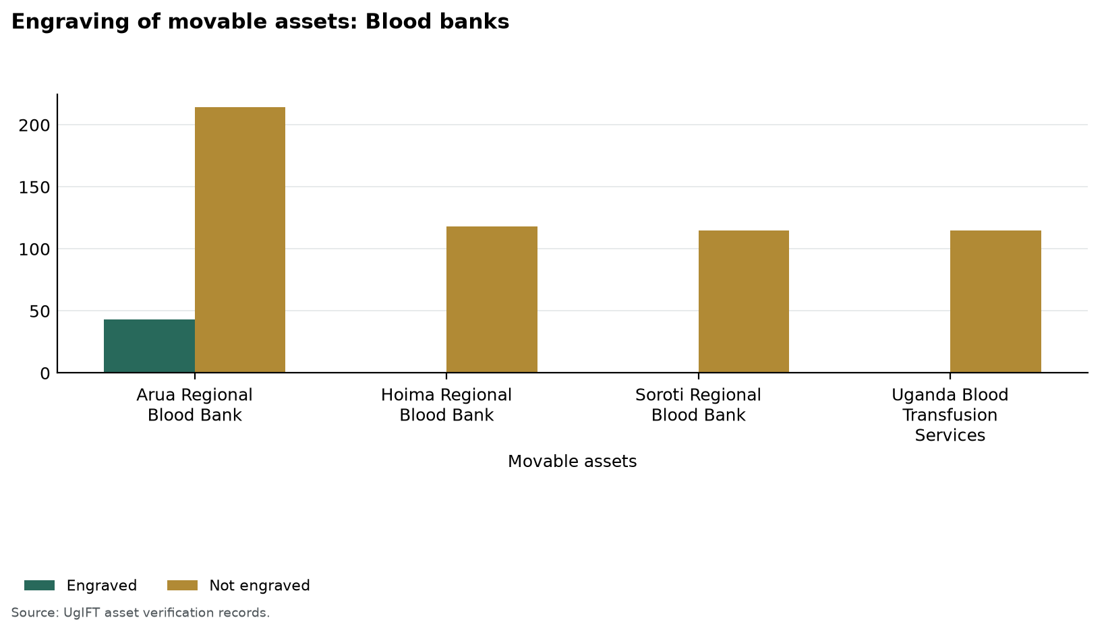
Figure 59: Engraving of movable assets: Blood banks
Table 25: Identification of assets: Blood banks
Institution | Assets verified | Movable assets | Engraved | Properly engraved | Not engraved
Arua Regional Blood Bank | 277 | 257 | 43 (16.7%) | 26 (10.1%) | 214 (83.3%)
Hoima Regional Blood Bank | 119 | 118 | 0 (0.0%) | 0 (0.0%) | 118 (100.0%)
Soroti Regional Blood Bank | 115 | 115 | 0 (0.0%) | 0 (0.0%) | 115 (100.0%)
Uganda Blood Transfusion Services | 115 | 115 | 0 (0.0%) | 0 (0.0%) | 115 (100.0%)
Total | 626 | 605 | 43 (7.1%) | 26 (4.3%) | 562 (92.9%)
Movable assets exclude buildings, structures and land. Properly engraved means the UgIFT marking. A dash means the assets are identified through property and site records rather than engraving.

3.5.4 Financial aspects
Recorded value was UGX 1,451,584,715 and net book value at 30 September 2026 was UGX 937,479,171. Accumulated depreciation was UGX 514,105,544. Figure 60 compares recorded value and net book value. Table 26 gives the figures.
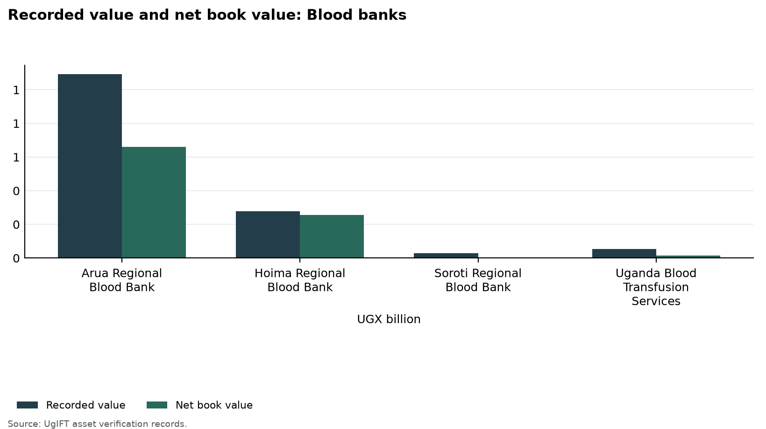
Figure 60: Recorded value and net book value: Blood banks
Table 26: Recorded value and net book value: Blood banks
Institution | Assets | Recorded value UGX | Depreciation UGX | Net book value UGX
Arua Regional Blood Bank | 277 | 1,091,262,791 | 430,462,000 | 660,800,791
Hoima Regional Blood Bank | 119 | 278,006,206 | 21,690,290 | 256,315,916
Soroti Regional Blood Bank | 115 | 29,317,538 | 25,122,550 | 4,194,988
Uganda Blood Transfusion Services | 115 | 52,998,180 | 36,830,704 | 16,167,476
Total | 626 | 1,451,584,715 | 514,105,544 | 937,479,171
Recorded value is the cost in the verification records. Net book value is that cost less accumulated depreciation to 30 September 2026, and is not taken below zero.
UgIFT financed the construction of the Arua and Hoima regional blood banks, which were completed and commissioned, and the rehabilitation of Soroti Regional Blood Bank. The photographs show the buildings, donor rooms and cold-chain equipment, and the engraving found on equipment at Arua and Hoima.
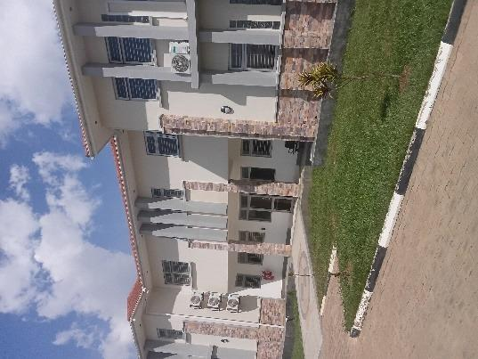  Figure 61: Completed blood bank building at Arua Regional Blood Bank, Arua City (West Nile) | 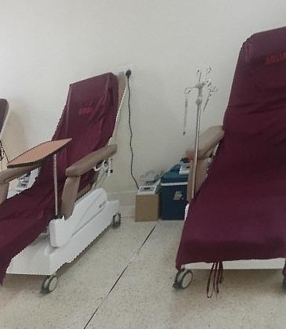  Figure 62: Donor couches in the donor room at Arua Regional Blood Bank, Arua City (West Nile) | 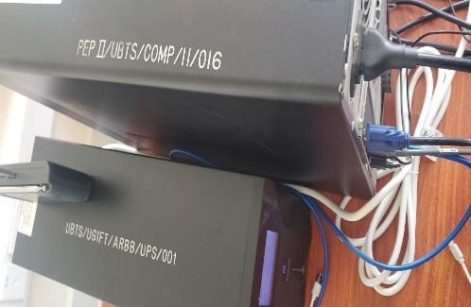  Figure 63: Markings PEP II/UBTS/COMP/11/016 and UBTS/UGIFT/ARBB/UPS/001 on uninterruptible power supplies at Arua Regional Blood Bank, Arua City (West Nile)

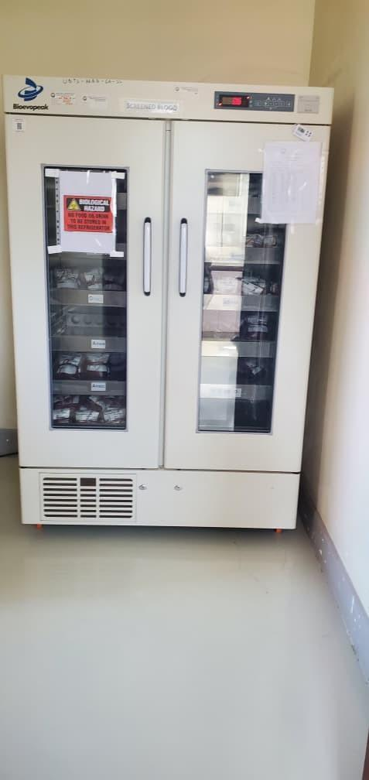  Figure 64: Blood bank refrigerator at Arua Regional Blood Bank, Arua City (West Nile) | 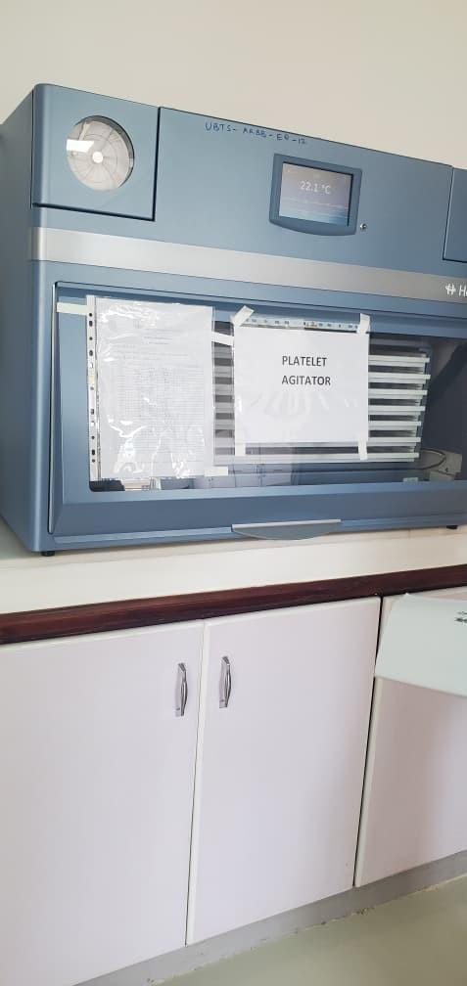  Figure 65: Platelet agitator at Arua Regional Blood Bank, Arua City (West Nile) | 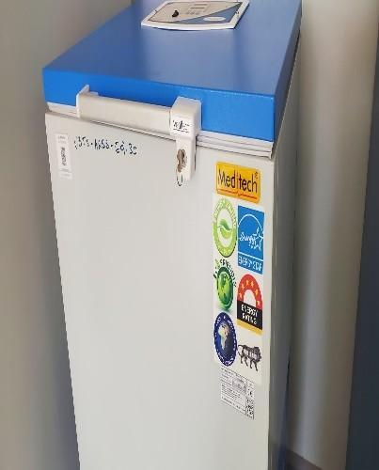  Figure 66: Chest freezer at Arua Regional Blood Bank, Arua City (West Nile)

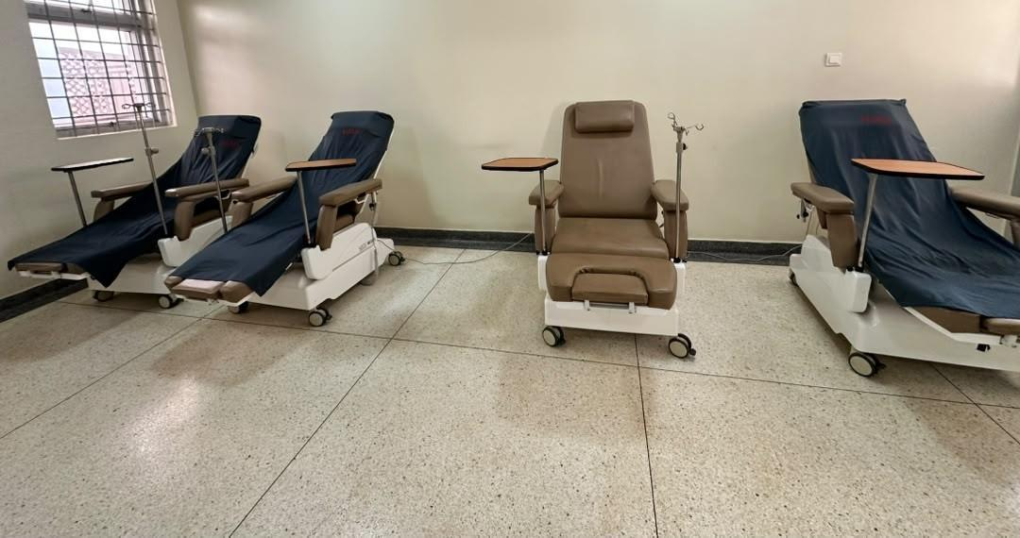  Figure 67: Donor couches in the donor room at Hoima Regional Blood Bank, Hoima City (Bunyoro) | 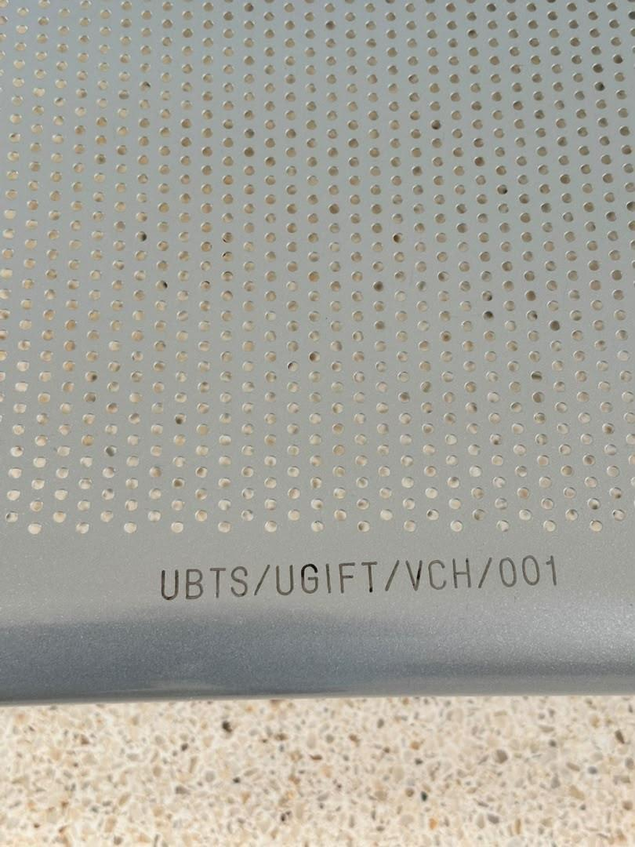  Figure 68: Engraving reading UBTS/UGIFT/VCH/001 on equipment at Hoima Regional Blood Bank, Hoima City (Bunyoro) | 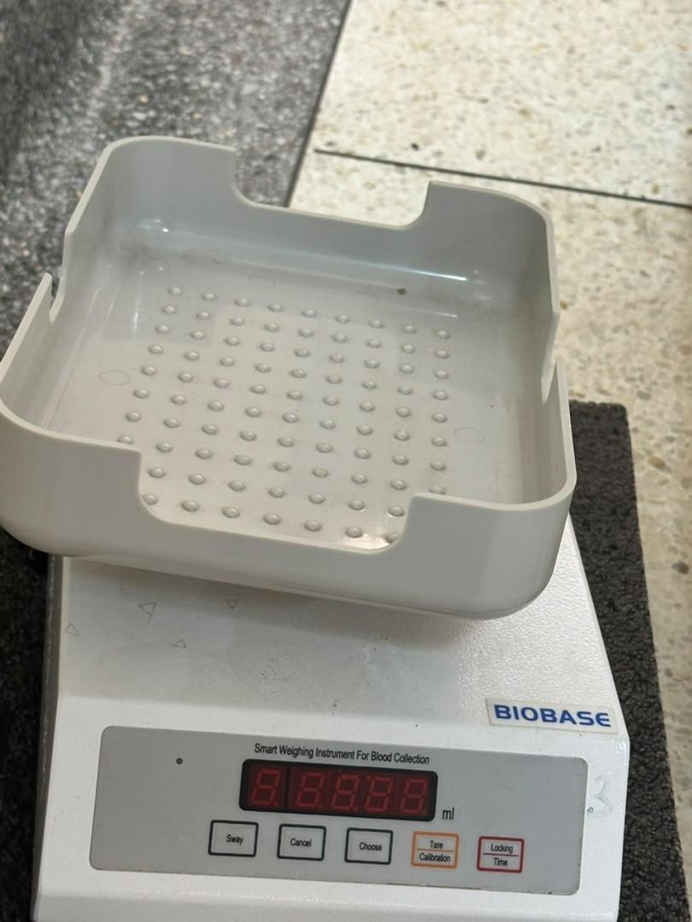  Figure 69: Blood collection balance at Hoima Regional Blood Bank, Hoima City (Bunyoro)

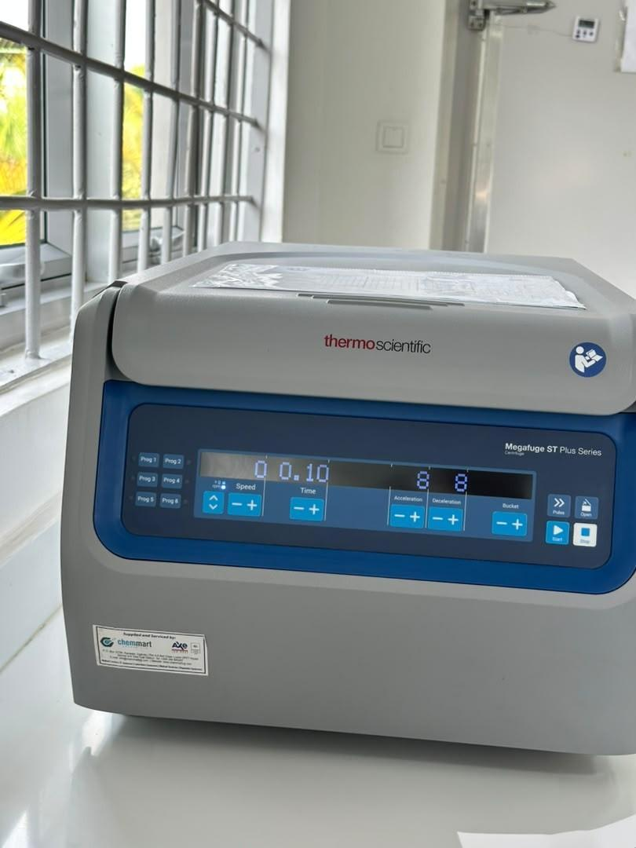  Figure 70: Benchtop centrifuge at Hoima Regional Blood Bank, Hoima City (Bunyoro) | 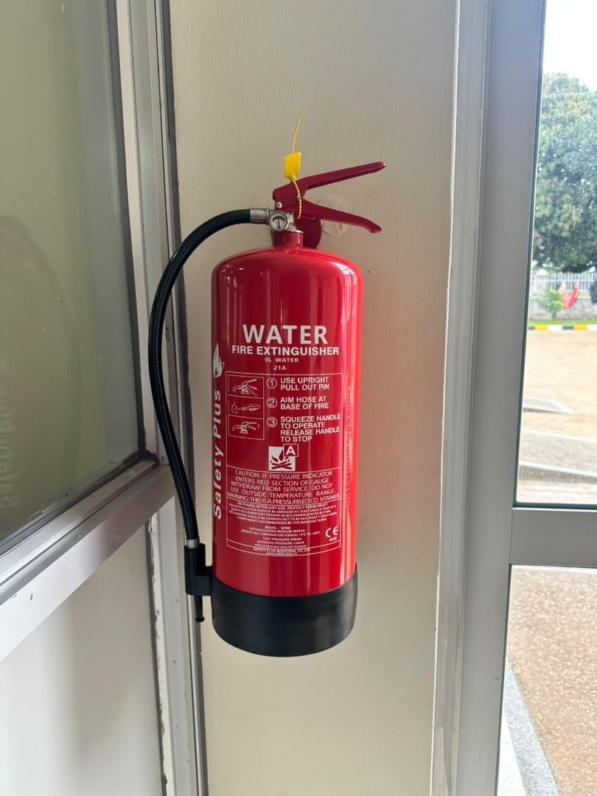  Figure 71: Water fire extinguisher at Hoima Regional Blood Bank, Hoima City (Bunyoro) | 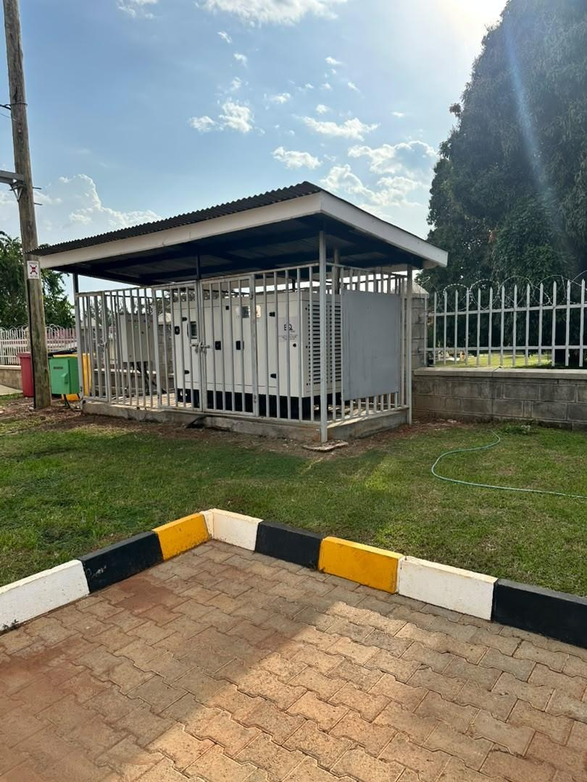  Figure 72: Generator in an outdoor enclosure at Hoima Regional Blood Bank, Hoima City (Bunyoro)

3.6 Facilities verified, completion and inconsistencies
Sections 3.3 and 3.4 give the assets at health centres and seed schools. This section records which facilities were verified, where works were still outstanding, and how the programme list was reconciled.
Local government verification began on 24 August 2026 and covered the 629 facilities on the programme list, the health centres and seed schools planned before the exercise started: 371 health centres and 258 seed schools (Table 3). Follow-up established which facilities retained their original names, which had replacements or relocated assets, and which listed institutions had not received programme support. These distinctions matter because a name on the list does not, by itself, demonstrate that the intended facility and its assets are available for service.
The findings are reported at national level. Section 3.3.1 shows how many programme-list facilities were verified, completed and providing services; Section 3.3.2 sets out the inconsistencies between the programme list and the facilities found; and Section 3.3.3 presents the assets verified at health centres and seed schools.

3.6.1 Facilities verified, completed and providing services
Of the 629 facilities on the programme list, teams verified 590 (93.8%) on the ground as UgIFT facilities: 347 health centres (93.5%) and 243 seed schools (94.2%). The verified count includes 29 facilities verified under their operating name and three verified through the facility that replaced them. The other 39 facilities (6.2%) were accounted for through reconciliation: 18 were not UgIFT facilities in practice, the UgIFT assets of three had been relocated to another facility, two are counted once under another programme-list entry, and 16 were accounted for through documented follow-up. Every programme-list facility was therefore accounted for through verification or reconciliation. Table 27 and Figure 73 summarise the position.
Table 27: Programme-list facilities verified, completed and providing services
Measure | Health centres | Seed schools | Total
Programme list | 371 | 258 | 629
Verified | 347 (93.5%) | 243 (94.2%) | 590 (93.8%)
Works completed | 320 (92.2%) | 155 (63.8%) | 475 (80.5%)
Works not completed | 27 (7.8%) | 88 (36.2%) | 115 (19.5%)
Providing services | 327 (94.2%) | 193 (79.4%) | 520 (88.1%)
Not yet providing services | 3 (0.9%) | 21 (8.6%) | 24 (4.1%)
Accounted for through reconciliation | 24 (6.5%) | 15 (5.8%) | 39 (6.2%)
Counts are facilities. Verified and accounted for through reconciliation are percentages of the programme list; the other percentages are of verified facilities.
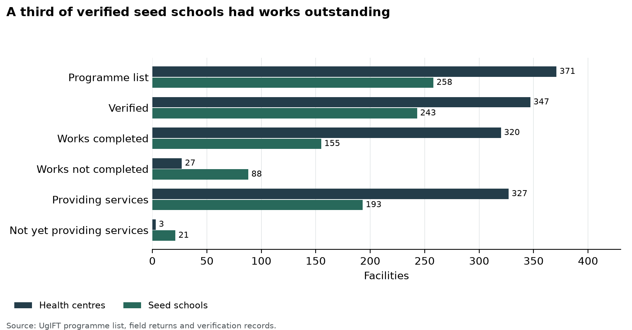
Figure 73: A third of verified seed schools had works outstanding
Works were complete at 475 of the verified facilities (80.5%): 320 health centres (92.2%) and 155 seed schools (63.8%). Works were not complete at 115 (19.5%): 27 health centres (7.8%) and 88 seed schools (36.2%). For 86 of these, the field returns or the building entries in the verification records confirmed that works were outstanding; the other 29 were recorded as ongoing on the programme list. In the field, 44 facilities recorded as complete on the programme list had works outstanding, for example Kaptum and Kitawoi seed schools in Kween, while four recorded as ongoing were found complete.
At 45 of the 86 facilities, main blocks such as classrooms, laboratories, libraries, ICT blocks or maternity wards were still under construction. At 16, only ancillary structures such as staff houses, latrines, kitchens, placenta pits or incinerators remained. At nine, the contractor had not yet handed the works over, and at the other 16 the works were reported as still under construction or incomplete.
At the time of the visits, 520 verified facilities (88.1%) were providing services: 327 health centres (94.2%) and 193 seed schools (79.4%). They include 63 facilities where some works were still outstanding. Twenty-four verified facilities (4.1%) were not yet providing services: three health centres (0.9%) and 21 seed schools (8.6%). Most were schools still under construction or not yet handed over by the contractor:
• Health centres (3): Bukibologoto Health Centre III (Bulambuli), Kaptum Health Centre III (Kween) and Amanyiri Health Centre III (Yumbe).
• Seed schools (21): Kotomor and Omiya Pacwa (Agago), Akwon (Amolatar), Amuru Town (Amuru), Bushiribo (Bududa), Senendet (Bukwo), Burondo (Bundibugyo), Muhula (Butaleja), St Luke Kibibi (Butambala), Sidok (Kaabong), Rengen (Kotido), Kaptum and Moyok (Kween), Padibe (Lamwo), Butta (Manafwa), Moruita (Nakapiripirit), Iriiri and Lopei (Napak), Got Apwoyo (Nwoya), Okum (Otuke) and Aleka (Oyam).
All three health centres and 19 of the 21 schools had works outstanding. At St Luke Kibibi the main structures were complete and the school awaited formal commissioning and handover, and Lopei was complete, handed over and due to open the following year. Several of these facilities kept their assets in store pending completion and handover of the works: the UgIFT equipment for Kaptum Health Centre III was packed in the facility store awaiting completion of the maternity ward, the assets of Omiya Pacwa and Padibe seed schools were held at the district stores, and most of the equipment for Amanyiri Health Centre III was held at the Yumbe district stores.
Table 28 sets out five facilities where completion or preparation for use was still needed, with the gap and the action recommended for each.
Table 28: Facilities requiring completion or preparation for use
Location | Expected position and field finding | Gap or service implication | Recommended action
Got Apwoyo Seed Secondary School, Nwoya | Expected: Got Apwoyo was intended to provide secondary education with completed buildings and installed ICT equipment.  Found: The team found construction continuing and the school uncommissioned. Its ICT package remained at Nwoya District headquarters, while delivered furniture and structures had not been brought into use. | The assets were not yet supporting teaching at the intended school, and custody was divided between the district and the site. | Nwoya District and the Ministry of Education should set a completion and handover plan, check the stored equipment, and arrange installation, testing and signed transfer when the school is ready.
Bukibologoto Health Centre, Bulambuli | Expected: Bukibologoto was listed as complete and was intended to provide care from the constructed health facility.  Found: The team found that mudslides had damaged the works before completion. A corner was undermined and a wall cracked. Care was being provided at Simu subcounty offices, with equipment held in district stores. | The planned facility was unavailable for its intended use, and the temporary service and storage arrangements needed a lasting solution. | Bulambuli District and the Ministry of Health should obtain an engineering assessment, decide on repair or relocation, inventory the equipment and provide for continuing care.
Kyangwali Seed Secondary School, Kikuube | Expected: Kyangwali school needed completed works, electricity, security and handover to use its assets fully.  Found: The team recorded continuing construction. The school reported a lack of electricity and an incomplete perimeter fence, and the facility had not been handed over. | Finishing the buildings alone would not make the school ready: power, security and responsibility for the assets also remained unresolved. | Kikuube District, the Ministry of Education and the contractor should close these requirements through one readiness plan, followed by joint testing and handover. The plan should name who will operate, safeguard and maintain the assets.
Sidok Seed Secondary School, Kaabong | Expected: Sidok school needed completed buildings and checked equipment before the investment could support full operations.  Found: The team found blocks, a kitchen and toilets under construction, with termite workings on the plaster of two blocks. The school consignment remained unopened and its contents had not been counted. | Unfinished works and equipment still to be opened and checked kept the school from being ready for use. | Kaabong District should secure completion and treatment of the affected works, then arrange a witnessed opening, count and condition check of the equipment. Accepted items should be recorded, assigned to custodians and issued for use.
Buwagogo Seed Secondary School, Manafwa | Expected: Buwagogo school was intended to use its supplied ICT equipment for teaching.  Found: The team found the March 2024 ICT consignment still boxed in the store, with contractor installation pending and commissioning delayed. | Delivery had not translated into operational ICT capacity. Equipment continued to require secure custody while installation remained outstanding. | Manafwa District and the Ministry of Education should agree an installation and commissioning date with the contractor, reconcile the stored equipment against delivery records and test it before acceptance. The handover should assign responsibility for operation, maintenance and reporting of faults.

The photographs that follow record works still in progress at the time of the visits. Figures 74 to 80 show unfinished school blocks, latrines and building works at seed schools, including Got Apwoyo (Figure 74) and Sidok (Figures 75 and 76). Figures 81 to 87 show laboratory, library and ICT buildings awaiting completion or equipment at a health centre and at seed schools, among them the ICT laboratory at Kitawoi (Figure 85) and the empty computer laboratory at Kaptum Seed Secondary School (Figure 87).
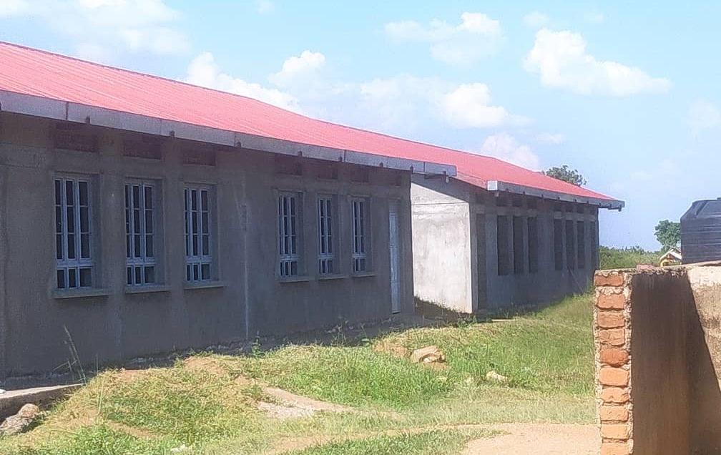  Figure 74: Unfinished school block at Got Apwoyo Seed Secondary School, Nwoya District (Acholi) | 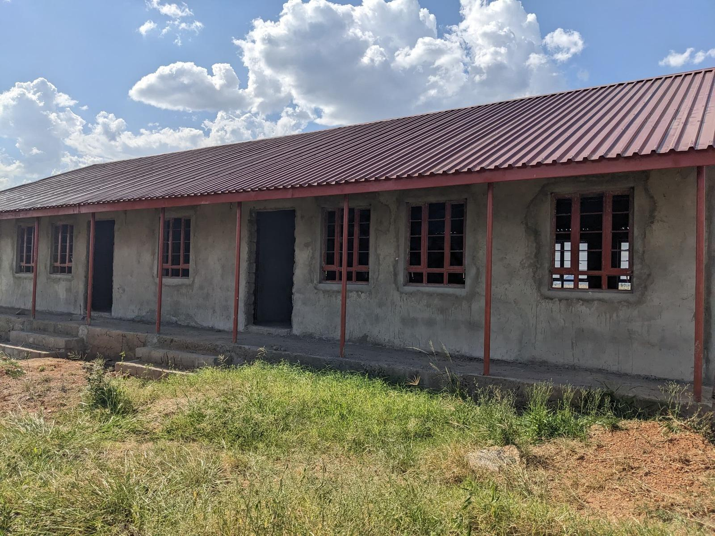  Figure 75: Unfinished classroom block at Sidok Seed Secondary School, Kaabong District (Karamoja)

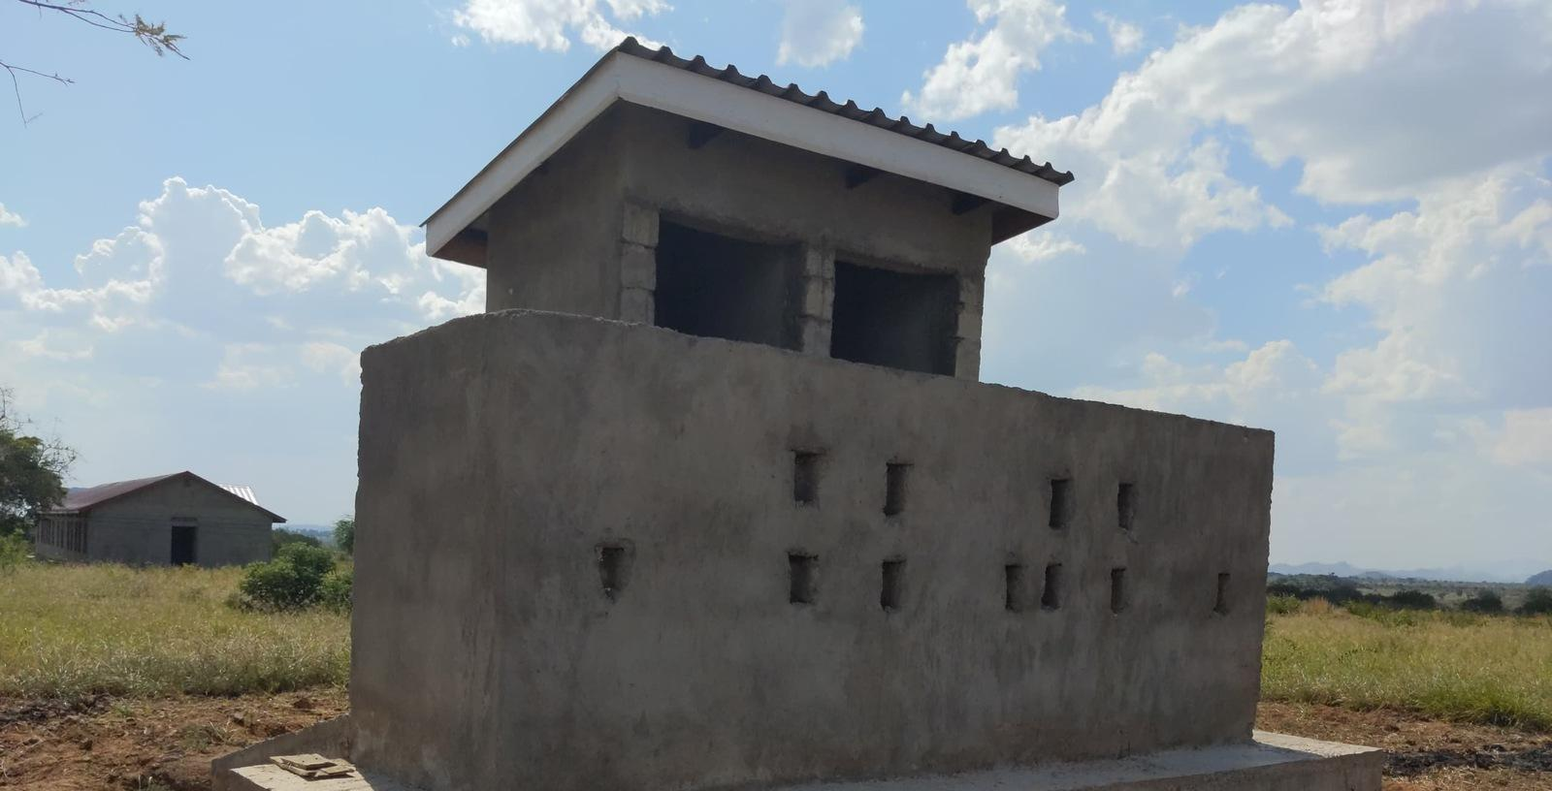  Figure 76: Latrine block under construction at Sidok Seed Secondary School, Kaabong District (Karamoja) | 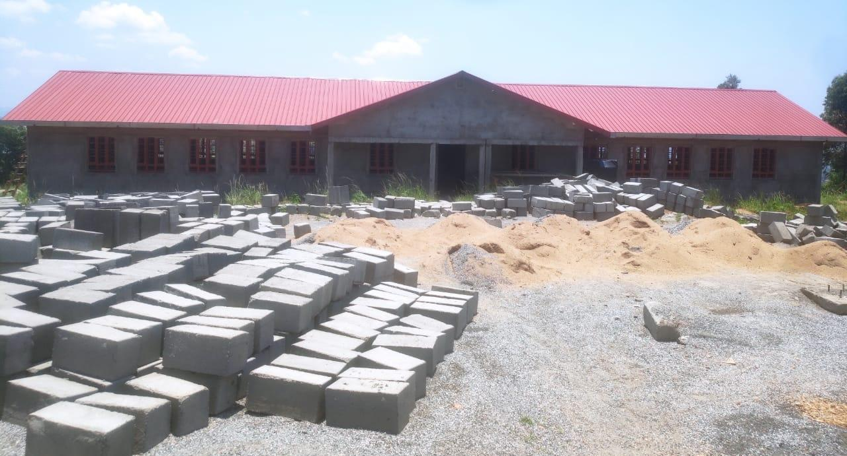  Figure 77: Building works and construction materials at Ndhew Seed Secondary School, Nebbi District (West Nile)

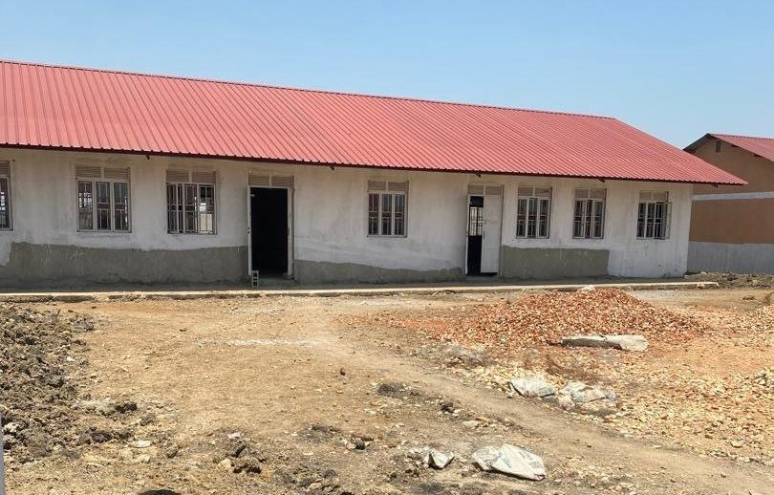  Figure 78: School block awaiting completion at Butungama Seed Secondary School, Ntoroko District (Tooro) | 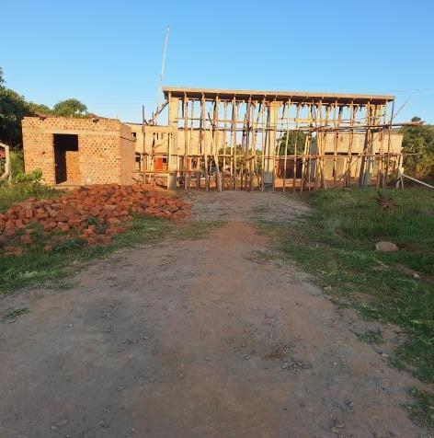  Figure 79: Building works at a seed secondary school, Kiboga District (Buganda) | 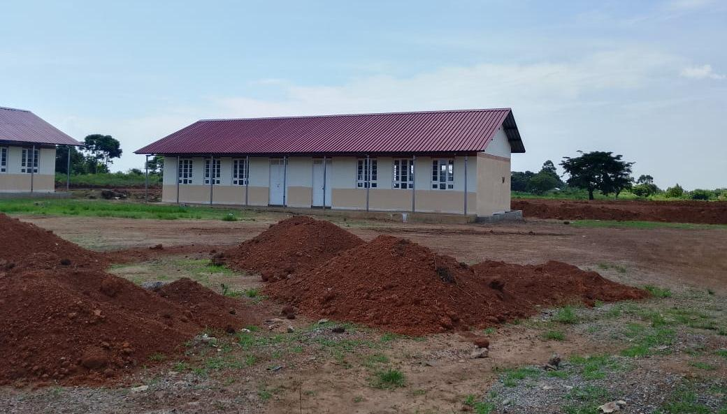  Figure 80: Classroom block with earthworks in the foreground at Kihungya Seed Secondary School, Buliisa District (Bunyoro)

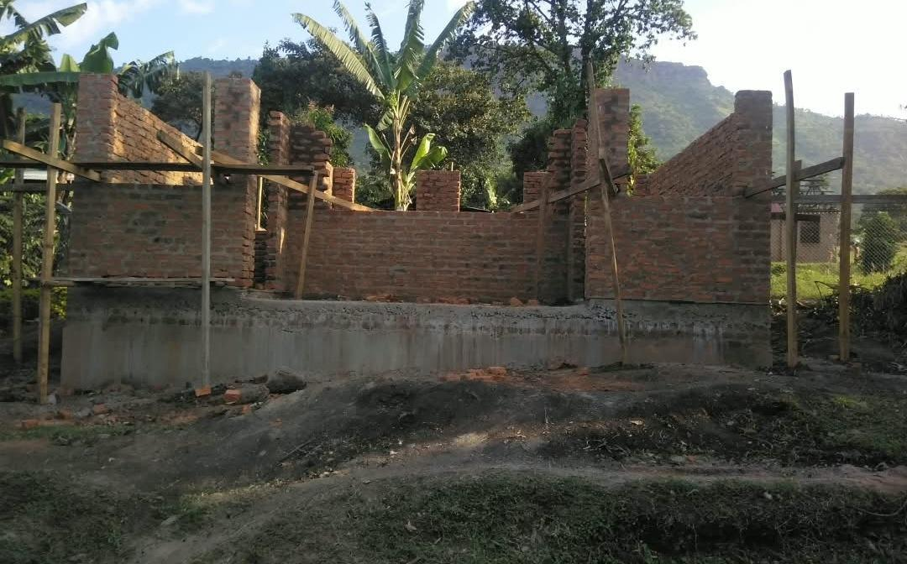  Figure 81: Unfinished laboratory building at a health centre, Sironko District (Bugisu) | 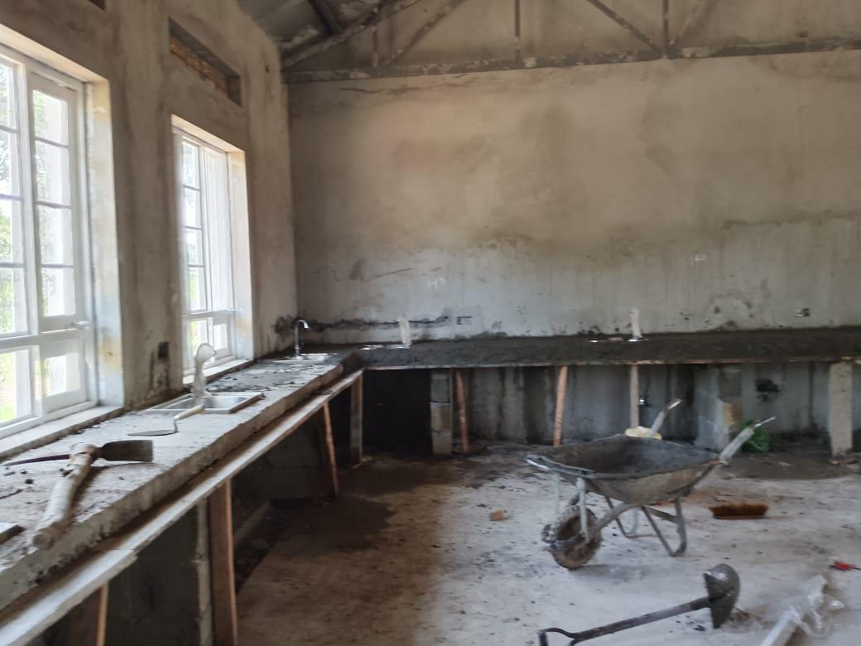  Figure 82: Biology laboratory under construction at a seed secondary school, Buliisa District (Bunyoro) | 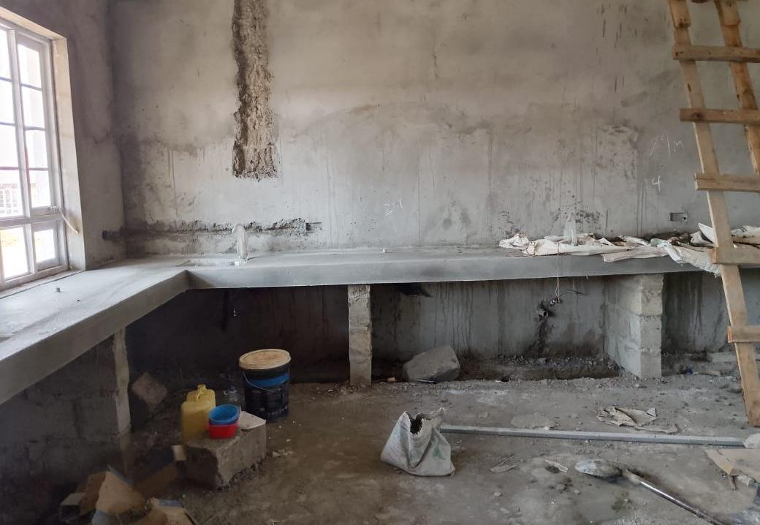  Figure 83: Unfinished laboratory interior at Kihungya Seed Secondary School, Buliisa District (Bunyoro)

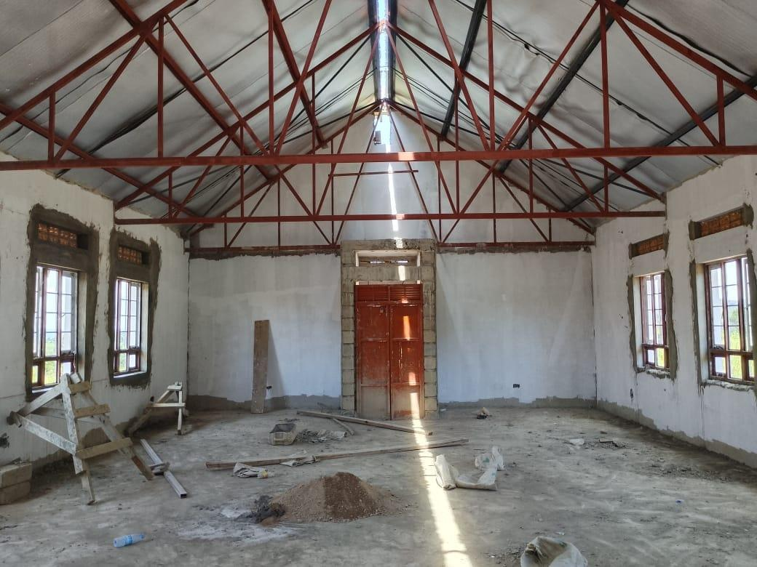  Figure 84: Library interior under construction at Kihungya Seed Secondary School, Buliisa District (Bunyoro) | 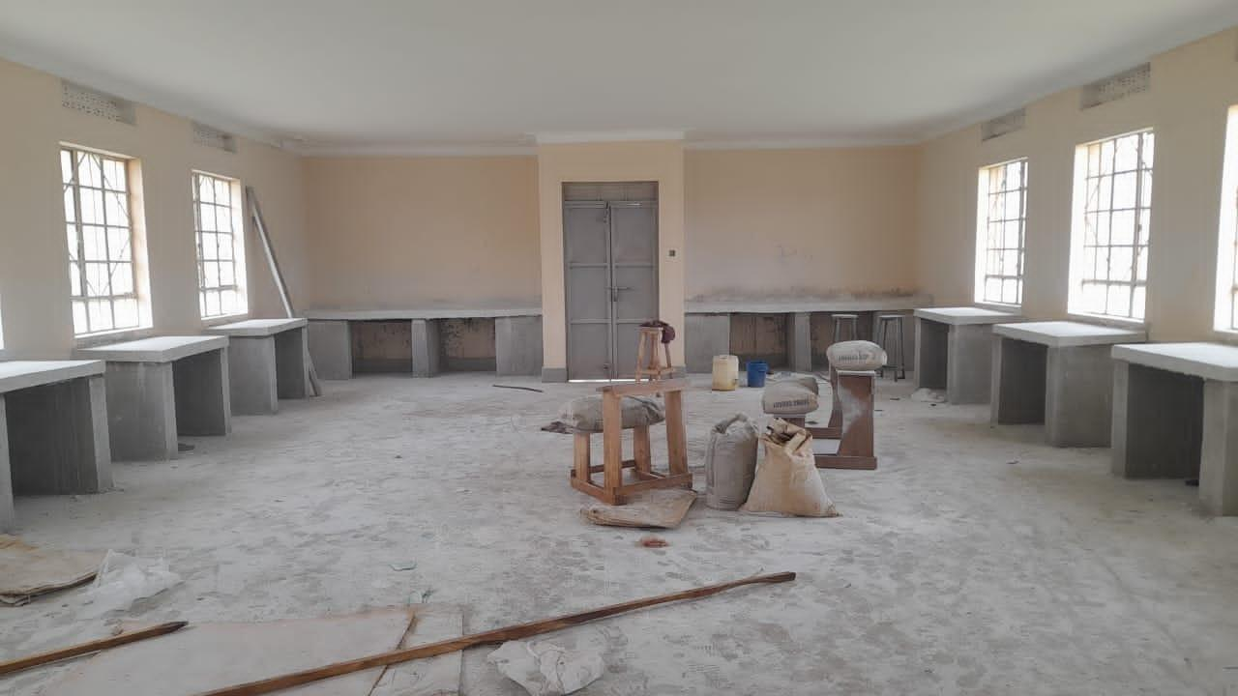  Figure 85: ICT laboratory interior under construction at Kitawoi Seed Secondary School, Kween District (Sebei)

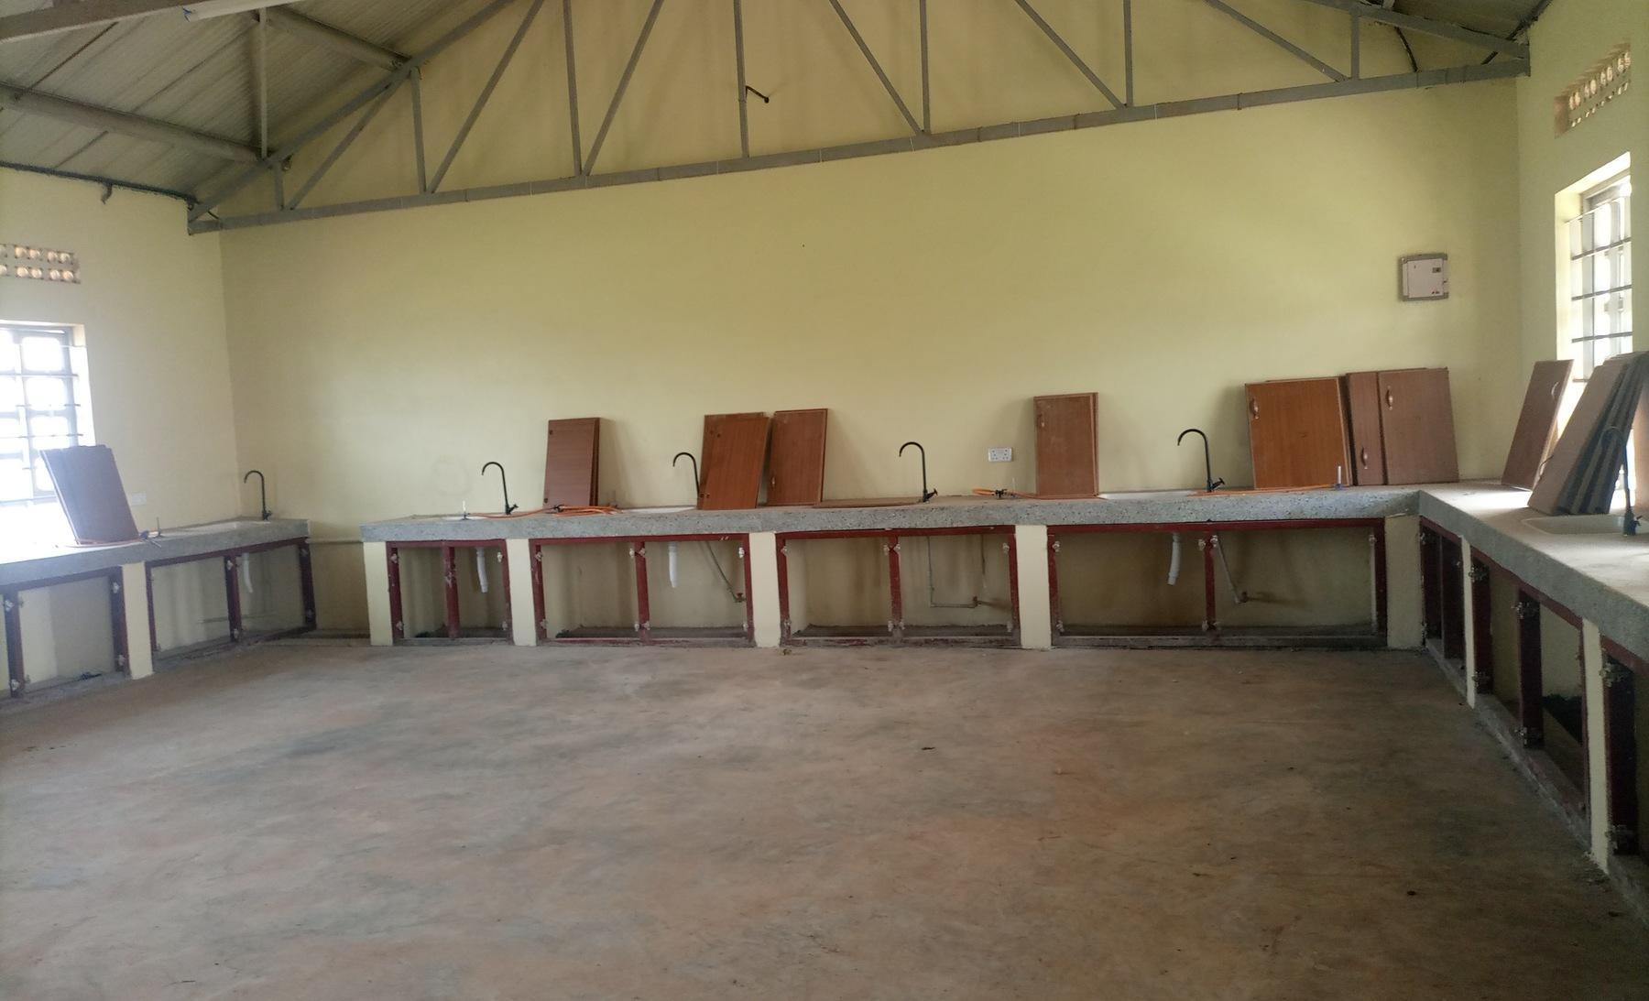  Figure 86: Laboratory benches with cupboard doors not yet fitted, in a science laboratory block recorded as under construction, at King Solomon Seed Secondary School, Kagadi District (Bunyoro) | 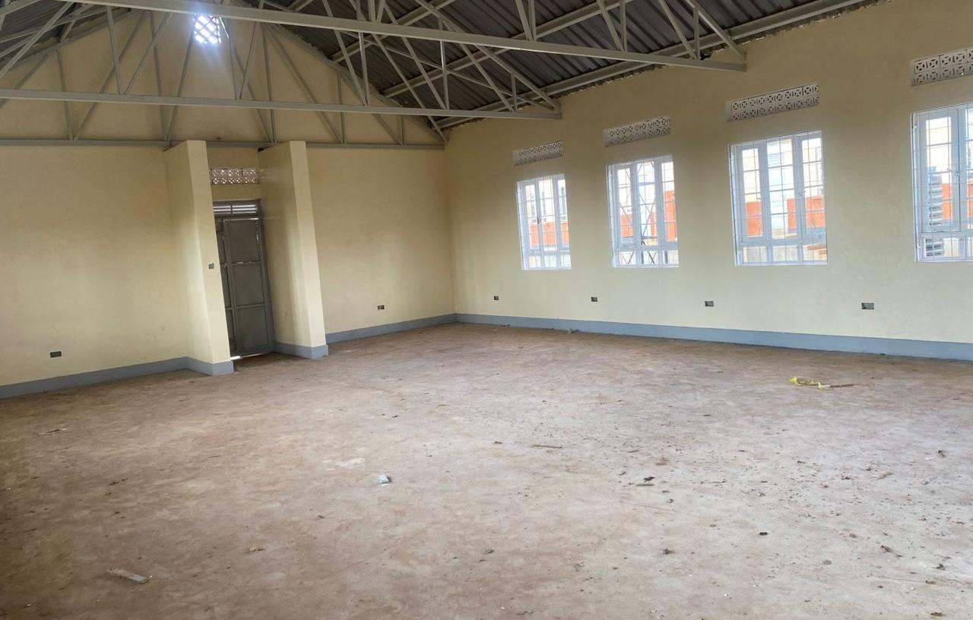  Figure 87: Empty computer laboratory at Kaptum Seed Secondary School, Kween District (Sebei), where the buildings had not been handed over and no ICT equipment had been received

3.6.2 Inconsistencies
Reconciliation of the programme list against the facilities found identified 55 entries (8.7% of the programme list) in six groups: 10 that do not exist or were not constructed under the programme, four replaced by another facility, 30 operating under another name, three that are not UgIFT beneficiaries, three whose UgIFT assets were relocated to another facility and five that exist with no UgIFT assets. Table 29 names the facilities in each group by their programme-list name and district.
The 55 entries are part of the 629 programme-list facilities, and 32 of them were verified under their operating or replacing name. Identity corrections should be settled alongside decisions on incomplete works, custody, handover and operational readiness, so that the programme account reflects where services and assets are located. Appendix F gives the outcome for each entry.
Table 29: Inconsistencies between the programme list and the facilities found
Outcome | Health centres | Seed schools | Total (% of 629) | Facilities (programme-list name and district: operating or receiving name)
Does not exist or was not constructed under the programme | 7 | 3 | 10 (1.6%) | Health centres: Olok HC II (Pader); Alik HC II (Lira); Acimi HC II (Oyam); Acokara HC II (Oyam); Ariba HC II (Oyam); Busia Eastern Division (Busia Municipal Council); Butoloogo HC II (Kassanda)  Seed schools: Eastern Division (Tororo Municipal Council); Central Division (Jinja City); Kishangara Seed School (Ibanda)
Replaced by another facility | 4 | 0 | 4 (0.6%) | Health centres: Oweko HC II (Nebbi): Pamaka HC III; Loinya HC II (Maracha): Liko HC III, already on the programme list; Ngomoromo HC II (Lamwo): Pangira HC III; Musandama HC II (Ntoroko): Butungama HC III
Operates under another name | 10 | 20 | 30 (4.8%) | Health centres: Kocheka HC II (Bukedea): Kangole/Kocheka HC III; Dabani (Busia): Buwumba HC III; Mantoroba HC II (Bundibugyo): Busanga HC III; Kidubuli HC II (Kabarole): Iruhura HC III; Nyabuswa HC II (Kabarole): Nyambuusa HC III; Kabbo (Mubende): Nakawala HC III; Kikoola (Kakumiro): Mukoora HC III; Kyakatebe HC II (Kassanda): Namabaale HC III; Kagganda HC II (Lwengo): Mbirizi SSS; Bussi HC II (Wakiso): Zinga HC III, already on the programme list  Seed schools: Kadungulu Seed School (Serere): Kagwara SSS; Pallisa (Pallisa): Akadot SSS; Bunambutye Seed School (Bulambuli): Bumufuni SSS; Igombe (Bugweri): Mpiita SSS; Butagaya (Jinja): Buwala SSS; Mwema Seed School (Namayingo): Mutumba SSS; Kimenyedde Seed School (Mukono): St Andrews Ndwaddemutwe SSS; Nsiika T/C (Buhweju): Ndibarema Memorial SSS; Kagadi (Kagadi): King Solomon SSS; Kiryanga Seed School (Kagadi): St Catherine Kicucura SSS; Ruteete (Kagadi): Kitegwa Community SSS; Kasenda Seed School (Kabarole): St Paul Nyabweya SSS; Kabonero (Bunyangabu): Katugunda SSS; Kyamukube Town Council (Bunyangabu): Nsuura SSS; Bufumira Seed School (Kalangala): Nekemiya Memorial SSS; Kiringente Seed School (Mpigi): Wamatovu SSS; Mpumudde Seed School (Lyantonde): Rwamabara SSS; Buhanika (Hoima): Kidukuru SSS; Maddu Seed School (Gomba): return submitted as Kyayi Seed School; Mugarama, new facilities for St Mugagga (Kibaale): St Mugagga Vocational SSS
Not a UgIFT beneficiary | 2 | 1 | 3 (0.5%) | Health centres: Alira HC II (Oyam); Buyinda HC II (Kaliro)  Seed schools: Kiziranfumbi Seed School (Kikuube)
UgIFT assets relocated to another facility | 2 | 1 | 3 (0.5%) | Health centres: Alangi (Zombo): Amwonyo HC III; Ther-uru HC II (Zombo): Atyak HC III  Seed schools: Abanga (Zombo): Kango SSS
Exists with no UgIFT assets | 2 | 3 | 5 (0.8%) | Health centres: Pandwong HC II (Kitgum Municipal Council); Rwamujojo HC II (Sheema Municipal Council)  Seed schools: Bumbaire Seed School (Bushenyi); Kyamuhunga (Bushenyi); Kashenshero (Mitooma)
Total | 27 | 28 | 55 (8.7%)
Counts are programme-list facilities. HC means health centre; SSS means Seed Secondary School.
Programme-list facilities that were not UgIFT
Eight programme-list facilities (1.3%) exist but were not UgIFT facilities in practice: three are not UgIFT beneficiaries and five exist with no UgIFT assets. They are four health centres (1.1% of 371) and four seed schools (1.6% of 258), and all eight were recorded as complete on the programme list. With the 10 that do not exist or were not constructed under the programme, 18 programme-list facilities (2.9%) were not UgIFT facilities: 11 health centres (3.0%) and seven seed schools (2.7%); 16 of the 18 were recorded as complete on the programme list. At three further facilities in Zombo (Alangi, Ther-uru and Abanga), the facilities exist but their UgIFT assets were relocated to another facility; with these, 21 programme-list facilities (3.3%) held no UgIFT assets at the listed site.
The ten programme-list facilities that do not exist or were not constructed under the programme are:
• Health centres (7): Olok HC II (Pader), Alik HC II (Lira), Acimi HC II, Acokara HC II and Ariba HC II (Oyam), Busia Eastern Division (Busia Municipal Council) and Butoloogo HC II (Kassanda).
• Seed schools (3): Eastern Division (Tororo Municipal Council), Central Division (Jinja City) and Kishangara Seed School (Ibanda).
Eight of the ten were recorded as complete on the programme list, and the Eastern Division and Central Division school entries as ongoing. Table 30 sets out the expected position, the finding and the recommended action for the main cases.
Table 30: Expected facilities and the outcomes established during verification
Location | Expected position and field finding | Gap or service implication | Recommended action
Olok Health Centre, Pader | Expected: Olok was listed as a completed health facility intended to serve its catchment in Pader.  Found: The district health officer confirmed to the verification team that Olok Health Centre had not been constructed and did not exist in the district. | The entry recorded as complete does not correspond to a facility on the ground. The reason for non-construction requires a documented resolution. | Pader District and the Ministry of Health should reconcile the approved project, construction and payment records, correct the beneficiary schedule and decide how the intended health-service need will be met.
Busia Eastern Division health-centre entry, Busia Municipal Council | Expected: The beneficiary schedule should identify the particular health facility supported in Busia Municipality.  Found: Reconciliation confirmed that no health facility called Busia Eastern Division existed. A separate return identified Sofia Health Centre III within Eastern Division. | An administrative division had been used as a facility name. The available confirmation did not identify Sofia as its replacement or establish that the two names referred to the same beneficiary. | The municipality and Ministry of Health should resolve the original beneficiary identity and document the programme status of Sofia before linking or changing the two entries.
Ngomoromo, Oweko, Musandama and Loinya health centres, Lamwo, Nebbi, Ntoroko and Maracha | Expected: The beneficiary schedule should name the facility that received each planned investment.  Found: Supervisors confirmed that Pangira replaced Ngomoromo in Lamwo, Pamaka replaced Oweko in Nebbi, Butungama replaced Musandama in Ntoroko, and Liko replaced Loinya in Maracha. Liko was already listed separately. | The programme account needs to link each original entry to its confirmed replacement to prevent duplicate counting and identify the service location. | The districts and Ministry of Health should attach the replacement decisions, link the original projects to their recipients and retain one active facility identity for each recipient.
Alangi, Ther-uru and Abanga, Zombo | Expected: Asset locations and custodians should agree with the facilities holding and using the equipment.  Found: The supervisor confirmed that Alangi, Ther-uru and Abanga existed, but their UgIFT assets had moved respectively to Amwonyo Health Centre, Atyak Health Centre and Kango Seed Secondary School. | The original beneficiary names no longer described where the assets were held. Custody, location and the service arrangements at the original sites needed to be made clear. | Zombo District should reconcile transfer approvals and signed receipts with both sets of inventories, name the current custodians and confirm how the original catchments are served.
Alira Health Centre and Kiziranfumbi Seed Secondary School, Oyam and Kikuube | Expected: The programme beneficiary schedule should include institutions supported under UgIFT.  Found: The later Oyam clarification confirmed that Alira Health Centre existed but was not among the facilities upgraded under UgIFT. The supervisor also confirmed that Kiziranfumbi Seed Secondary School in Kikuube was outside the programme. | The list confused the existence of an institution with its status as a UgIFT beneficiary. Alira had initially been reported absent, but that account was corrected. | The local governments and sector ministries should approve the scope corrections, remove the institutions from the active UgIFT schedule and preserve the reasons for the changes.
Pandwong Health Centre; Bumbaire, Kyamuhunga and Kashenshero schools; Rwamujojo Health Centre, Kitgum Municipal Council, Bushenyi, Mitooma and Sheema Municipal Council | Expected: Each listed beneficiary should have a supported account of the programme assistance it received.  Found: Supervisors confirmed that Pandwong Health Centre, Bumbaire and Kyamuhunga schools, Kashenshero school and Rwamujojo Health Centre existed but had not benefited from UgIFT assets. | Their appearance on the beneficiary list did not establish delivery. The cause of the difference between the list and the reported benefits needs to be resolved. | The responsible districts, municipalities and sector ministries should check beneficiary approvals and delivery records, then correct the schedule or record an approved outstanding delivery with an accountable officer and follow-up date.
Bussi/Zinga and Dabani/Buwumba, Wakiso and Busia | Expected: Each facility should have one stable identity, with local and former names linked to it.  Found: Bussi was confirmed to be the village name for the already-listed Zinga Health Centre in Wakiso. In Busia, the Buwumba return was reconciled to the programme-list entry named Dabani. | Different names could make one facility appear to be two, distort coverage and separate its asset history from the correct institution. | The districts should adopt the confirmed operating names, retain the old names as aliases and link the beneficiary, project and asset information to one facility identifier. Zinga should be counted once.

Facilities found outside the programme list
Teams also submitted information under 24 facility names that are not on the programme list: 15 health facilities and nine seed schools. The verification records hold 6,090 assets under these names, with a recorded value of UGX 23,219,308,548. They are counted separately from the 629 programme-list facilities. Follow-up confirmed three as additional programme beneficiaries: Rukoki General Hospital in Kasese Municipality, Silumira Health Centre III in Kakumiro and Bukuuku Community Seed Secondary School in Fort Portal City. Together they hold 692 assets with a recorded value of UGX 1,626,028,542, and their inclusion in the approved programme account should be regularised (Table 31).
Table 31: Confirmed additional beneficiaries outside the programme list
Location | Expected position and field finding | Gap or service implication | Recommended action
Rukoki General Hospital, Kasese Municipality | Expected: Confirmed beneficiaries should be included in the programme account.  Found: The supervisor confirmed that Rukoki General Hospital was a UgIFT beneficiary in Kasese Municipality, although it was absent from the programme list used for verification. The verification records hold 183 assets for the hospital, with a recorded value of UGX 541,711,918. | The programme list omitted a confirmed recipient. | The Ministry of Health and municipality should approve the beneficiary entry and link its asset information to a stable facility identifier.
Silumira Health Centre III, Kakumiro | Expected: The beneficiary schedule should include supported health facilities.  Found: The supervisor confirmed that Silumira Health Centre III had benefited in Kakumiro but was not on the programme list. The verification records hold 155 assets for the health centre, with a recorded value of UGX 385,797,109. | The facility was missing from the list used to plan and account for verification. | Kakumiro District and the Ministry of Health should approve the addition and connect the beneficiary decision to the facility asset inventory.
Bukuuku Community Seed Secondary School, Fort Portal City | Expected: Confirmed seed-school beneficiaries should appear in the programme account, with assets handed over for full use.  Found: Bukuuku was confirmed as an additional beneficiary. The team recorded improved science and computer teaching following laboratory construction, while some asset handover remained pending. The verification records hold 354 assets for the school, with a recorded value of UGX 698,519,515. | The school was omitted from the programme list and handover was incomplete. | The city and Ministry of Education should regularise the beneficiary entry and complete joint handover of the outstanding assets.

The remaining 21 names should be resolved through the same checks of facility identity, programme approval and asset custody. Some entries came from combined returns, and some may be local or former names of programme-list facilities. A further 11 names found on the ground match a programme-list entry, as the facility that replaced it, the facility that received its relocated assets, or the same facility under its operating name or a corrected district; they are counted on that entry and are not additional. Appendix F lists all 24 names while the outstanding identity and scope decisions are completed.

3.7 UgIFT support to service delivery
During the interviews, teams asked each facility how the UgIFT support had helped service delivery in the area, and what issues, challenges and recommendations it had. Of the facilities on the programme list, 284 health centres and 193 seed schools described service delivery in their answers. The percentages in this section are shares of these facilities: they show how widely a benefit or a gap was reported, not the number of patients, mothers or learners served. A facility counts once under each benefit or gap it described.

3.7.1 Benefits reported by facilities
Of the 284 health centres, 237 (83.5%) reported at least one benefit from the UgIFT support. Improved maternity and delivery services were reported by 117 (41.2%), and 51 (18.0%) reported more or safer births at the facility. Improved antenatal, immunisation, laboratory or other specific services were reported by 89 (31.3%), improved access to care or shorter distances by 70 (24.6%) and more patients attending by 60 (21.1%). More than half, 163 (57.4%), linked better services to the equipment and furniture supplied.
Of the 193 seed schools, 144 (74.6%) reported at least one benefit. A better learning environment, with classrooms, furniture and libraries, was reported by 74 (38.3%), and improved access to secondary education or shorter distances by 59 (30.6%). Practical science or ICT teaching improved at 39 schools (20.2%), and 37 (19.2%) reported higher enrolment. Forty schools (20.7%) also reported jobs and local economic benefits around the school. Figure 88 compares the benefits most often reported by the two types of facility.
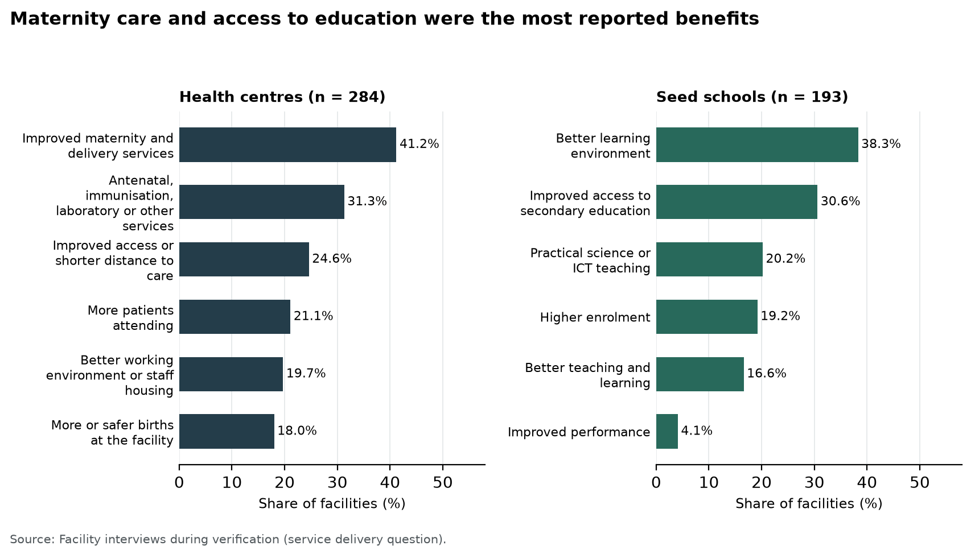
Figure 88: Maternity care and access to education were the most reported benefits
Health centre accounts show what these benefits meant for mothers and patients. Staff at Lukale Health Centre III in Buvuma said women could give birth locally instead of crossing water and had greater privacy. Kagumba Health Centre III in Kamuli reported more than 50 deliveries a month in the new maternity ward, and antenatal attendance rose from 56 to over 165 mothers a month. Kabahango Health Centre III in Bunyangabu conducted about 55 deliveries a month where it had conducted none before, and patient attendance rose from about 400 to 750. At Kataraza Health Centre III in Kyenjojo, pregnant mothers no longer walk about 40 kilometres to reach a health centre, and at Pamaka Health Centre III in Nebbi staff described increased attendance and community confidence.
Health centres gave equally practical examples of wider services. Kachuru Health Centre III in Butebo now offers laboratory services, inpatient care and minor surgery, and at Mutungo Health Centre III in Makindye-Ssabagabo Municipal Council the new building replaced an open tent shelter. Kibiri Health Centre III, in the same municipality, had begun operations by 31 August 2026, while staff were still arranging some equipment.
At Kihuukya Health Centre III in Hoima City, the renovated maternity block and walkways were recorded in use and a binocular microscope was seen functioning. Iruhura Health Centre III in Kabarole recorded adult weighing scales and waiting benches in use. Kamuli Health Centre III in Tororo reported improved service delivery, alongside continuing staffing and accommodation needs. Figures 89 to 93 show these health centre buildings and equipment in service.
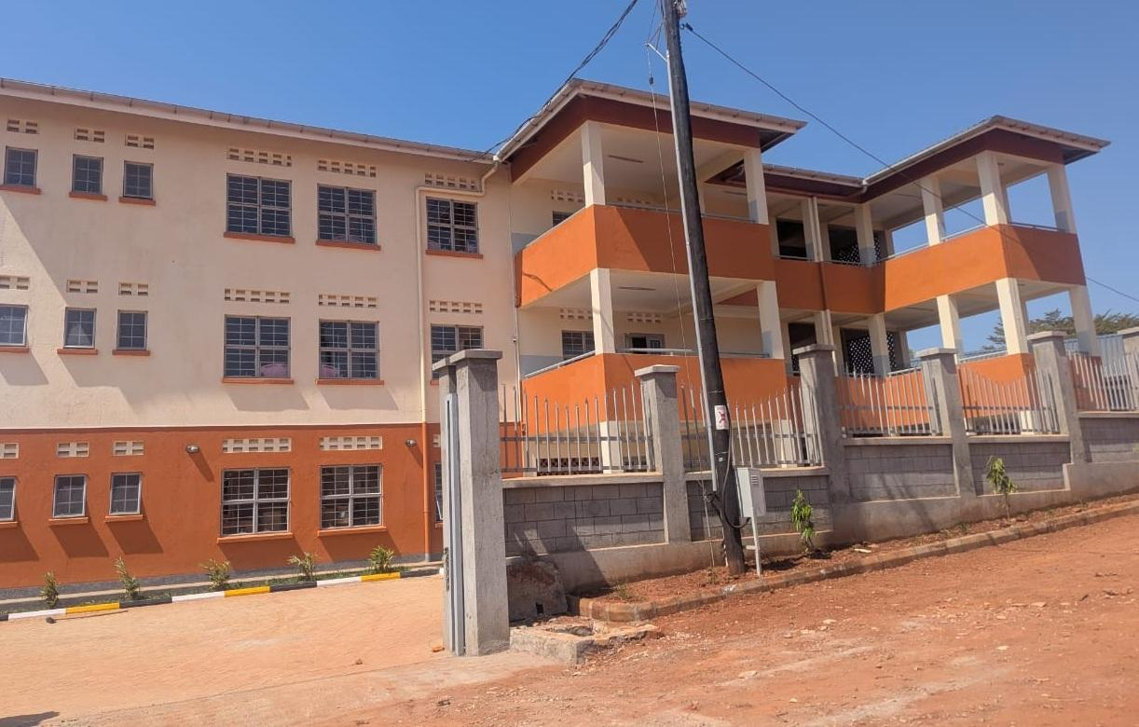  Figure 89: Health centre building at Kibiri HC III, Makindye-Ssabagabo Municipal Council (Buganda) | 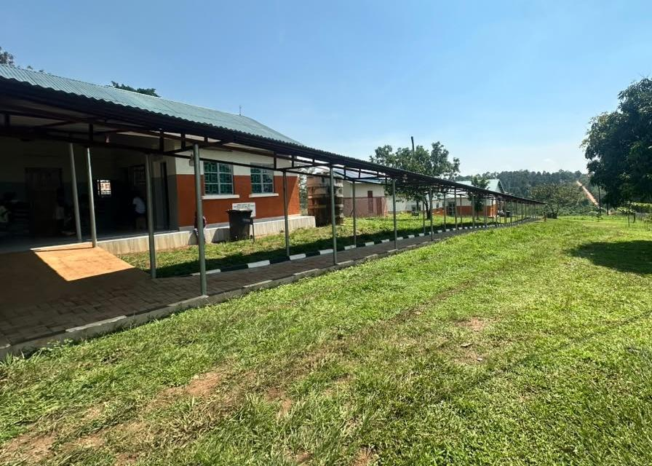  Figure 90: Health centre buildings and covered walkway at Kihuukya HC III, Hoima City (Bunyoro)

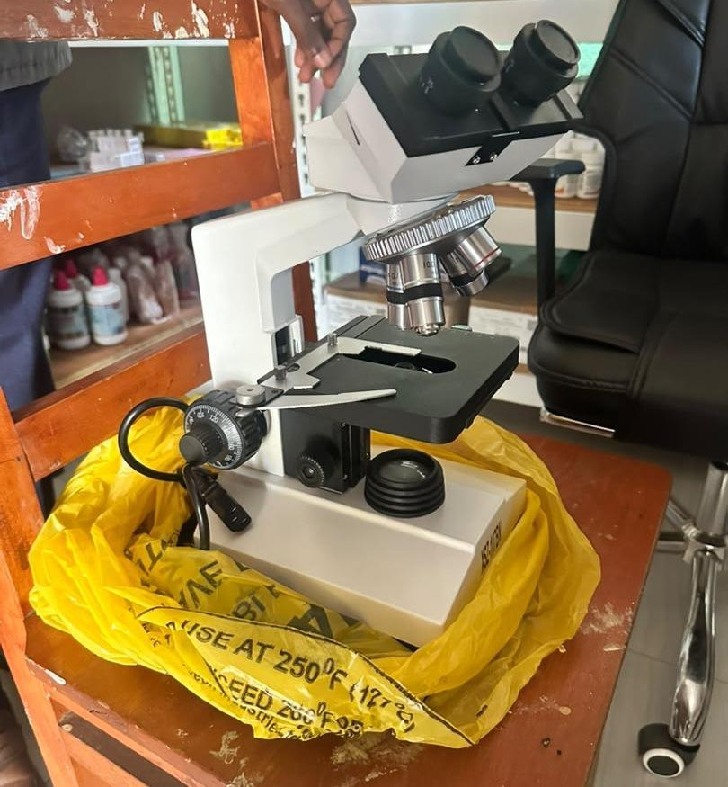  Figure 91: Binocular microscope at Kihuukya HC III, Hoima City (Bunyoro) | 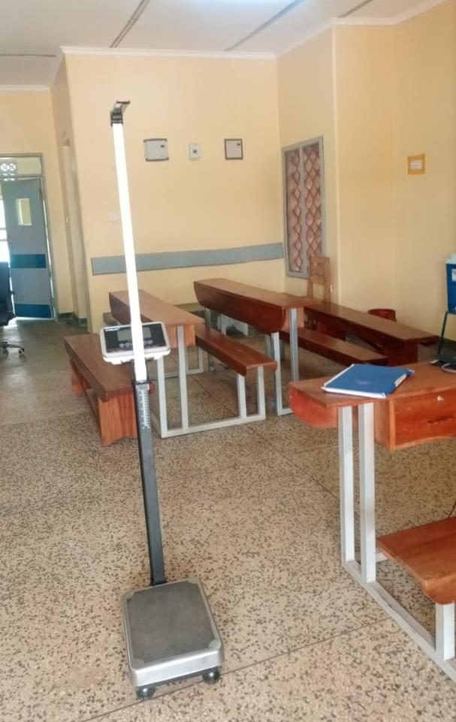  Figure 92: Adult weighing scale with a height meter and waiting benches at Iruhura HC III, Kabarole District (Tooro) | 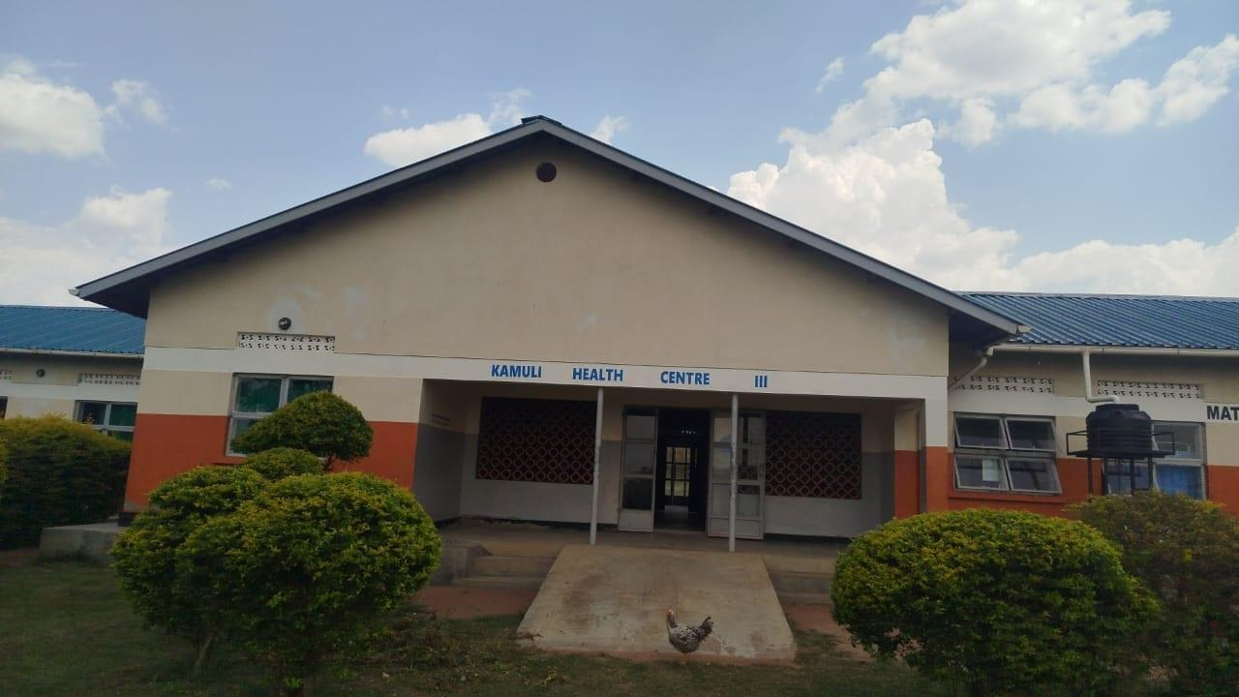  Figure 93: Maternity block entrance and access ramp at Kamuli HC III, Tororo District (Bukedi)

Schools also described practical gains. Musiitwa Nazigo Seed Secondary School in Kayunga used the irrigation system for teaching and food production and provided secondary education closer to surrounding communities. Kigorobya Seed Secondary School in Hoima used its classrooms, computer room and chemistry laboratory to support teaching, and at Kihanga Seed Secondary School in Ntungamo learners acquire computer skills in the equipped computer laboratory. At Rupa Seed Secondary School in Moroto, all 41 pioneer candidates scored first grade in the Uganda Certificate of Education examinations in 2024.
Other school visits showed the value of bringing teaching space closer to communities. Enrolment at Bwizi Seed Secondary School in Kamwenge grew from 204 to 1,108 students, and at Sisuni Seed Secondary School in Manafwa from 170 to 540. Gyagenda Memorial Seed Secondary School in Bujumba reported better access to secondary education about 35 kilometres from Kalangala town, and Buyende Seed Secondary School serves learners from islands in Lake Kyoga.
Sisiyi Seed Secondary School in Bulambuli recorded its buildings, furniture and ICT in use. Sibanga Seed Secondary School in Manafwa reported shorter distances for learners and less teenage pregnancy and school dropout, although full handover was still pending. Figures 94 to 96 show teaching spaces at Gyagenda Memorial, Sibanga and Sisiyi.
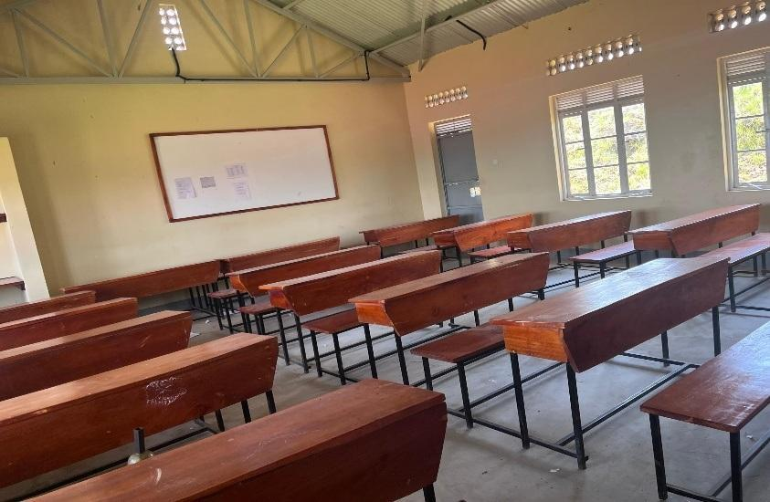  Figure 94: Classroom furnished with desks and a whiteboard at Gyagenda Memorial Seed Secondary School, Kalangala District (Buganda) | 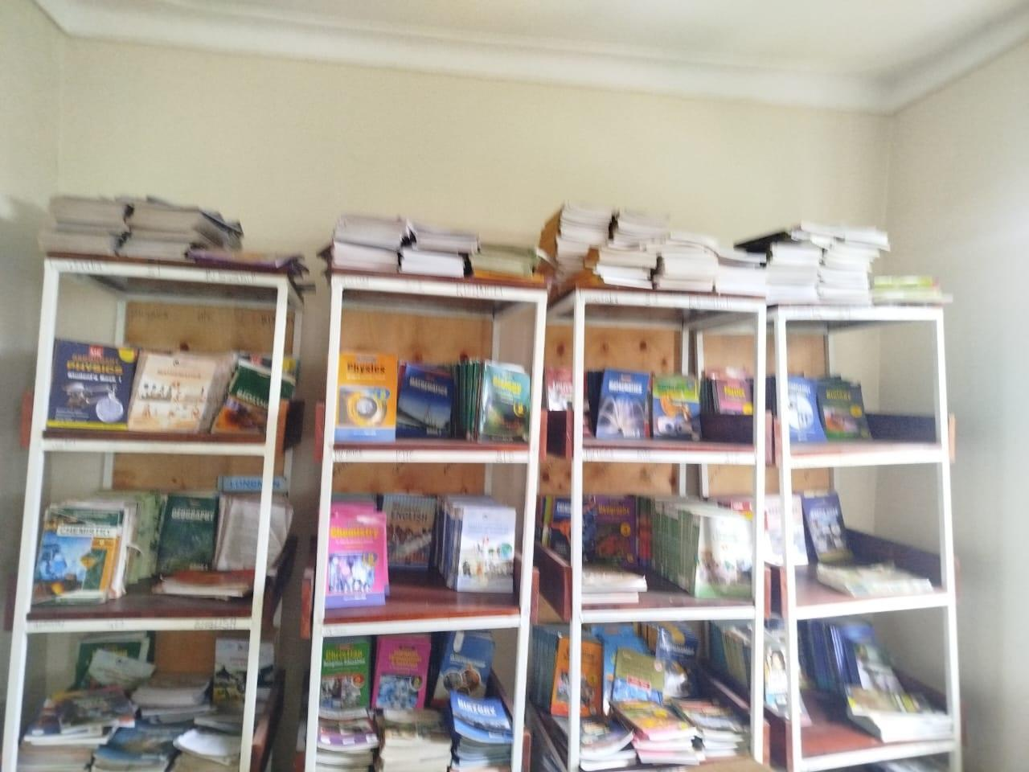  Figure 95: Books displayed on library shelves at Sibanga Seed School, Manafwa District (Bugisu) | 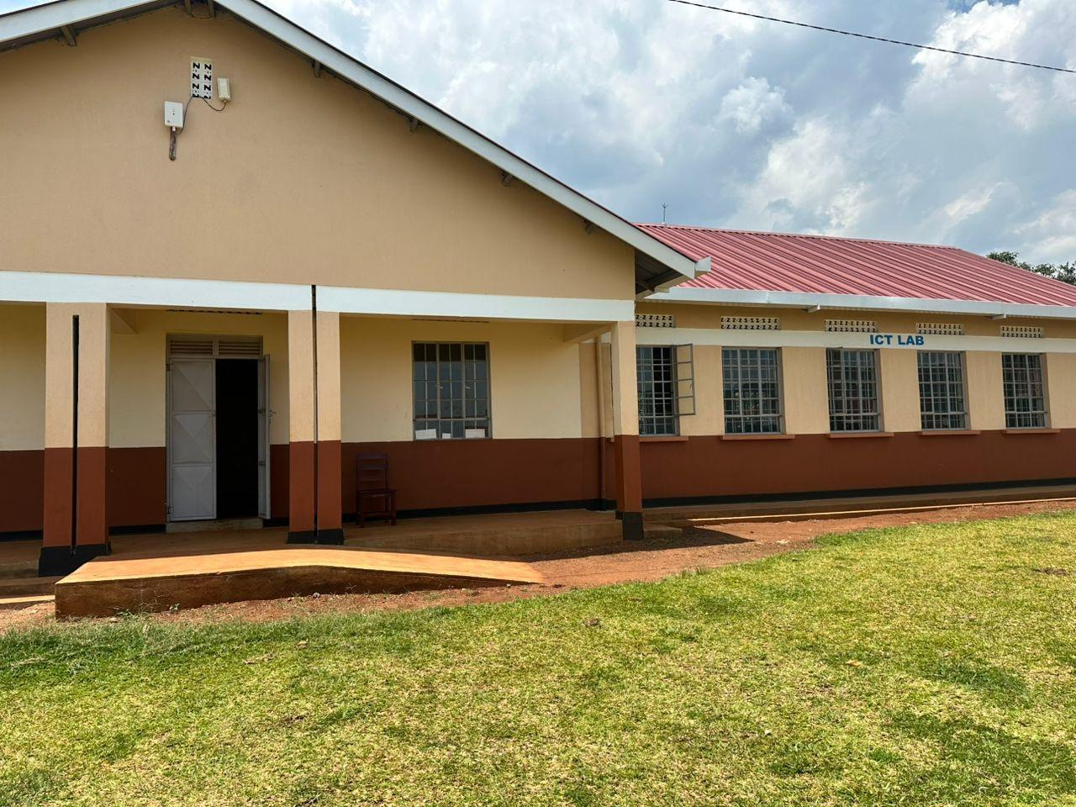  Figure 96: ICT laboratory block and entrance ramp at Sisiyi Seed Secondary School, Bulambuli District (Bugisu)

3.7.2 User gaps and challenges
Facilities also described what held the service back. Nearly all raised at least one gap: 272 health centres (95.8%) and 180 seed schools (93.3%), or 452 of the 477 facilities (94.8%). The figures in this section count a gap as raised when a facility named it as a challenge or asked for it as a remedy in its recommendations; a facility that asked for a fence, for example, is counted under security or fencing. Table 32 gives the counts and Figure 97 compares the two types of facility.
Power was the gap raised most often, by 200 facilities (41.9%): 44.0% of health centres and 38.9% of seed schools. Staffing followed at 32.3%, inadequate space or infrastructure at 31.7% and security or fencing at 27.3%, the last raised by 37.8% of seed schools. Repair or maintenance support was raised by 22.2% of facilities, staff housing by 22.0% and water supply by 20.1%. Two gaps belonged mainly to one type of facility: training to operate equipment was raised by 28.9% of health centres, and incomplete or delayed works by 28.0% of seed schools. Equipment not installed, not assembled or delivered incomplete was raised by 17.6% of facilities.
Table 32: User gaps and challenges raised by facilities that described service delivery
Gap or challenge raised | Health centres (n = 284) | Seed schools (n = 193) | All facilities (n = 477)
Power or electricity | 125 (44.0%) | 75 (38.9%) | 200 (41.9%)
Staffing or manpower | 102 (35.9%) | 52 (26.9%) | 154 (32.3%)
Inadequate space or infrastructure | 85 (29.9%) | 66 (34.2%) | 151 (31.7%)
Security or fencing | 57 (20.1%) | 73 (37.8%) | 130 (27.3%)
Repair or maintenance support | 77 (27.1%) | 29 (15.0%) | 106 (22.2%)
Staff housing | 66 (23.2%) | 39 (20.2%) | 105 (22.0%)
Water supply | 51 (18.0%) | 45 (23.3%) | 96 (20.1%)
Training to operate equipment | 82 (28.9%) | 3 (1.6%) | 85 (17.8%)
Equipment not installed, not assembled or delivered incomplete | 46 (16.2%) | 38 (19.7%) | 84 (17.6%)
Works incomplete, delayed, not handed over or not commissioned | 28 (9.9%) | 54 (28.0%) | 82 (17.2%)
Access roads or transport | 39 (13.7%) | 19 (9.8%) | 58 (12.2%)
Accessories or consumables for supplied equipment | 21 (7.4%) | 8 (4.1%) | 29 (6.1%)
Internet or network connectivity | 5 (1.8%) | 7 (3.6%) | 12 (2.5%)
At least one gap raised | 272 (95.8%) | 180 (93.3%) | 452 (94.8%)
Number of facilities and share of the facilities that described service delivery. A gap is raised when the facility named it as a challenge or asked for it as a remedy; a facility can raise several gaps.
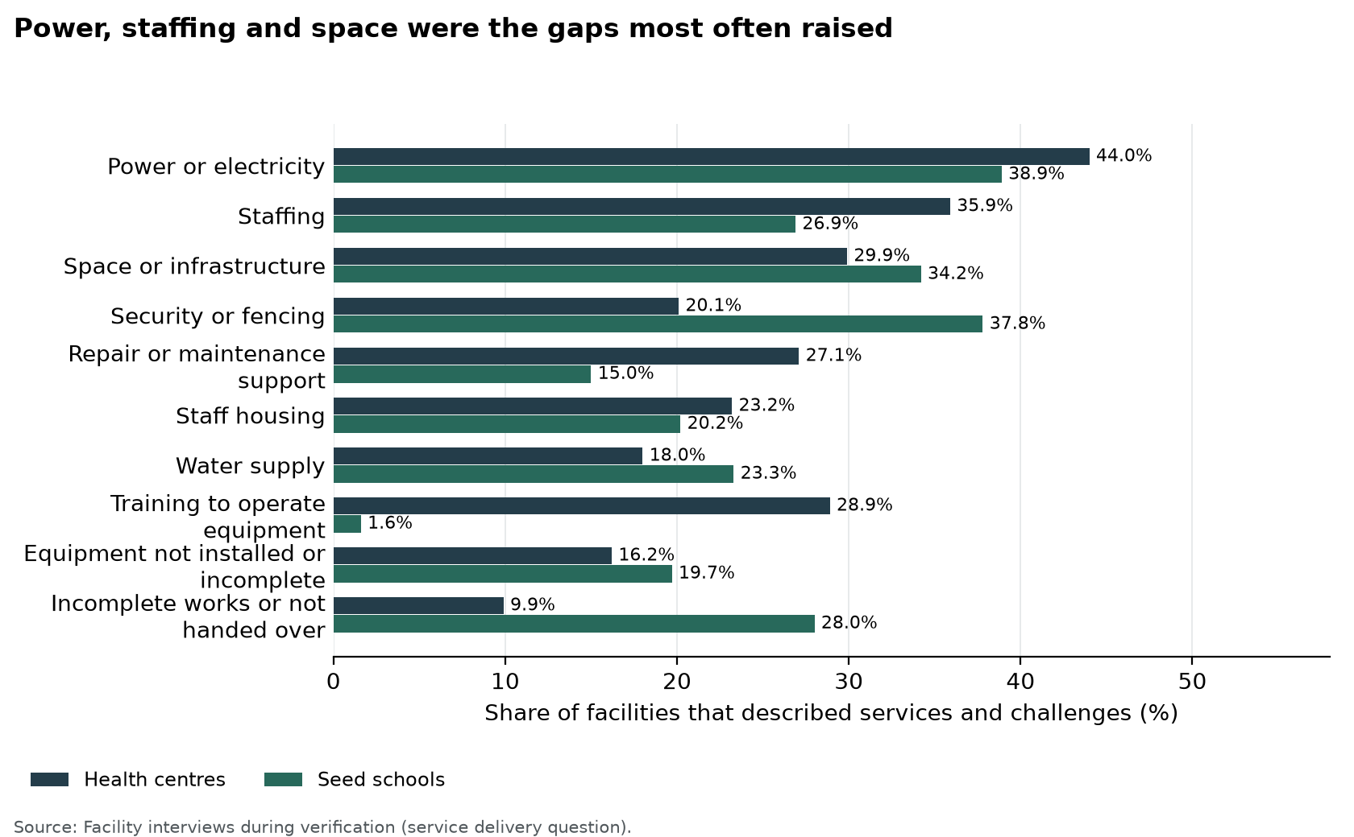
Figure 97: Power, staffing and space were the gaps most often raised
Power gaps limit the use of equipment already supplied. Loyoajonga Health Centre III in Omoro has no grid connection, so machines that need mains power cannot be used, and at Nkata Health Centre III in Buvuma weak solar batteries cannot run the equipment at the same time. Power restricted oxygen equipment at Pamaka, where the solar panel worked for only three months after commissioning. Alwi Seed Secondary School in Pakwach hires a generator to use its ICT equipment after power surges damaged some of it, and at Rupa teaching spaces served as dormitories and practical lessons depended on a hired generator.
Water and repairs were each raised by about one facility in five. Makokoto Health Centre III in Kassanda relies only on rainwater, and at Loyoajonga two of the three maternity water tanks were not connected. Nkombe Health Centre III in Mayuge reported that repairs by the regional workshop take weeks or months.
Demand also brought pressure on staff. Acii Health Centre III in Amolatar had 7 staff against 55 under the new staffing norms, and at Punuluru Health Centre III in Lira two nurses served the whole health centre. Pamaka reported too few medical personnel for its growing number of patients, and Kigorobya reported a shortage of staff and few study materials. Mpungwe Seed Secondary School in Mayuge reported a teacher to student ratio of 1:100 against 1:60.
Space and housing gaps affect patients, learners and staff. Lakwatomer Health Centre III in Omoro attends to patients under trees for lack of space, Mpungwe hires tents at examination time for lack of classrooms, and at Kiyombya Seed Secondary School in Bunyangabu classes planned for 60 learners hold about 130. Kagumba identified needs for staff housing and for outpatient, laboratory, storage and kitchen space, and at Gyagenda Memorial 30 teachers share six housing units.
Security and access gaps affect assets and attendance. Christ the King Mpasana Seed Secondary School in Kakumiro, which has no fence, lost 20 computers from its laboratory, and Budongo Seed Secondary School in Masindi lost 16 of its 28 computers through theft. At Musiitwa Nazigo, the long distances that learners walk affected attendance.
Works, deliveries and installation also held back some services. Kigumba Town Seed Secondary School in Kiryandongo reported that construction took over two years against a six-month programme; section 3.3.1 presents the facilities whose works were outstanding at the time of the visit. At Katuugo Health Centre III in Luweero, 26 items on the delivery schedule had not yet been delivered by the supplier, and at Anamwany Health Centre III in Amolatar delivery beds had not been assembled because they arrived without their nuts. Training needs came almost entirely from health centres, where staff asked for orientation on the equipment supplied; section 3.7.2 shows how user skills kept some of it idle.

3.8 Summary of findings
The report covers 226,273 assets at ministries and agencies, blood banks, health centres and seed secondary schools. 215,892 (95.4%) were in good condition, comprising 212,773 in use and 3,119 in store. 3,392 (1.5%) were broken. 49,457 of 216,736 movable assets (22.8%) were engraved. Recorded value was UGX 971,615,425,138 and net book value was UGX 808,621,845,836. The same four headings, availability, condition, identification and financial aspects, organise the ministry, health centre, school and blood bank sections.

4 Recommendations
The verification found that most UgIFT assets were in place and serving their purpose: 212,773 of the 226,273 assets (94.0%) were working and in use, and 590 of the 629 facilities on the programme list were verified on the ground. The next phase should turn these findings into actions that protect assets and improve care, teaching and programme administration. The recommendations in this chapter address the gaps that remain between delivery and use: the 13,500 assets (5.8%) not in use, the 115 verified facilities with works outstanding, the 78.0% of verified assets not engraved and the practices that keep assets in service. Each recommendation first sets out the finding it answers, with its figure, and then the action and the institutions responsible.
The recommendations begin with maintenance, which applies to every asset, and end with the actions for individual facilities. Where a finding differs by level, national institutions are covered first, then the blood banks and then local governments. Accounting Officers should use the priority action plan in Table 33 to assign responsibility, agree resources and check completion, and Table 34 sets out the recommended action for individual facilities where the field visits identified a specific need or a practice to sustain.

4.1 Maintenance and repairs
Maintenance keeps UgIFT assets working for the services they were bought to support. Most of the verified assets are furniture, clinical equipment and computers in daily use at health centres and seed schools, where wear and breakage are to be expected. Routine checks, a record of faults and a dependable route for repair decide whether a broken item returns to use quickly or stays out of service. During the verification, each facility was asked how it maintains, repairs, services or replaces UgIFT assets and whether it keeps a regular record of their functionality or breakdown.
Repair arrangements. Of the 469 facilities that described their maintenance arrangements, 260 (55.4%) met repairs at facility level, from their own funds or with their own staff. Health centres named Primary Health Care funds (94 of 278, 33.8%), while schools named the capitation or Universal Secondary Education grant, parents' contributions or the school budget (52 of 191, 27.2%). Busaale Health Centre III in Kayunga used Primary Health Care funds for repairs, and Kagumba Seed Secondary School in Kamuli had repaired broken furniture during the second term. A facility could describe more than one arrangement.
Support from outside the facility was cited by 151 facilities (32.2%): district offices, mainly the District Health Officer, 84 (17.9%); regional referral hospital workshops or national teams 52 (11.1%); hired technicians and artisans 27 (5.8%); and contractors or suppliers under defects liability, guarantee or warranty 12 (2.6%). Major medical equipment repairs depended on this support. Todora Health Centre III in Nwoya worked through the District Health Officer and the Gulu Regional Referral Hospital technical team, Avogera Health Centre III in Buliisa received support from Hoima Regional Referral Hospital, and Bundimulangya Health Centre III in Bundibugyo obtained a team through the District Health Officer.
In all, 97 facilities (20.7%), 59 of them schools, had not yet needed maintenance because the assets were new, not yet handed over or the buildings were still under construction, and 36 (7.7%) reported no repair arrangement, with broken items set aside or not repaired. Funds for maintenance and repair were reported as insufficient, particularly for major repairs, by 32 of the 505 facilities that described maintenance or challenges (6.3%). At Kyankaramata Health Centre III in Kyenjojo, Primary Health Care funds met minor repairs, but the cost of major repairs was a constraint.
Figure 98 compares these arrangements at health centres and seed schools. Health centres relied more on outside technical support (41.0% of health centres against 19.4% of schools), while schools more often had not yet needed maintenance (30.9% against 13.7%).
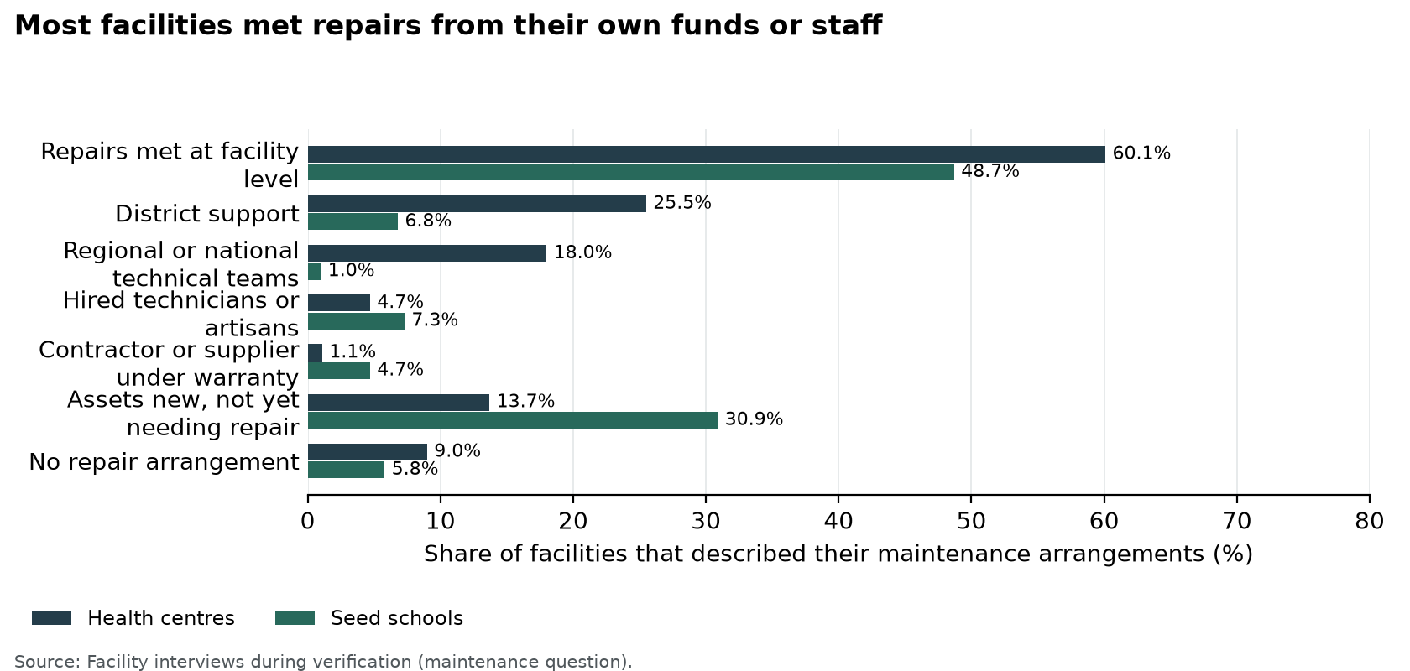
Figure 98: Most facilities met repairs from their own funds or staff
Frequency. Few facilities worked to a fixed maintenance interval. Of the 494 programme-list facilities that described how they maintain UgIFT assets or check their condition, 50 (10.1%) did so at a fixed interval. Of these 50, 14 (28.0%) worked annually, 11 (22.0%) monthly, 10 (20.0%) quarterly, 9 (18.0%) every school term, 3 (6.0%) twice a year and 3 (6.0%) weekly or daily, as Figure 99 shows. A further 18 facilities (3.6%) described routine or scheduled servicing without a set interval, mostly scheduled visits by regional referral hospital maintenance teams, and 62 (12.6%) repaired items as the need arose. Ngwedo Seed Secondary School in Buliisa engaged a caretaker every month and used the Directorate of Industrial Training for furniture repairs, while Busaale reviewed asset condition every quarter.
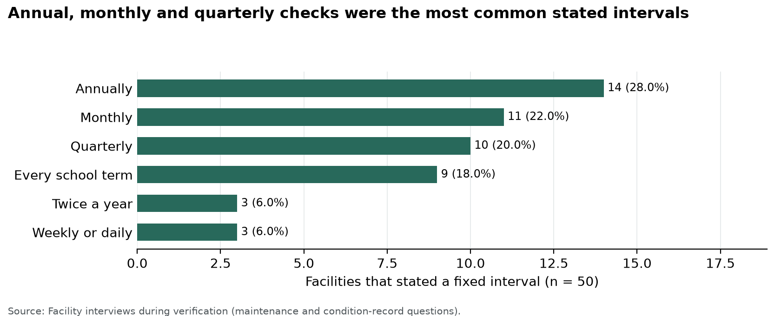
Figure 99: Annual, monthly and quarterly checks were the most common stated intervals
Records. Of the 463 facilities that answered, 318 (68.7%) kept a regular record of asset functionality or breakdowns, 36 (7.8%) kept a partial or informal record, 80 (17.3%) kept none and 29 (6.3%) had not yet started because the assets were new or the facility was not yet operating. Of the 478 facilities that answered, 355 (74.3%) held a record of the UgIFT assets they received, 40 (8.4%) held a partial record, such as delivery notes only or a general register that does not identify UgIFT items, and 83 (17.4%) held none. Kagumba Health Centre III in Kamuli kept an asset condition book, a simple practice that other facilities can adopt.
Recommendation. Facility managers and school governing bodies should keep the local and regional repair arrangements that already work and adopt a fixed routine: a condition check at least every school term in schools and every quarter in health centres, and a full count of UgIFT assets each year. Each facility should keep a condition book or fault list naming each item requiring action, the responsible person and the agreed completion date; the 36 facilities with no repair arrangement and the 80 with no functionality or breakdown record should set these up first.
District health and education offices should review unresolved repairs each quarter and arrange technical assistance, and regional referral hospital workshops should include UgIFT equipment in their scheduled visits. Annual maintenance plans should separate minor repairs, which facilities can meet from Primary Health Care funds or school grants, from specialist and major repairs that need district or national funding, as the experience at Kyankaramata shows, and their costs should be included in the next budget cycle. A repair should count as complete only when the item has been checked and returned to safe use, or formally assigned another outcome.

4.2 Restore safe operation
Finding. Of the 226,273 assets in this report, 13,500 (6.0%) were not in use. Of these, 3,392 (25.1%) were broken and 3,119 (23.1%) were in store and in good condition. At the ministries and agencies, 4 assets (0.0%) were not in use, three of them laptops at the Office of the Prime Minister recorded as damaged. The blood banks had 24 assets (3.8%) not in use, including six blood pressure machines at Arua Regional Blood Bank recorded as damaged or not functional. In local governments, 5,681 assets at health centres (8.9%) and 7,791 at seed schools (5.4%) were not in use. Broken school furniture is concentrated in chairs, desks and stools (section 3.4.2).
Some damaged items remained in use or presented a risk. A cracked laboratory stool was still in use at Sikuda Seed Secondary School in Busia, a broken water-tank stand presented a threat to students at Wadelai Seed Secondary School in Pakwach, and staff at Nyamarunda Health Centre III in Kibaale raised concerns about the electrical installation. Table 34 sets out the action recommended at each of these facilities.
Recommendation. Facility managers, district health and education officers, engineers and technical teams should prioritise unsafe furniture, electrical concerns and failed equipment needed for essential services. Withdraw unsafe items, obtain technical assessments and verify safe operation after repair. The broken down and not functional assets should be assessed in order of their effect on care and teaching, beginning with clinical equipment and the school furniture that makes up most of the broken down assets; items beyond economic repair should receive a formal disposal decision. At national level, the Office of the Prime Minister should decide on repair or replacement of its three damaged laptops, and Uganda Blood Transfusion Services (UBTS) should repair or replace the six broken blood pressure machines at Arua Regional Blood Bank. Keep damaged assets separate from usable assets awaiting installation so that each receives the appropriate action.

4.3 Complete works and bring stored assets into use
Finding. Of the 590 facilities verified, 475 (80.5%) had completed works and 115 (19.5%) had works outstanding: 27 health centres (7.8% of those verified) and 88 seed schools (36.2%). Of the 115, 63 were already providing services, while 24 verified facilities, 21 of them seed schools, were not yet providing services; 22 of these 24 had works outstanding. At Ndhew and Mamba Seed Secondary Schools in Nebbi, unfinished buildings delayed installation: science equipment was held at district headquarters, and Mamba accommodated its computers in older structures.
Of the 13,500 assets not in use, 3,200 (23.7%) were in storage at 181 facilities, 164 health centres and 17 seed schools; at national level the asset records place no assets in storage, although the field teams observed furniture left in a former MoFPED store and equipment kept in the Hoima blood bank stores (sections 3.1.1 and 3.2). Of the stored assets, 190 (5.9%) were waiting for power, 80 (2.5%) for a building or room and 141 (4.4%) were held at district stores or another facility, while 519 (16.2%) were described as new, boxed or in good condition. More widely, 1,324 assets not in use (9.8%), at 79 facilities, were waiting for power (331, 2.4% of assets not in use), a building or room (483, 3.6%), installation or assembly (493, 3.6%), trained users (16) or staff (1), and a further 97 (0.7%) lacked accessories, parts or consumables.
Facility accounts point to the same blockers. Of the 477 facilities that described services and challenges, 156 (32.7%) reported idle or unusable equipment: 71 of these (45.5%) linked it to power, 32 (20.5%) to installation and 27 (17.3%) to incomplete buildings or lack of space. Lungulu Seed Secondary School in Nwoya kept computers boxed in store pending a power connection, and at Nansanga Seed Secondary School in Budaka 27 of 28 desktop computers remained packed for lack of reliable power.
Recommendation. District Accounting Officers, engineers, health and education officers and contractors should coordinate outstanding buildings, utilities, furniture and equipment through site-specific completion plans for each of the 115 facilities with works outstanding, starting with the 22 of them that were not yet providing services. Installation should follow confirmation that rooms, power, water and security are ready. Stored assets described as new or in good condition should be issued to the rooms where they are needed, and each asset waiting for power or installation should have a named date for connection and testing. Protect services already operating during construction, and complete testing and signed handover before closing each action.

4.4 Equip staff to operate and maintain assets
Finding. Skills and staffing limited the use of equipment most at health centres. Of the 156 facilities that reported idle or unusable equipment, 52 (33.3%) linked it to staff being unable to operate the equipment; 51 of these were health centres, 45.9% of the 111 health centres reporting idle equipment. Training or skills to operate equipment was raised as a gap by 85 facilities (17.8%), 82 health centres (28.9%) and 3 seed schools (1.6%), and 61 facilities (12.8%) asked for training or orientation on the equipment. Staffing was raised by 154 facilities (32.3%), and 9 of the facilities with idle equipment (5.8%) had no personnel or specialist to use it.
At Bubago Health Centre III in Kamuli, staff needed training to operate and maintain an oxygen concentrator. At Sop Sop Health Centre III in Tororo, much of the equipment remained in store because staff did not know how to operate it, and Avogera Health Centre III asked for user orientation and technical skills.
Recommendation. District health officers, facility managers, suppliers and regional technical teams should provide practical training for staff who use specialist equipment, starting with the health centres that linked idle equipment to a lack of skills, including oxygen equipment users at Bubago and Sop Sop and staff requiring orientation at Avogera. Handover should include a demonstration, basic maintenance guidance and a named route for technical support. Future supply contracts should make on-site demonstration to the staff who will use the equipment a condition of acceptance, and staffing reviews should take account of the equipment each health centre now holds.

4.5 Strengthen identification and custody
Finding. Of the 216,736 movable assets, 49,457 (22.8%) were engraved and 167,279 (77.2%) were not engraved. 23,434 (10.8%) were properly engraved with the UgIFT marking, and 26,023 (12.0%) carried another marking only. Ministries and agencies had engraved 4,843 of 15,385 movable assets (31.5%). The Ministry of Education and Sports accounts for most ministry assets that were not engraved, because the TELA handsets and tablets carry no engraving. Blood banks had engraved 43 of 605 (7.1%), health centres 9,446 of 62,071 (15.2%) and seed schools 35,121 of 138,671 (25.3%).
The custody findings concern assets held away from the facility or still in delivery. Of the assets not in use, 2,506 (18.6%) were in this position: 985, mainly furniture for five seed schools, had not yet been delivered by the suppliers, who were still finishing them; 703 had not yet been received at 98 facilities; 159 were held at district stores or another facility; and 659 were not at the facility at the time of the visit. A further 525 assets (3.9%), 515 of them at seed schools, were reported stolen, lost or missing, and 45 were kept in store because of insecurity.
Equipment from Bumunji, Buwembe and Majanji health centres in Busia had been transferred to Masafu General Hospital, and equipment intended for Todora in Nwoya had gone to Paraa during construction. Security or fencing was raised as a gap by 130 facilities (27.3%), and 42 facilities (8.8%) themselves asked for assets to be engraved and asset registers kept.
Recommendation. Institution asset managers and district finance, health and education offices should engrave verified movable assets with the UgIFT marking and confirm their locations and custodians, starting with hospital equipment, the Ministry of Education and Sports handsets and tablets, and the Lungulu holdings. Assets carrying another marking only should receive the programme identifier at their next check. Resolve the continuing allocation of equipment at Todora, Paraa and Masafu through signed transfer or receipt documentation, bring assets held at district stores to their facilities once rooms are ready, and complete delivery of the items still with suppliers.
The Ministry of Works and Transport should retain the completed tracing record and keep the confirmed custodians and locations current. Losses should be reported and investigated under the public finance rules, and every facility should hold a list of the UgIFT assets it received, showing each item, its engraving and its custodian. Maintain site, ownership and handover records for buildings and land.

4.6 Resolve programme-list inconsistencies
Finding. All 629 facilities on the programme list were accounted for, and 590 (93.8%) were verified on the ground. Table 29 shows that 55 programme-list entries differed from what the teams found: 10 facilities (1.6%) did not exist or were not constructed under the programme, 4 had been replaced by another facility, 30 operated under another name, 3 were not UgIFT beneficiaries, 3 had their assets relocated to another facility and 5 existed with no UgIFT assets. In all, 18 facilities (2.9% of the programme list) were not UgIFT facilities in practice, including the 10 that do not exist.
The programme list also recorded 44 facilities as complete where works were outstanding in the field, and 4 as ongoing where works were complete. Teams found a further 24 facility names outside the programme list, of which Rukoki General Hospital, Silumira Health Centre III and Bukuuku Community Seed Secondary School were confirmed as additional beneficiaries.
Recommendation. The Ministry of Finance, Planning and Economic Development, with the Ministry of Health, the Ministry of Education and Sports and the local governments concerned, should approve a corrected programme list. It should remove or annotate the 18 entries that were not UgIFT facilities in practice, with the reason for each change; link the 4 replaced and 30 renamed entries to one facility identifier, keeping the former names as aliases; record the 3 relocations with signed transfers and receipts; correct the construction status of the 48 entries that differed from the field; and add the 3 confirmed additional beneficiaries. The other 21 names found outside the programme list should be resolved through the same checks of identity, programme approval and asset custody. The corrected list should then guide decisions wherever planned locations differed from what teams found. Appendix F lists every facility concerned.

4.7 Plan for continued service delivery
Finding. The assets are supporting services: 520 of the 590 verified facilities (88.1%) were providing services. Of the 284 health centres that described the effect of UgIFT support, 237 (83.5%) reported a benefit, including improved maternity and delivery services at 117 (41.2%); of the 193 seed schools, 144 (74.6%) did so, including a better learning environment at 74 (38.3%) and improved access to secondary education at 59 (30.6%). The gaps raised most often were power (200 facilities, 41.9%), staffing (154, 32.3%), space or infrastructure (151, 31.7%), security or fencing (130, 27.3%), repair and maintenance support (106, 22.2%), staff housing (105, 22.0%) and water supply (96, 20.1%).
Kagumba Health Centre III needed staff housing and outpatient, laboratory, storage and kitchen space; Pamaka Health Centre III in Nebbi reported staffing pressure; Kigorobya Seed Secondary School in Hoima was constrained by teaching staff and study materials; and attendance at Musiitwa Nazigo Seed Secondary School in Kayunga was affected by long walking distances. Facilities also asked to take part in planning and procurement (37 facilities, 7.8%) and for quality and specifications to be checked before delivery (48, 10.1%).
Recommendation. Districts and sector ministries should review staffing, operating funds, clinical and teaching space, consumables and utilities alongside asset needs, taking power, staffing and space first as the gaps most often raised. The first round of follow-up should go to actions that restore or expand a service using assets already supplied: reliable electricity, completion of classrooms and laboratories, repair of maternity buildings, practical equipment training and return of damaged furniture to safe use. Future deliveries should follow confirmation of facility readiness, with facility managers involved in planning and in checking specifications before equipment is accepted. Managers should report progress through rooms opened, assets installed, repairs completed and staff able to operate equipment, using the proposed timeframes and evidence of completion in Table 33.

4.8 Priorities for follow-up
The first priority is to make unsafe items and installations safe and restore equipment needed for care and teaching. The next is to complete works, provide utilities and install assets that can then be used. Engraving, custody checks and routine servicing should form part of the same follow-up, with responsibility assigned to the institution and its supervising office.
Future delivery plans should confirm the room, power, water, storage and staff requirements before equipment arrives. Facility managers should take part in that planning, as recommended at Kyankaramata and Avogera. Table 33 sets out eight priority actions with proposed owners, timing and evidence of completion. The timeframes are proposed from approval of this report; Accounting Officers should assign responsible staff and track each action to completion.
Table 33: Priority actions to protect assets and restore service
Priority | Action | Responsible institution | Proposed timing | Evidence of completion
1 | Withdraw damaged furniture that presents a safety concern, inspect the electrical concerns at Nyamarunda Health Centre III, and assess the failed solar and oxygen equipment arrangements at Pamaka Health Centre III. Assess the 3,392 assets recorded as broken down, damaged or obsolete, starting with essential clinical equipment and unsafe school furniture. | Facility managers, district health and education officers, district engineers and regional medical equipment technical teams | Inspect within 30 days of report approval; complete minor corrective work within 60 days. | Unsafe items withdrawn; signed technical assessment; repair record and demonstration of safe operation.
2 | Agree completion plans for Got Apwoyo, Ndhew, Mamba and Butungama seed secondary schools and the other facilities among the 115 verified with works outstanding (27 health centres and 88 seed schools). Coordinate the remaining works, utilities, furniture and equipment installation; protect ongoing equipment use at Atego Seed Secondary School. | District Accounting Officers, district engineers, district education officers, contractors and Ministry of Education and Sports, with the Ministry of Health for health centres | Agree site-specific completion plans within 30 days; track progress monthly against the approved dates. | Schedule of outstanding works; approved completion dates; inspection and handover documents; classrooms or laboratories opened for their intended use.
3 | Provide the power required at Lungulu Seed Secondary School, assess and install the boxed equipment at Kalemungole Health Centre III, and assess the repair needs of stored items at Avogera Health Centre III. Review the 3,200 assets in storage at 181 facilities and the 1,324 assets waiting for power, a building, installation or trained users. Keep damaged and usable stored items on separate action lists. | District health and education officers, facility managers, electrical contractors and regional technical teams | Confirm readiness and actions within 30 days; complete installation within 90 days where rooms and utilities are ready. | Equipment location check; power and installation sign-off; named custodian; practical demonstration and date first used.
4 | Repair the roof, doors and solar system at Busaale Health Centre III, arrange the major repair support needed at Kyankaramata Health Centre III, assess the three damaged laptops at the Office of the Prime Minister and repair or replace the six broken blood pressure machines at Arua Regional Blood Bank. | Facility managers, district health officers, district engineers and the responsible national institution asset managers | Agree priority work within 30 days and complete funded repairs within 90 days. | Approved repair list; work orders; repairs checked and assets returned to use or assigned a formal disposal decision.
5 | Provide practical operation and basic maintenance training for oxygen equipment users at Bubago Health Centre III and Sop Sop Health Centre III and the staff requiring equipment orientation at Avogera Health Centre III, then extend it to the 52 facilities that linked idle equipment to a lack of skills. | District health officers, facility in-charges, suppliers and regional medical equipment technical teams | Complete initial training within 60 days and review use after a further 30 days. | Training attendance by role; practical demonstration of equipment use; named technical support contact.
6 | Engrave the 175,242 verified assets that are not engraved (78.0%), starting with the identified Lungulu holdings and hospital equipment; add the UgIFT marking to the 26,023 assets carrying another marking only; and confirm the final allocation of transferred equipment at Todora, Paraa and Masafu. | Institution asset managers, facility managers and district finance, health and education offices | Confirm allocation within 30 days and complete priority engraving and custody checks within 90 days. | Readable engraving; item-to-custodian match; signed transfer or receipt and agreed final location.
7 | Retain the functioning local and regional repair arrangements and prepare annual maintenance plans that separate minor repairs from specialist work, starting with the 36 facilities (7.7%) that reported no repair arrangement. Review unresolved faults each quarter. | Facility managers, school governing bodies, district health and education officers and national institution Accounting Officers | Prepare plans within 90 days, include costs in the next budget cycle and review quarterly. | Funded maintenance plan; fault list with responsible roles and due dates; service history and closed repair actions.
8 | Review supporting clinical space and staffing at Kagumba Health Centre III and Pamaka Health Centre III, teaching staff and materials at Kigorobya Seed Secondary School, and attendance barriers at Musiitwa Nazigo Seed Secondary School. Include power, staffing and space, the gaps most often raised (41.9%, 32.3% and 31.7% of facilities), in future asset planning. | District health and education officers, facility managers and the relevant sector ministries | Complete service-needs reviews within 90 days and include agreed measures in the next planning and budget cycle. | Agreed staffing and space priorities; service or teaching plan; funded actions and periodic review of use.

4.9 Facility findings and recommended actions
Table 34 brings together the facility findings from the field visits and the action recommended for each, grouped by theme: repairs and safety, completion and utilities, installation and skills, custody, service needs, and practices to sustain. The construction cases and programme-list inconsistencies discussed in section 3.3 carry their recommended actions in those tables and are not repeated here.
Table 34: Facility findings and recommended actions
Facility and district | Finding | Recommended action
Repairs and safety
Busaale Health Centre III, Kayunga | The facility used Primary Health Care funds for maintenance and kept a quarterly condition record, but the maternity roof leaked, door hinges were damaged and the solar battery needed replacement. | Cost and complete the roof, door and battery repairs, then confirm that the affected rooms and solar system are working.
Musiitwa Nazigo Seed Secondary School, Kayunga | The school checked furniture and fittings each term and repaired them when funds allowed; broken furniture remained out of use while funding was arranged. | Prepare a termly repair list and fund repairs in order of their effect on teaching and safety.
Sikuda Seed Secondary School, Busia | Broken desks and a cracked laboratory stool were found, and the cracked stool was still in use. In all, 23 desks were out of use, 21 of them awaiting repair. | Withdraw unsafe furniture from use and repair or replace it before returning it to classrooms or laboratories.
Nyamarunda Health Centre III, Kibaale | The facility identified and set aside broken items and referred them to the District Health Officer. Staff raised concerns about staff-quarter workmanship, electrical installation, drainage, water security and storage. | Carry out a joint engineering and health inspection, make unsafe installations safe and complete the agreed repairs.
Kijuna Health Centre III, Kassanda | The wheelchairs were not functional, and a failed water pump left the facility with inadequate water. Inadequate power also prevented full use of electronic equipment. | Kassanda District should arrange technical assessment and repair of the wheelchairs and pump, restore a dependable power supply and test the affected equipment before returning it to use.
Kyasansuwa Health Centre III, Kassanda | Three computers were completely damaged following unstable power and surges. Poor floor finishes and defective staff bathroom levels were also observed. | Kassanda District should stabilise and protect the electrical supply, assess the three computers for repair or replacement, and correct the floor and bathroom defects under technical supervision.
Alwi Seed Secondary School, Pakwach | The school reported power surges. Nine monitors and 10 system units were not working, as were the server power-backup unit and 20 other power-backup units, and only one of 13 security cameras was functional. | Pakwach District and the school should first assess the electrical supply and protection, then repair or replace failed equipment and test the whole laboratory and camera system before acceptance.
Wadelai Seed Secondary School, Pakwach | The school's 20 desktop computers were working and in use, but a solar fault interrupted use of electrical equipment. One water-tank stand was broken and presented a threat to students. | Restrict access around the damaged tank support pending an engineering assessment, repair the support, and restore and test the solar system.
Kyankaramata Health Centre III, Kyenjojo | Primary Health Care funds paid for minor repairs, but the cost of major repairs was a constraint; 57 assets were not in use, 30 of them recorded as not functional. | Prepare costed technical referrals for major repairs and agree district funding and follow-up.
Completion and utilities
Ndhew Seed Secondary School, Nebbi | Buildings were incomplete, with computer and science equipment held at district headquarters and furniture not yet installed. Delivery of equipment had not yet produced an equipped school. | Complete the outstanding works and sanitation facilities and coordinate furniture and equipment installation with handover.
Mamba Seed Secondary School, Nebbi | Construction was incomplete. Computers were temporarily accommodated in older structures, while science equipment remained at district headquarters, so the planned laboratory and computer spaces were not ready for full installation. | Complete and commission the buildings, install the equipment and confirm safe operation before formal handover.
Atego Seed Secondary School, Nebbi | Computers were connected and working in older rooms while construction continued. Staff reported power surges, and the planned facilities were not fully commissioned. | Stabilise the power supply, protect the installed computers and finish the remaining works.
Butungama Seed Secondary School, Ntoroko | The school was still under construction at the time of the interview. | Confirm the outstanding works with the district engineer and agree the completion and handover sequence.
Muhula Seed Secondary School, Butaleja | The contractor had not handed over the school, and it was not operating. Buildings showed cracks, an air conditioner remained boxed with a missing fan and the installed water pump was not working; 120 desks and 20 desktop computers were new and not yet in use. | Butaleja District and the Ministry of Education and Sports should agree a defects and handover schedule with the contractor, rectify the works, complete the equipment and witness operational tests before handover.
Kihungya Seed Secondary School, Buliisa | The science block, computer laboratory and library were still under construction, and staff quarters were incomplete. The school reported no electricity for computer sessions, no water for sanitation and no perimeter fence; its administration block was already in use. | Buliisa District and the Ministry of Education and Sports should use one completion plan for the laboratories, staff housing, electricity, water and security, with separate testing and handover of each finished element.
Lungulu Seed Secondary School, Nwoya | The school funded minor repairs and kept breakdown information, but computers remained in storage pending power. The stored equipment included defective desktop units, and the assets were not engraved. | Provide a suitable power connection, repair defective units, install the usable equipment and engrave the assets with the UgIFT marking.
Nansanga Seed Secondary School, Budaka | The school lacked reliable power, and 27 of its 28 desktop computers remained packed. | Budaka District and the school should settle the power connection or a suitable alternative, arrange installation and testing, and confirm the number of computers available to learners.
Rupa Seed Secondary School, Moroto | The school hired a generator for practical lessons and used its library and computer laboratory block as dormitories; 58 assets, including 26 UPS units and 25 desktop sets, were not in use for lack of power. | Agree a room-use plan and power solution that restores the library and computer laboratory functions.
Pamaka Health Centre III, Nebbi | Staff reported increased attendance and community confidence, but the solar system was not working, oxygen equipment could not be used because of power constraints, and staffing was under pressure. | Restore reliable power and demonstrate oxygen equipment operation; review staffing against patient demand.
Kikandwa Health Centre III, Kassanda | Electronic equipment could not be used because reliable electricity and solar power were unavailable. Storage for damaged assets was inadequate, the facility lacked a perimeter fence, and defects were observed in flooring and skirting. | Kassanda District should agree a joint power, security and defects plan, provide secure temporary storage, and have technical staff verify repairs and equipment operation.
Installation and skills
Kalemungole Health Centre III, Moroto | Neonatal respiratory equipment remained in an unopened carton and treatment trolleys were still wrapped, so delivered items had not been brought into routine use. | Check the equipment, confirm the room and staff requirements, and arrange installation and user orientation.
Bubago Health Centre III, Kamuli | Staff identified difficulty operating and maintaining an oxygen concentrator. | Arrange practical user training and a technical check, then demonstrate operation with the staff responsible for the equipment.
Sop Sop Health Centre III, Tororo | Much of the equipment remained in store because staff did not know how to operate it, and oxygen equipment had arrived without cylinders. Tuberculosis testing and maternity services had nevertheless improved. | Tororo District and the Ministry of Health should arrange practical training at the facility, confirm the required oxygen components, and check that trained staff can safely use each released item.
Butiaba Health Centre III, Buliisa | The hydraulic delivery bed was not in use because staff needed operating guidance, and staff had difficulty obtaining test strips for the supplied glucometers. In all, 41 assets, mostly instrument sets, kits and hollow ware, were kept in store. | Demonstrate safe operation of the delivery bed with its users, arrange a reliable supply of compatible glucometer strips and issue the stored instrument sets for use.
Avogera Health Centre III, Buliisa | The facility carried out local repairs and received technical support from Hoima Regional Referral Hospital. Items that could not be repaired remained stored, and staff identified technical skills, user orientation and storage needs. | Assess the stored items for repair, give practical user training and agree a suitable storage arrangement.
Bunamono Health Centre III, Bududa | The water tank was not working and the solar pump was not connected, leaving the staff houses without water. A supplied laboratory stand remained boxed because staff could not assemble it, and a glucometer lacked test strips. | Bududa District should complete and test the water connection, arrange assembly and user demonstration for the laboratory stand, and establish a supply of compatible glucometer strips.
Custody
Bumunji, Buwembe and Majanji Health Centres III and Masafu General Hospital, Busia | Equipment had been transferred from the health centres to Masafu General Hospital, so allocation and custody required confirmation. | Confirm the receiving custodian, location and service need, and retain signed transfer and receipt documentation.
Todora and Paraa Health Centres III, Nwoya | Todora used the regional technical maintenance team, while some equipment originally intended for Todora remained at Paraa after redirection during construction. | Confirm the service need at both facilities, formally allocate or transfer the equipment and update the named custodians.
Kihungya Health Centre III, Buliisa | Staff reported more room for patients, easier working arrangements through staff accommodation and electricity from the new solar power house. A gas stove, electric suction apparatus, laboratory stool and electric centrifuge were held at the subcounty rather than the health centre. | Preserve the working building and solar arrangements, confirm who holds the equipment kept at the subcounty and agree whether it should be deployed to the health centre.
Service needs
Kagumba Health Centre III, Kamuli | Staff reported increased maternity and antenatal service use. Staff housing was under pressure, and outpatient, laboratory, storage and kitchen space were identified as needs. | Assess the supporting space against patient demand and include the agreed works in the district health investment plan.
Musiitwa Nazigo Seed Secondary School, Kayunga | The school improved access to secondary education and used irrigation equipment for teaching and food production, but long walking distances and pupils' engagement in petty trade affected attendance. | Maintain the practical teaching equipment and work with parents and the district education office on attendance barriers.
Kigorobya Seed Secondary School, Hoima | Equipped classrooms, the computer room and chemistry laboratory supported teaching, and the school and ministry shared maintenance work. Staffing and study materials constrained use of the improved facilities. | Review teaching staff and materials alongside the maintenance plan.
Practices to sustain
Lukale Health Centre III, Buvuma | Staff reported that the maternity ward allowed women to give birth locally, instead of crossing water, and with greater privacy. | Protect the service through routine care of the maternity building and equipment.
Kagumba Seed Secondary School, Kamuli | Broken furniture had been repaired during the second term. The school also held 17 UPS units needing repair or replacement. | Continue condition checks and scheduled furniture repairs before each term, and assess the 17 UPS units for repair or replacement.
Ngwedo Seed Secondary School, Buliisa | A caretaker attended monthly for repairs, and the Directorate of Industrial Training repaired furniture. | Continue the repair schedule and record the items returned to use.
Bundimulangya Health Centre III, Bundibugyo | The District Health Officer arranged maintenance support, and staff said the power house and solar installation supported continued operation. In all, 15 items were faulty, including 10 office chairs delivered without some parts. | Keep the technical referral arrangement active, include the power and solar systems in routine servicing and follow up the incomplete chairs with the supplier.

5 Conclusion
This report brings together information on 226,273 assets verified at ministries, departments and agencies, the regional blood banks, and local government health centres and seed schools. Of the 629 facilities on the programme list, 590 were verified on the ground and every facility was accounted for through verification or reconciliation. Most assets were in good condition and in use, and facility accounts show benefits including care closer to communities, safer deliveries, improved teaching spaces and equipment supporting daily services.
The findings also show why delivery alone does not secure the intended benefit. Unfinished buildings, unreliable power and water, stored equipment, repair needs and limited user skills kept some assets from being used as intended, and most verified assets were not engraved. These findings call for coordinated action at national, district and facility levels, with clear responsibility for completion, installation, custody and maintenance.
The priority is to protect services already operating and bring the remaining assets into safe, intended use. The recommendations and the priority action plan provide a basis for that follow-up. Progress should be judged by functioning facilities, equipment in use, completed repairs and accountable custody. Sustained maintenance and provision for operating needs will help preserve the programme benefits for the communities it serves.

Appendices

Appendix A Summary count schedule
The summary schedule brings the asset counts, facility coverage and reconciliation outcomes together by institution group: ministries, departments and agencies, blood banks, health centres and seed schools. Each asset is counted once. Table 35 gives the full schedule. The total column covers all 226,273 assets in this report, including four transport assets held by district offices.
Table 35: Summary count schedule by institution group
Measure | MDAs | Blood banks | Health centres | Seed schools | Total
Assets | 16,668 | 626 | 63,599 | 145,376 | 226,273
Verified assets (engraving base) | 15,385 | 605 | 62,071 | 138,671 | 216,736
Engraved | 4,843 | 43 | 9,446 | 35,121 | 49,457
Properly engraved (UgIFT marking) | 4,730 | 26 | 3,817 | 14,861 | 23,434
Not properly engraved (other marking only) | 113 | 17 | 5,629 | 20,260 | 26,023
Not engraved | 10,542 | 562 | 52,625 | 103,550 | 167,279
Good condition | 16,664 | 602 | 60,547 | 138,075 | 215,892
In use | 16,664 | 602 | 57,918 | 137,585 | 212,773
In store | 0 | 0 | 2,629 | 490 | 3,119
Broken | 4 | 6 | 660 | 2,722 | 3,392
Other | 0 | 18 | 2,392 | 4,579 | 6,989
Not in use | 4 | 24 | 5,681 | 7,791 | 13,500
MDAs and blood banks visited | 15 | 3 | - | - | 18
Facilities on the programme list | - | - | 371 | 258 | 629
Facilities verified | - | - | 347 | 243 | 590
Facilities with works completed | - | - | 320 | 155 | 475
Facilities with works not completed | - | - | 27 | 88 | 115
Facilities providing services | - | - | 327 | 193 | 520
Facilities not yet providing services | - | - | 3 | 21 | 24
Programme-list facilities accounted for through reconciliation | - | - | 24 | 15 | 39
Programme-list entries with an inconsistency | - | - | 27 | 28 | 55
Does not exist or was not constructed under the programme | - | - | 7 | 3 | 10
Replaced by another facility | - | - | 4 | 0 | 4
Operates under another name | - | - | 10 | 20 | 30
Not a UgIFT beneficiary | - | - | 2 | 1 | 3
Assets relocated to another facility or held at district | - | - | 2 | 1 | 3
Exists with no UgIFT assets | - | - | 2 | 3 | 5
Ground-return identities outside the programme list | - | - | 15 | 9 | 24
Good condition is assets in use plus assets in store. Broken assets found in store are counted under Broken. The total column includes four transport assets held by district offices, so it can exceed the sum of the four institution columns. Facility rows count local government facilities on the programme list. A dash shows that a measure does not apply to the group.
Report-category and register-class totals continue in Appendix B. Programme-list entries that operate under another name or were replaced are counted among the facilities verified under their operating or replacing name, so the reconciliation outcomes are not additive to the facilities verified. The 590 facilities verified and the 39 accounted for through reconciliation make up the 629 facilities on the programme list.

Appendix B Asset totals by category and register class
Table 36 reconciles the report categories to the programme asset count, by institution group. School furniture, held entirely by seed schools, forms the largest category, while most assets held at national level fall under other ICT equipment and other assets.
Table 36: Assets by report category and institution group
Report category | MDAs | Blood banks | Health centres | Seed schools | Total
ICT equipment | 15,308 | 48 | 410 | 1,503 | 17,269
Furniture and fittings | 99 | 68 | - | - | 167
Vehicles and motorcycles | 76 | 3 | - | - | 79
Buildings and structures | - | 1 | - | - | 1
Medical and laboratory equipment | - | 318 | - | - | 318
Other MDA assets | 1,185 | - | - | - | 1,185
Other blood bank assets | - | 188 | - | - | 188
Clinical equipment | - | - | 25,960 | - | 25,960
Clinical furniture | - | - | 20,139 | - | 20,139
Maternity ward equipment | - | - | 7,438 | - | 7,438
Health centre buildings | - | - | 1,525 | - | 1,525
Other health centre assets | - | - | 8,124 | - | 8,124
School buildings | - | - | - | 4,341 | 4,341
Water facilities | - | - | - | 594 | 594
School furniture | - | - | - | 109,646 | 109,646
Computers and related equipment | - | - | - | 10,266 | 10,266
Other school assets | - | - | - | 19,026 | 19,026
District office vehicles | - | - | - | - | 4
Land | - | - | 3 | - | 3
Total | 16,668 | 626 | 63,599 | 145,376 | 226,273
Each asset is counted once under the category used in the findings. A dash shows that the group holds no assets in the category. The total column includes four district-office vehicles.
Table 37 preserves the register class distribution used in the government asset records alongside the report categories. Furniture and fittings, medical, laboratory and research appliances and light ICT hardware together account for 85.0% of assets.
Table 37: Assets by register class and institution group
Register class | MDAs | Blood banks | Health centres | Seed schools | Total
Buildings and structures | - | 1 | 1,525 | 4,839 | 6,365
Furniture and fittings | 99 | 68 | 15,732 | 109,713 | 125,612
ICT equipment | 15,136 | 48 | 412 | 11,765 | 27,361
Medical and laboratory equipment | - | 318 | 37,164 | 5,261 | 42,743
Other assets | 1,357 | 188 | 8,768 | 13,792 | 24,105
Vehicles and motorcycles | 76 | 3 | 5 | 6 | 94
Total | 16,668 | 626 | 63,599 | 145,376 | 226,273
The total column includes four transport assets held by district offices. A dash shows that the group holds no assets in the class.

Appendix C Condition and use schedules
Condition follows the definition in section 2.7: good condition is assets in use plus assets in store, and broken assets are counted separately. Table 38 supplies the category figures behind the condition charts in section 3.1.2 (Figure 4 and Figure 3).
Table 38: Condition of assets by report category
Report category | In use | In store | Broken | Other | Good condition | Assets
ICT equipment | 17,109 | 35 | 19 | 106 | 17,144 (99.3%) | 17,269
Furniture and fittings | 167 | 0 | 0 | 0 | 167 (100.0%) | 167
Vehicles and motorcycles | 78 | 0 | 1 | 0 | 78 (98.7%) | 79
Buildings and structures | 1 | 0 | 0 | 0 | 1 (100.0%) | 1
Medical and laboratory equipment | 301 | 0 | 6 | 11 | 301 (94.7%) | 318
Other MDA assets | 1,185 | 0 | 0 | 0 | 1,185 (100.0%) | 1,185
Other blood bank assets | 181 | 0 | 0 | 7 | 181 (96.3%) | 188
Clinical equipment | 22,507 | 1,677 | 220 | 1,556 | 24,184 (93.2%) | 25,960
Clinical furniture | 19,110 | 360 | 277 | 392 | 19,470 (96.7%) | 20,139
Maternity ward equipment | 6,918 | 303 | 69 | 148 | 7,221 (97.1%) | 7,438
Health centre buildings | 1,495 | 0 | 6 | 24 | 1,495 (98.0%) | 1,525
Other health centre assets | 7,527 | 284 | 83 | 230 | 7,811 (96.2%) | 8,124
Land | 3 | 0 | 0 | 0 | 3 (100.0%) | 3
School buildings | 4,238 | 3 | 14 | 86 | 4,241 (97.7%) | 4,341
Water facilities | 560 | 0 | 15 | 19 | 560 (94.3%) | 594
School furniture | 104,233 | 0 | 2,455 | 2,958 | 104,233 (95.1%) | 109,646
Computers and related equipment | 8,777 | 301 | 208 | 980 | 9,078 (88.4%) | 10,266
Other school assets | 18,382 | 156 | 19 | 469 | 18,538 (97.4%) | 19,026
District office vehicles | 4 | 0 | 0 | 0 | 4 (100.0%) | 4
Total | 212,773 | 3,119 | 3,392 | 6,989 | 215,892 (95.4%) | 226,273
Good condition is assets in use plus assets in store. Shares on the good condition column are of the assets in the category.
Table 39 sets out the reasons stated for assets not in use, by institution group. It covers the 12,993 assets not in use with a stated reason, and each asset is counted once under its main reason. Assets that were not at the facility at the time of the visit are shown together: the supplier had not yet delivered them, they had not yet been handed over, or they were held at the district store or elsewhere. The table supplies the data behind Figure 23 in section 3.1.2, which discusses the reasons with the utilisation blockers.
Table 39: Stated reasons for assets not in use by institution group
Main reason | MDAs | Blood banks | Health centres | Seed schools | Total | Share of assets not in use
Broken down, damaged or obsolete | 4 | 6 | 660 | 2,722 | 3,392 | 25.1%
In storage, no other cause given | - | - | 2,412 | 130 | 2,542 | 18.8%
Not yet delivered, handed over or held elsewhere | - | - | 953 | 1,553 | 2,506 | 18.6%
Functional or in good condition but not in use | - | - | 133 | 1,214 | 1,347 | 10.0%
Awaiting power, building works, installation, trained users or staff | - | - | 186 | 1,138 | 1,324 | 9.8%
Recorded as not functional | - | - | 675 | 439 | 1,114 | 8.2%
Stolen, lost or missing | - | - | 10 | 515 | 525 | 3.9%
Other stated reasons | - | 18 | 119 | 9 | 146 | 1.1%
Missing accessories, parts or consumables | - | - | 89 | 8 | 97 | 0.7%
Total | 4 | 24 | 5,237 | 7,728 | 12,993 | 96.2%
Each asset not in use is counted once under its main reason. Shares use the assets not in use in this report. The total includes every institution group in the report.

Appendix D Recorded value and net book value schedules
The programme assets have a total recorded value of UGX 997,840,855,042, accumulated depreciation of UGX 185,538,888,776 and net book value of UGX 812,316,492,277 at 30 September 2026. These amounts support the financial handover and are presented separately from the field findings. The valuation basis is set out in section 2.8.
Table 40 gives the values by institution group behind Figure 42.
Table 40: Recorded value and net book value by institution group
Institution group | Assets | Recorded value UGX | Depreciation UGX | Net book value UGX | Share of value
Ministries and agencies | 16,668 | 30,466,956,001 | 0 | 30,466,956,001 | 3.1%
Blood banks | 626 | 1,451,584,715 | 514,105,544 | 937,479,171 | 0.1%
Health centres | 63,599 | 259,662,759,164 | 41,291,769,808 | 218,378,252,366 | 26.8%
Seed secondary schools | 145,376 | 678,247,549,426 | 101,549,907,057 | 576,704,905,370 | 70.0%
District offices | 4 | 0 | 0 | 0 | 0.0%
Total | 226,273 | 969,828,849,306 | 143,355,782,409 | 826,487,592,908 | 100.0%
Recorded value is the cost in the verification records. Net book value is that cost less accumulated depreciation to 30 September 2026, and is not taken below zero.
Table 41 gives each ministry, department and agency and the regional blood banks. It supplies the data for Figure 46. Ministries, agencies and blood banks together carry a recorded value of UGX 31,918,540,716 and a net book value of UGX 31,404,435,172.
Table 41: Recorded value and net book value by ministry and blood bank
Institution | Assets | Recorded value UGX | Depreciation UGX | Net book value UGX
MoFPED | 458 | 5,615,661,760 | 0 | 5,615,661,760
MoWT | 88 | 340,968,220 | 0 | 340,968,220
MoES | 10,783 | 14,760,581,751 | 0 | 14,760,581,751
MAAIF | 2,045 | 1,844,366,458 | 0 | 1,844,366,458
MoH | 264 | 953,859,009 | 0 | 953,859,009
OPM | 10 | 53,535,300 | 0 | 53,535,300
MoWE | 2,939 | 5,993,100,537 | 0 | 5,993,100,537
MoGLSD | 10 | 20,120,000 | 0 | 20,120,000
NEMA | 6 | 27,324,409 | 0 | 27,324,409
PPDA | 5 | 0 | 0 | 0
OAG | 20 | 228,773,680 | 0 | 228,773,680
MoLG | 13 | 31,114,879 | 0 | 31,114,879
MoLHUD | 27 | 597,549,997 | 0 | 597,549,997
Arua Regional Blood Bank | 277 | 1,091,262,791 | 430,462,000 | 660,800,791
Hoima Regional Blood Bank | 119 | 278,006,206 | 21,690,290 | 256,315,916
Soroti Regional Blood Bank | 115 | 29,317,538 | 25,122,550 | 4,194,988
Uganda Blood Transfusion Services | 115 | 52,998,180 | 36,830,704 | 16,167,476
Total: ministries and blood banks | 17,294 | 31,918,540,716 | 514,105,544 | 31,404,435,172
Amounts are rounded to the nearest shilling. This schedule covers ministries, departments, agencies and blood banks.
Table 42 gives the values by report category. School buildings carry the largest recorded value at UGX 495,160,116,359, followed by health centre buildings at UGX 198,198,049,954 and school furniture at UGX 94,322,583,307.
Table 42: Recorded value and net book value by report category
Report category | Assets | Recorded value UGX | Depreciation UGX | Net book value UGX
ICT equipment | 17,269 | 28,518,151,540 | 2,865,099,768 | 25,653,051,772
Furniture and fittings | 167 | 168,367,147 | 13,236,041 | 155,131,106
Vehicles and motorcycles | 79 | 5,833,089,338 | 123,999,999 | 5,709,089,339
Buildings and structures | 1 | 251,438,720 | 6,705,033 | 244,733,687
Medical and laboratory equipment | 318 | 103,430,463 | 74,900,116 | 28,530,347
Other MDA assets | 1,185 | 971,652,580 | 0 | 971,652,580
Other blood bank assets | 188 | 739,065,115 | 251,458,549 | 487,606,566
Clinical equipment | 25,960 | 32,419,253,988 | 12,264,441,553 | 20,154,812,435
Clinical furniture | 20,139 | 16,115,597,625 | 6,920,036,277 | 9,202,824,358
Maternity ward equipment | 7,438 | 7,419,395,159 | 3,270,066,317 | 4,149,328,842
Health centre buildings | 1,525 | 198,198,049,954 | 17,166,034,514 | 181,032,015,440
Other health centre assets | 8,124 | 4,583,995,063 | 1,024,744,897 | 3,559,250,166
Land | 3 | 50,000,000 | 0 | 50,000,000
School buildings | 4,341 | 495,160,116,359 | 54,728,357,865 | 440,431,758,495
Water facilities | 594 | 3,076,630,427 | 817,399,552 | 2,259,230,875
School furniture | 109,646 | 94,322,583,307 | 18,004,437,908 | 76,325,408,399
Computers and related equipment | 10,266 | 25,434,940,136 | 13,385,662,572 | 12,049,277,564
Other school assets | 19,026 | 56,463,092,385 | 12,439,201,448 | 44,023,890,937
District office vehicles | 4 | 0 | 0 | 0
Total | 226,273 | 969,828,849,306 | 143,355,782,409 | 826,487,592,908
Recorded value is the cost in the verification records. Net book value is that cost less accumulated depreciation to 30 September 2026, and is not taken below zero.

Appendix E Utilisation and identification schedules
Table 43 contains the data behind the identification chart in section 3.1.3 (Figure 25). It covers the 216,736 movable assets. Buildings, structures and land are tracked through property and site records. Properly engraved assets carry the UgIFT marking.
Table 43: Engraving of verified assets by institution group
Institution group | Verified assets | Engraved | Properly engraved | Not properly engraved | Not engraved
Ministries and agencies | 15,385 | 4,843 (31.5%) | 4,730 (30.7%) | 113 (0.7%) | 10,542 (68.5%)
Blood banks | 605 | 43 (7.1%) | 26 (4.3%) | 17 (2.8%) | 562 (92.9%)
Health centres | 62,071 | 9,446 (15.2%) | 3,817 (6.1%) | 5,629 (9.1%) | 52,625 (84.8%)
Seed secondary schools | 138,671 | 35,121 (25.3%) | 14,861 (10.7%) | 20,260 (14.6%) | 103,550 (74.7%)
Total | 216,736 | 49,457 (22.8%) | 23,434 (10.8%) | 26,023 (12.0%) | 167,279 (77.2%)
Percentages are shares of movable assets in each group. District-office vehicles are in the total.
Table 44 gives the same measures by report category. Building blocks are identified through property and site records, so engraving does not apply to them. Where a category has fewer verified assets than assets in Table 36, the difference is accessories and consumables, which were not part of the verification, and land.
Table 44: Engraving of verified assets by report category
Report category | Verified assets | Engraved | Properly engraved | Not properly engraved | Not engraved
ICT equipment | 17,090 | 5,019 (29.4%) | 4,783 (28.0%) | 236 (1.4%) | 12,071 (70.6%)
Furniture and fittings | 167 | 82 (49.1%) | 82 (49.1%) | 0 (0.0%) | 85 (50.9%)
Vehicles and motorcycles | 79 | 55 (69.6%) | 0 (0.0%) | 55 (69.6%) | 24 (30.4%)
Buildings and structures | 1 | - | - | - | -
Medical and laboratory equipment | 318 | 9 (2.8%) | 0 (0.0%) | 9 (2.8%) | 309 (97.2%)
Other MDA assets | 81 | 38 (46.9%) | 24 (29.6%) | 14 (17.3%) | 43 (53.1%)
Other blood bank assets | 168 | 7 (4.2%) | 5 (3.0%) | 2 (1.2%) | 161 (95.8%)
Clinical equipment | 25,960 | 2,815 (10.8%) | 1,043 (4.0%) | 1,772 (6.8%) | 23,145 (89.2%)
Clinical furniture | 20,139 | 3,934 (19.5%) | 1,576 (7.8%) | 2,358 (11.7%) | 16,205 (80.5%)
Maternity ward equipment | 7,438 | 1,510 (20.3%) | 815 (11.0%) | 695 (9.3%) | 5,928 (79.7%)
Health centre buildings | 1,525 | - | - | - | -
Other health centre assets | 8,124 | 1,032 (12.7%) | 250 (3.1%) | 782 (9.6%) | 7,092 (87.3%)
School buildings | 4,341 | - | - | - | -
Water facilities | 96 | 0 (0.0%) | 0 (0.0%) | 0 (0.0%) | 96 (100.0%)
School furniture | 109,646 | 31,656 (28.9%) | 14,405 (13.1%) | 17,251 (15.7%) | 77,990 (71.1%)
Computers and related equipment | 10,059 | 2,445 (24.3%) | 310 (3.1%) | 2,135 (21.2%) | 7,614 (75.7%)
Other school assets | 17,367 | 851 (4.9%) | 141 (0.8%) | 710 (4.1%) | 16,516 (95.1%)
District office vehicles | 4 | 4 (100.0%) | 0 (0.0%) | 4 (100.0%) | 0 (0.0%)
A dash means engraving is not the means of identification for that category. Percentages are shares of movable assets.
Table 45 counts the facilities and units holding at least one asset not in use, in storage or broken down, by institution group. Assets in storage were concentrated at health centres, where 164 of the 354 facilities in the records (46.3%) held assets in storage, compared with 17 seed schools (6.7%). At national level the asset records place no assets in storage; the stored items observed at MoFPED and at the Hoima blood bank are described in sections 3.1.1 and 3.2. Assets broken down, damaged or obsolete were recorded at 183 facilities and units, among them 112 health centres (31.6%) and 68 seed schools (26.7%).
Table 45: Facilities with assets not in use, in storage or broken down by institution group
Institution group | Facilities or units | Any asset not in use | Assets in storage | Assets broken down, damaged or obsolete
MDAs | 204 | 2 (1.0%) | 0 (0.0%) | 2 (1.0%)
Hospitals | 75 | 0 (0.0%) | 0 (0.0%) | 0 (0.0%)
Blood banks | 6 | 1 (16.7%) | 0 (0.0%) | 1 (16.7%)
Health centres | 354 | 255 (72.0%) | 164 (46.3%) | 112 (31.6%)
Seed schools | 255 | 132 (51.8%) | 17 (6.7%) | 68 (26.7%)
Local government offices | 4 | 0 (0.0%) | 0 (0.0%) | 0 (0.0%)
Total | 898 | 390 (43.4%) | 181 (20.2%) | 183 (20.4%)
Percentages are shares of the facilities or units in each group. Assets in store were concentrated at health centres. Broken assets are those recorded as damaged, broken or obsolete.

Appendix F Programme-list reconciliation
Table 46 lists every programme-list entry with an inconsistency, 55 in all, with its local government and the outcome of the reconciliation. Each entry retains its original programme-list name, and the names used by operating and receiving facilities are shown in the outcome. Section 3.3.2 summarises these outcomes.
Table 46: Programme-list entries with an inconsistency
Programme-list entry | Local government | Outcome
Does not exist or was not constructed under the programme (10)
H070 Busia Eastern Division | Busia MC | Does not exist under the programme
S216 Kishangara seed school | Ibanda | Does not exist under the programme
S012 Central Division | Jinja City | Does not exist under the programme
H010 Butoloogo HC II | Kassanda | Does not exist under the programme
H190 Alik HCII | Lira | Does not exist under the programme
H197 Acimi HC II | Oyam | Does not exist under the programme
H195 Acokara HCII | Oyam | Does not exist under the programme
H200 Ariba HC II | Oyam | Does not exist under the programme
H205 Olok HC II | Pader | Not constructed under the programme
S010 Eastern Division | Tororo MC | Does not exist under the programme
Replaced by another facility (4)
H150 Ngomoromo HC II | Lamwo | Replaced by Pangira Health Centre III
H213 Loinya HC II | Maracha | Replaced by Liko Health Centre III, which is counted under its own programme-list entry
H218 Oweko HC II | Nebbi | Replaced by Pamaka Health Centre III
H354 Musandama HC II | Ntoroko | Replaced by Butungama Health Centre III
Operates under another name (30)
S011 Igombe | Bugweri | Operates as Mpiita Seed Secondary School
S213 Nsiika T/C | Buhweju | Operates as Ndibarema Memorial Seed Secondary School
H125 Kocheka HC II | Bukedea | Operates as Kangole / Kocheka Health Centre III
S127 Bunambutye Seed School | Bulambuli | Operates as Bumufuni Seed Secondary School
H318 Mantoroba HC II | Bundibugyo | Operates as Busanga Health Centre III
S056 Kabonero | Bunyangabu | Operates as Katugunda Seed Secondary School
S057 Kyamukube Town Council | Bunyangabu | Operates as Nsuura Seed Secondary School
H065 Dabani | Busia | Operates as Buwumba Health Centre III
S065 Maddu Seed School | Gomba | Return submitted as Kyayi Seed School
S230 Buhanika | Hoima | Operates as Kidukuru Seed Secondary School
S112 Butagaya | Jinja | Operates as Buwala Seed Secondary School
S252 Kasenda Seed School | Kabarole | Operates as St Paul Nyabweya Seed Secondary School
H329 Kidubuli HC II | Kabarole | Operates as Iruhura Health Centre III
H332 Nyabuswa HC II | Kabarole | Operates as Nyambuusa Health Centre III
S048 Kagadi | Kagadi | Operates as King Solomon Seed Secondary School
S232 Kiryanga Seed School | Kagadi | Operates as St Catherine Kicucura Seed Secondary School
S049 Ruteete | Kagadi | Operates as Kitegwa Community Seed Secondary School
H292 Kikoola | Kakumiro | Operates as Mukoora Health Centre III
S066 Bufumira Seed School | Kalangala | Operates as Nekemiya Memorial Seed Secondary School
H015 Kyakatebe HC II | Kassanda | Operates as Namabaale Health Centre III
S235 Mugarama (new facilities for St Mugagga S.S) | Kibaale | Operates as St Mugagga Vocational Seed Secondary School
H027 Kagganda HC II | Lwengo | Reconciled to the Mbirizi Seed Secondary School return
S081 Mpumudde seed school | Lyantonde | Operates as Rwamabara Seed Secondary School
S084 Kiringente Seed School | Mpigi | Operates as Wamatovu Seed Secondary School
H036 Kabbo | Mubende | Operates as Nakawala Health Centre III
S086 Kimenyedde Seed School | Mukono | Operates as St Andrews Ndwaddemutwe Seed Secondary School
S122 Mwema Seed School | Namayingo | Operates as Mutumba Seed Secondary School
S103 Pallisa | Pallisa | Operates as Akadot Seed Secondary School
S167 Kadungulu Seed School | Serere | Operates as Kagwara Seed Secondary School
H054 Bussi HC II | Wakiso | Bussi is the village name for Zinga Health Centre III, which is counted under its own programme-list entry
Not a UgIFT beneficiary (3)
H086 Buyinda HC II | Kaliro | Not a UgIFT beneficiary
S237 Kiziranfumbi Seed School | Kikuube | Not a UgIFT beneficiary
H193 Alira HCII | Oyam | Not a UgIFT beneficiary
Assets relocated to another facility or held at district (3)
S208 Abanga | Zombo | UgIFT assets relocated to Kango Seed Secondary School
H231 Alangi | Zombo | UgIFT assets relocated to Amwonyo Health Centre III
H233 Ther-uru HC II | Zombo | UgIFT assets relocated to Atyak Health Centre III
Exists with no UgIFT assets (5)
S214 Bumbaire Seed School | Bushenyi | Exists with no UgIFT assets
S215 Kyamuhunga | Bushenyi | Exists with no UgIFT assets
H149 Pandwong HC II | Kitgum MC | Exists with no UgIFT assets
S221 Kashenshero | Mitooma | Exists with no UgIFT assets
H282 Rwamujojo HC II | Sheema MC | Exists with no UgIFT assets
Entries are grouped by outcome; the number of entries in each group is shown in brackets.
Table 47 lists the 24 ground-return identities: facility names found in the field returns that are not on the programme list. They are counted separately from the 629 programme-list facilities. Three of them, marked with an asterisk, are confirmed UgIFT beneficiaries that were not on the programme list. Linked receiving facilities and the separately allocated blood banks remain in their own reconciliation accounts.
Table 47: Ground-return identities outside the programme list
Name | Local government
Arocha Health Centre III | Apac
Kabushaho Seed Secondary School | Bushenyi
Sofia Health Centre III | Busia MC
Buvuma Health Centre III | Buvuma
Bukuuku Community Seed Secondary School * | Fort Portal City
Silumira Health Centre III * | Kakumiro
Bushogye Seed Secondary School | Kanungu
Lokori Seed Secondary School | Karenga
Rukoki General Hospital * | Kasese
Onywako Health Centre III | Lira
Lwengenyi Health Centre III | Lwengo
Odupiri Health Centre III | Maracha
Kitojo Seed Secondary School | Mitooma
Rupa Seed Secondary School | Moroto
Kibuzigye Seed Secondary School | Rubanda
Bikurungu Seed Secondary School | Rukungiri
Migina Health Centre III | Sheema
Simu Pondo Health Centre III | Sironko
Buloba Health Centre III | Wakiso
Ekaligo Health Centre III | Yumbe
Liko Health Centre III | Yumbe
Lobe Health Centre III | Yumbe
Nyori Health Centre III | Yumbe
Amei Seed Secondary School | Zombo
* Confirmed UgIFT beneficiary that was not on the programme list.
Table 48 lists the 89 verified facilities where works were outstanding, as confirmed in the field returns or the building records, or where services had not yet started. It supports section 3.3.1. Works were outstanding at 86 facilities, 50 of which were already providing services. The 24 facilities not yet providing services include two seed schools whose works were complete and Aleka Seed Secondary School in Oyam, recorded as ongoing on the programme list. The other 28 facilities counted as not completed in section 3.3.1 are recorded as ongoing on the programme list.
Table 48: Verified facilities with works outstanding or not yet providing services
Facility | Local government | Type | Position at the visit
Omot Health Centre III | Agago | Health centre | Main works outstanding; providing services
Bukibologoto Health Centre III | Bulambuli | Health centre | Main works outstanding; not yet providing services
Adagmon Health Centre III | Dokolo | Health centre | Main works outstanding; providing services
Mamba Health Centre III | Gomba | Health centre | Ancillary works outstanding; providing services
Ngomamene Health Centre III | Gomba | Health centre | Ancillary works outstanding; providing services
Maregamo Health Centre III | Kisoro | Health centre | Works outstanding
Benet Health Centre III | Kween | Health centre | Main works outstanding; providing services
Kaptum Health Centre III | Kween | Health centre | Main works outstanding; not yet providing services
Moyok Health Centre III | Kween | Health centre | Awaiting handover by the contractor; providing services
Mutungo Health Centre III | Makindye-Ssabagabo MC | Health centre | Ancillary works outstanding; providing services
Lama Health Centre III | Moyo | Health centre | Main works outstanding; providing services
Matugga Health Centre III | Nansana MC | Health centre | Ancillary works outstanding; providing services
Abwoch Health Centre III | Omoro | Health centre | Main works outstanding; providing services
Tekulu Health Centre III | Omoro | Health centre | Main works outstanding; providing services
Kyamwinula Health Centre III | Tororo MC | Health centre | Main works outstanding; providing services
Amanyiri Health Centre III | Yumbe | Health centre | Main works outstanding; not yet providing services
Alerek Seed Secondary School | Abim | Seed school | Awaiting handover by the contractor; providing services
Kotomor Seed Secondary School | Agago | Seed school | Main works outstanding; not yet providing services
Lamiyo Seed Secondary School | Agago | Seed school | Main works outstanding
Omiya Pacwa Seed Secondary School | Agago | Seed school | Main works outstanding; not yet providing services
Akwon Seed Secondary School | Amolatar | Seed school | Works outstanding; not yet providing services
Looro Seed Secondary School | Amudat | Seed school | Main works outstanding; providing services
Asamuk Seed Secondary School | Amuria | Seed school | Works outstanding
Amuru Town Seed Secondary School | Amuru | Seed school | Awaiting handover by the contractor; not yet providing services
St Peters Aroi Seed Secondary School | Arua | Seed school | Main works outstanding; providing services
Bushiribo Seed Secondary School | Bududa | Seed school | Main works outstanding; not yet providing services
Mpiita Seed Secondary School | Bugweri | Seed school | Main works outstanding; providing services
Senendet Seed Secondary School | Bukwo | Seed school | Main works outstanding; not yet providing services
Kihungya Seed Secondary School | Buliisa | Seed school | Main works outstanding; providing services
Burondo Seed Secondary School | Bundibugyo | Seed school | Main works outstanding; not yet providing services
Kabango Seed Secondary School | Bundibugyo | Seed school | Main works outstanding; providing services
Kisuba Seed Secondary School | Bundibugyo | Seed school | Works outstanding; providing services
Katugunda Seed Secondary School | Bunyangabu | Seed school | Works outstanding; providing services
Nsuura Seed Secondary School | Bunyangabu | Seed school | Main works outstanding; providing services
Muhula Seed Secondary School | Butaleja | Seed school | Main works outstanding; not yet providing services
St Luke Kibibi Seed Secondary School | Butambala | Seed school | Works complete, awaiting commissioning; not yet providing services
Patiko Seed Secondary School | Gulu | Seed school | Works outstanding; providing services
Kidukuru Seed Secondary School | Hoima | Seed school | Awaiting handover by the contractor; providing services
Sidok Seed Secondary School | Kaabong | Seed school | Main works outstanding; not yet providing services
Aperikira Seed Secondary School | Kaberamaido | Seed school | Ancillary works outstanding; providing services
Burora Seed Secondary School | Kagadi | Seed school | Awaiting handover by the contractor
King Solomon Seed Secondary School | Kagadi | Seed school | Main works outstanding; providing services
Kitegwa Community Seed Secondary School | Kagadi | Seed school | Works outstanding; providing services
St Catherine Kicucura Seed Secondary School | Kagadi | Seed school | Works outstanding; providing services
Kapedo Seed Secondary School | Karenga | Seed school | Main works outstanding
Bwesumbu Seed Secondary School | Kasese | Seed school | Main works outstanding; providing services
Lwamata Town Council Seed Secondary School | Kiboga | Seed school | Works outstanding; providing services
Kyangwali Seed Secondary School | Kikuube | Seed school | Awaiting handover by the contractor; providing services
Lake Mburo Seed Secondary School | Kiruhura | Seed school | Works outstanding
Nyakasharara Seed Secondary School | Kiruhura | Seed school | Ancillary works outstanding
Kigumba Town Seed Secondary School | Kiryandongo | Seed school | Main works outstanding; providing services
Kanara Seed Secondary School | Kitagwenda | Seed school | Awaiting handover by the contractor; providing services
Rengen Seed Secondary School | Kotido | Seed school | Main works outstanding; not yet providing services
Kumi Seed Secondary School | Kumi | Seed school | Ancillary works outstanding; providing services
Kaptum Seed Secondary School | Kween | Seed school | Main works outstanding; not yet providing services
Kitawoi Seed Secondary School | Kween | Seed school | Main works outstanding; providing services
Moyok Seed Secondary School | Kween | Seed school | Main works outstanding; not yet providing services
Ntwetwe Seed Secondary School | Kyankwanzi | Seed school | Works outstanding; providing services
Rwentuha Seed Secondary School | Kyegegwa | Seed school | Ancillary works outstanding; providing services
Kigaraale Seed Secondary School | Kyenjojo | Seed school | Works outstanding; providing services
Kyarusozi Seed Secondary School | Kyenjojo | Seed school | Ancillary works outstanding
Kyembogo Seed Secondary School | Kyenjojo | Seed school | Ancillary works outstanding
Padibe Seed Secondary School | Lamwo | Seed school | Main works outstanding; not yet providing services
Butta Seed Secondary School | Manafwa | Seed school | Main works outstanding; not yet providing services
Khabutoola Seed Secondary School | Manafwa | Seed school | Main works outstanding; providing services
Sibanga Seed Secondary School | Manafwa | Seed school | Awaiting handover by the contractor; providing services
Sisuni Seed Secondary School | Manafwa | Seed school | Main works outstanding; providing services
Rupa Seed Secondary School | Moroto | Seed school | Ancillary works outstanding; providing services
Dufile Seed Secondary School | Moyo | Seed school | Main works outstanding
Kigando Seed Secondary School | Mubende | Seed school | Ancillary works outstanding; providing services
Moruita Seed Secondary School | Nakapiripirit | Seed school | Main works outstanding; not yet providing services
Nakapiripirit Seed Secondary School | Nakapiripirit | Seed school | Works outstanding; providing services
Mukuto Seed Secondary School | Namisindwa | Seed school | Works outstanding; providing services
Iriiri Seed Secondary School | Napak | Seed school | Awaiting handover by the contractor; not yet providing services
Lopei Seed Secondary School | Napak | Seed school | Works complete and handed over, opening the following year; not yet providing services
Atego Seed Secondary School | Nebbi | Seed school | Main works outstanding; providing services
Mamba Seed Secondary School | Nebbi | Seed school | Main works outstanding; providing services
Ndhew Seed Secondary School | Nebbi | Seed school | Main works outstanding
Ngora Seed Secondary School | Ngora | Seed school | Ancillary works outstanding
Butungama Seed Secondary School | Ntoroko | Seed school | Main works outstanding; providing services
Kibuuku Seed Secondary School | Ntoroko | Seed school | Ancillary works outstanding
Got Apwoyo Seed Secondary School | Nwoya | Seed school | Main works outstanding; not yet providing services
Okum Seed Secondary School | Otuke | Seed school | Main works outstanding; not yet providing services
Aleka Seed Secondary School | Oyam | Seed school | Works recorded as ongoing; not yet providing services
Olok Seed Secondary School | Pallisa | Seed school | Ancillary works outstanding; providing services
Ryakasinga Seed Secondary School | Sheema | Seed school | Main works outstanding
Kamuda Seed Secondary School | Soroti | Seed school | Works outstanding
Atyak Seed Secondary School | Zombo | Seed school | Works outstanding; providing services
Kango Seed Secondary School | Zombo | Seed school | Ancillary works outstanding; providing services
Main works are classroom, laboratory, library, ICT, administration, ward, maternity or outpatient blocks, or the whole facility; ancillary works are staff houses, latrines, toilets, kitchens, placenta pits or incinerators.

Appendix G Asset information for institutional handover
The information prepared for institutional handover covers 226,273 assets: 16,668 at ministries and agencies, 626 at blood banks, and 208,986 at health centres, seed schools and district offices. Table 49 summarises the information held. It includes asset descriptions, locations, condition, use and custody details, together with available valuation and depreciation information.
Table 49: Asset information prepared for handover
Asset scope | Assets | Information held | Handover purpose
Whole programme | 226,273 | Identification, location, condition, use, custody and available valuation details. | Institutional accountability, maintenance planning and financial reporting.
The asset count is the population reported here.
Asset identifiers, classifications, identification marks, use and custody details, and available cost and depreciation values support institutional accountability, maintenance planning and financial reporting.

Appendix H Evidence supporting the findings
The findings draw on physical inspection, discussions with facility managers and technical officers, photographs, asset inventories and supervisor reconciliation. Facility examples identify the location, the issue requiring action and its effect on services. Photographs document the condition of selected facilities and assets at the time of the visits.
Service benefits described by facility managers are presented as their experience of the programme. The action plan sets out the recommended next steps and proposed responsibilities.

Appendix I Photographic record of verified assets
The photographs in this appendix record assets verified at health centres and seed schools during the local government fieldwork, and show their condition at the time of the visits. Photographs of works in progress, engraving, storage, damage and services appear with the related findings in chapter 3.
Health centres
Figures 100 to 119 show clinical, maternity and laboratory equipment and furniture at health centres, including an infant radiant warmer, oxygen concentrators and cylinders, delivery beds, autoclaves, a binocular microscope, weighing scales and kangaroo care chairs.
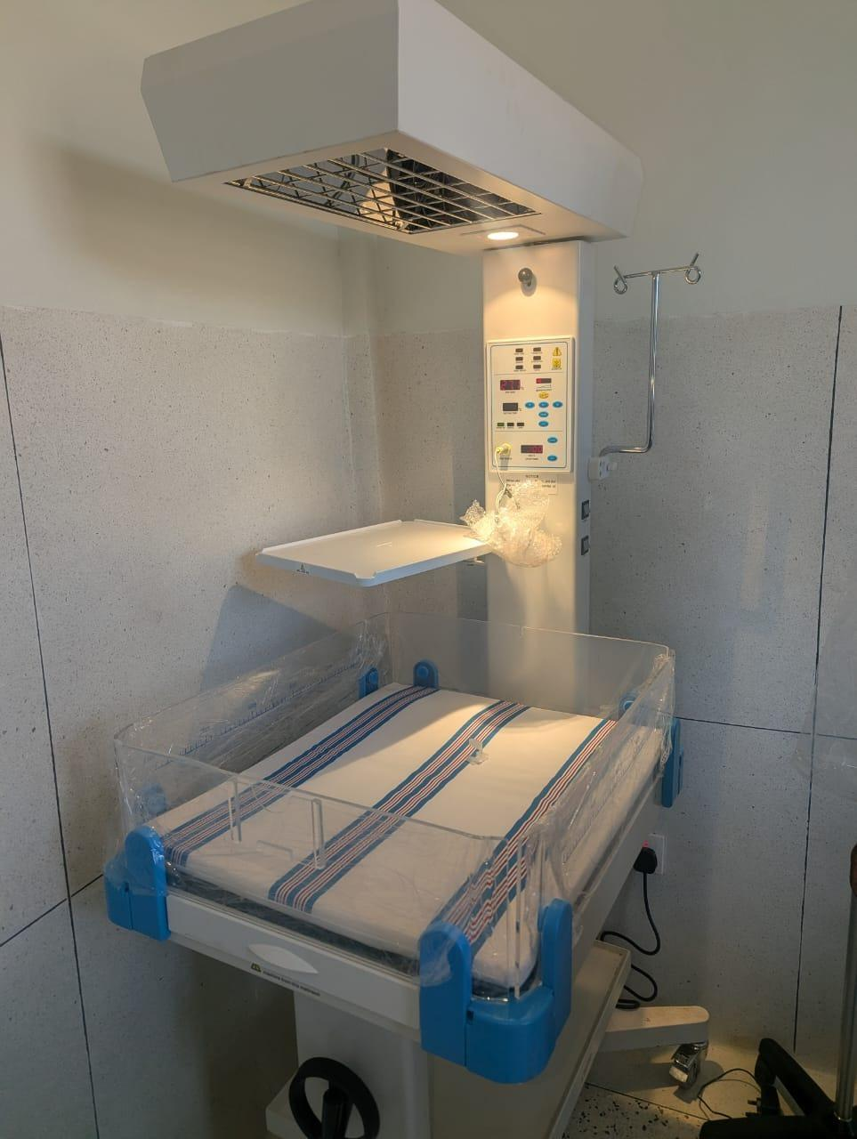  Figure 100: Infant radiant warmer at a health centre, Makindye-Ssabagabo Municipal Council (Buganda) | 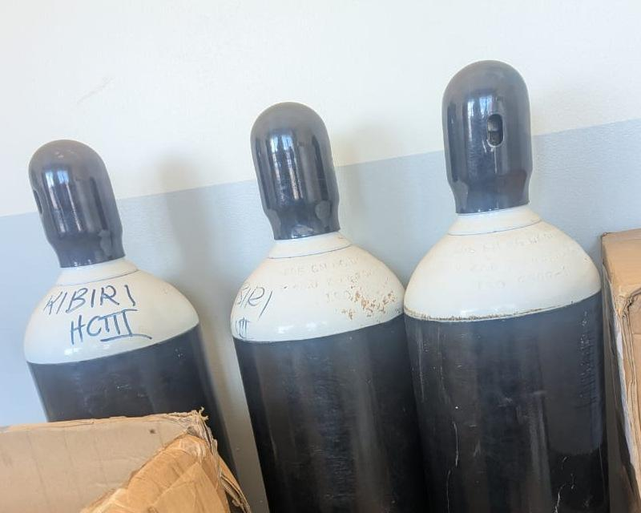  Figure 101: Oxygen cylinders marked KIBIRI HCIII at Kibiri HC III, Makindye-Ssabagabo Municipal Council (Buganda) | 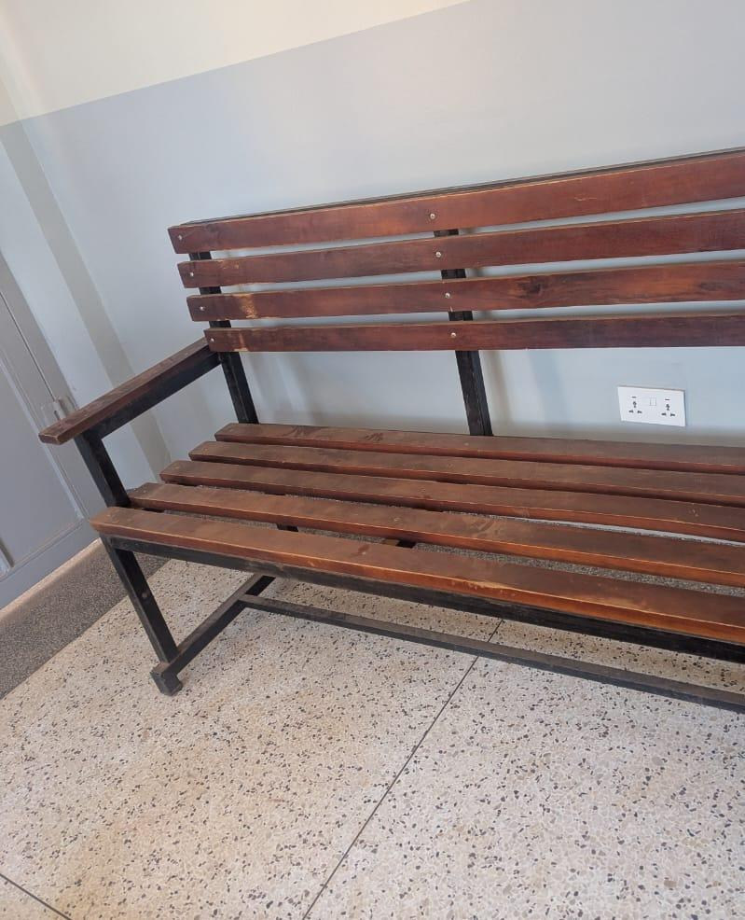  Figure 102: Wooden waiting bench at Kibiri HC III, Makindye-Ssabagabo Municipal Council (Buganda) | 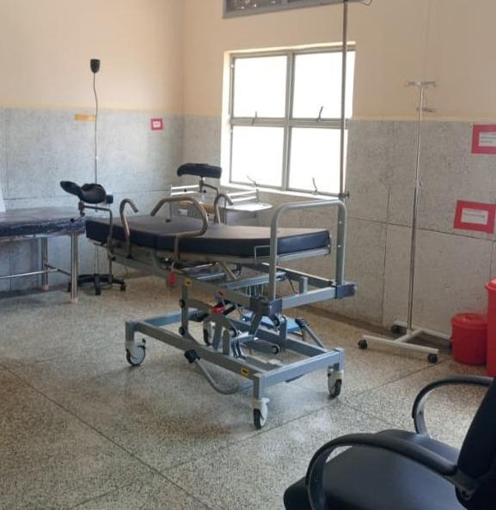  Figure 103: Delivery bed and clinical furniture at a health centre, Kabarole District (Tooro)

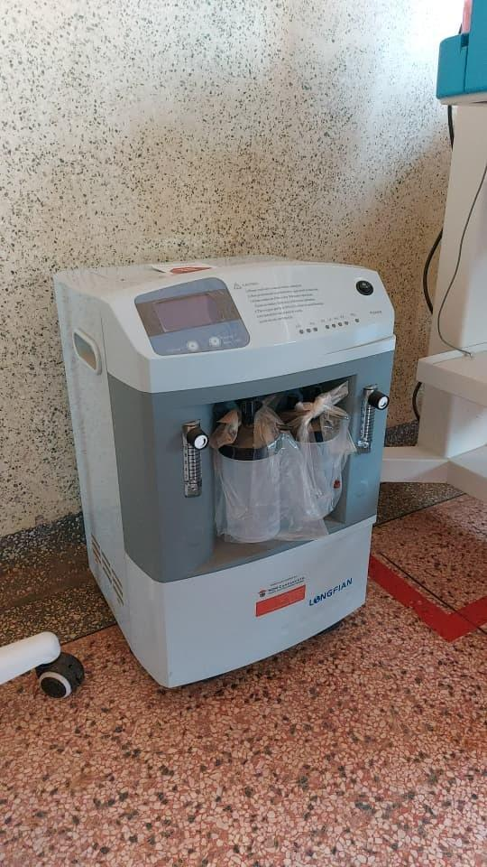  Figure 104: Oxygen concentrator at Kalemungole HC III, Moroto District (Karamoja) | 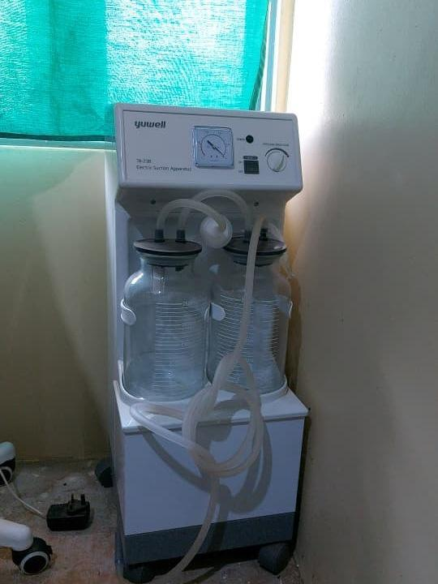  Figure 105: Suction apparatus at Kalemungole HC III, Moroto District (Karamoja) | 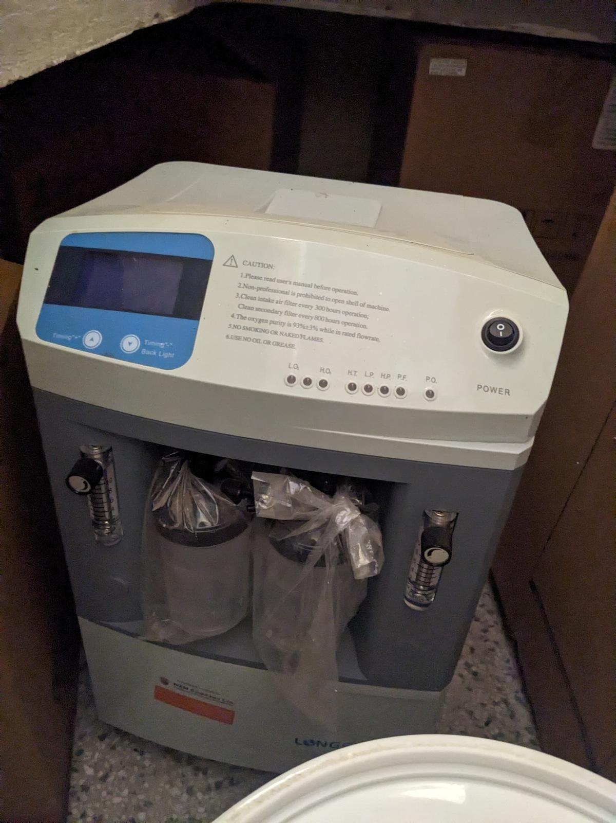  Figure 106: Oxygen concentrator at Kamoru HC III, Kotido District (Karamoja) | 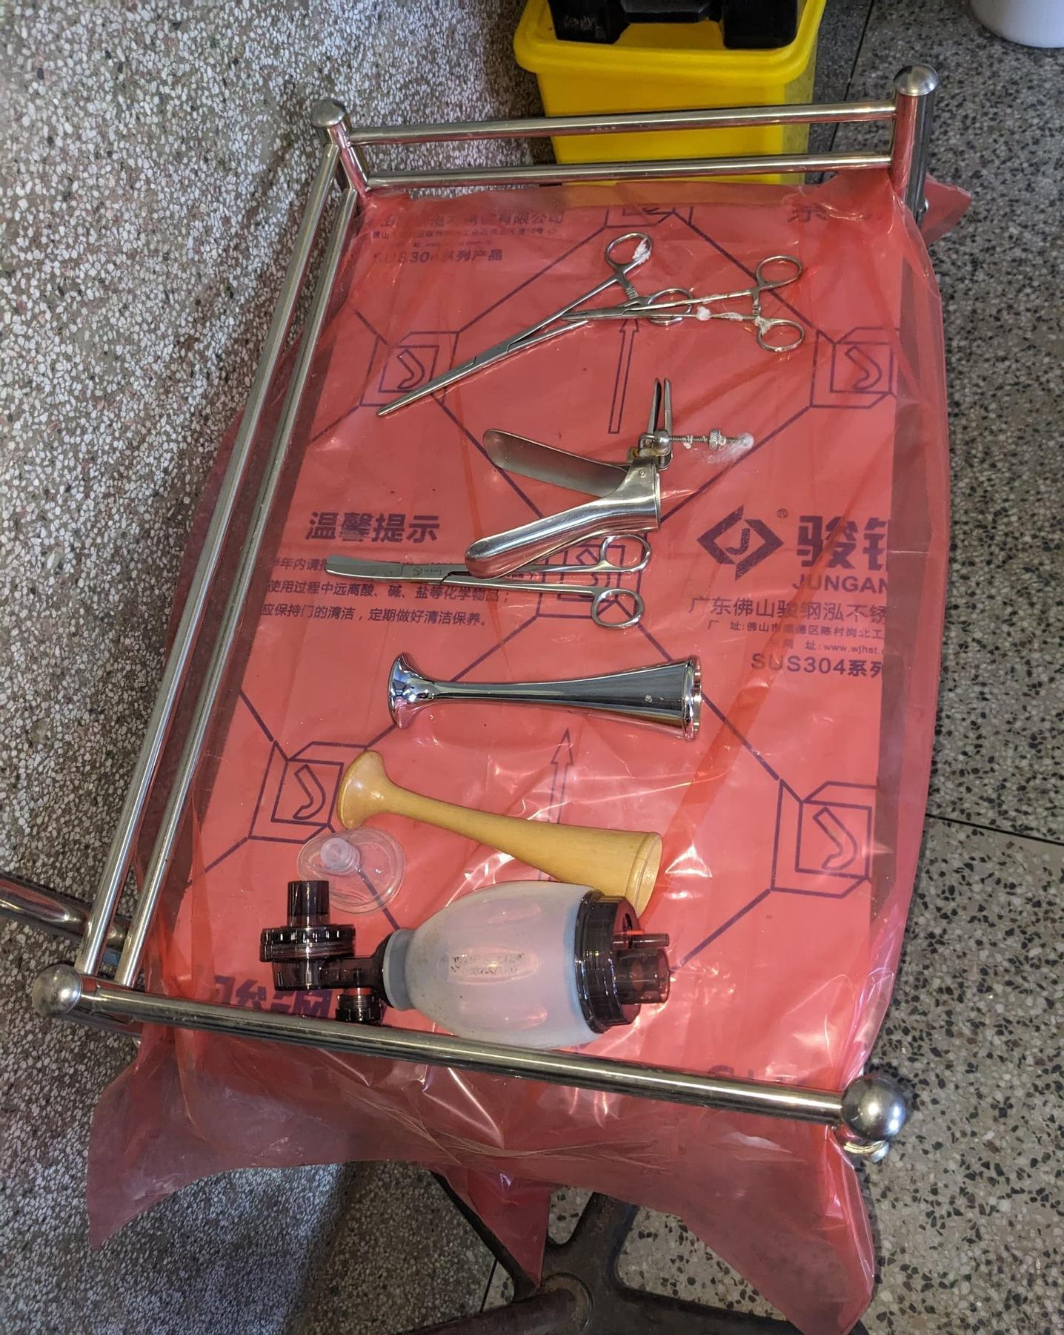  Figure 107: Instrument trolley with delivery instruments at Kamoru HC III, Kotido District (Karamoja)

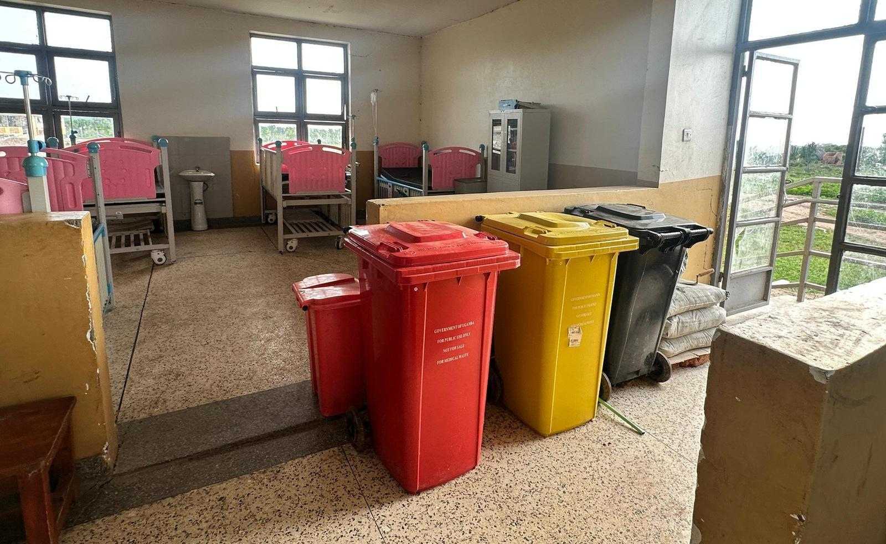  Figure 108: Medical-waste bins and ward beds at Butiaba HC III, Buliisa District (Bunyoro) | 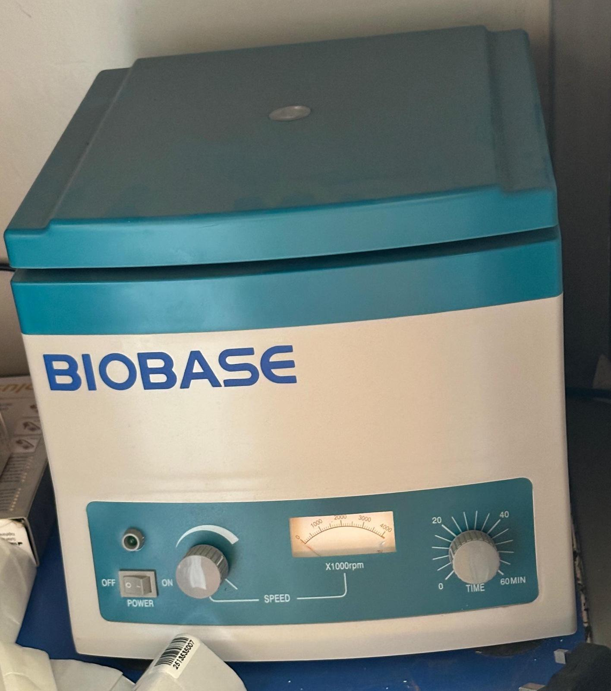  Figure 109: Laboratory centrifuge at Butiaba HC III, Buliisa District (Bunyoro)

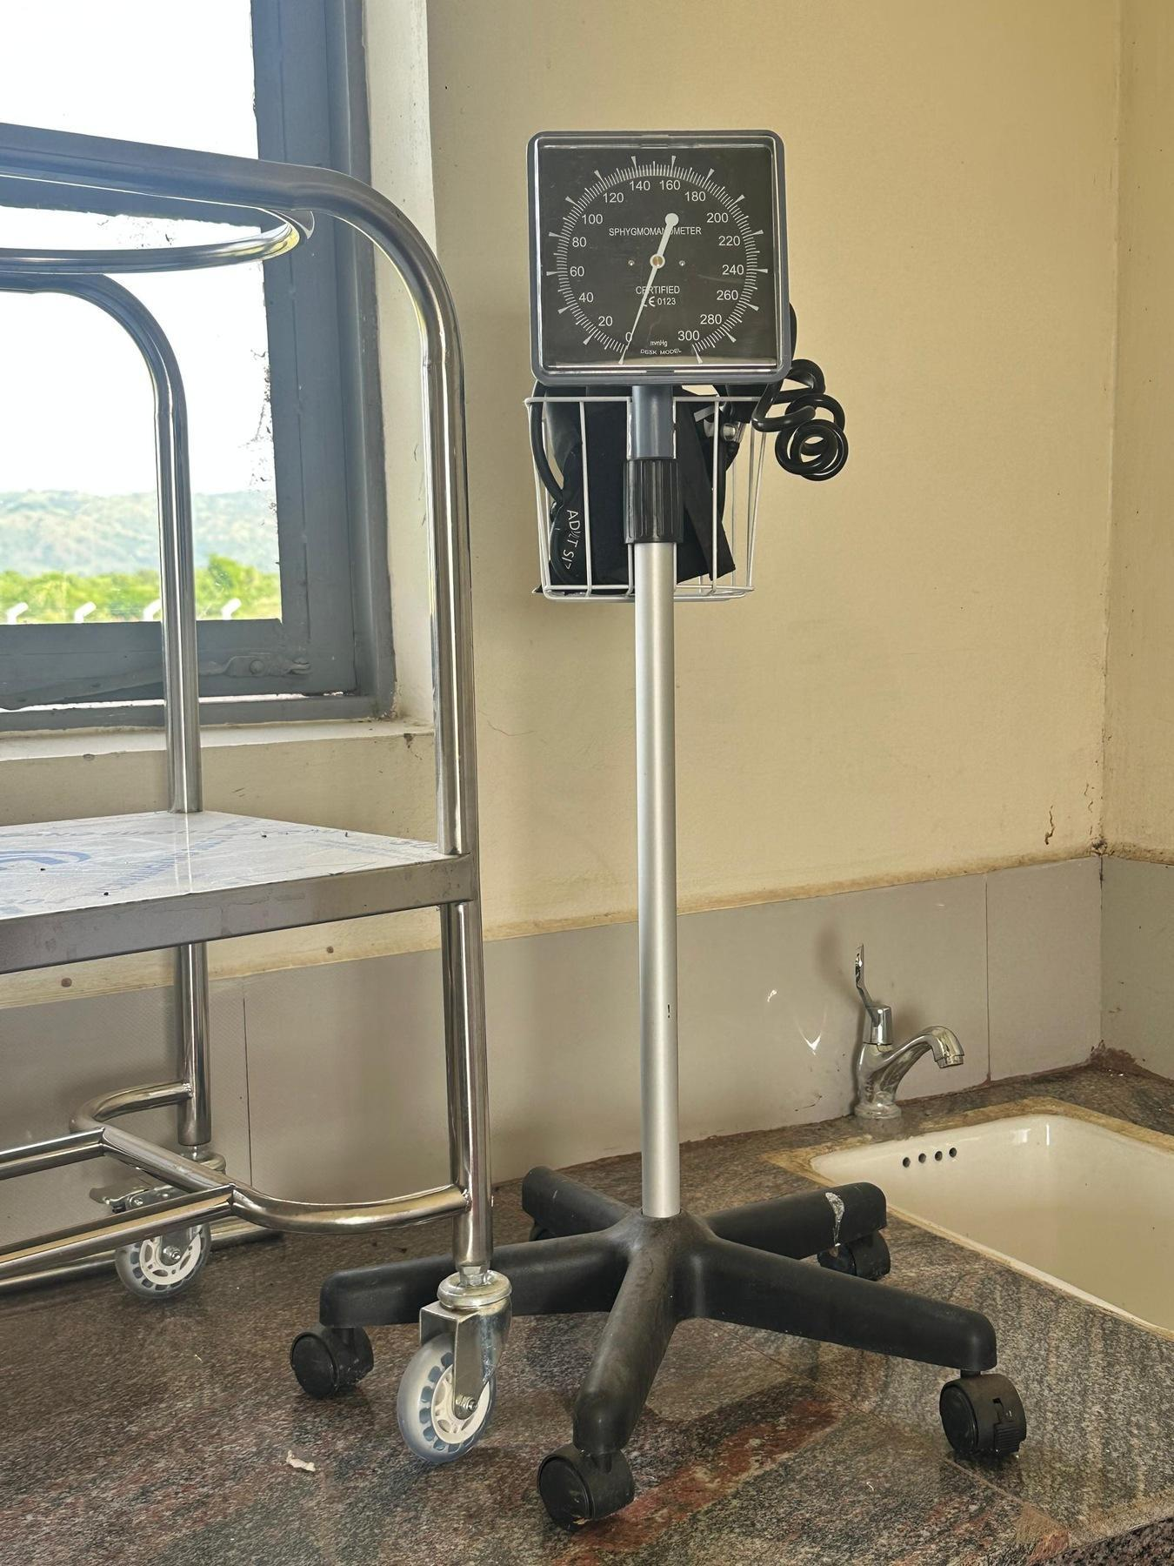  Figure 110: Blood pressure apparatus on a mobile stand at Butiaba HC III, Buliisa District (Bunyoro) | 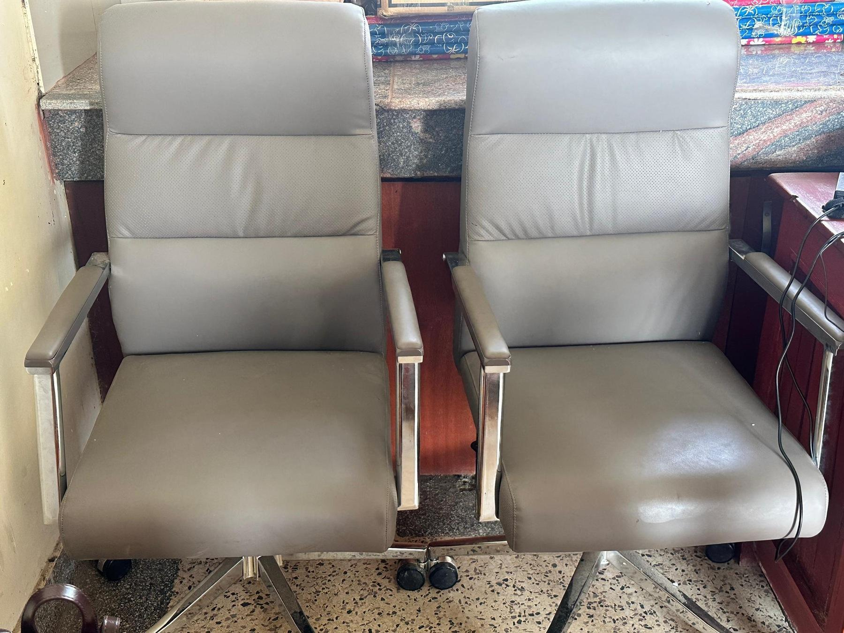  Figure 111: Office chairs at Butiaba HC III, Buliisa District (Bunyoro) | 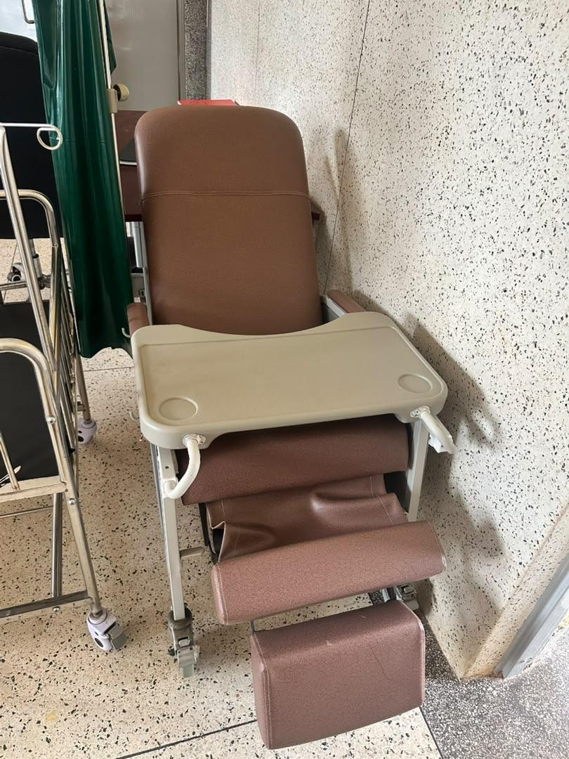  Figure 112: Kangaroo care chair at Kyabasara HC III, Kagadi District (Bunyoro)

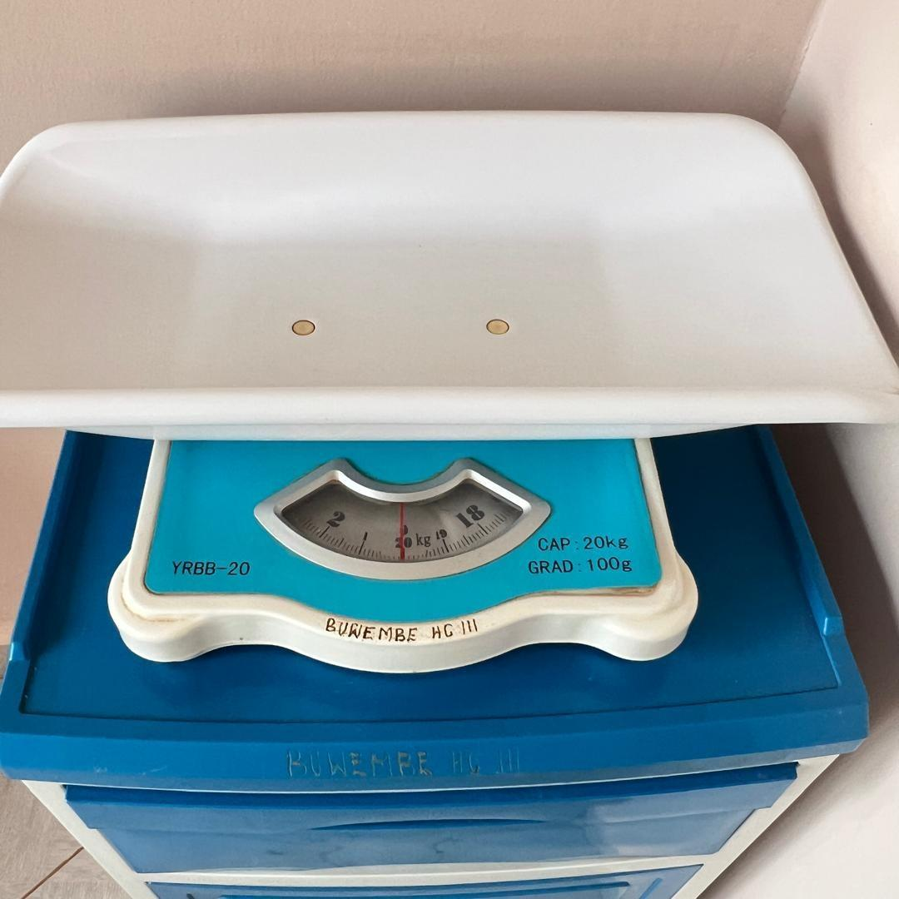  Figure 113: Infant weighing scale at Buwembe HC III, Busia District (Bukedi) | 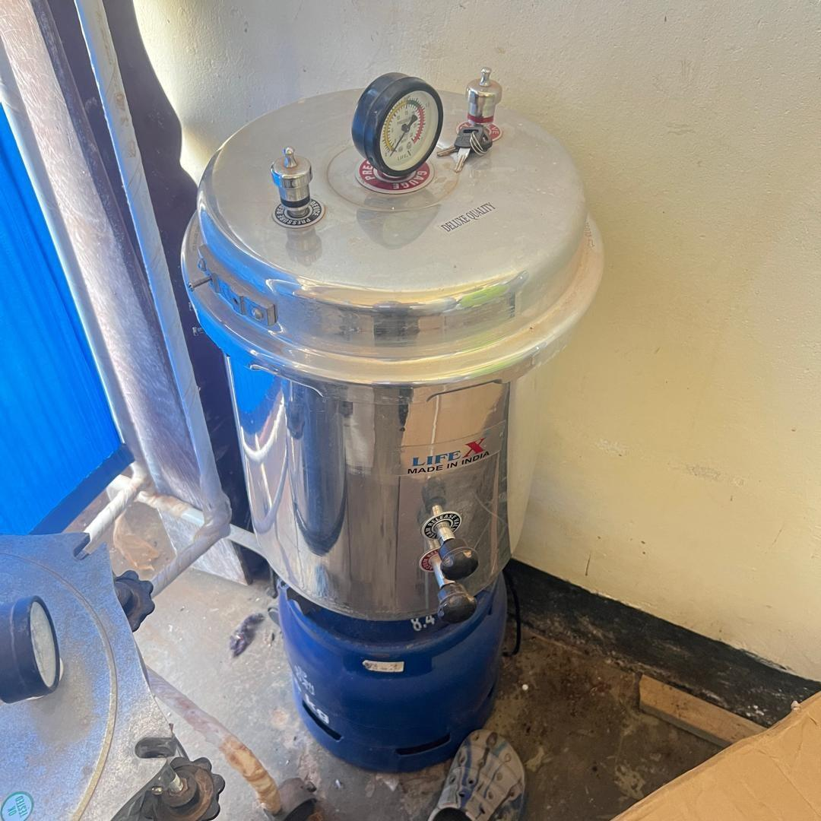  Figure 114: Autoclave above a gas cylinder at Buwembe HC III, Busia District (Bukedi) | 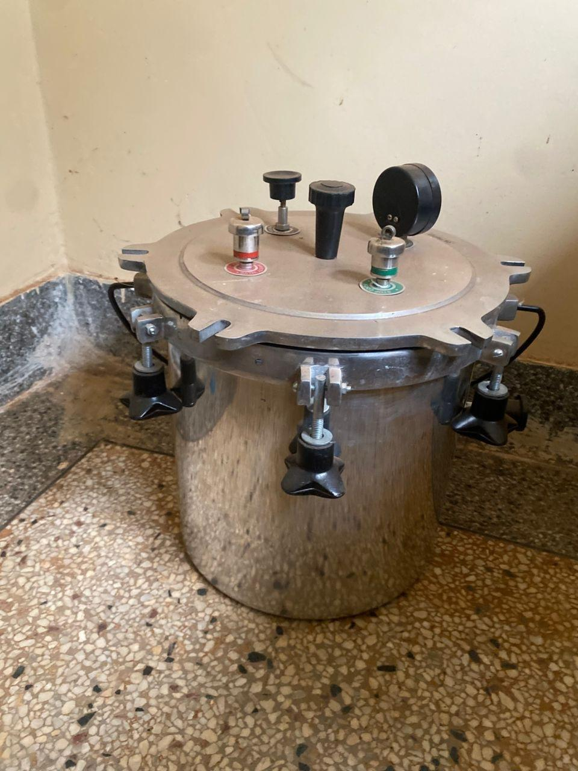  Figure 115: Autoclave at Atar HC III, Kween District (Sebei)

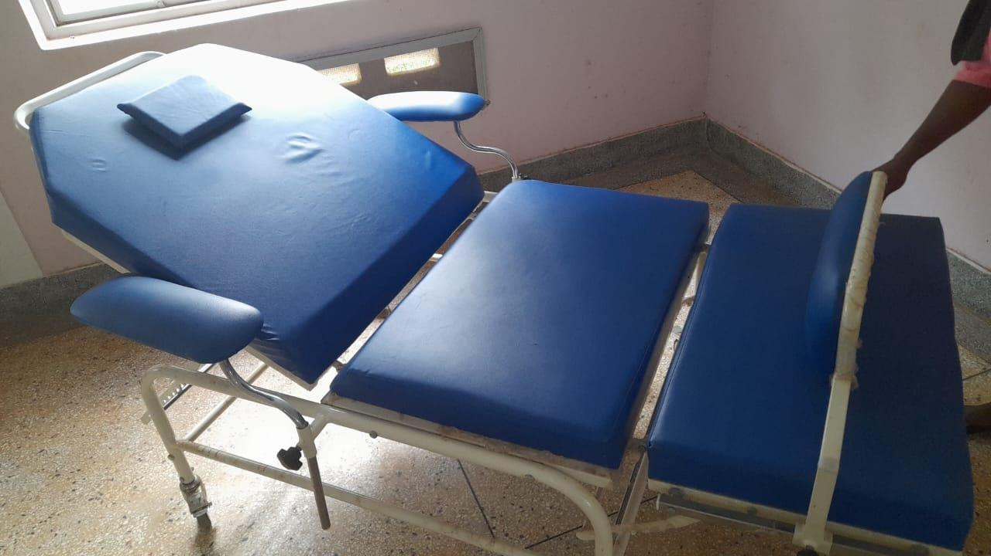  Figure 116: Kangaroo care chair at Atar HC III, Kween District (Sebei) | 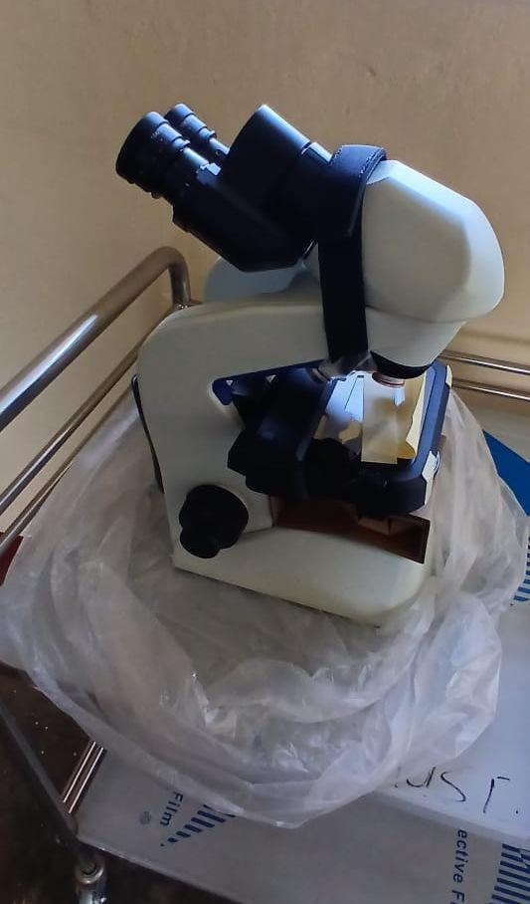  Figure 117: Binocular microscope on a trolley at Namusita HC III, Budaka District (Bukedi)

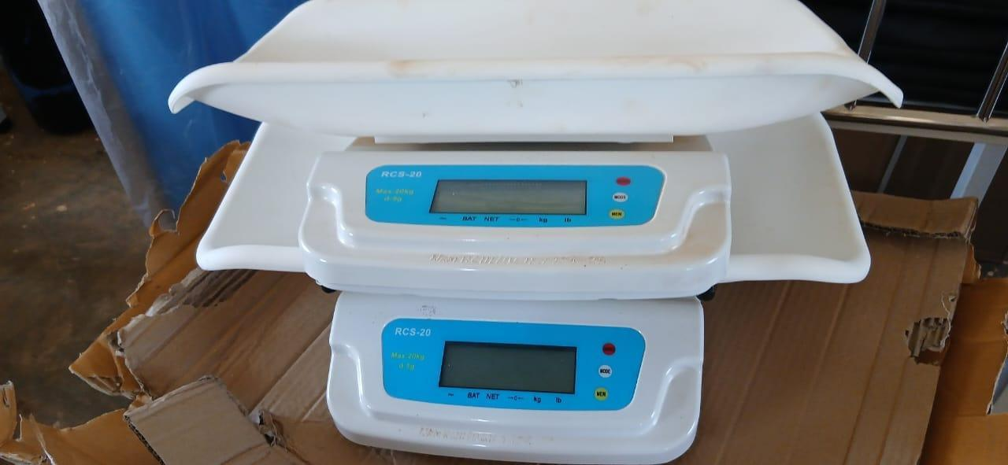  Figure 118: Infant weighing scales at Namusita HC III, Budaka District (Bukedi) | 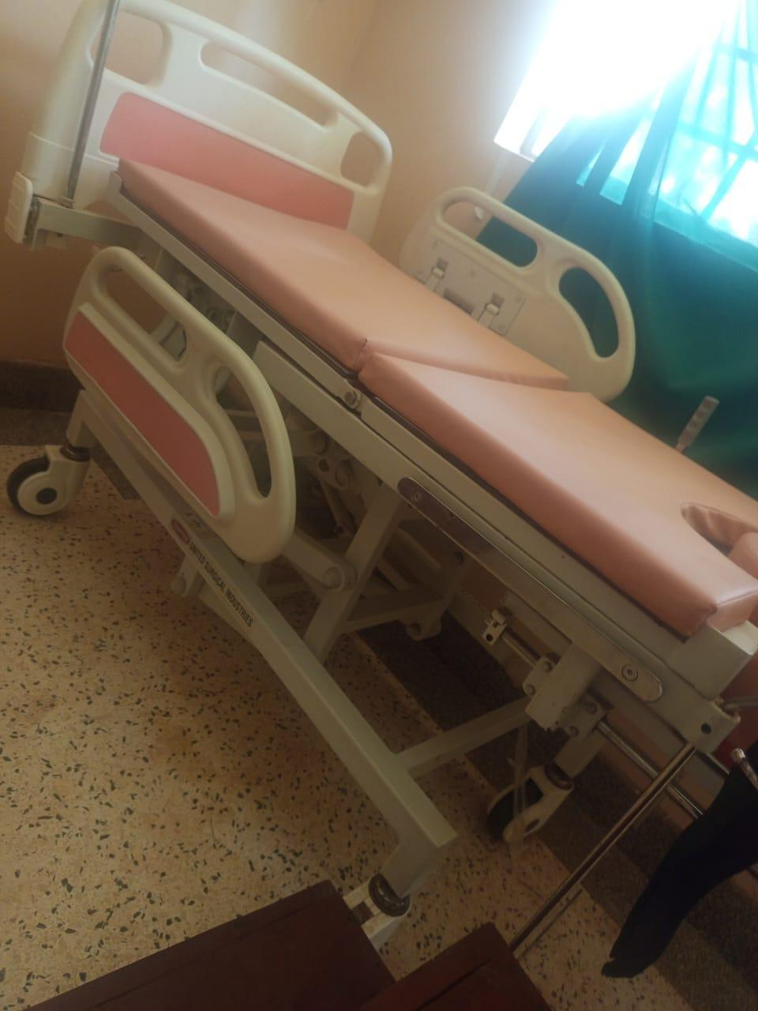  Figure 119: Delivery bed with side rails at Kabweri HC III, Kibuku District (Bukedi)

Figures 120 to 129 show health centre buildings and the power, water and sanitation installations that serve them, including solar panels and batteries, a power house, latrine and sanitation blocks, a waste disposal structure and water tanks.
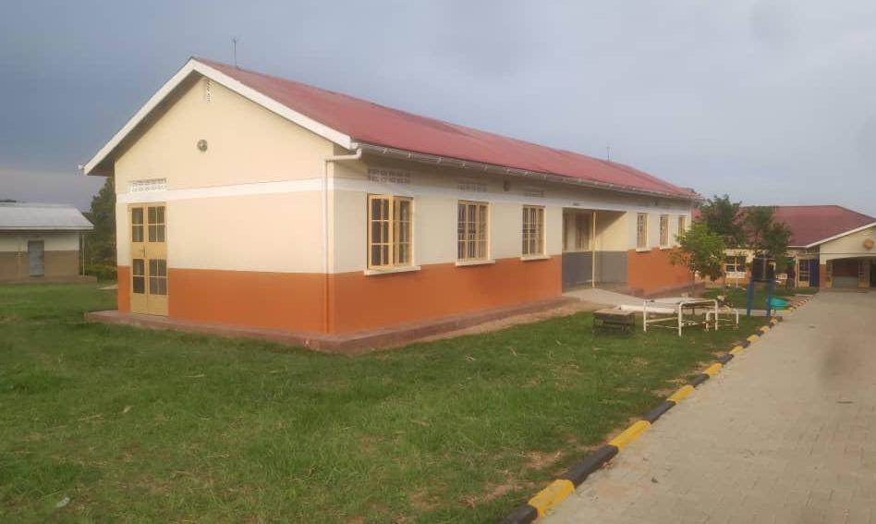  Figure 120: Health centre building, Nwoya District (Acholi) | 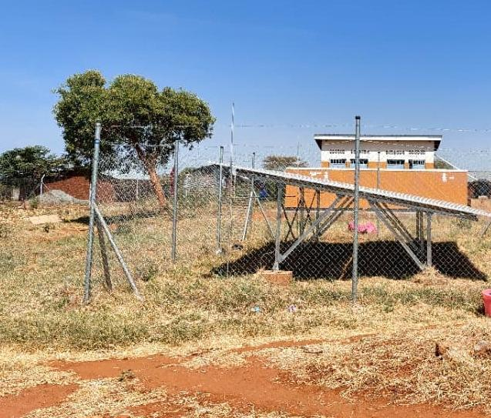  Figure 121: Solar panels at Kalemungole HC III, Moroto District (Karamoja)

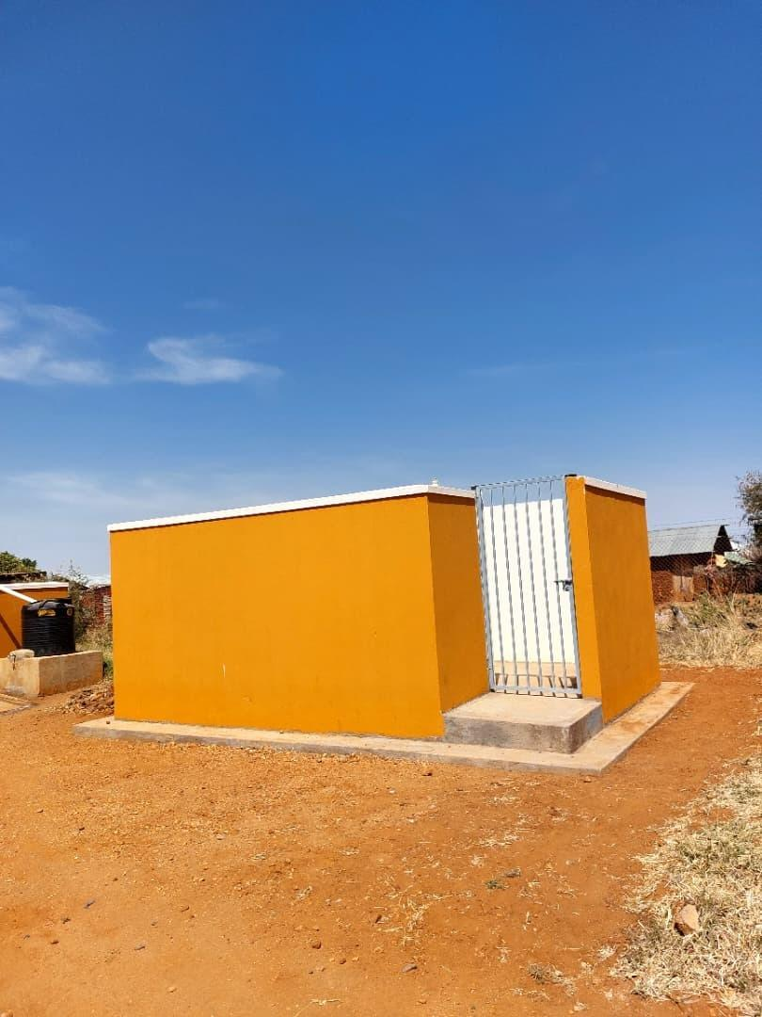  Figure 122: Patient toilet block at Kalemungole HC III, Moroto District (Karamoja) | 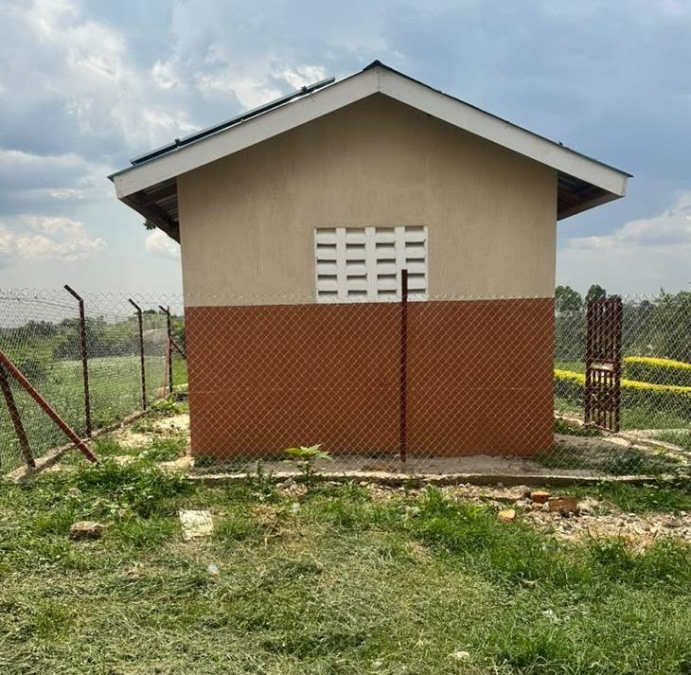  Figure 123: Power house at Kyabasara HC III, Kagadi District (Bunyoro) | 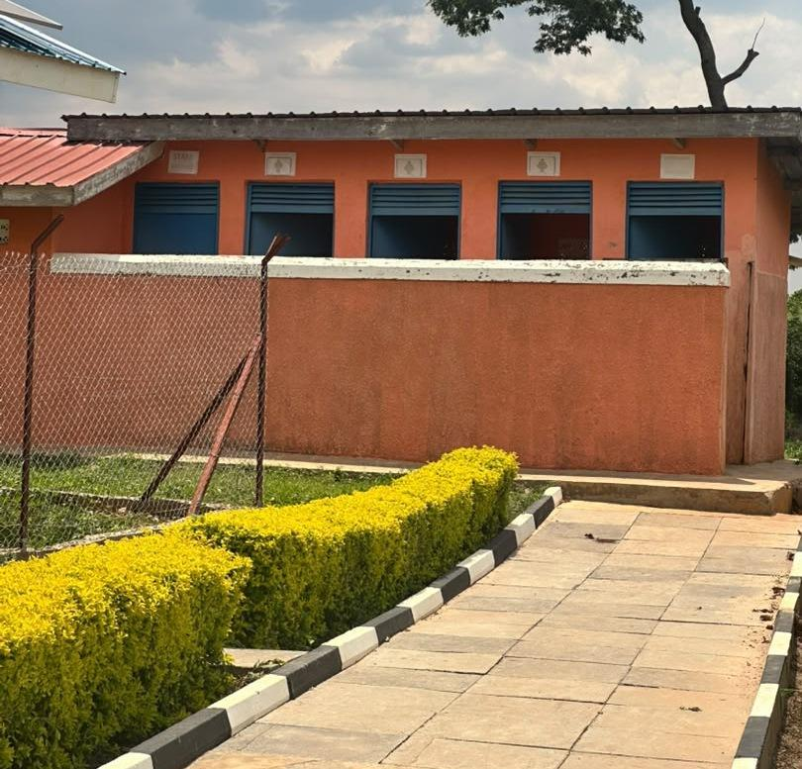  Figure 124: Latrine block and paved access at Kyabasara HC III, Kagadi District (Bunyoro)

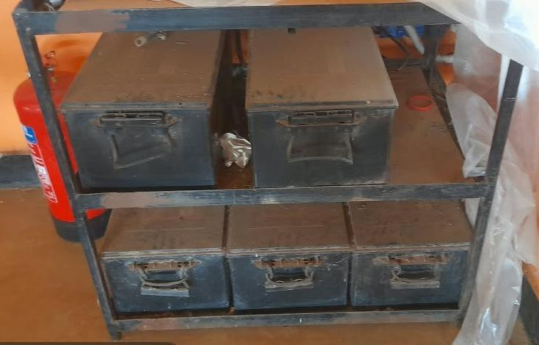  Figure 125: Solar batteries at Bunangaka HC III, Bulambuli District (Bugisu) | 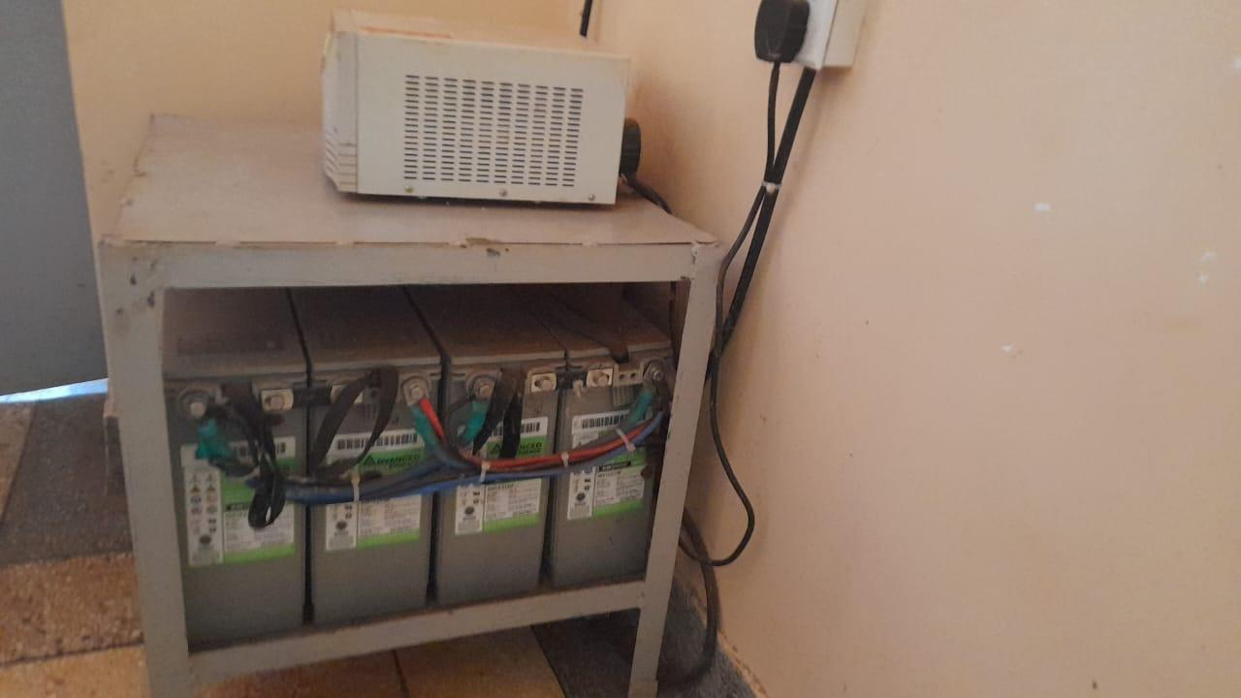  Figure 126: Solar batteries and control equipment at Atar HC III, Kween District (Sebei)

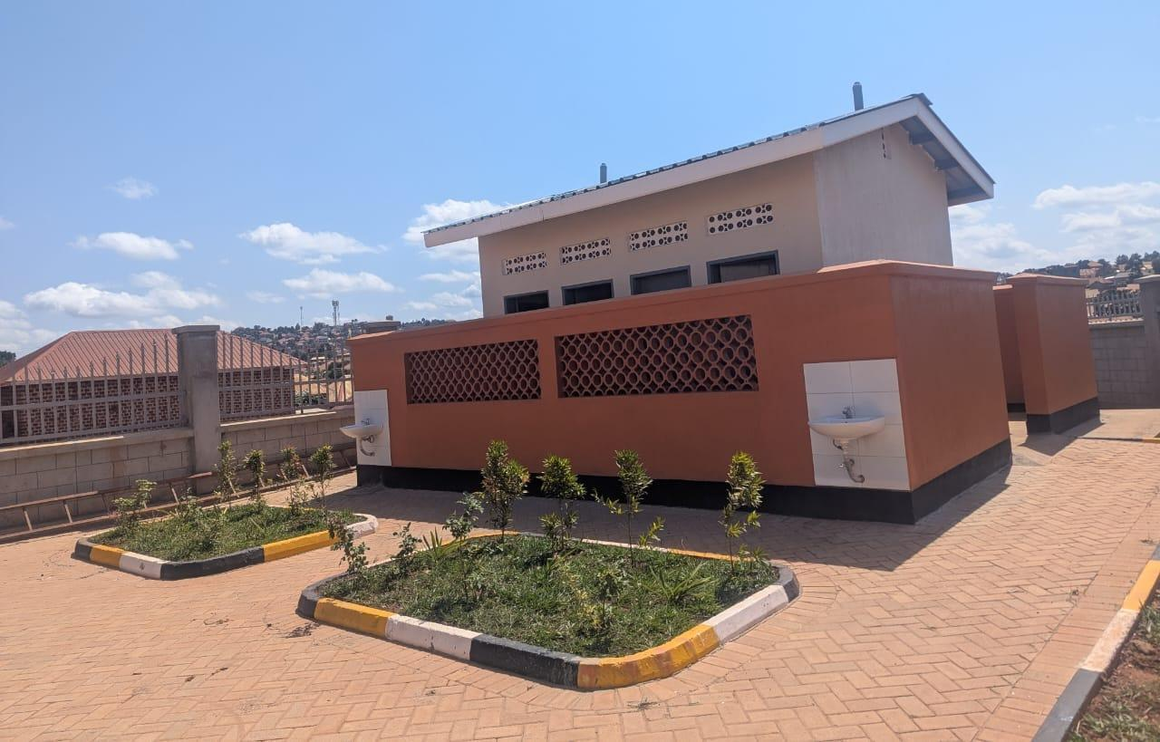  Figure 127: Sanitation block with external handwashing basins at Kibiri HC III, Makindye-Ssabagabo Municipal Council (Buganda) | 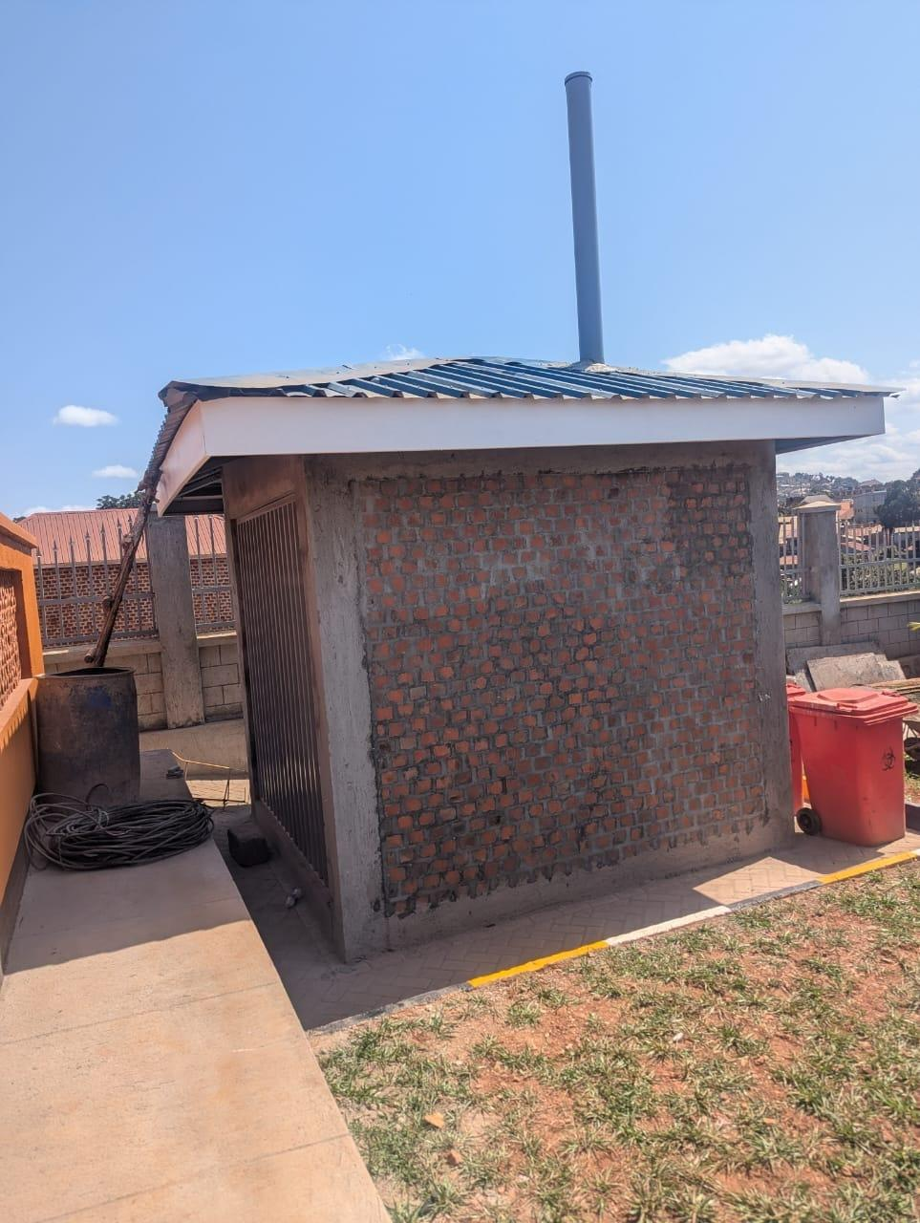  Figure 128: Waste disposal structure at Kibiri HC III, Makindye-Ssabagabo Municipal Council (Buganda) | 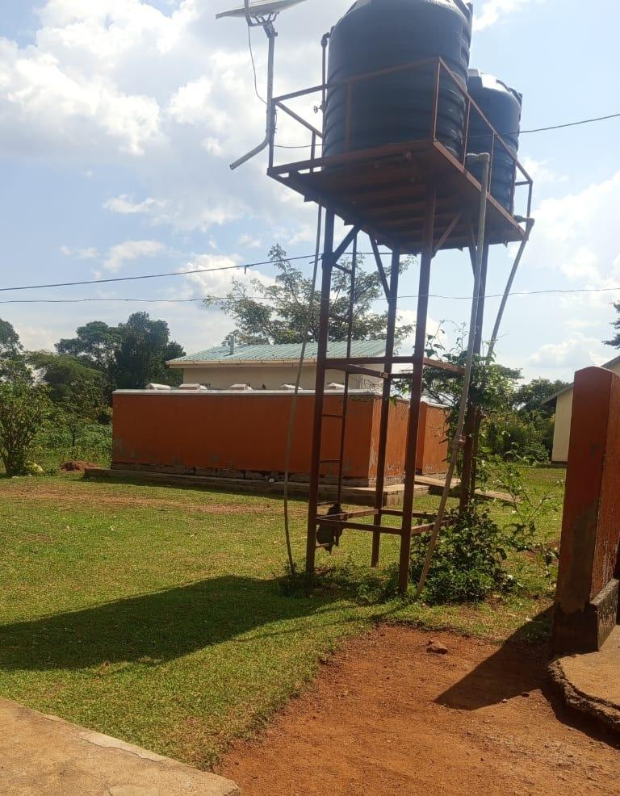  Figure 129: Water tanks on a steel tower at Kabweri HC III, Kibuku District (Bukedi)

Seed schools
Figures 130 to 147 show furniture and teaching equipment at seed schools, including laboratory benches and stools, laboratory glassware, anatomical teaching models, classroom desks, library shelving and computer equipment.
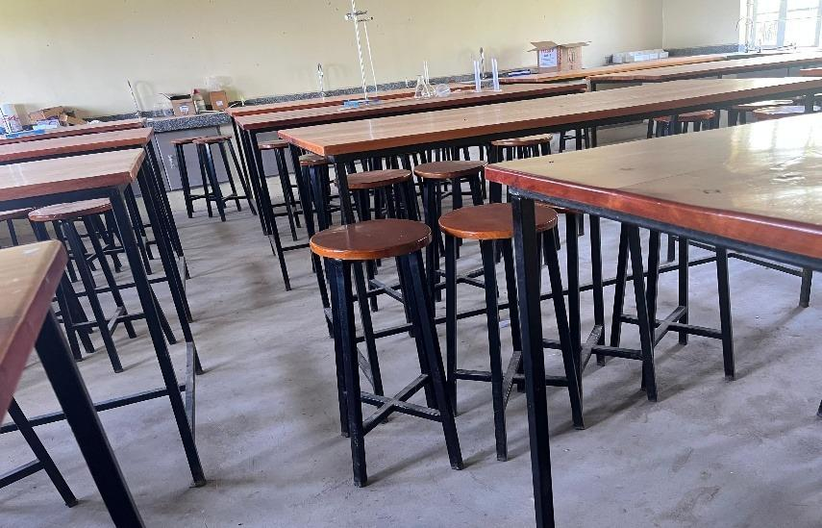  Figure 130: Science laboratory tables and stools at a seed secondary school, Kalangala District (Buganda) | 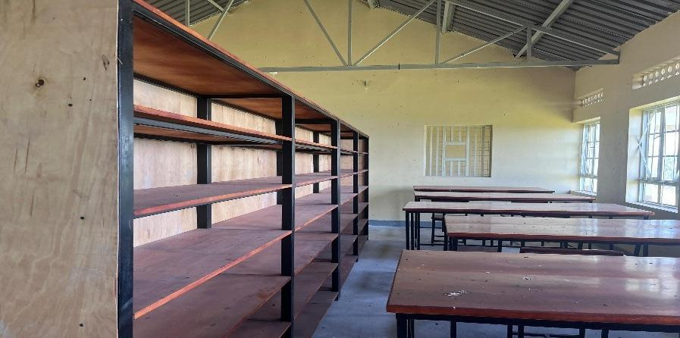  Figure 131: Library shelves and reading tables at Gyagenda Memorial Seed Secondary School, Kalangala District (Buganda)

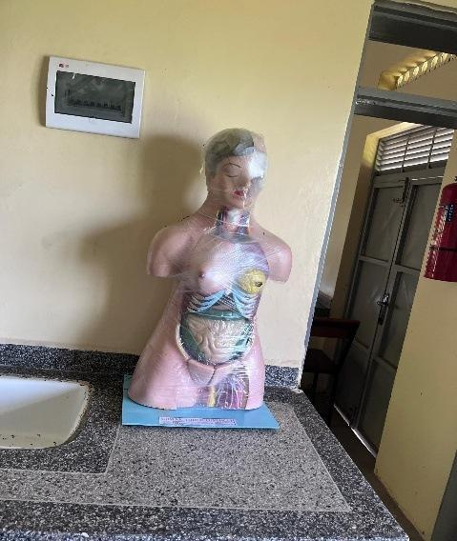  Figure 132: Anatomical teaching model at Gyagenda Memorial Seed Secondary School, Kalangala District (Buganda) | 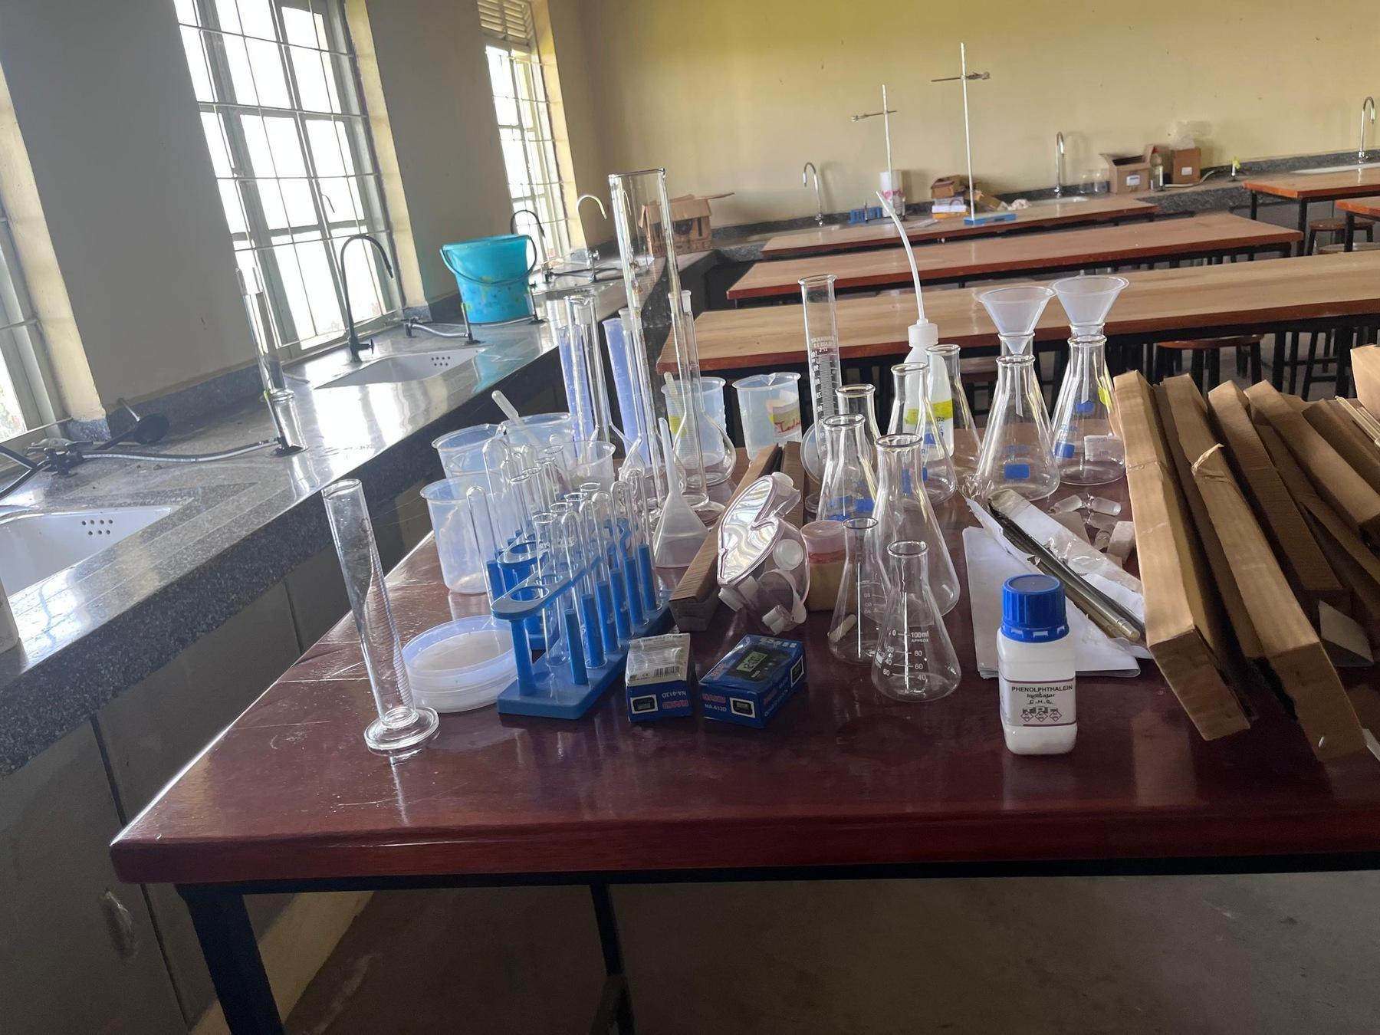  Figure 133: Laboratory glassware and equipment at Gyagenda Memorial Seed Secondary School, Kalangala District (Buganda)

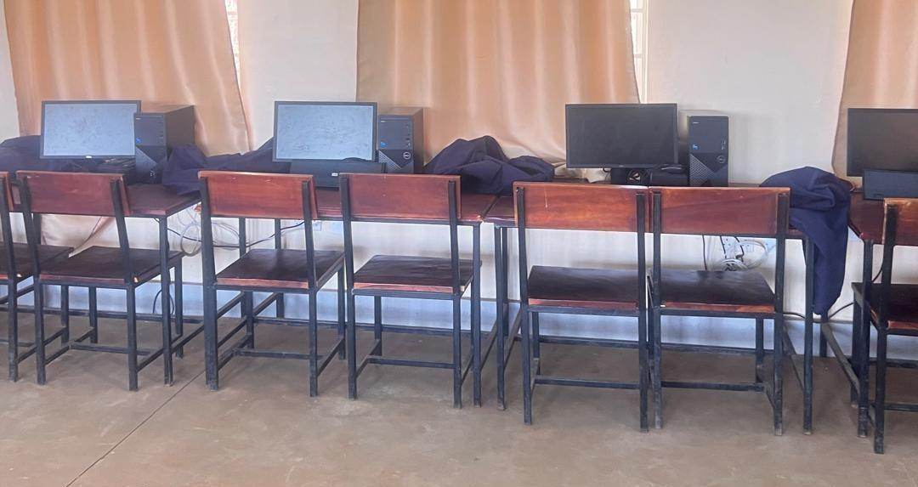  Figure 134: Desktop computers and classroom furniture at a seed secondary school, Busia District (Bukedi) | 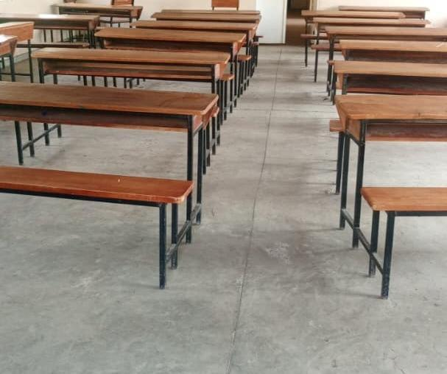  Figure 135: Classroom desks at a seed secondary school, Ntoroko District (Tooro)

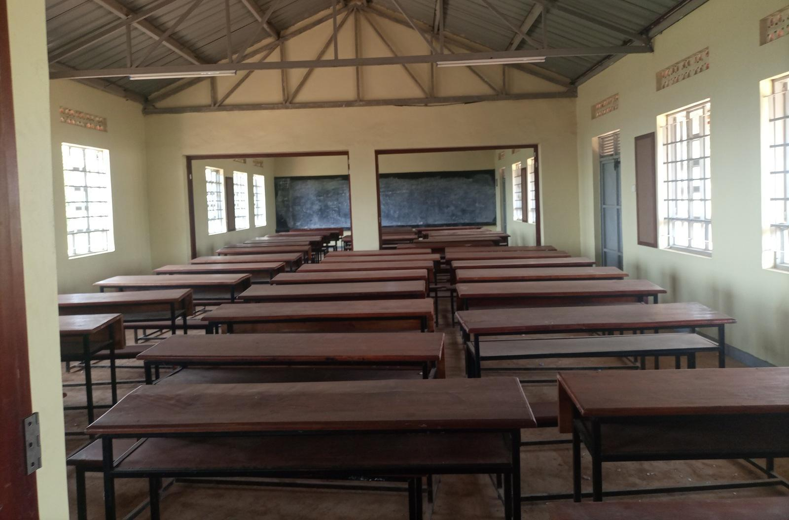  Figure 136: Classroom desks at King Solomon Seed Secondary School, Kagadi District (Bunyoro) | 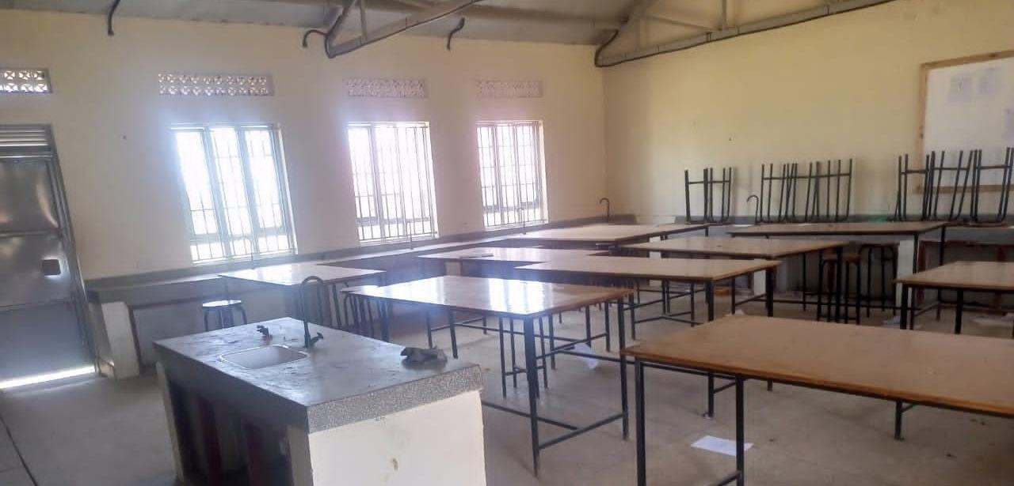  Figure 137: Laboratory benches and sinks at Bweema Seed Secondary School, Buvuma District (Buganda)

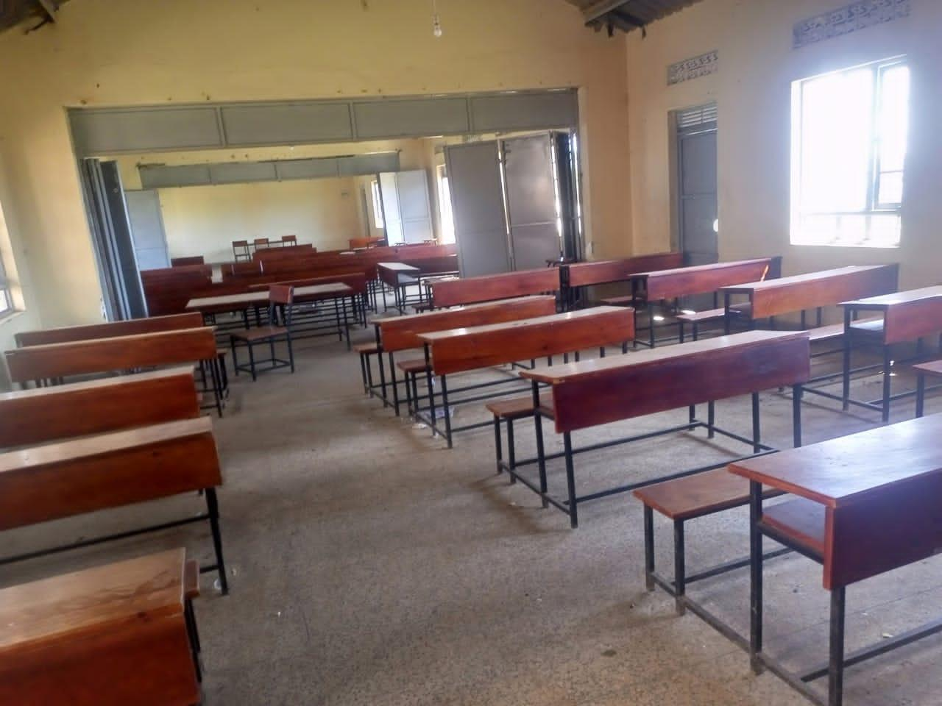  Figure 138: Classroom desks at Bweema Seed Secondary School, Buvuma District (Buganda) | 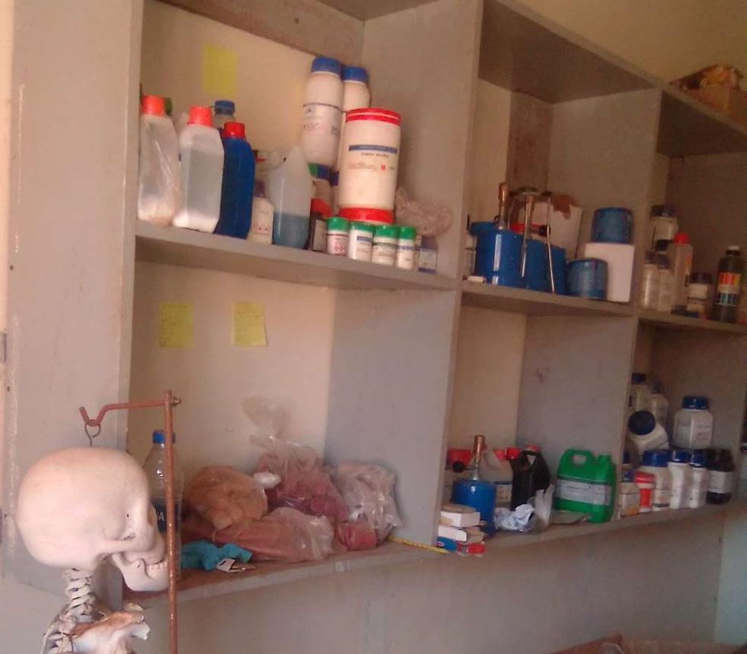  Figure 139: Laboratory supplies and an anatomical teaching model at Rupa Seed School, Moroto District (Karamoja)

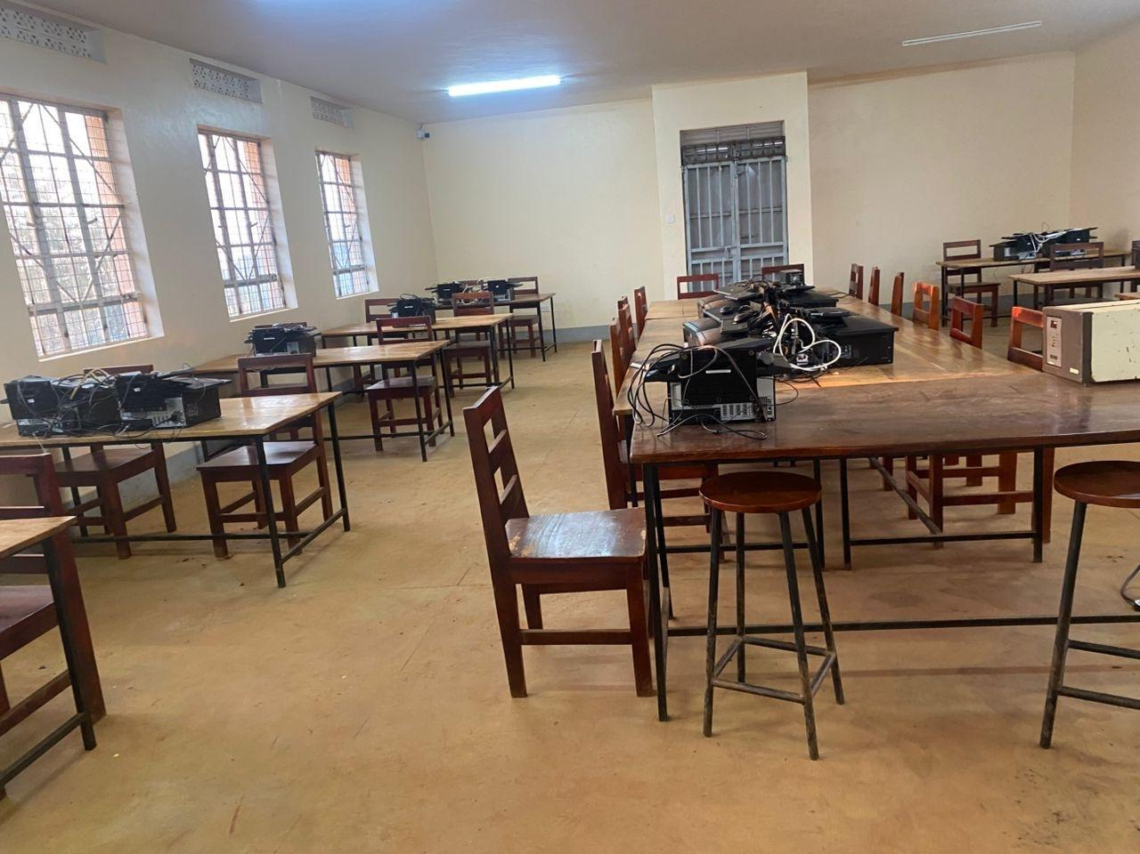  Figure 140: Computer equipment in the school ICT room at Kabeywa Seed Secondary School, Kapchorwa District (Sebei) | 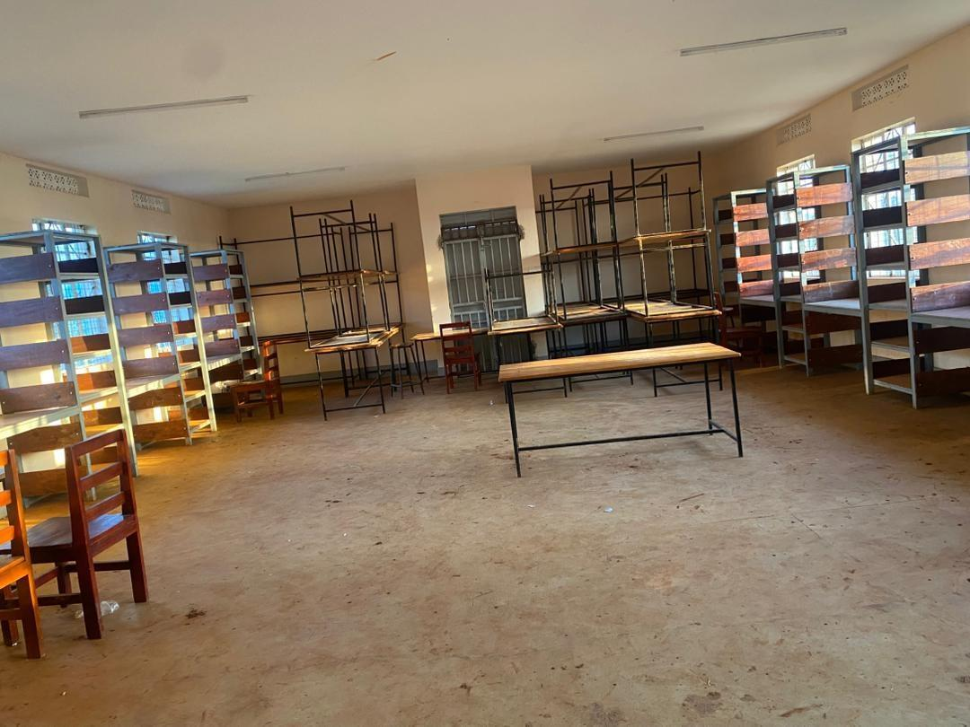  Figure 141: Library shelving and tables at Kabeywa Seed Secondary School, Kapchorwa District (Sebei) | 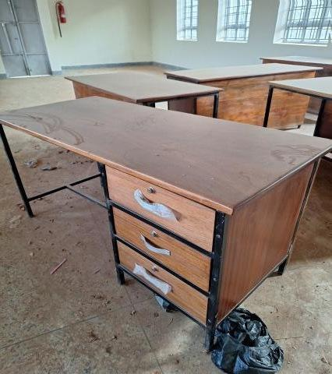  Figure 142: Office desk and other furniture at Lwamata Town Council Seed Secondary School, Kiboga District (Buganda)

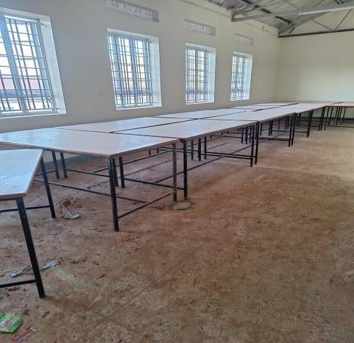  Figure 143: Laboratory tables at Lwamata Town Council Seed Secondary School, Kiboga District (Buganda) | 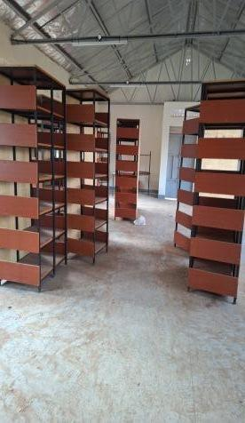  Figure 144: Library shelving at Lwamata Town Council Seed Secondary School, Kiboga District (Buganda) | 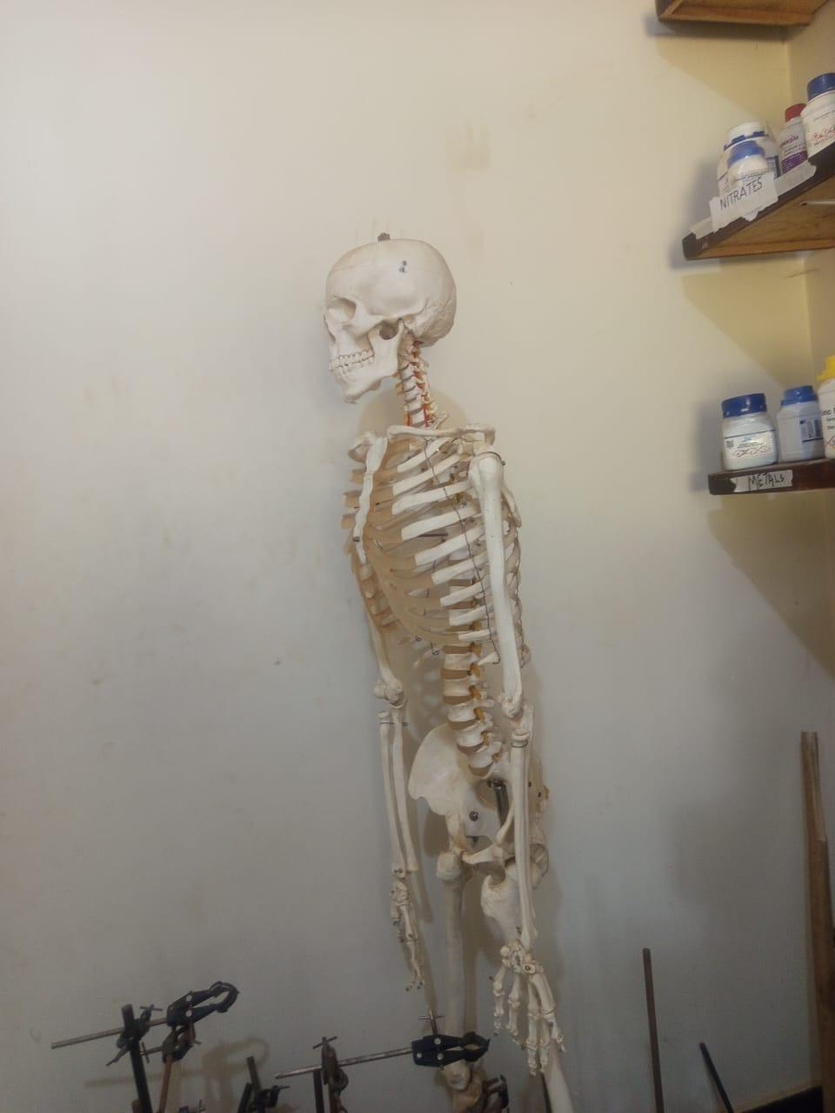  Figure 145: Anatomical skeleton teaching model at Kamonkoli Seed Secondary School, Budaka District (Bukedi)

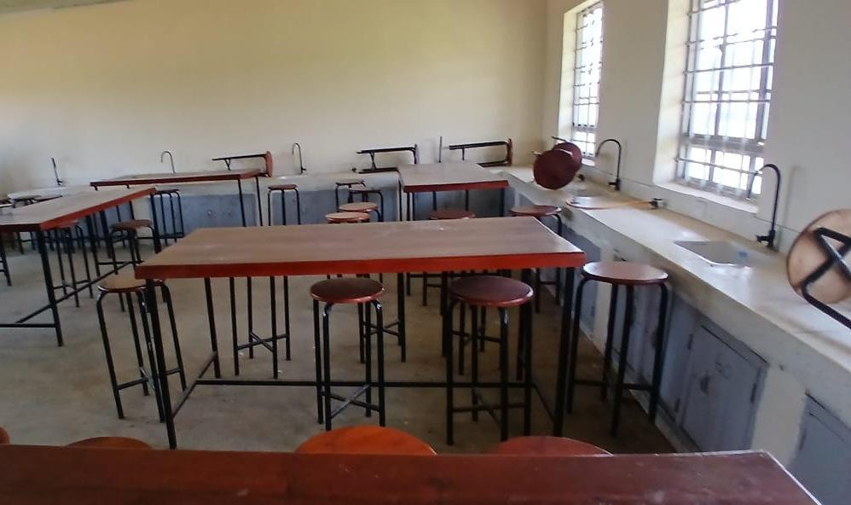  Figure 146: Laboratory benches, stools and sinks at Nansanga Seed Secondary School, Budaka District (Bukedi) | 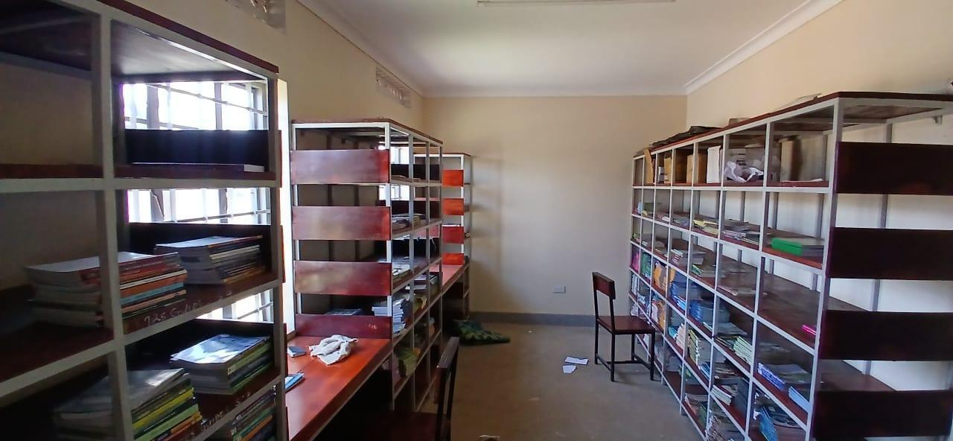  Figure 147: Library shelving with books at Nansanga Seed Secondary School, Budaka District (Bukedi)

Figures 148 to 163 show seed school buildings and the water, sanitation and gas installations that serve them, including school blocks, a science laboratory, a computer and library block, water storage tanks, a borehole, a sanitation block and gas cylinders with their pipework.
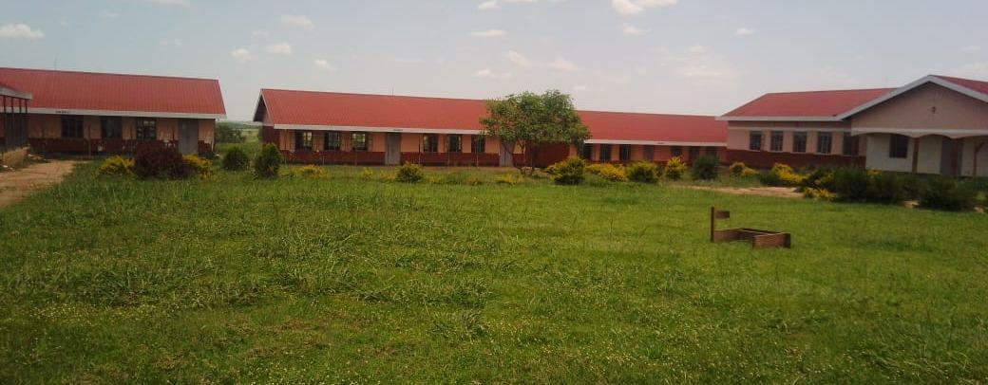
Figure 148: Buildings at a seed secondary school, Nwoya District (Acholi)

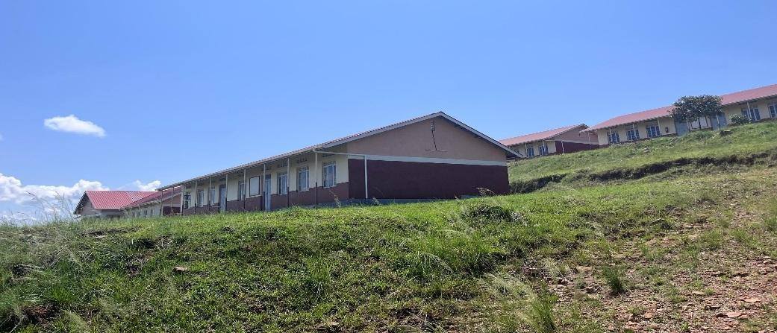
Figure 149: School blocks at Gyagenda Memorial Seed Secondary School, Kalangala District (Buganda)

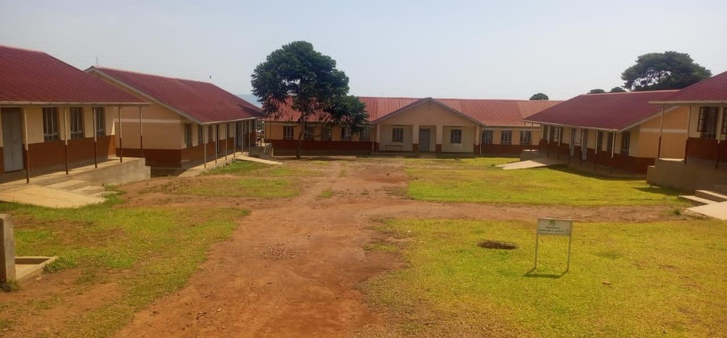  Figure 150: School buildings and courtyard at a seed secondary school, Buvuma District (Buganda) | 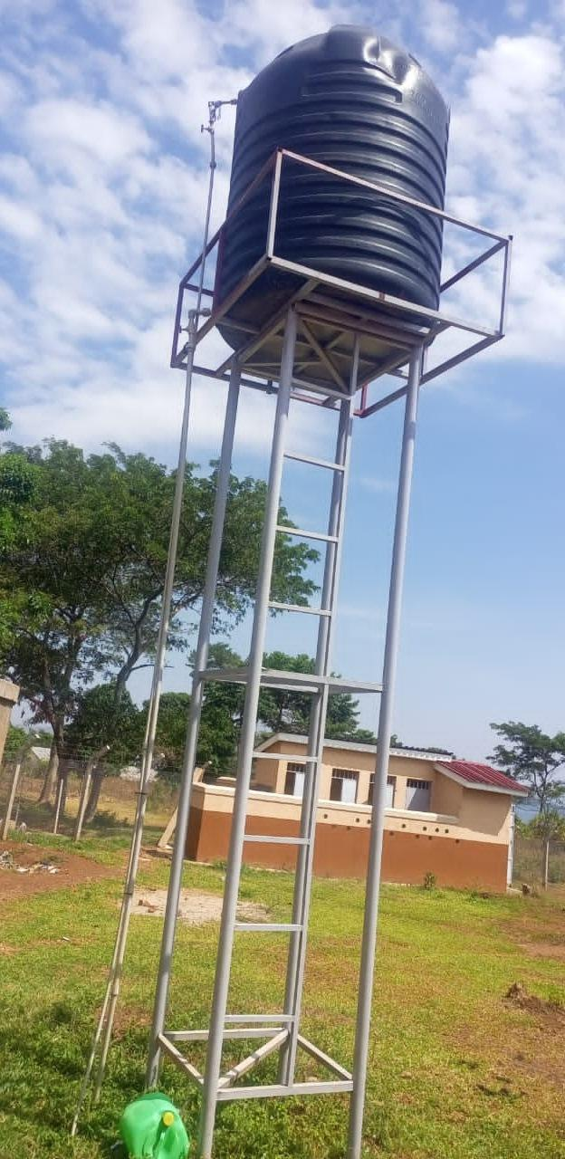  Figure 151: Raised water storage tank at a seed secondary school, Buvuma District (Buganda)

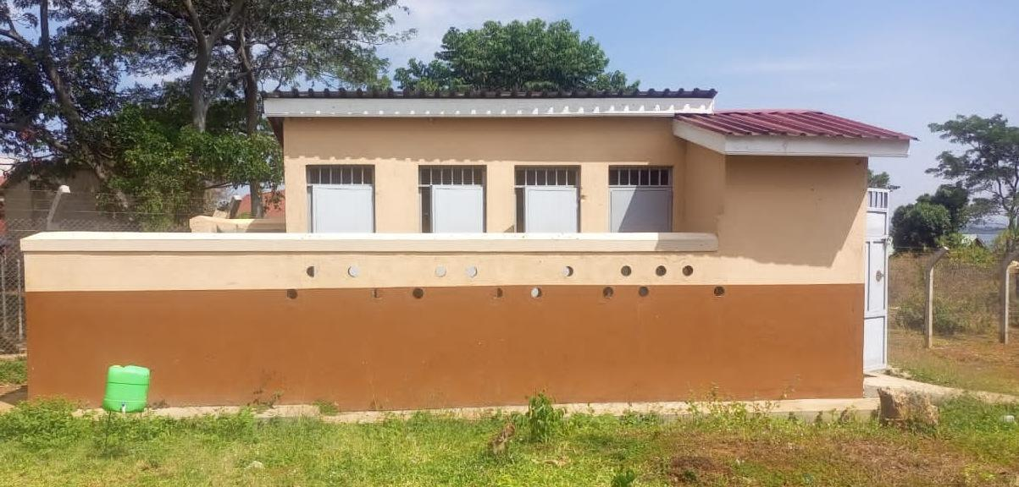  Figure 152: Sanitation block at Bweema Seed Secondary School, Buvuma District (Buganda) | 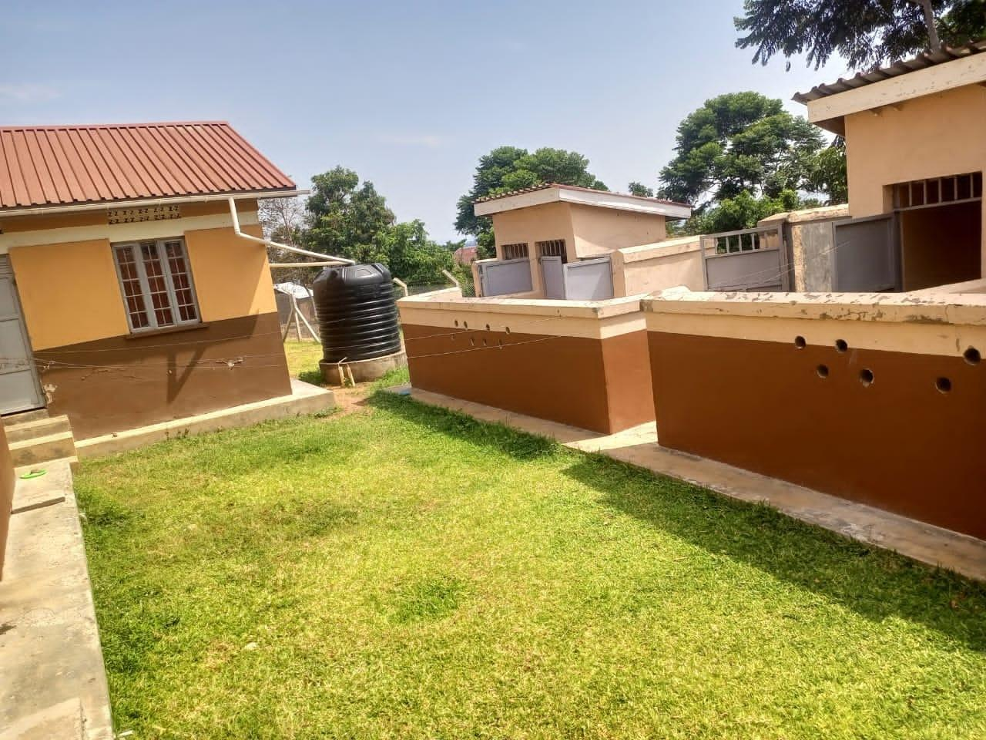  Figure 153: Water tank and enclosed service structures at Bweema Seed Secondary School, Buvuma District (Buganda)

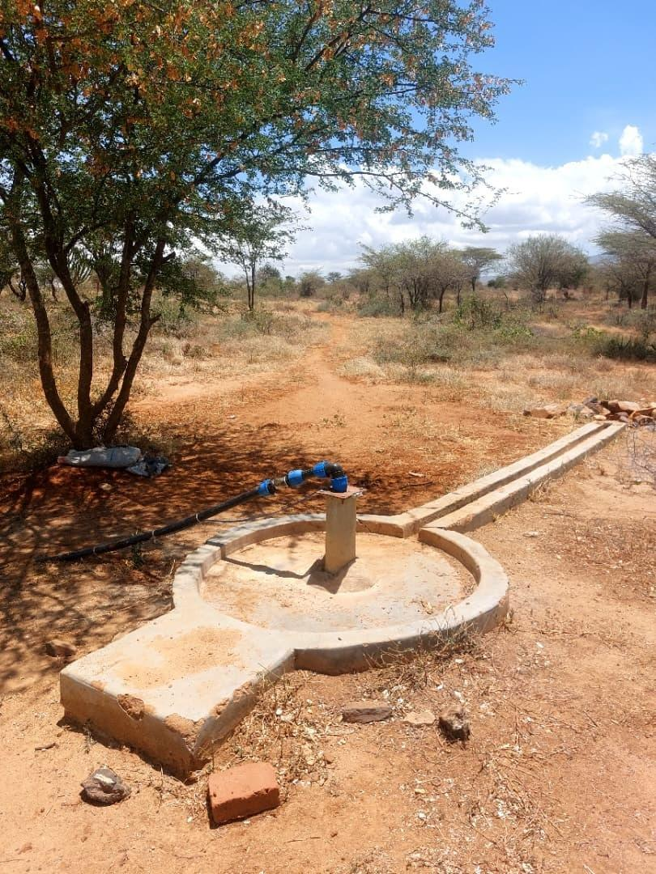  Figure 154: Borehole apron and pipework at Katikekire Seed School, Moroto District (Karamoja) | 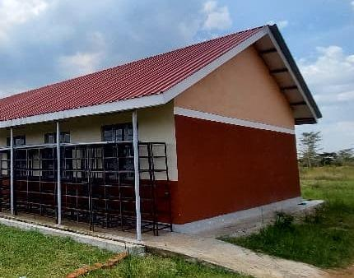  Figure 155: Section of the science laboratory exterior at Iriiri Seed Secondary School, Napak District (Karamoja) | 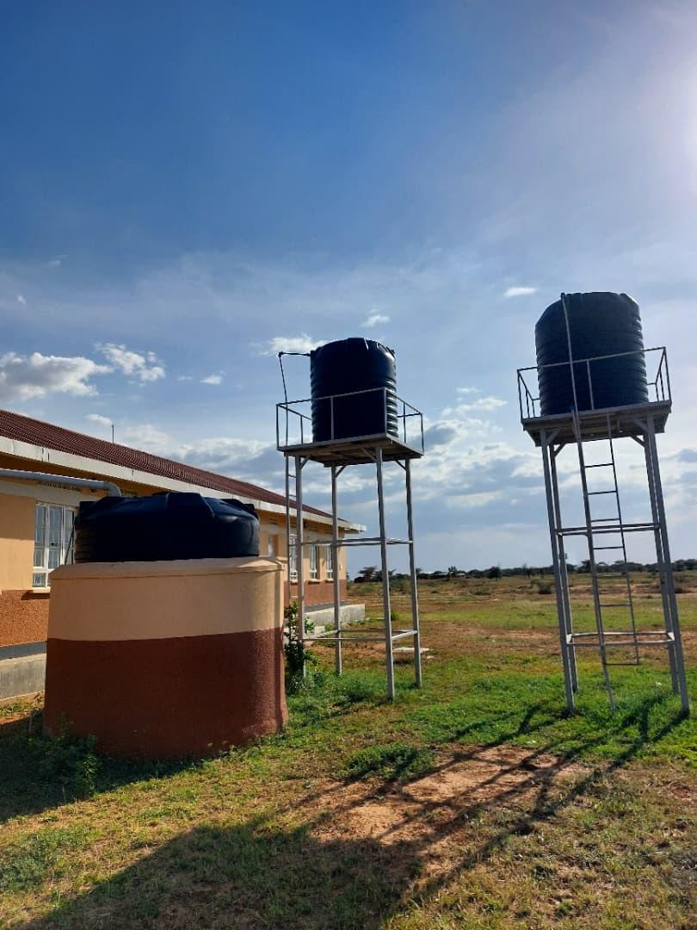  Figure 156: Water storage tanks at Lopei Seed Secondary School, Napak District (Karamoja)

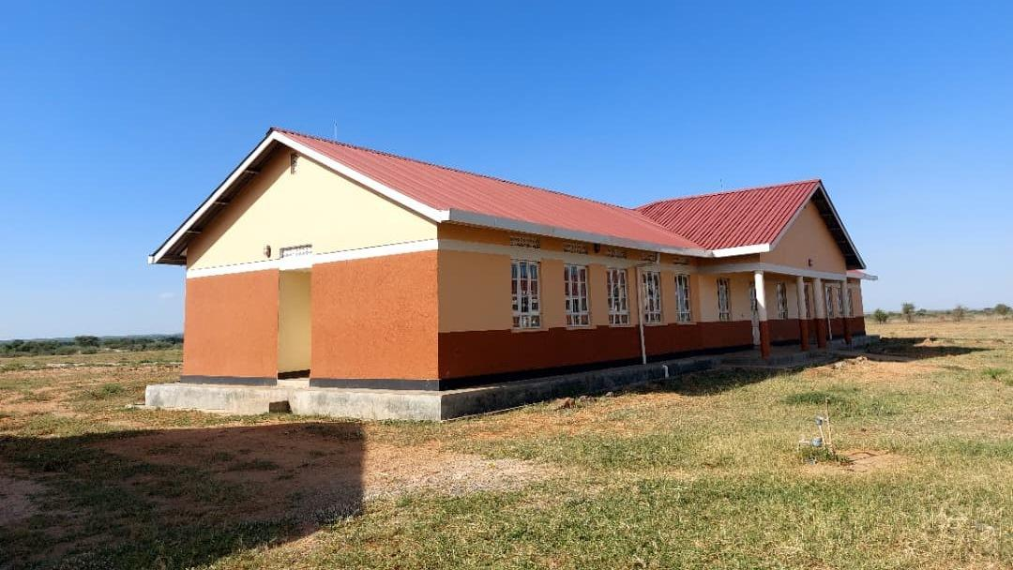  Figure 157: Computer and library block at Lopei Seed Secondary School, Napak District (Karamoja) | 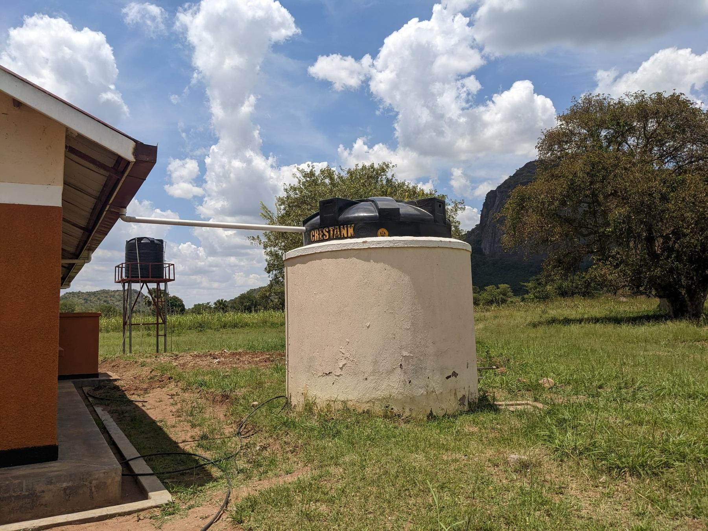  Figure 158: Water tanks on a rendered plinth and steel tower at Alerek Seed Secondary School, Abim District (Karamoja)

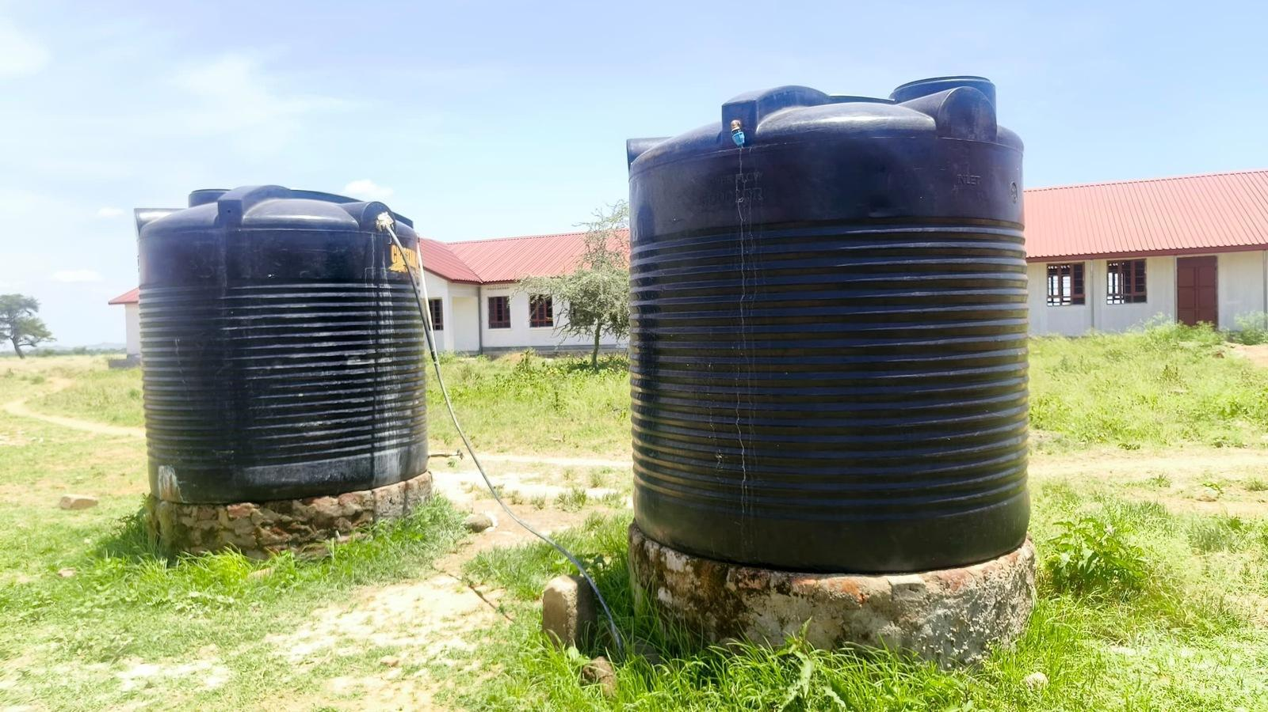  Figure 159: Water storage tanks at Rengen Seed School, Kotido District (Karamoja) | 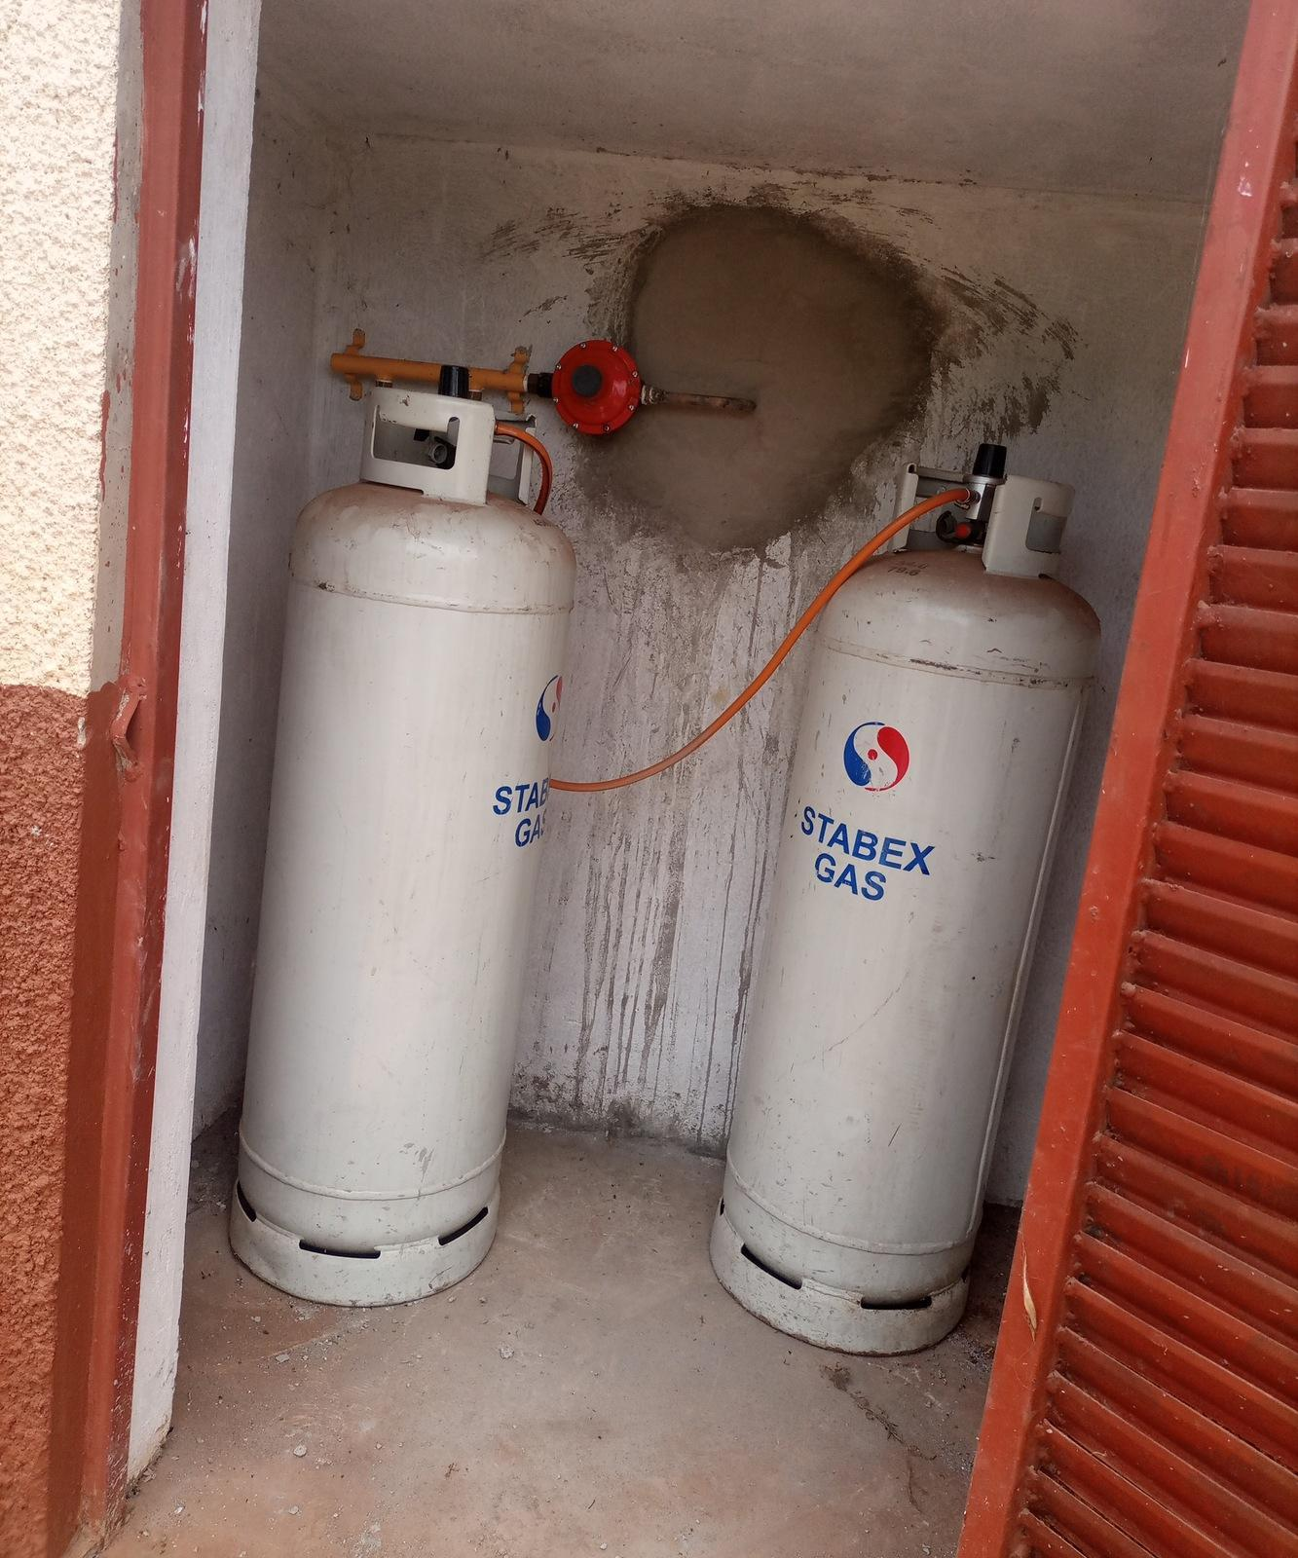  Figure 160: Gas cylinders and pipework at King Solomon Seed Secondary School, Kagadi District (Bunyoro)

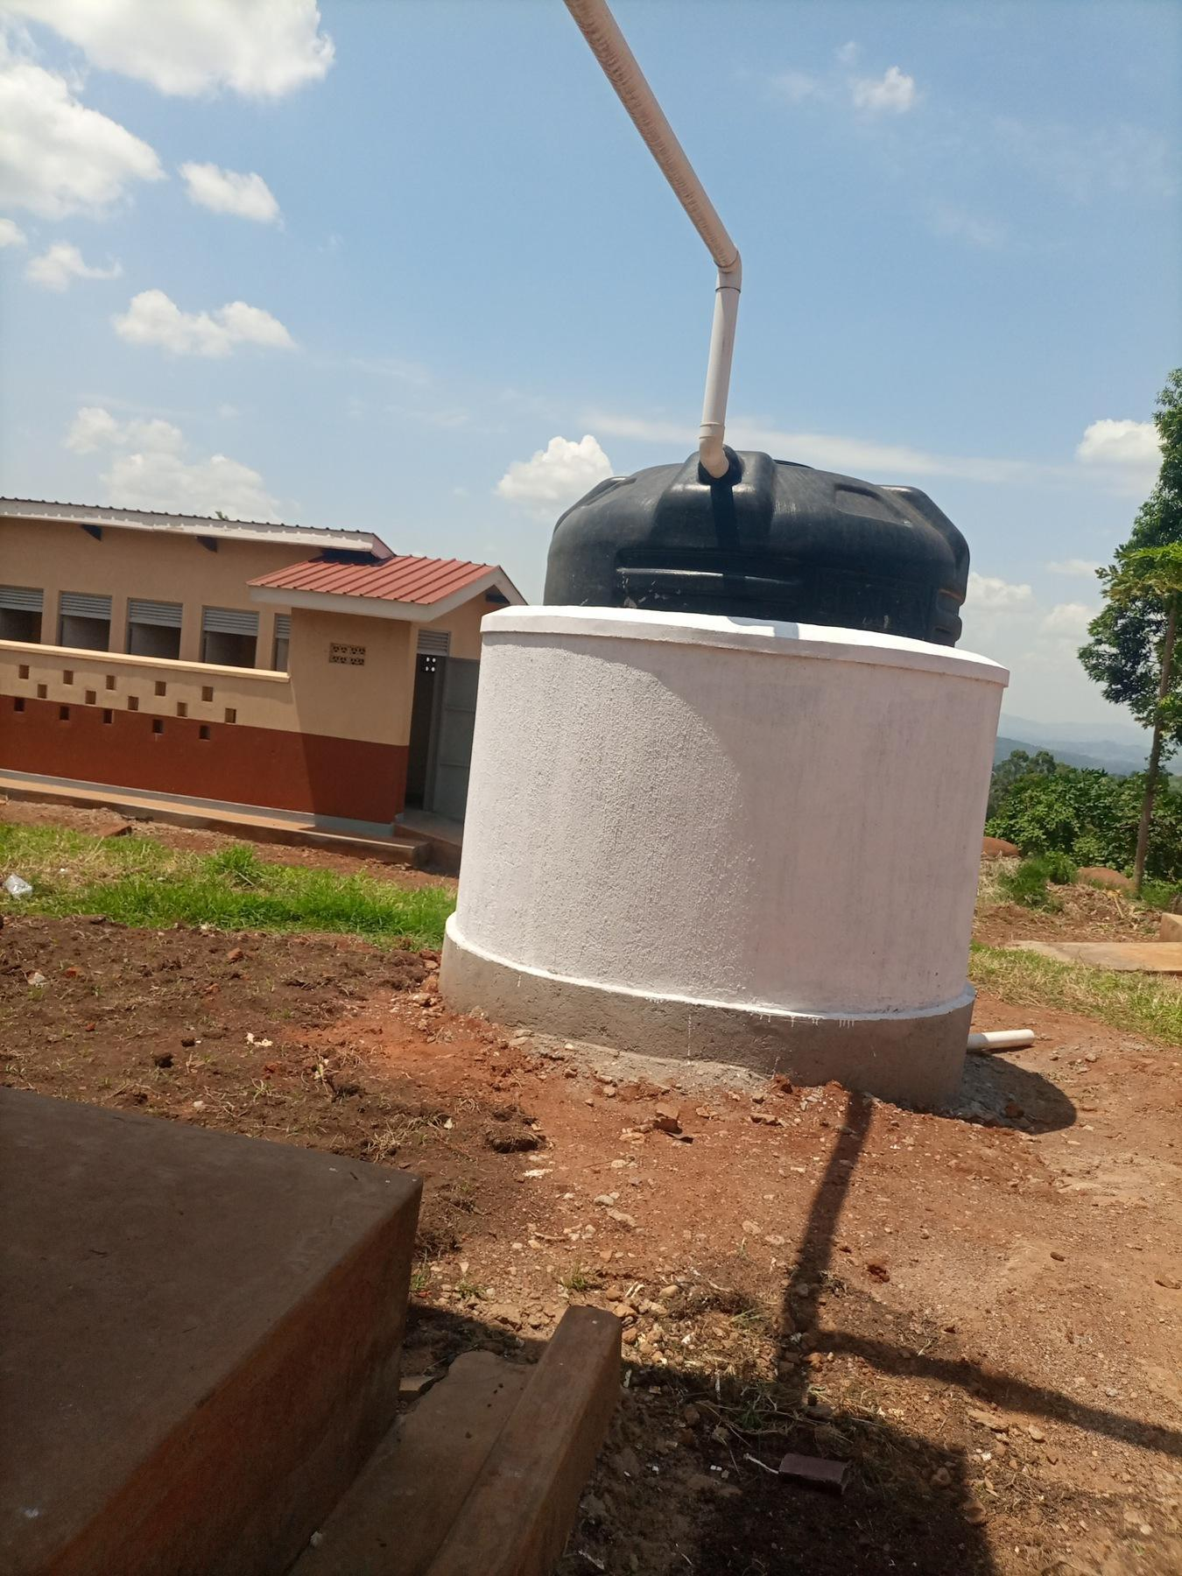  Figure 161: Water tank on a masonry support at King Solomon Seed Secondary School, Kagadi District (Bunyoro) | 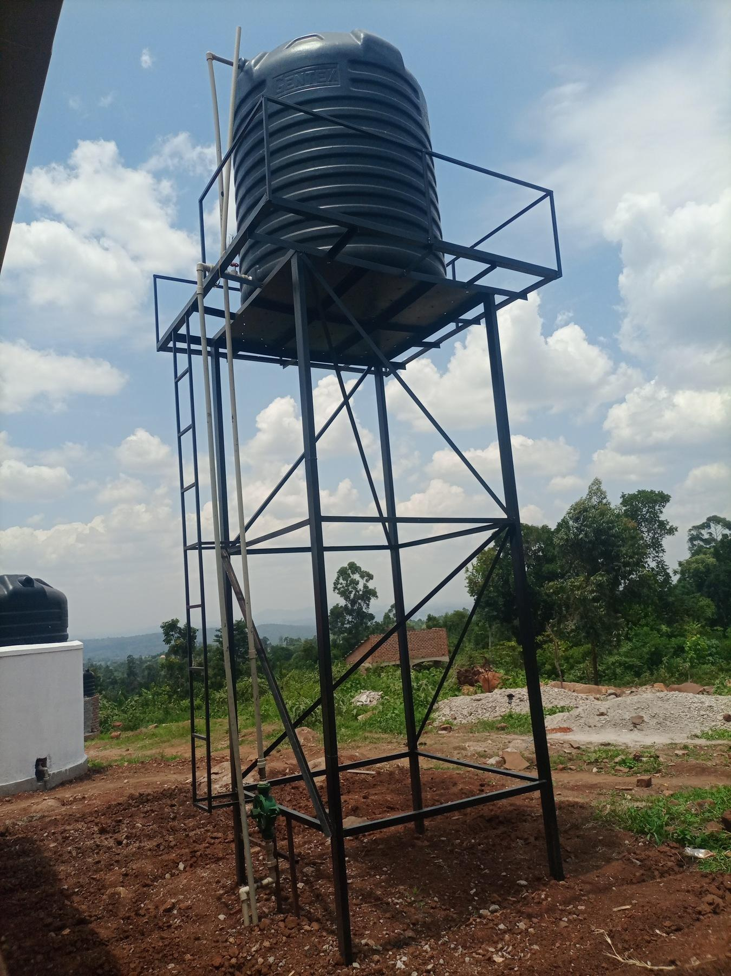  Figure 162: Elevated water tank on a steel tower at King Solomon Seed Secondary School, Kagadi District (Bunyoro) | 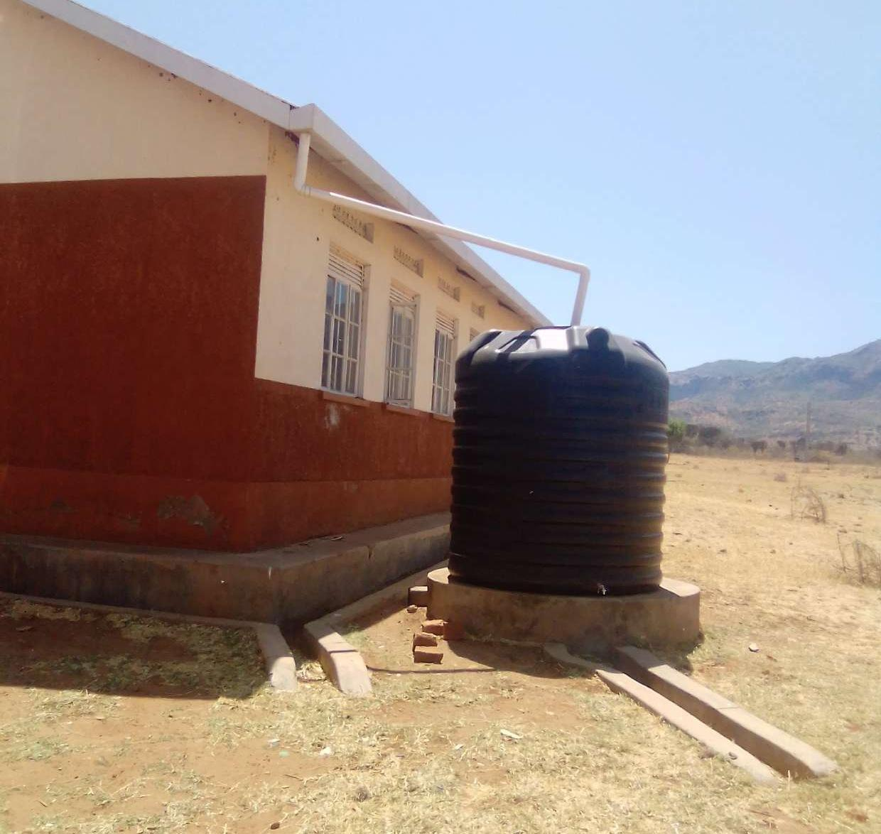  Figure 163: Rainwater tank beside a staff house at Rupa Seed School, Moroto District (Karamoja)

UgIFT Programme provided assets to other national and subnational agencies that were not directly involved in implementation such as KCCA, MODVA, hospitals and health centres across the country

